1.

a) To pass changes to remote repository we should use command:

$ git push –u origin master

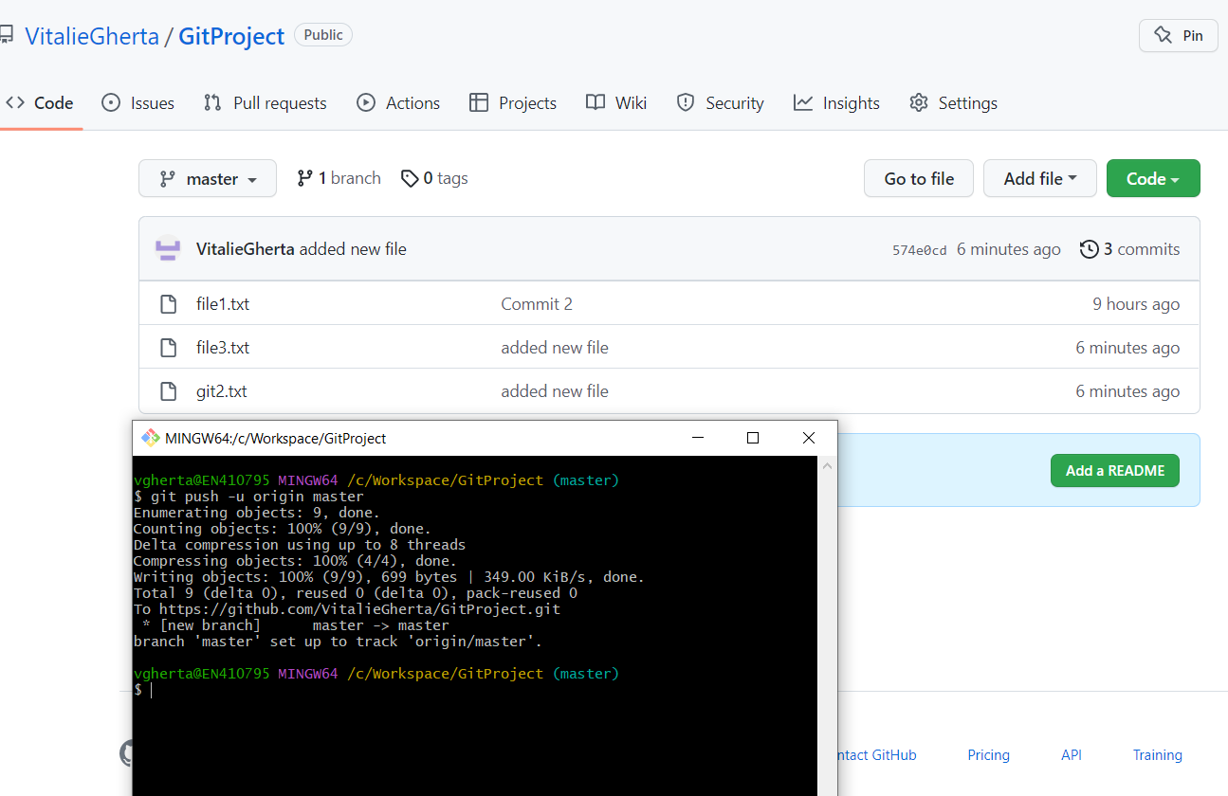

b) To commit without registering a new commit you have to use this comment.

$ git commit -m "Changed commit message" --amend

$ git push origin master -f

C) In case you don’t want some configurations to be promoted in future commits you need to create

file .gitignore and list them there. You can write file extensions, folders and file names. 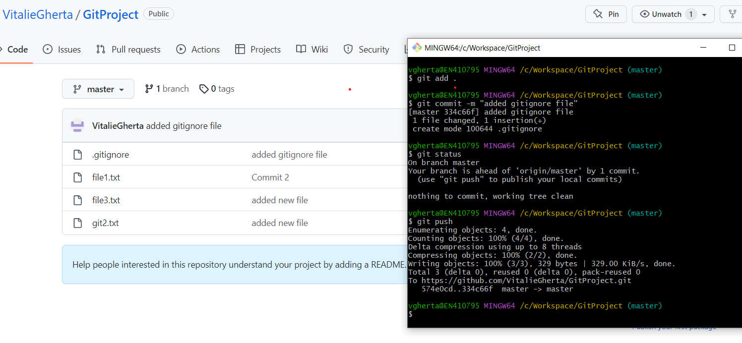

d) In case we need to add additional fix to last commit we have not pushed we should use the command:

$ git reset –soft head~

$ git add .

$ git commit –m “message”

2. To recreate the project from remote repo to local I have to use the command:

$ git clone <https://github.com/VitalieGherta/GitProject.git> My Project

3. I have to create and switch to a new branch. I have to use the command:

$ git checkout -b feature1

4. In this case I can save my changes on branch feature1 using command:

$ git stash

After that I have to switch to branch master (hotfix) and create a new branch:

$ git checkout master

$ git checkout –b fix1