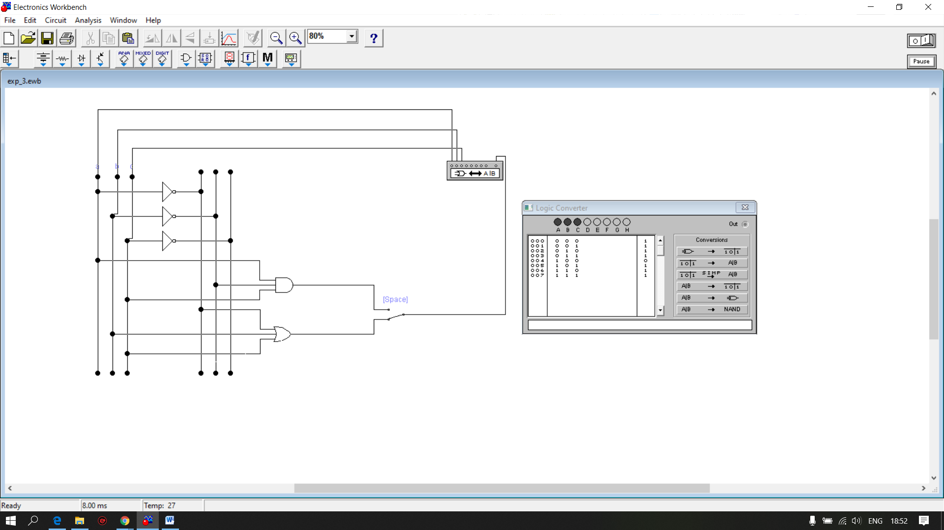

Fig. Logic Convert SAU(OR)

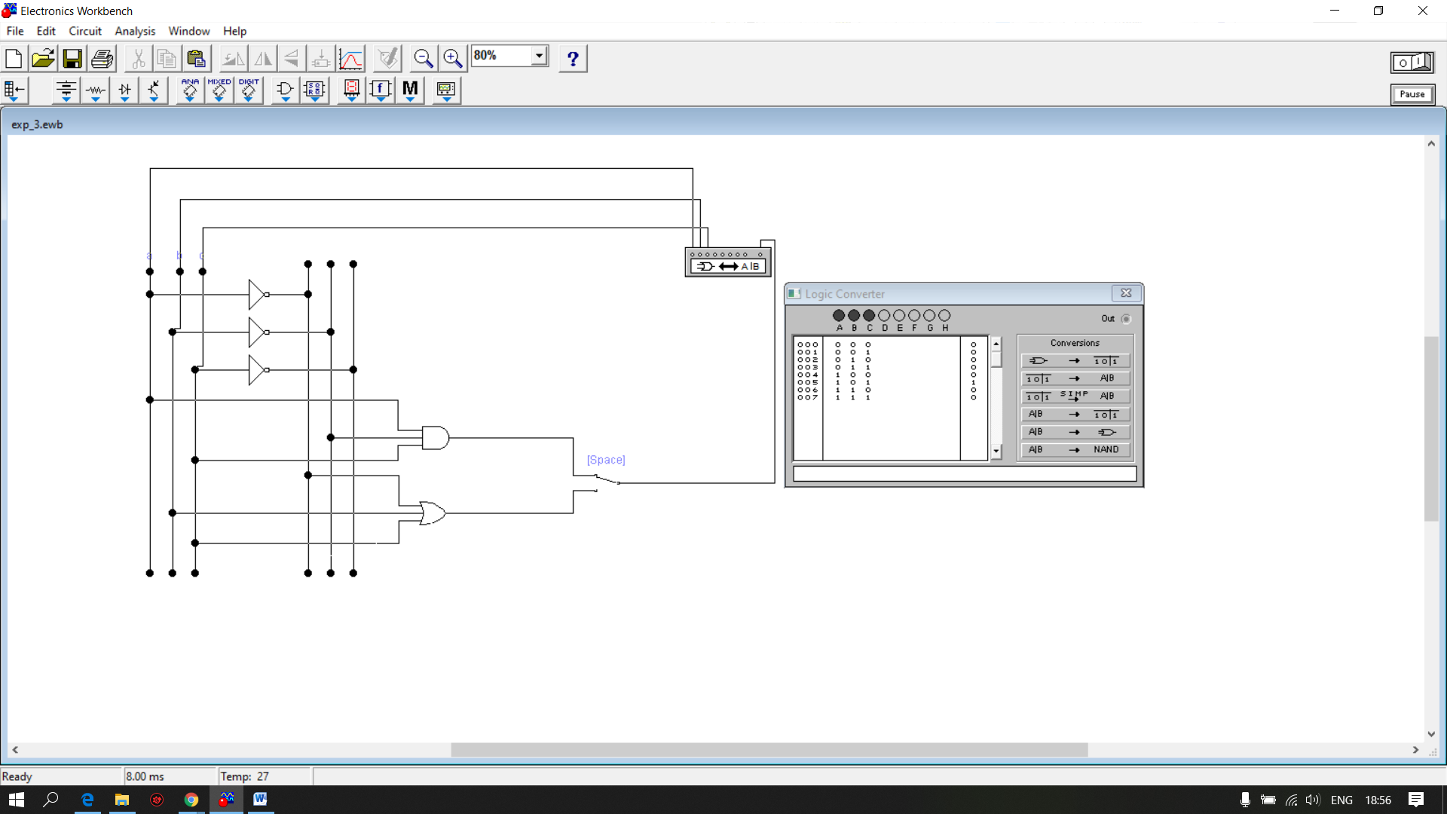

Fig. Logic Convert SI(AND)

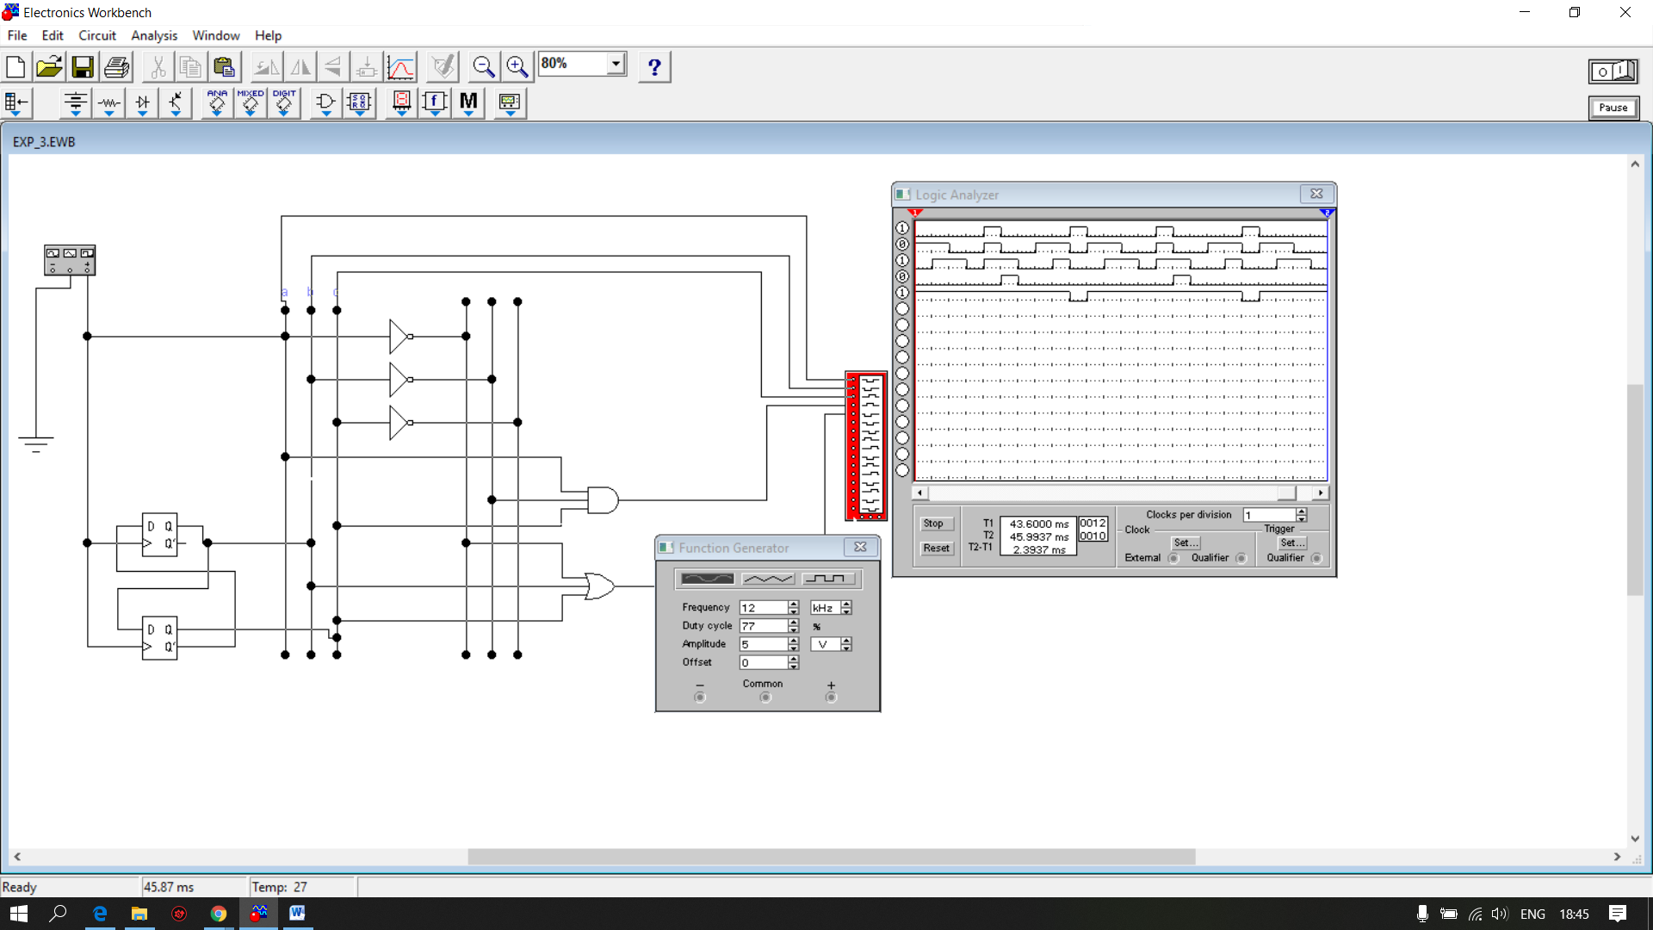

Fig. Analyzer initial

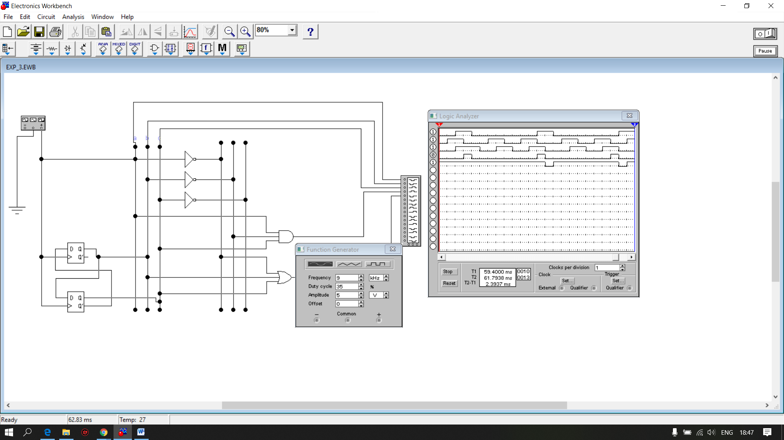

Fig. Analyzer modificat