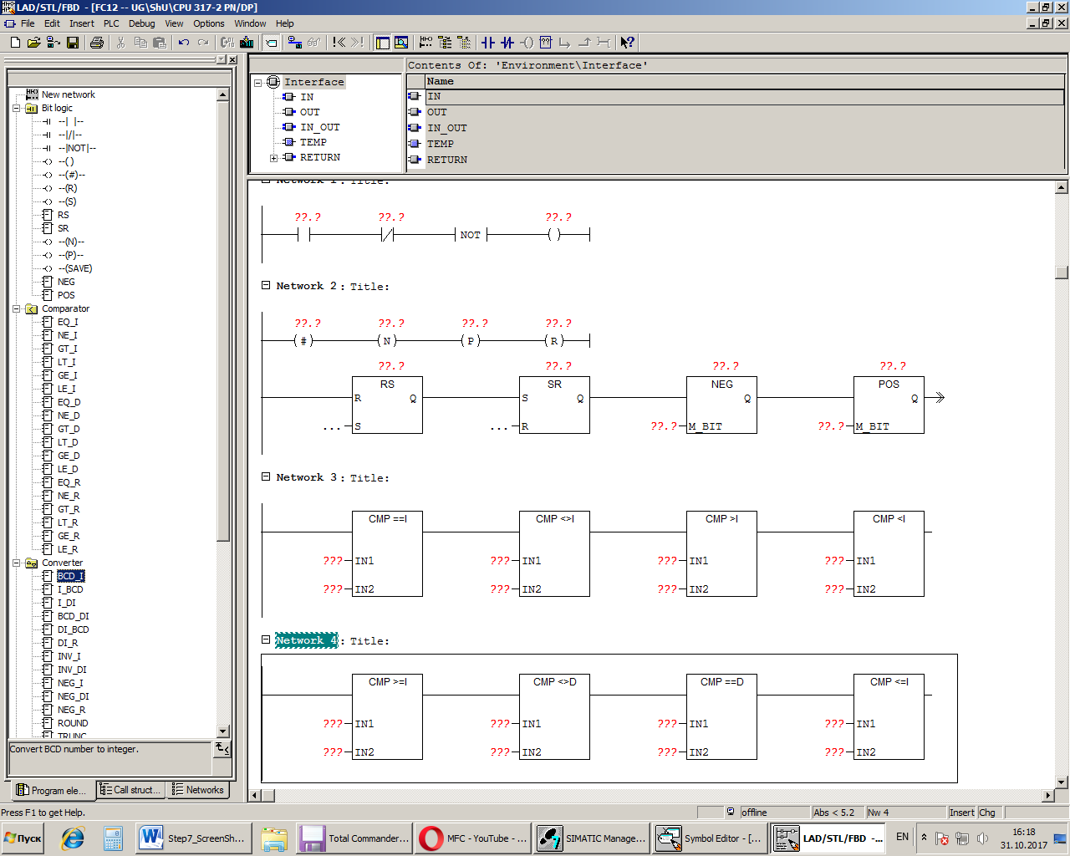

Symbol

Parameter Data Type Memory Area Description

<address> BOOL I, Q, M, L, D Set or reset bit

S BOOL I, Q, M, L, D Enabled reset instruction

R BOOL I, Q, M, L, D Enabled reset instruction

Q BOOL I, Q, M, L, D Signal state of <address>

Description

RS (Reset-Set Flip Flop) is reset if the signal state is "1" at the R input, and "0" at the S input. Otherwise, if the signal state is "0" at the R input and "1" at the S input, the flip flop is set. If the RLO is "1" at both inputs, the order is of primary importance. The RS flip flop executes first the reset instruction then the set instruction at the specified <address>, so that this address remains set for the remainder of program scanning.

The S (Set) and R (Reset) instructions are executed only when the RLO is "1". RLO "0" has no effect on these instructions and the address specified in the instruction remains unchanged.

MCR (Master Control Relay) dependency

MCR dependency is activated only if a RS flip flop is placed inside an active MCR zone. Within an activated MCR zone, if the MCR is on, the addressed bit is reset to "0" or set to "1" as described above. If the MCR is off, the current state of the specified address remains unchanged regardless of input states.

Status word

BR CC 1 CC 0 OV OS OR STA RLO /FC

writes: - - - - - x x x 1

Example

If the signal state is "1" at input I0.0 and "0" at I0.1, memory bit M0.0 is set and output Q4.0 is "0". Otherwise, if the signal state at input I0.0 is "0" and at I0.1 is "1", memory bit M0.0 is reset and output Q4.0 is "1". If both signal states are "0", nothing is changed. If both signal states are "1", the set instruction dominates because of the order; M0.0 is set and Q4.0 is "1".

If the example is within an activated MCR zone:

When MCR is on, Q4.0 is reset or set as described above.

When MCR is off, Q4.0 is left unchanged regardless of input states.

