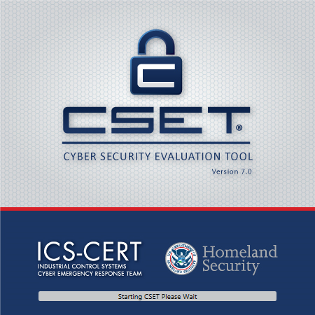

**CSET 8.1 – ReadMe**

Files on the CSET disk or contained in the .ISO file include

|  |  |
| --- | --- |
| **File Name** | **Description** |
| CSET_Setup.exe | This is the installation program that will start up if you have auto-run enabled. If not, then this is the file that should be initiated to begin the installation process. |
| ReadMe.pdf | This document. It includes basics on system requirements and how to get started with an assessment. It also includes advisory information and any known issues. |
| Accessibility_Features.pdf | The document contains information about accessibility features in the tool. |
| User Guide.pdf | This is the complete User Guide for the system. It is available from the Home screen in the tool. Additional user help can be found within the tool through the on-screen CSET Help system. |

System Requirements

It is recommended that users meet the minimum system hardware and software requirements prior to installing CSET. This includes:

* Pentium dual core 2.2 GHz processor (Intel x86 compatible)
* 5 GB free disk space
* 3 GB of RAM
* Microsoft Windows 7 or higher. (Windows XP is no longer supported)
* Microsoft Office compatible (.docx) document reader and/or pdf reader.
* Microsoft .NET Framework 4.6 Runtime (included in CSET installation)
* SQL Server 2012 Express LocalDB (included in CSET installation)

Other Items of Note:

* For all platforms, we recommend that you upgrade to the latest Windows Service Pack and install critical updates available from the Windows Update website to ensure the best compatibility and security.
* A CD-ROM disk drive may be needed to install the CSET software.
* The latest version of Adobe Reader may be downloaded free from <http://get.adobe.com/reader/>.
* Microsoft Visio 2010 and lower are no longer supported
* If the Microsoft .NET framework 4.6 Runtime is not available on the user’s computer, CSET will automatically install it, which can add several minutes to the installation time.

Installation Procedure

CSET is distributed in several ways. Each is addressed below.

**From Disk**

Insert the installation disk into the disk drive. Navigate to the drive and then run the executable file *CSET_Setup.exe*. With some CD-ROM drives and depending on the installed antivirus software, the installation process may take 10 to 15 minutes.

**Web Install:** <http://ics-cert.us-cert.gov/Downloading-and-Installing-CSET>

To install from the Internet, go to the Department of Homeland Security (DHS) web site at http://ics-cert.us-cert.gov/Downloading-and-Installing-CSET and download the .ISO file labeled *cset_8.1.iso*

The *.ISO* file is a disk image file and will need to be burned to a disk, mounted as a virtual drive, or uncompressed using compression utility software. To install, run *CSET_Setup.exe*.

**Setup**

Running the *CSET_Setup.exe* file will start the installation and setup process. Follow the on-screen prompts to complete the installation.

The default installation options are appropriate for most users. When installation is complete, close the setup window if necessary.

Advisory Information

**ADVISORY**

**Cyber Security Evaluation Tool**

The Cyber Security Evaluation Tool (CSET) ® is only one component of the overall cybersecurity picture and should be complemented with a robust cybersecurity program within the organization. A self-assessment with CSET cannot reveal all types of security weaknesses and should not be the sole means of determining an organization’s security posture.

The tool will not provide a detailed architectural analysis of the network or a detailed network hardware/software configuration review. It is not a risk analysis tool so it will not generate a complex risk assessment. CSET® is not intended as a substitute for in‑depth analysis of control system vulnerabilities as performed by trained professionals. Periodic onsite reviews and inspections must still be conducted using a holistic approach including facility walk-downs, interviews, and observation and examination of facility practices. Consideration should also be given to additional steps including scanning, penetration testing, and exercises on surrogate, training, or nonproduction systems, or systems where failures, unexpected faults, or other unexpected results will not compromise production or safety.

CSET® assessments cannot be completed effectively by any one individual. A cross‑functional team consisting of representatives from operational, maintenance, information technology, business, and security areas is essential. The representatives must be subject matter experts with significant expertise in their respective areas. No one individual has the span of responsibility or knowledge to effectively answer all the questions.

Data and reports generated by the tool should be managed securely and marked, stored, and distributed in a manner appropriate to their sensitivity.

Disclaimer

**DISCLAIMER**

The analysis, data, and reports in CSET® are provided “as is” for informational purposes only. The Department of Homeland Security (DHS) does not provide any warranties of any kind regarding any information contained within. In no event shall the United States Government or its contractors or subcontractors be liable for any damages, including but not limited to, direct, indirect, special, or consequential damages and including damages based on any negligence of the United States Government or its contractors or subcontractors, arising out of, resulting from, or in any way connected with this report, whether based on warranty, contract, tort, or otherwise, whether injury was sustained from, or arose out of the results of, or reliance upon the report.

DHS does not endorse any commercial product or service, including the subject of the assessment or evaluation in this report. Any reference to specific commercial products, processes, or services by trademark, manufacturer, or otherwise, does not constitute or imply its endorsement, recommendation, or favoring by DHS.

The display of the DHS official seal or other DHS visual identities on this report shall not be interpreted to provide the recipient organization authorization to use the official seal, insignia or other visual identities of DHS. The DHS seal, insignia, or other visual identities shall not be used in any manner to imply endorsement of any commercial product or activity by DHS or the United States Government. Use of the DHS seal without proper authorization violates federal law (e.g., 18 U.S.C. §§ 506, 701, 1017) and is against DHS policies governing usage of the seal.

The report is prepared and intended for internal use by the organization that made the request. The contents of this report may be subject to government or private intellectual property rights. To request distribution of this report outside the organization for which it was prepared, contact the CSET Program Office. The contents of this report may be reproduced or incorporated into other reports, but may not be modified without the prior express written permission of the CSET Program Office.

Limitations of the Tool

The tool has a component focus rather than a system focus. Therefore, network architecture analyses, including network hardware and software configuration analyses, will be limited to the extent that they are defined by programmatic and procedural requirements.

CSET is not a risk analysis tool; it will not create a detailed risk assessment.

Most importantly, CSET is only one component of a comprehensive control system security program. A security program based on a CSET assessment alone must never be considered complete or adequate.

User Qualifications

CSET assessments cannot be completed effectively by any individual. A cross-functional team consisting of representatives from multiple company areas is essential. The representatives must be subject matter experts with significant expertise in their respective areas. No one individual has the span of responsibility or knowledge to be able to fully and accurately answer all the questions.

CSET Framework

The underlying framework for CSET includes:

* analysis and user interface tools to assist in the evaluation of an ICS,
* a knowledge base of ICS cybersecurity requirements, regulations, and practices, and
* a database of solutions to help mitigate vulnerabilities.

CSET was designed to assist in identifying control system parameters by guiding the user through a series of questions that represent ICS security requirements. The presented requirement questionnaires are based on selected standards, common requirements, and the design of the control system component diagram (or network topology and architecture).

Basic Evaluation Process

Figure 1 graphically depicts the basic steps of the self-assessment process.

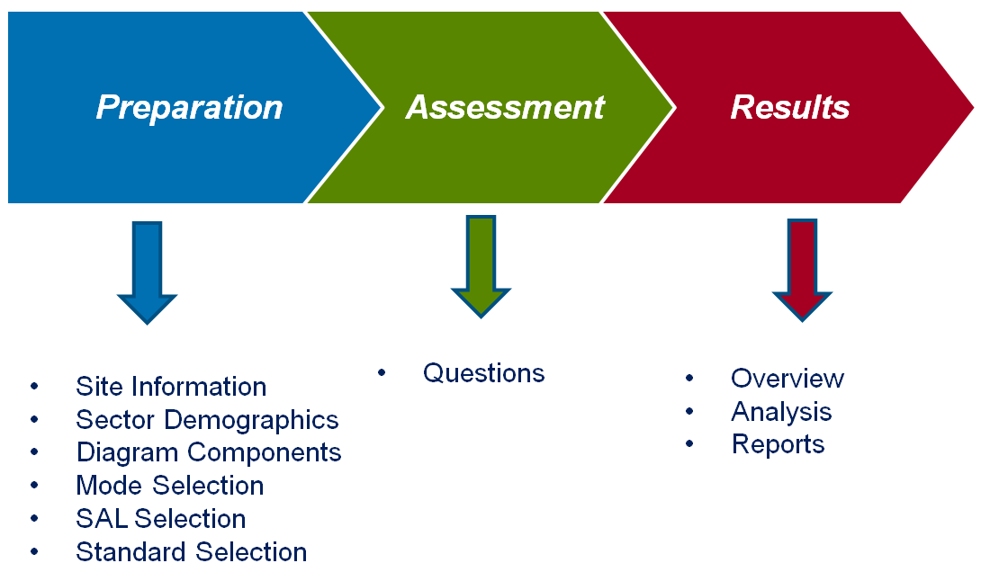

Figure 1. CSET Process.

An explanation of the process is provided in the User Guide. A description of each screen used in the assessment process is explained in detail in both the User Guide and the on-line help system.

Known Technical Issues

1. When opening a CSET assessment, diagram, or aggregation file received via email or the internet, it may fail to function if the temporary folder assigned by the email or internet application becomes locked or is removed. This happens because files attached to emails are often stored in a “Temp” folder which is deleted or locked when the email application is closed. If a CSET file is open in CSET when the email application is closed and the Temp folder deleted, the CSET file can become corrupted and unusable.
   1. The issue can be prevented by downloading and saving the CSET file to a new location before opening it in CSET.
2. Occasionally the PDF version of the Executive Summary report will have spurious line spaces in the Top 5 List.
   1. The issue can be resolved by creating a .DOCX version of the report and saving it to a PDF format.
3. Some anti-virus software programs have been found to significantly slow the download and installation of CSET from the Department of Homeland Security (DHS) website. An installation disk may be requested from DHS if this is a problem.
4. Having a screen resolution of less than 1024 x 768 on Windows-based systems can cause CSET display problems.
   1. Correct the issue by using a higher screen resolution setting.
5. If using a tablet device to run CSET, the placement of popup windows and drop-down menu lists may be affected by the tablet’s default display settings.
   1. Correct the issue by changing the tablet display setting to left-handed.
6. On Windows 8.1, the installation of CSET may fail.
   1. The Windows 8.1 Update (KB2919355, available through Windows Update or manually downloaded from the following URL: <https://www.microsoft.com/en-us/download/details.aspx?id=42327>) is required for installation.
7. In rare circumstances, CSET may fail immediately after launching on systems with another database installation.
   1. This condition can be verified by checking the CSET log file, typically located at *\Users\%username%\AppData\Roaming\DHS\CSET\CSET.log,* for an error message such as “'DbProviderFactories' section can only appear once per config file error”.
   2. If the specified error message appears in the log file, the issue may be corrected by opening *C:\Windows\Microsoft.NET\Framework\v4.0.30319\Config\Machine.Config* and removing text matching the following: <DbProviderFactories/>.
8. If a document viewer (Adobe Reader, etc) is updated or installed while CSET is running and a document is selected for viewing, CSET may open the document in an internal viewer and/or display a notification that the file cannot be opened.
   1. This issue can be resolved by restarting the CSET application.
9. Under some circumstances, components on the diagram may become disassociated from the layer containing them.
   1. This can be rectified by saving and reloading the assessment.
10. If CSET Will not start there may be an issue with a Microsoft Patch. See the following links below.  
    Please run the fix file included:   
    fixittool-kb4074906_eb1134097ca5e981dfb99938f57e5f959d8e88ce.exe  
      
    see <https://github.com/dotnet/announcements/issues/53>  
    see <https://support.microsoft.com/en-us/help/4074906/typeinitializationexception-or-fileformatexception-error-in-wpf-apps-t>