Template for State Communications Interoperability Plan

This template was developed to assist statewide communications interoperability planners. Once content has been identified, it may be loaded into this template.

1. Introduction

Provide a general introduction to the statewide plan and present the factors driving the creation of the statewide plan.

1. Background

Describe the events that have occurred to develop the statewide plan. Provide a high-level description of the process that was used to develop the statewide plan and people who were involved in the planning process.

## State Overview

Describe background information on the state. Identify its regions, geography, and demographics, providing an understanding of what the state looks like and how it is organized. Include: population; size (square miles); number of emergency response agencies; type of climate; critical infrastructure; major roadways and waterways; major geographical considerations (mountains, lakes, deserts, state parks, etc); state and foreign country borders; recurring large events (parades, sporting events, musical events, etc.) with frequency and size; and current status of interoperability.

## NIMS/Multi-Agency Coordination System (MCS) Incorporation

*Describe how the state currently incorporates concepts and principles of NIMS Chapter II, Command and Management, including ICS characteristics. Describe how the state’s MCS is used to coordinate and support emergency incident and event management.*

## Regions/Jurisdictions

Describe how the state’s agencies are organized, (i.e., regions, counties, and/or jurisdictions. Include maps if available (see Figure 1).

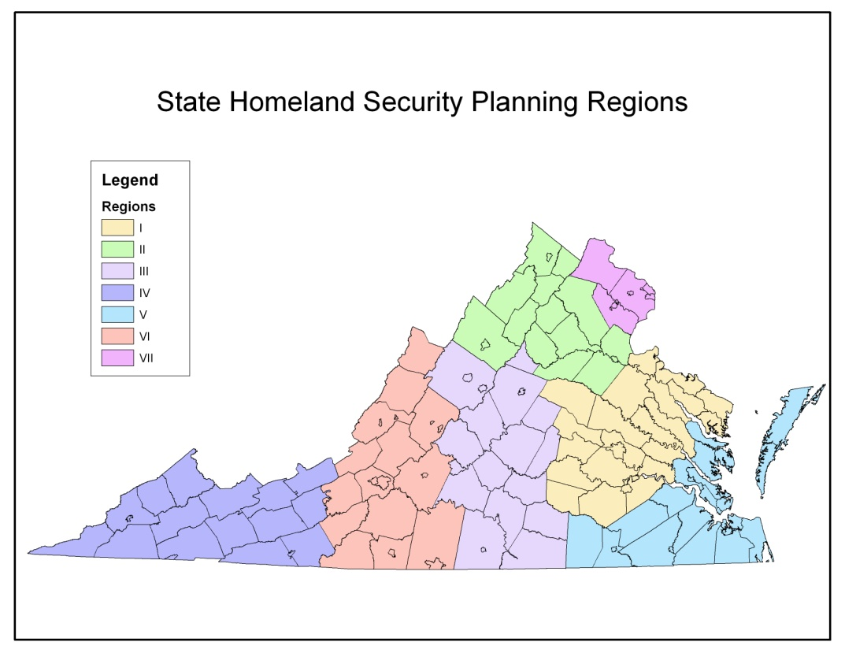

Figure 1 – Sample map of planning regions

The following table provides a list of the regions within the state and lists the jurisdictions included in each region:

|  |  |  |  |  |
| --- | --- | --- | --- | --- |
| ***Region 1*** | ***Region 2*** | ***Region 3*** | ***Region 4*** | ***Region 5*** |
| * A County * B County * C County | * D County * Blue City * Red City | * E County * F County * G County | * H County * Green City | * I County * J County * K County * Town of Yellow |
| ***Region 6*** | ***Region 7*** | ***Region 8*** | ***Region 9*** | ***Region 10*** |
|  |  |  |  |  |

## UASI Areas/TIC Plans

Identify any UASI areas within the state borders and any other areas that currently have a tactical interoperable communications plan.

|  |  |  |  |  |
| --- | --- | --- | --- | --- |
| ***UASI Area*** | ***Regions / Jurisdictions*** | ***TICP Title/ Completion Date*** | ***POC Name*** | ***POC Email*** |
|  |  |  |  |  |

## Participating Agencies and Points of Contact

Identify the agencies that helped develop the statewide communications interoperability plan.

|  |  |  |  |
| --- | --- | --- | --- |
| ***Agency Name*** | ***Agency POC*** | ***POC Email*** | ***POC Telephone (s)*** |
|  |  |  |  |

## Statewide Plan Point of Contact

Identify the point of contact acting as the statewide plan coordinator, including name and contact information (i.e., e-mail address and phone number). Specify if the POC is operating as a full-time interoperability coordinator or not.

## Scope and Timeframe

Include scope (define specific elements/initiatives that are included in the strategy as well as elements/initiatives that are not addressed) and high-level timeframe for completing milestone initiatives, with any key assumptions relative to the scope or timeframe.

1. Methodology

Summarize the process used to encourage cross-jurisdictional and cross disciplinary participation in developing the statewide plan. Address the method used for incorporating TIC plans into the statewide plan. Describe the approach for sustaining participation after the initial plan has been completed.

1. Current Statewide Assessment

Describe the current status of communications and interoperability statewide: include what is working well; what is not working well; key strategies (if applicable) that are currently underway to address what is not working well; and the barriers to implementation.

## Governance Structure

Define any governance structures currently in place to oversee communications interoperability. Include copies of the group’s charter, executive, or legislative authority.

## Technology

Identify and describe all of the communications systems and equipment **currently** operating in the state. Include actual hardware and software in place, as well as the frequencies being used, licenses, existing, channel plans, what channels are used for what purpose or coverages. Identify any shared systems.

## Standard Operating Procedures

Identify existing SOP documents that address interoperable communications in the state and other SOPs that need to be developed. Determine compliancy with existing standards, including NIMS.

|  |  |  |  |  |
| --- | --- | --- | --- | --- |
| ***SOP Name*** | ***Agencies Included*** | ***Disciplines Included*** | ***SOP Location\**** | ***Frequency of Use*** |
| *SOP Name:*  *SOP Description* |  |  |  |  |

*\* Where is the SOP made available to the state emergency response community? (e.g., Web site, newsletter, etc.)*

## Training and Exercises Plan

Describe the current plan for statewide communications training, including type(s) of communications interoperability training still needed for each discipline. Describe the current exercises plan for the state and the level of statewide participation (including state, local, tribal, and Federal agencies).

## Usage

Describe any steps taken or policies put in place to encourage emergency responders to adopt and utilize interoperable technologies, SOPs, training, and exercises. Describe the frequency interoperable procedures and technologies are used by emergency responders in the field.

1. Strategy

Describe the vision, mission, goals, and objectives, and strategic initiatives for interoperability statewide.

## Interoperability Vision

Describe the overall vision for statewide communications interoperability once the plan has been fully implemented. A compelling vision statement should include the following characteristics:

* Provides the local officials and the responder community with a clear, inspiring picture of what communications and interoperability looks like when performed in its desired state.
* Describes how the delivery of critical services is enhanced and the benefits to the citizens.
* Demonstrates to users what interoperability looks like when the ideal relationships statewide are realized.
* Describes a state of emergency services that are being delivered in the way that first responders believe they should be.

## Mission

Describe the group’s mission for achieving effective communications and interoperability statewide. The mission should state how the state, as a whole, intends to operate and where its focus will be to ultimately achieve the vision statement. The mission should also specify, at a high level, what the state will do to deliver the vision.

## Goals and Objectives

Identify the project’s goals (the accomplishments needed if the vision is to become real) and the target objectives (the specific activities required to achieve the goals), starting from the current state.

## Strategic Initiatives

Describe the set of strategic initiatives the state has identified and that will be accomplished in order to achieve the vision. Define the specific actions to be taken, how they will be measured, and the agreed upon timeframe within which they will be accomplished.

## National Incident Management System (NIMS) Compliance

Describe how the statewide plan promotes and supports the use of NIMS operating procedures.

## Review and Update Process

Describe the process for reviewing and updating the statewide plan regularly, including review cycle, participants, and approval process.

1. Implementation

Describe the approach for implementing the statewide plan’s strategic initiatives, short- and long-term goals for implementation, key roles and responsibilities, performance measures, critical success factors, plans for educating policy makers and practitioners and a plan for overseeing operational requirements, SOPs, training, and technical solutions.

1. Funding

Determine the budget needed to implement the statewide plan. Identify who will provide funding, what the plan is to obtain initial funding, and how sustained funding will be provided to support the statewide plan, and its mission and goals.

1. Close

Provide a summary of the plan and the next steps.