For importing partOf item values it is necessary to reference these items by means other than the usual unique column technique because partOf items often do not provide a unique key but only hold their enclosing parent as foreign key.
The most prominent example is the Customer.addresses attribute: the customer owns addresses exclusively and the addresses hold the customer PK as back reference. Unfortunately, when using ImpEx both customer and address have to be imported within separate lines.
In fact, removing obsolete addresses requires you to fill the Customer.addresses cell with all currently valid addresses, which allows the setter method to remove obsolete ones. Therefore, it is required to reference these valid addresses by some kind of unique key, which addresses simply do not provide. For these cases where a reference within the ImpEx script is needed, ImpEx provides a special header attribute marked with the prefix & for specifying a virtual ID called Document ID. Each imported item line optionally can define such a Document ID, which allows other lines to reference it later using the same attribute qualifier (with & prefix). It should be also noted that Document ID is case-sensitive.

Example:

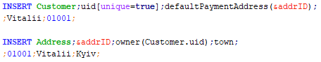

Link:

