Step 1. Go to localextensions.xml and add platform webservices extension.

Step 2. Rebuild, start and update your project. After that necessary “Resource” and “DTO” classes should be automatically generated in your project.

Step 3. We will use a Postman client to test the web-services functionality. To authorize your client, use login “admin” and password “nimda”.

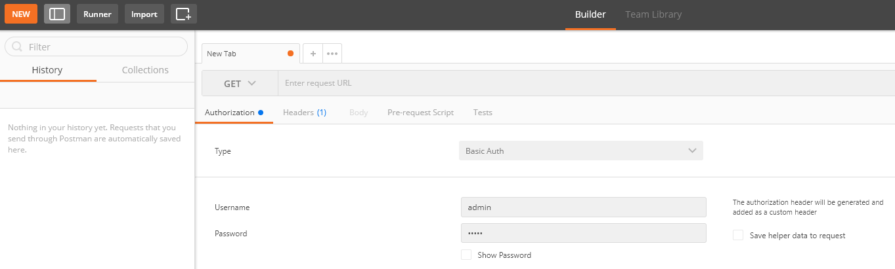

Step 4. Perform PUT request to create a new user.

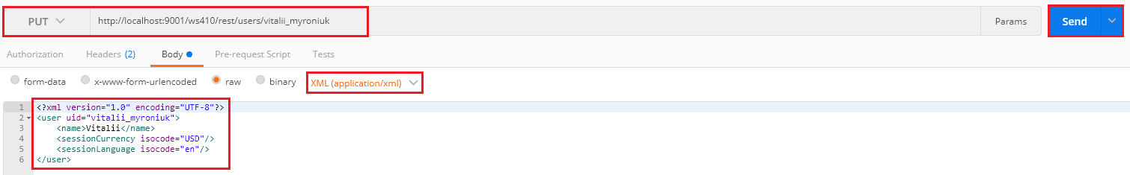

Step 5. Perform GET request to check that a new user was created.

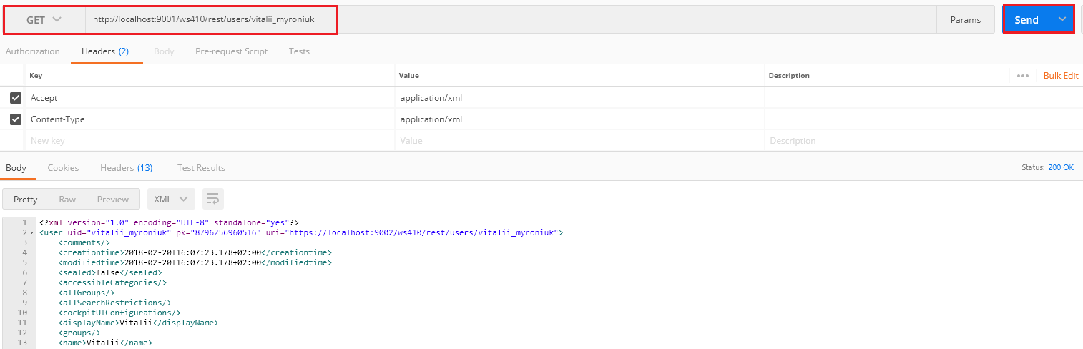

Step 6. Perform PUT request to update user name.

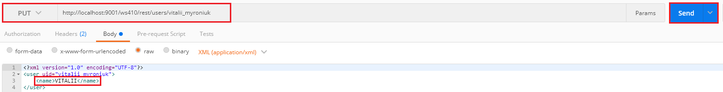

Step 7. Perform GET request to check that a user name was updated.

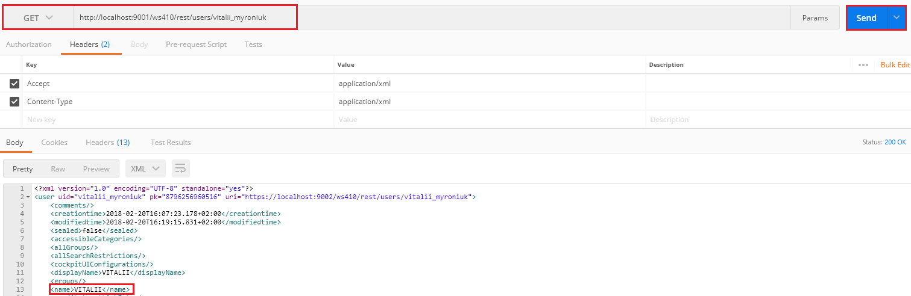

Step 8. Perform DELETE request to delete a user.

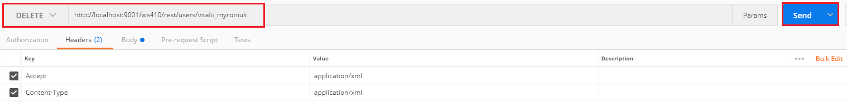

Step 9. Perform GET request to check that a user was deleted.

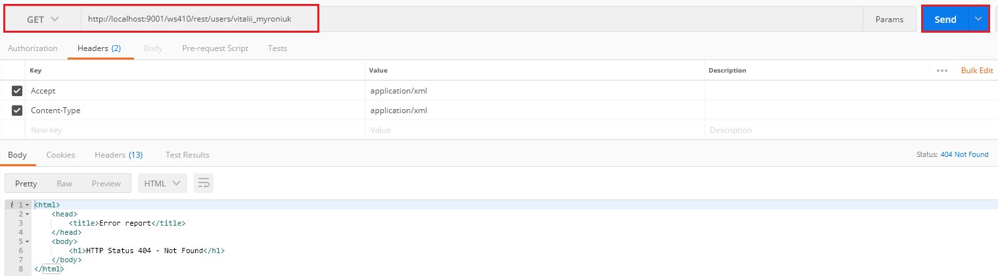

Link:

