Step 1. Go to myextension-items.xml and add “age” attribute to “Customer” item type.

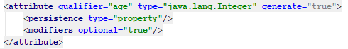

Step 2. Localize above created “age” attribute.

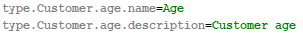

Step 3. Rebuild, start and update you project.

Step 4. Go to “admincockpit” and create “CustomerAgeConstraint”. Alternatively, you can go to HAC and import corresponding impex-script to create “CustomerAgeConstraint” (see more details at the repository).

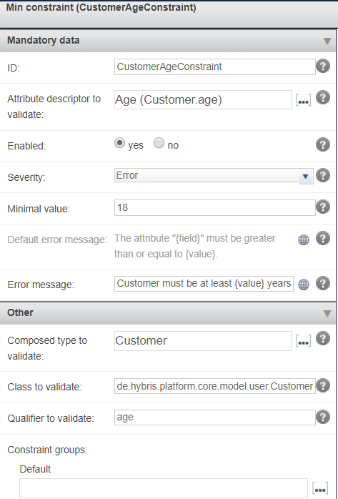

Step 5. Reload validation engine at the “admincockpit”.

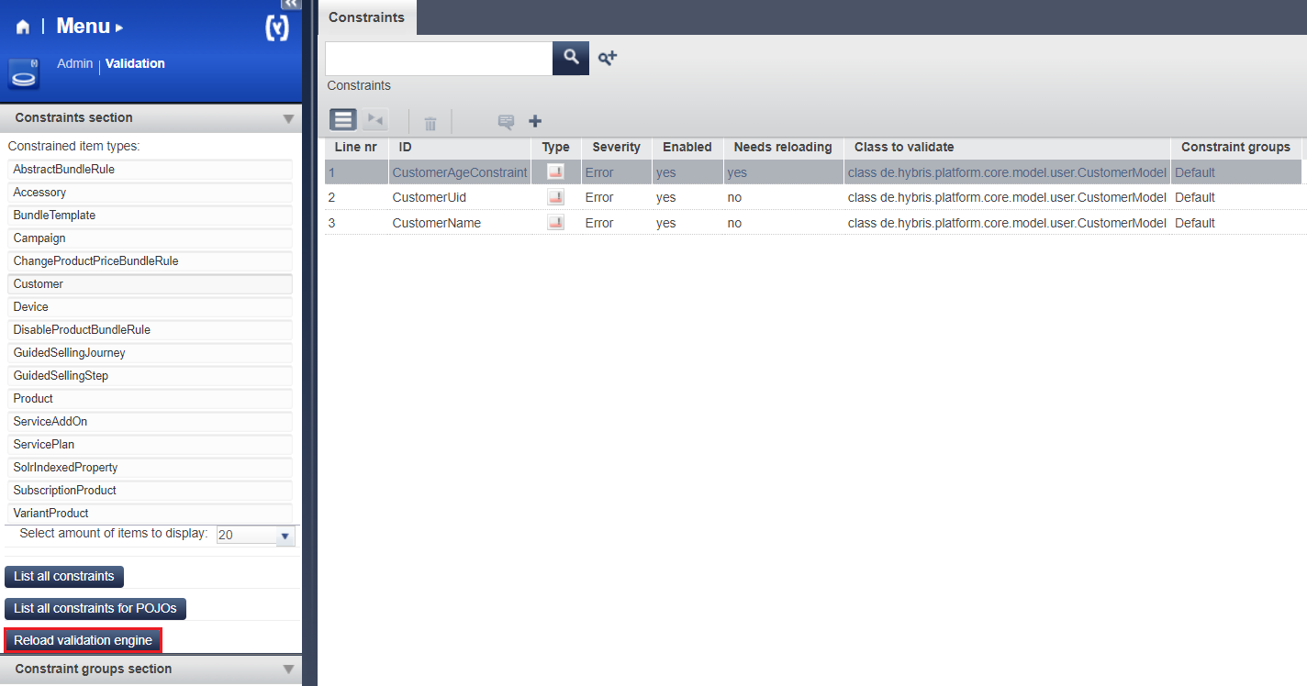

Step 6. Go to HMC and try to create a customer with age < 18. You should obtain the following error.

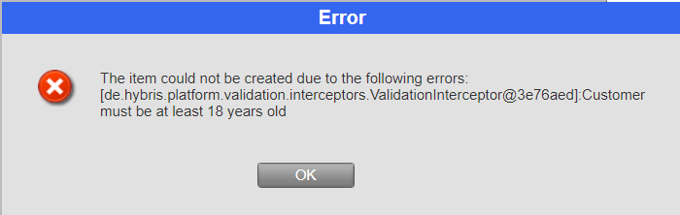

Step 7. Go to HMC and try to create a customer with age >= 18. In this case creation should be successful.

Link: https://git.epam.com/Vitalii_Myroniuk/hybris-mentoring/commit/c3ca3eb51efd83988dba20fe816379aabd0cd69e

