Step 1. Go to myextension-items.xml and add “ProductBundleWithOnlineProductsConstraint” item type.

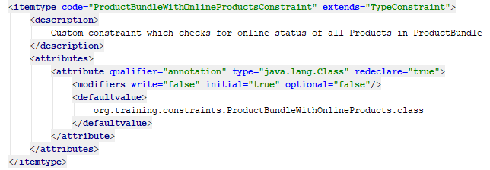

Step 2. Localize “ProductBundleWithOnlineProductsConstraint” item type.

Step 3. Write “ProductBundleWithOnlineProducts” annotation (see more details at the repository).

Step 4. Write “ProductBundleWithOnlineProductsValidator” class (see more details at the repository).

Step 5. Create default validation message at myextension\resources\myextension\ValidationMessages.properties file.

Step 6. Rebuild, start and update your project.

Step 7. Go to “admincockpit”, create “ProductBundleWithOnlineProductsConstraint” and “ProductBundleSizeConstraint”. Alternatively, you can go to HAC and import corresponding impex-script to create necessary constraints (see more details at the repository).

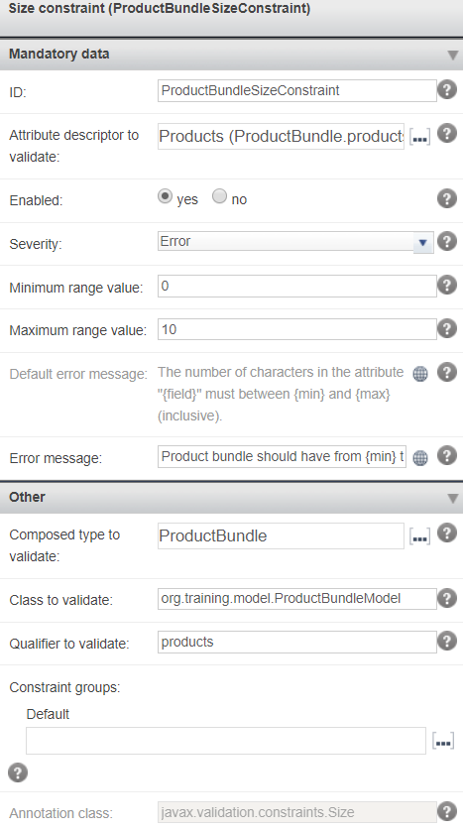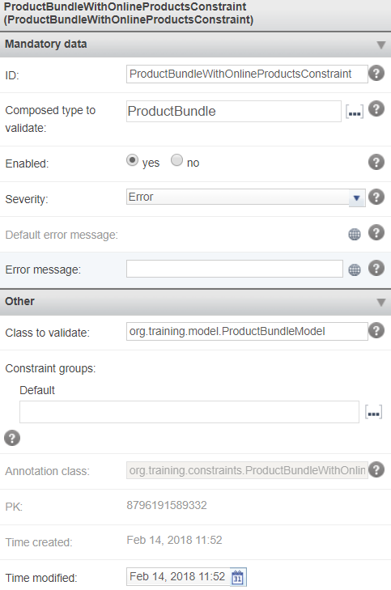
Step 8. Reload validation engine at the “admincockpit”.

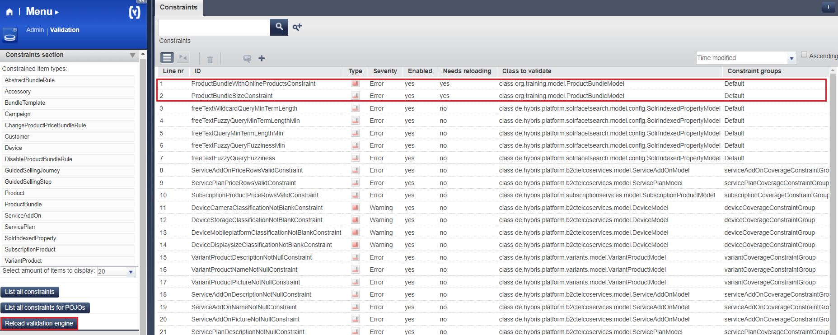

Step 9. Go to HMC and try to create ProductBundle with not more than 10 products (at least one of them should have offline status). You should obtain the following error.

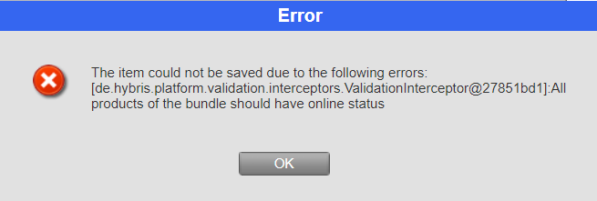

Step 10. Now try to create ProductBundle with more than 10 products (all of them should have online status). You should obtain the following error.

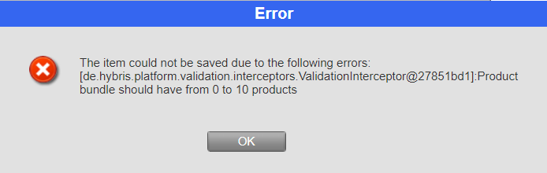

Step 11. Finally, try to create ProductBundle with not more than 10 products (all of them should have online status). In this case creation should be successful.

Link: https://git.epam.com/Vitalii_Myroniuk/hybris-mentoring/commit/8e5ae01929560df37b20abe3479b7a8f36b97f2d

