PART_1

Step 1. Go to trainingcore-items.xml file, add new attribute “confirmed” to “Customer” type item and redeclare “loginDisabled” attribute.

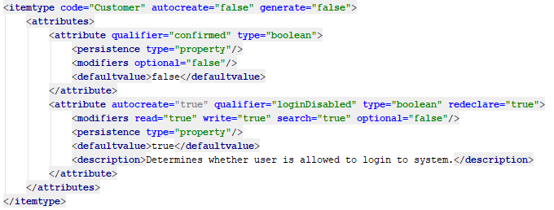

Step 2. Localize above created “confirmed” attribute.

Step 3. Rebuild your project.

Step 4. Create necessary workflow templates, actions, decisions and links. You can do this manually by using HMC or alternatively by using impex-script (see more details at the repository).

Step 5. Create action jobs for the automated workflow steps (see more details at the repository).

Step 6. Go to trainingcore-spring.xml and define spring beans for the automated workflow steps.

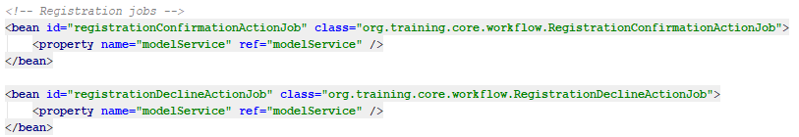

Step 7. Integrate the creation and start of the workflow into the “UserModelService” class (see more details at the repository).

Step 8. Go to trainingcore-spring.xml and define spring bean for the “UserModelService” class.

Step 9. Rebuild, restart and update your project.

Step 10. Go to the telco website and register a new user.

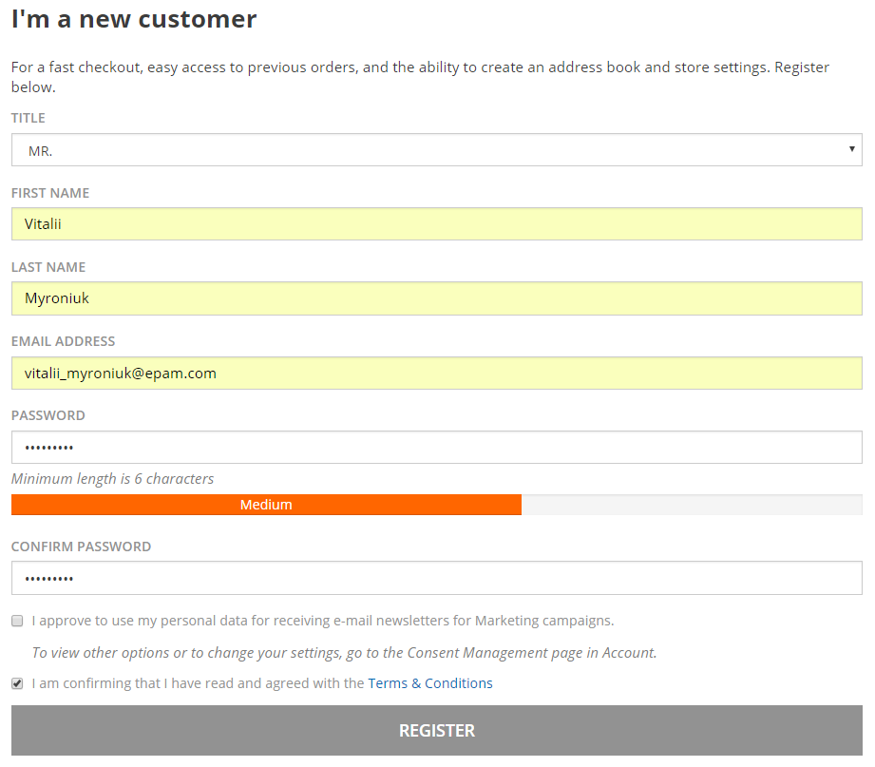

Step 11. Try to log into the telco website by using login and password of the above created user.

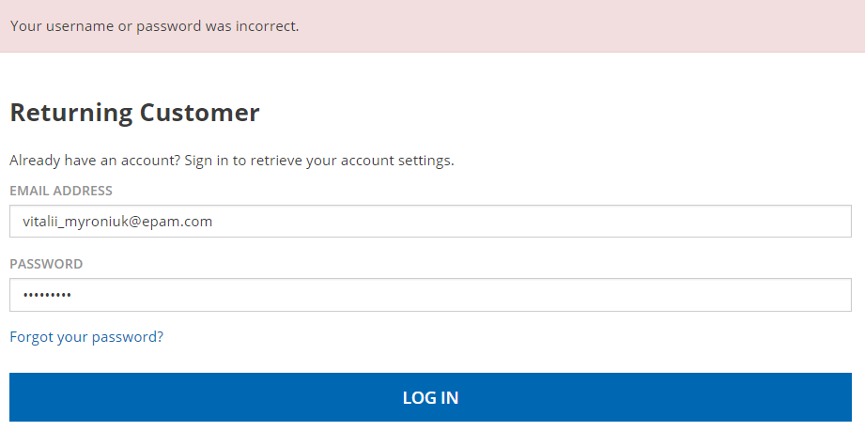

Step 12. Go to the telco backoffice as an “admin” and confirm registration.

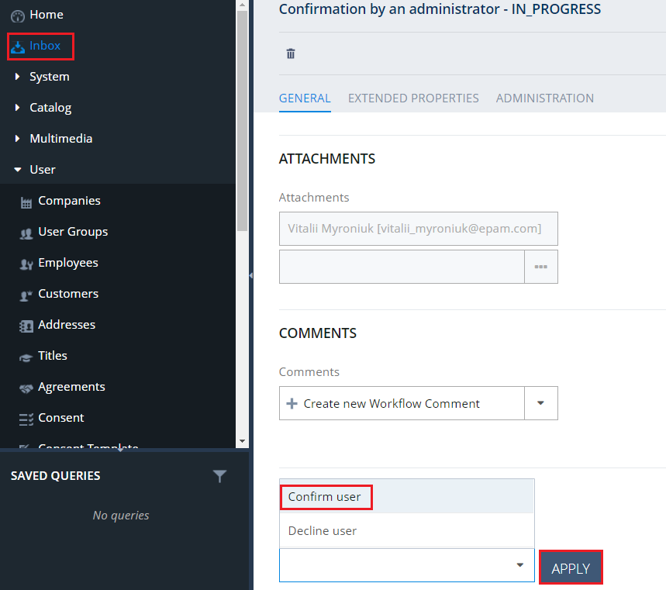

Step 13. Now you should have a possibility to sign in the telco website by using login and password of the above created user.



Step 14. If an admin declines the registration, then you should have no possibility to sign in the telco website. Besides the user should be deleted from the database (you can check it in HMC).

Link: https://git.epam.com/Vitalii_Myroniuk/hybris-mentoring/commit/e8e6f98bff5bff6f47791b96eb236281433fec13

PART_2

Step 1. Go to trainingcore-items.xml file, add new “RegistrationStatus” enum type.

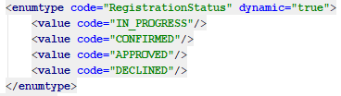

Step 2. Go to trainingcore-items.xml file, add new attribute “registrationStatus” to “Customer” type item and redeclare “loginDisabled” attribute.

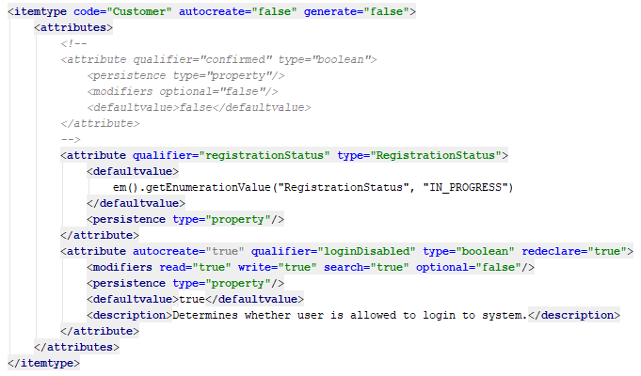

Step 3. Localize above created enum type and attributes.

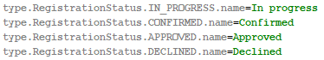

Step 4. Rebuild your project.

Step 5. Go to HMC, create “userManagerGroup” and “supervisorManagerGroup” that are members of “admingroup”. Create users for each group. It should be noted that you can do all this work by using an appropriate impex-script (see more details at the repository).

Step 6. Create necessary workflow templates, actions, decisions and links. You can do this manually by using HMC or alternatively by using the following impex-script.

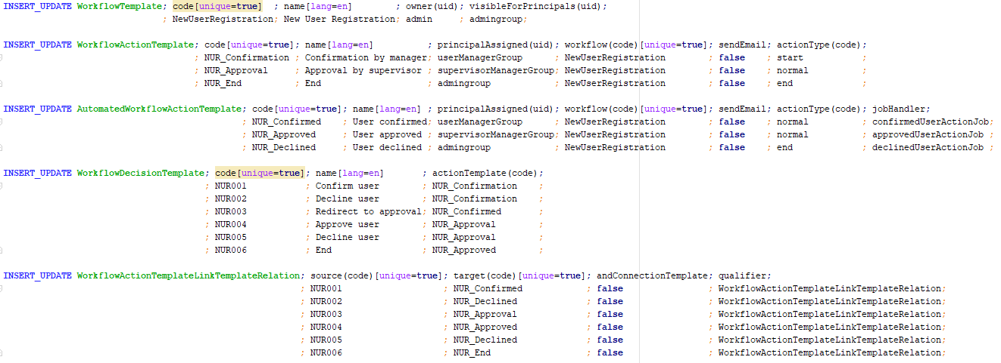

Step 7. Create action jobs for the automated workflow steps (see more details at the repository).

Step 8. Go to trainingcore-spring.xml and define spring beans for the automated workflow steps.

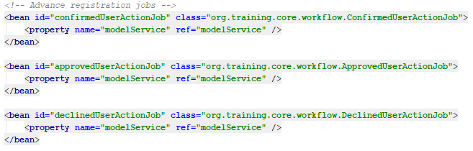

Step 9. Integrate the creation and start of the workflow into the “CustomDefaultCustomerAccountService” class (see more details at the repository).

Step 10. Go to trainingcore-spring.xml and define spring bean for the “CustomDefaultCustomerAccountService” class.

Step 11. Rebuild, restart and update your project.

Step 12. Go to the telco website and register a new user.

Step 13. Try to log into the telco website by using login and password of the above created user. You should obtain an error. Registration status of the user should be “In progress” (you can check it in HMC).

Step 14. Go to the telco backoffice as an “userManager” and confirm registration. Registration status of the user should become “Confirmed” (you can check it in HMC). At this step the user should not be able to login yet.

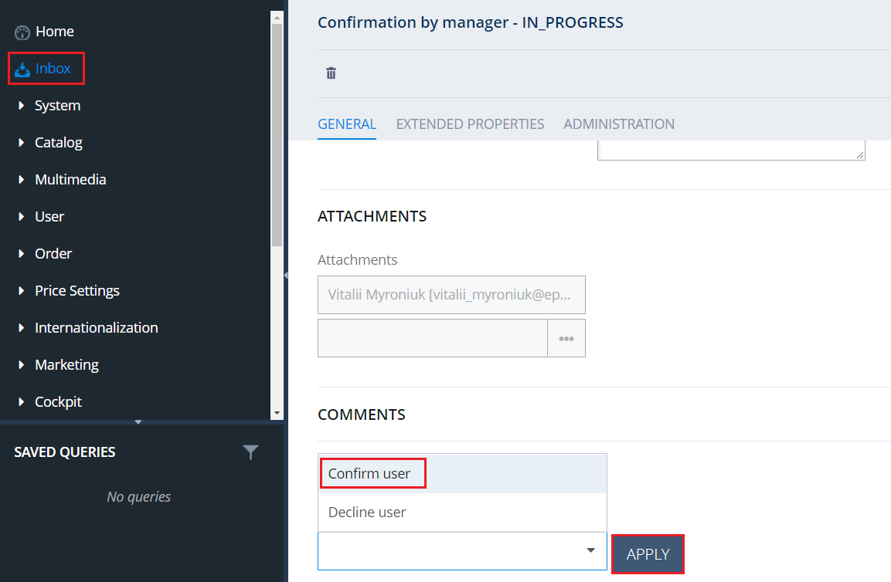

Step 15. Go to the telco backoffice as an “supervisorManager” and approve registration. Registration status of the user should become “Approved” (you can check it in HMC).

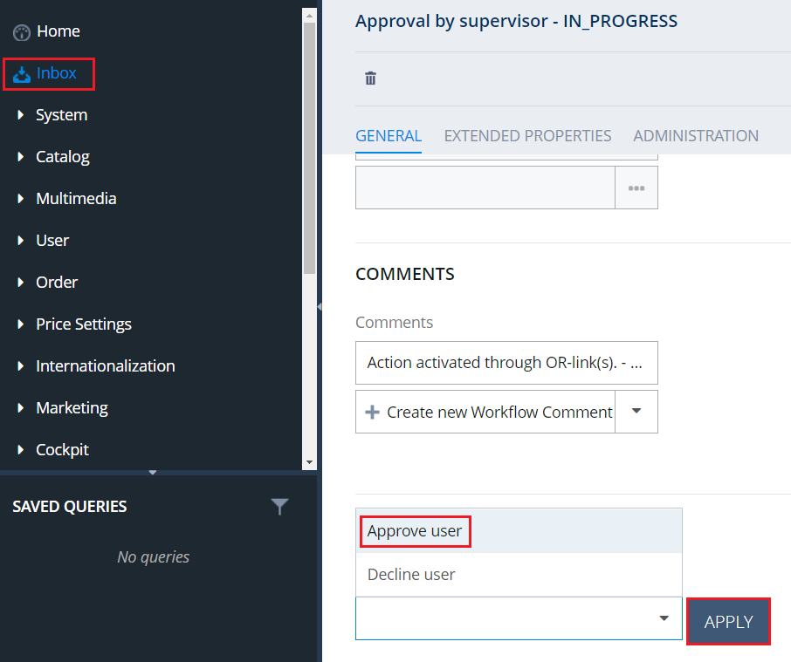

Step 16. Now you should have a possibility to sign in the telco website by using login and password of the above created user.

Step 17. If “userManager” or “supervisorManager” decides to decline the registration, then you should have no possibility to sign in the telco website. Besides the user should be deleted from the database (you can check it in HMC).

Link: https://git.epam.com/Vitalii_Myroniuk/hybris-mentoring/commit/56339196ece9a430379c33ec0a32836bed8fe43e

