Step 1. Go to telco website and check whether an anonymous customer has access to “tabs” pages.

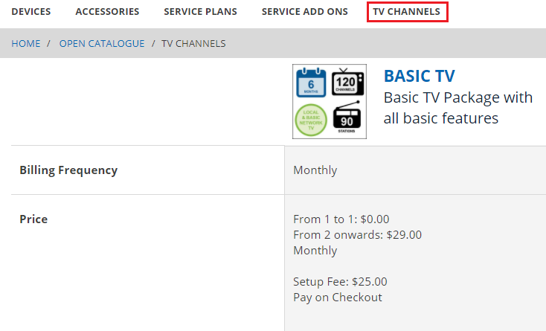

Step 2. Go to trainingstorefront\web\webroot\WEB-INF\config\spring-security-config.xml and add the following security configuration.

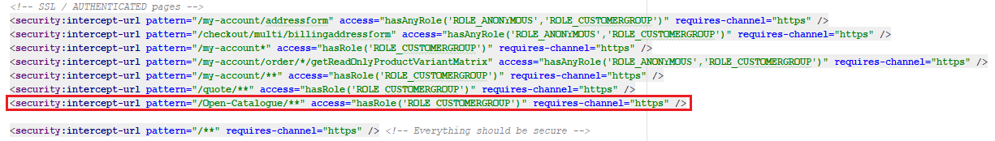

Step 3. Restart hybris platform.
Step 4. Go to telco website again and check whether an anonymous customer has access to “tabs” pages now. Anonymous customer should be redirected to the login page.

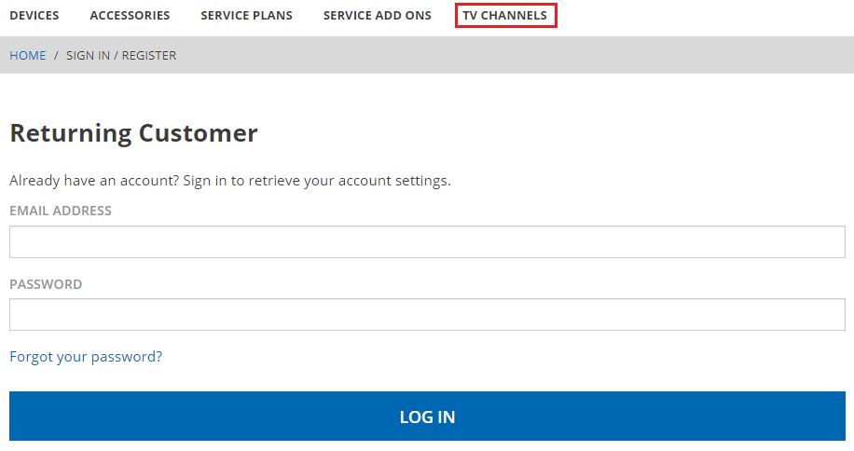

Link: https://git.epam.com/Vitalii_Myroniuk/hybris-mentoring/commit/656e69690afa4aa874212b6750dc41dd8bf91a59

