Step 1. Go to HAC > Monitoring > Cache and check what the configuration is for “entityCacheRegion”.

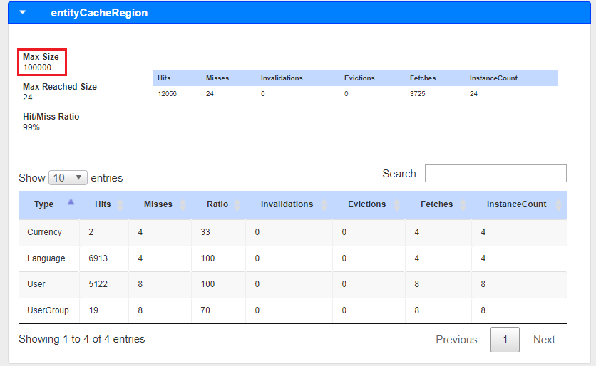

Step 2. Go to local.properties file and add the following lines.

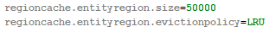

Step 3. Restart hybris platform.

Step 4. Go to HAC > Monitoring > Cache and check whether a new configuration is applied.

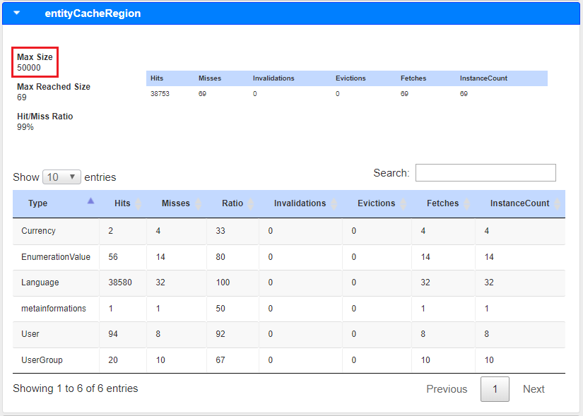

Link: https://git.epam.com/Vitalii_Myroniuk/hybris-mentoring/commit/f3340da5970a60f5aebe149feb822b6e0f8870f3

