Step 1. Generate a new backoffice extension by using “ant extgen” command.

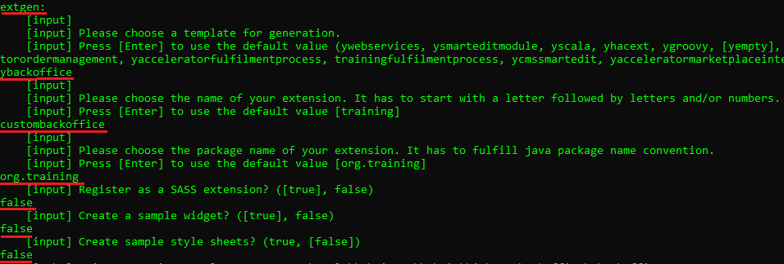

Step 2. Copy above created backoffice extension into your custom directory.

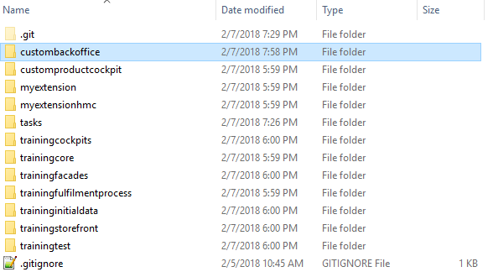

Step 3. Add above created backoffice extension to localextensions.xml file.

Step 4. Go to myextension-items.xml file and add “referredBy” attribute to “Customer” item type.

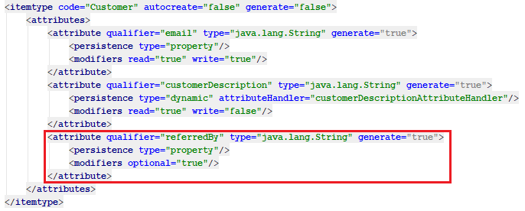

Step 5. Go to myextension-locales_en.properties and localize “referredBy” attribute of “Customer” item type.

Step 6. Go to custombackoffice\resources\custombackoffice-backoffice-config.xml file and add the following configuration.

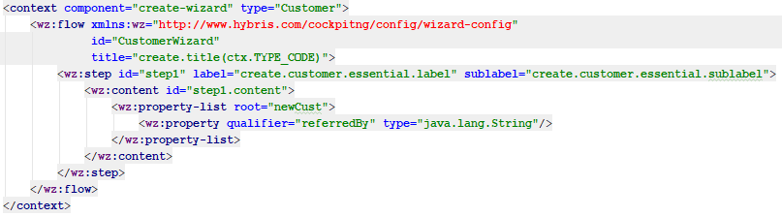

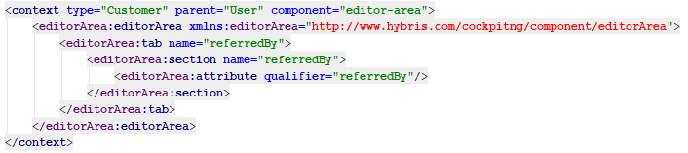

Step 7. Go to custombackoffice\resources\custombackoffice-backoffice-labels\labels_en.properties and add necessary localization.

Step 8. Rebuild, restart and update your project (do not forget to select project data of custombackoffice).

Step 9. Go to backoffice website and check possibility to edit “referredBy” attribute during creation and updating customers.

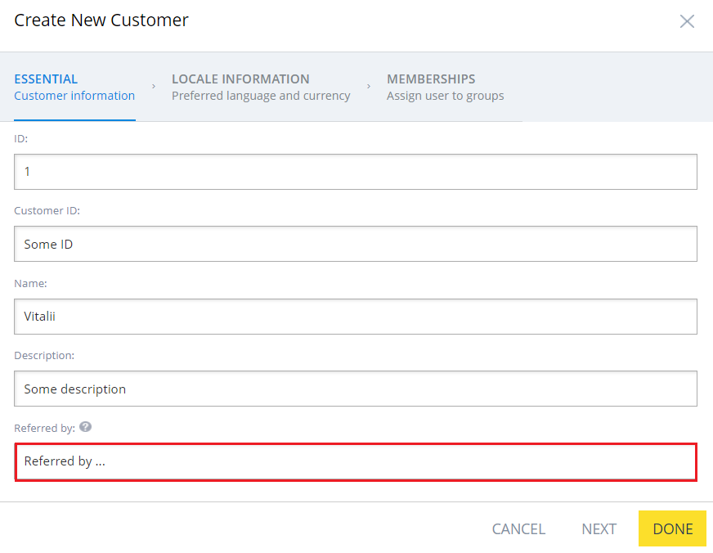

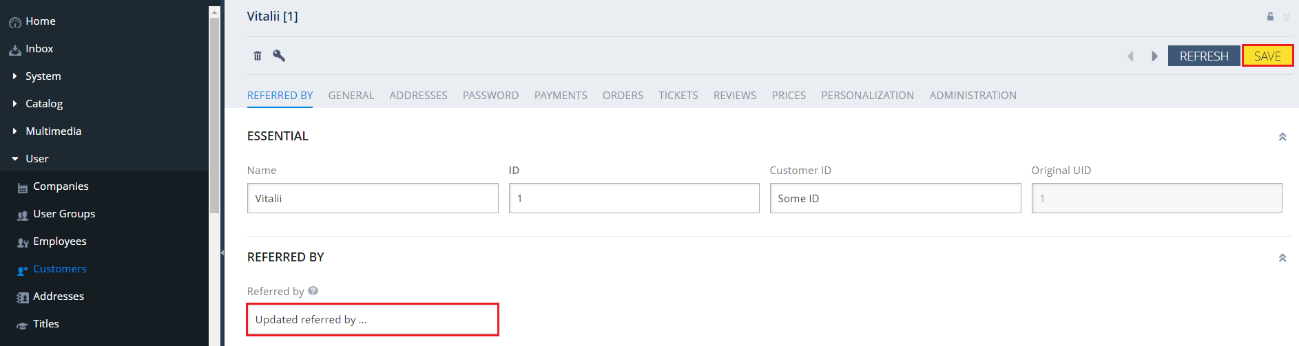
Link:

