Step 1. Go to HMC > Multimedia and create a new Media Folder.

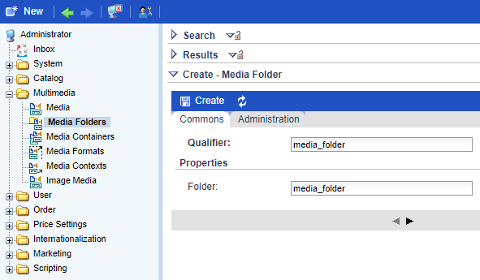

Step 2. Create a new Image Media, upload a necessary photo and assign it to above created Media Folder. Press “Save” button.

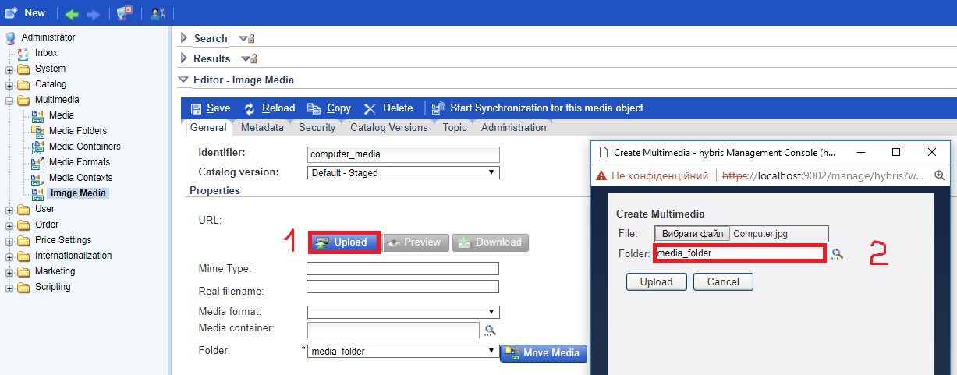

Step 3. Create a new Product and assign it to above created Image Media.

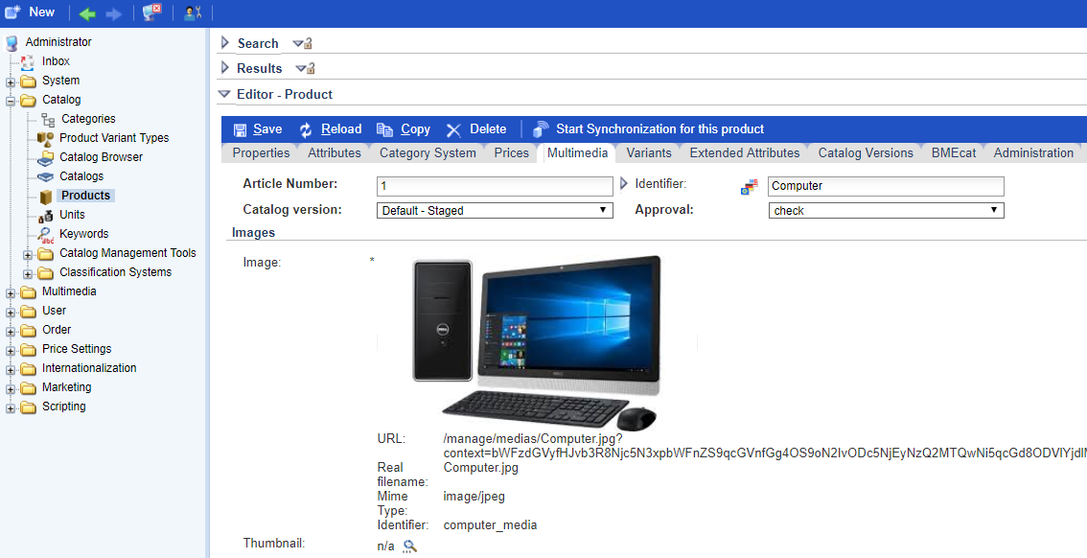

Step 4. The deployed media file is in the following location: ${HYBRIS_DATA_DIR}/media/sys_master/media_folder/….

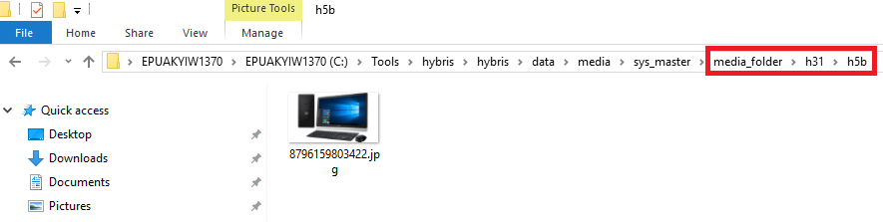

Link: https://git.epam.com/Vitalii_Myroniuk/hybris-mentoring/commit/1df9e273003a35b38eb9e0cd0806b914412f6eac

