Step 1. Go to myextension-items.xml and create a new item “Supplier” in the following way.

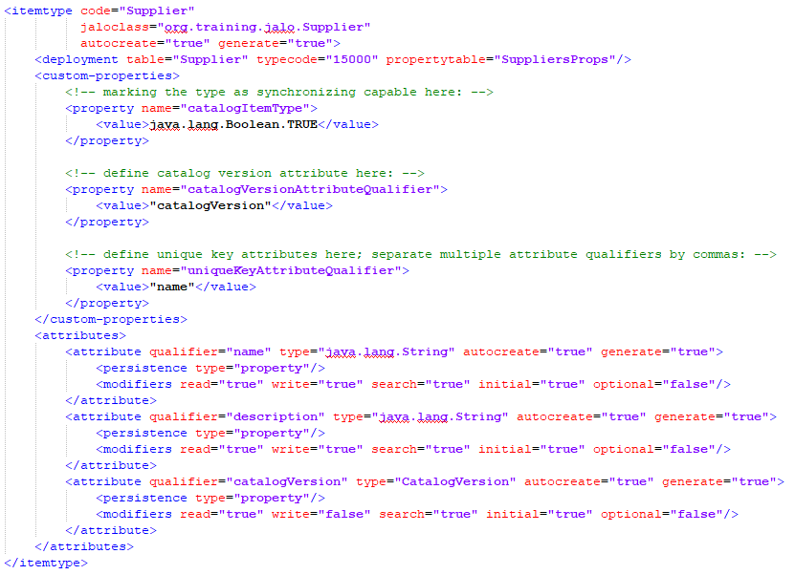

Step 2. Go to myextensionhmc, find hmc.xml file and add “Supplier” type to “user” group.

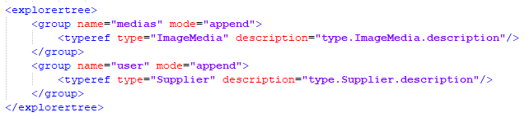

Step 3. In the above mentioned hmc.xml file add appropriate organizer for “Supplier” type.

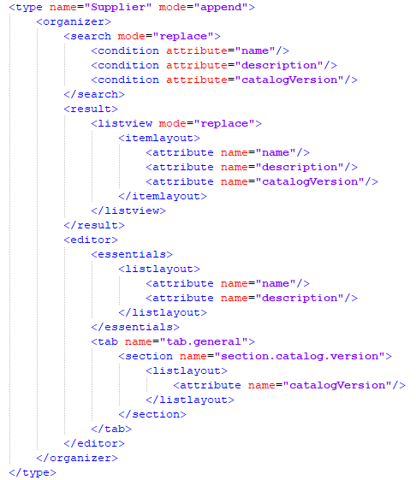

Step 4. Localize all created types and attributes. Rebuild and update your project.

Step 5. Go to HMC and create several suppliers. For Catalog Version attribute select Default Staged catalog.

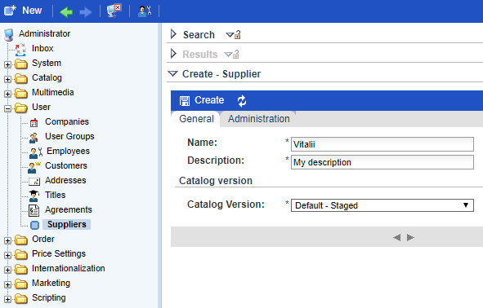

Step 6. Synchronize created suppliers with Default Online catalog.

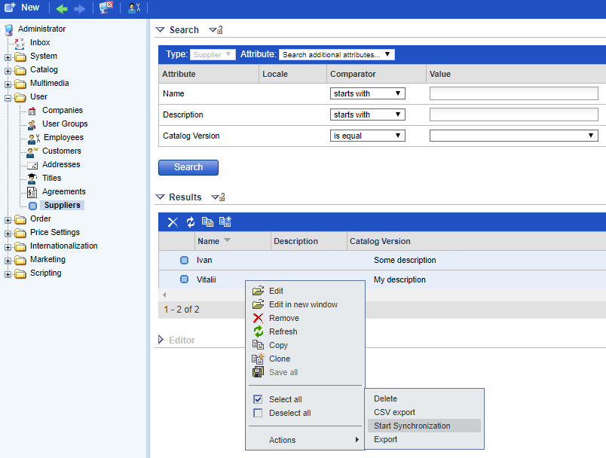

Step 7. Now if you search all suppliers you will get the following result.

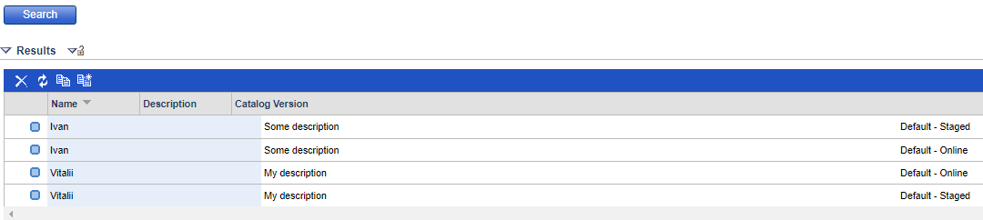

Link: https://git.epam.com/Vitalii_Myroniuk/hybris-mentoring/commit/24798366cf161c3f9e32756a3f891c01967dc336

