Step 1. Open myextension-item.xml file at /myextension/resources directory.

Step 2. Add new itemtype as follows.

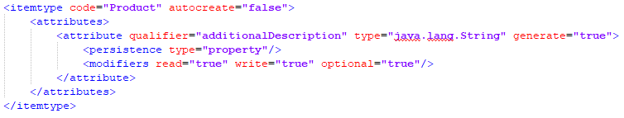

Step 3. Go to /myextension/resources/localization directory and open corresponding property file to set up localization.

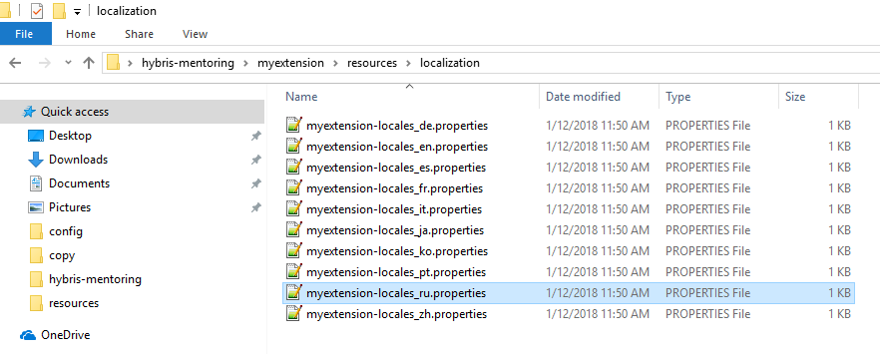

Step 4. Add necessary properties to localize your new attribute. Set appropriate encoding of the file, e.g. UTF-8.

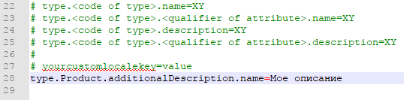

Step 5. Update your system using HAC or command prompt (ant updatesystem).

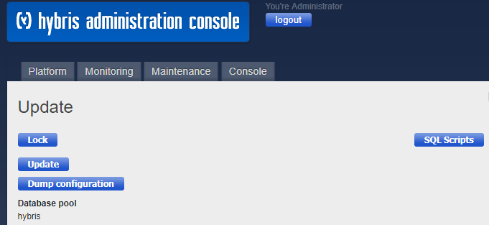

Step 6. Go to HMC and create a new product.

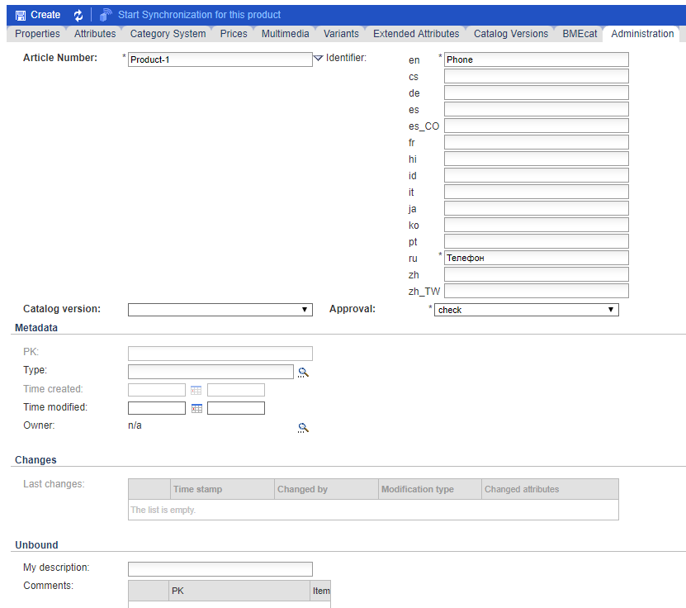

Step 7. Now you can find your product in HMC with correct localization.

