Step 1. Go to HAC>Console>ImpEX Import and import the following content.

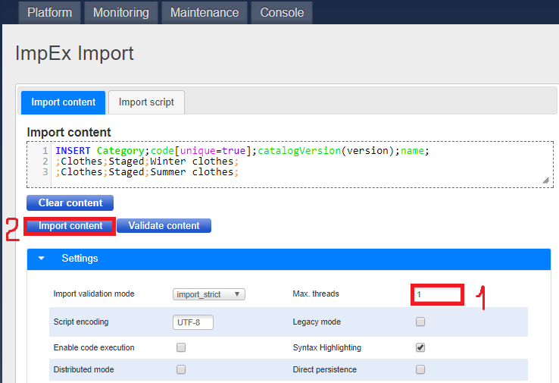

Step 2. Now, if you go to HMC and search above created category you will see the following result.

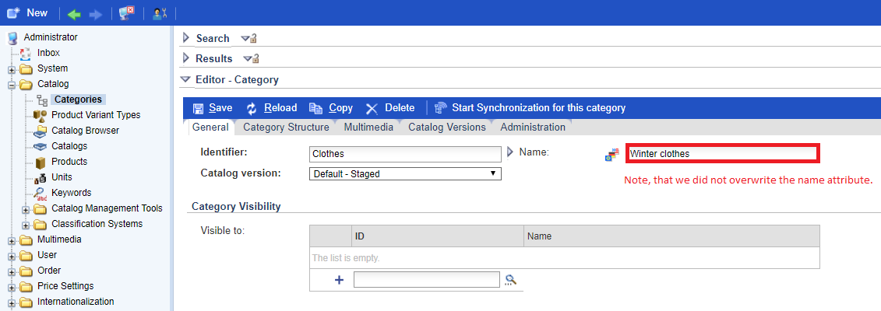

Link:

