Step 1. Find local.properties file in {HYBRIS_HOME}/hybris/config folder.

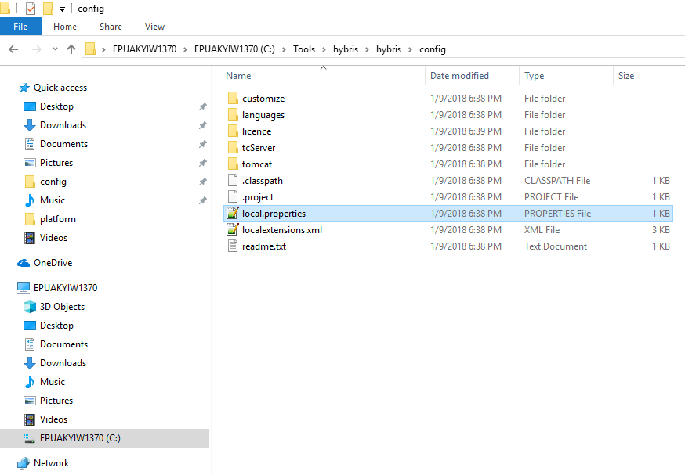

Step 2. Open local.properties file with any text redactor.

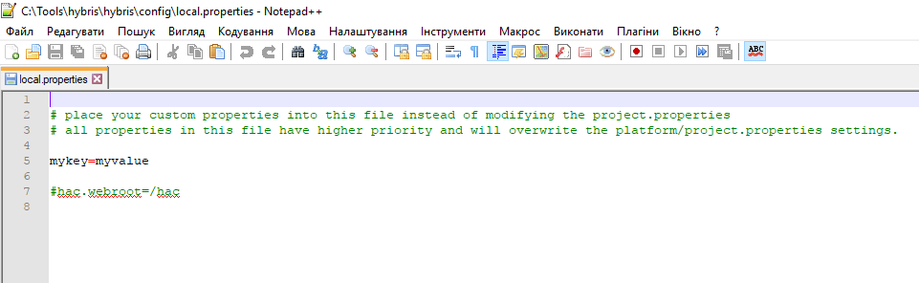

Step 3. Modify local.properties file in the following way.

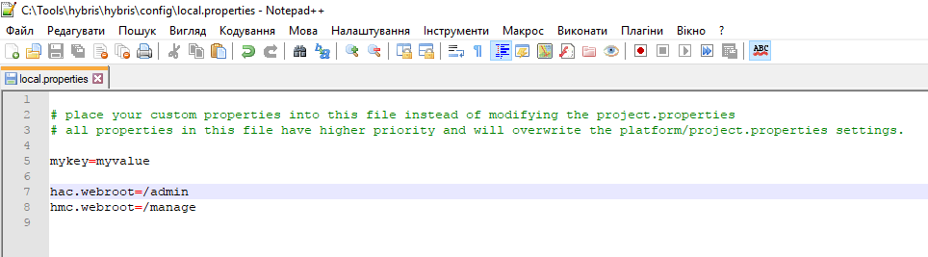

Step 4. Find localextensions.xml file in {HYBRIS_HOME}/hybris/config folder.

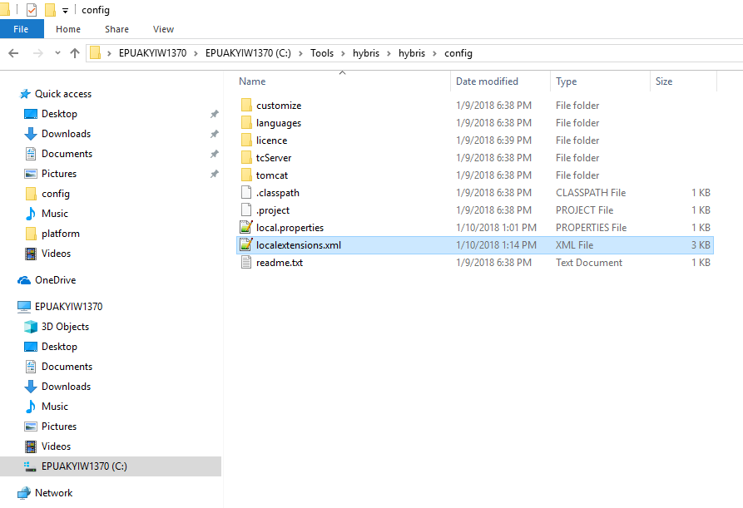

Step 5. Uncomment hmc extension in localextensions.xml file.

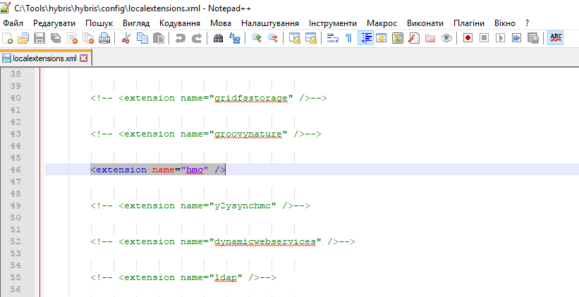

Step 6. Rebuild and relaunch your server.

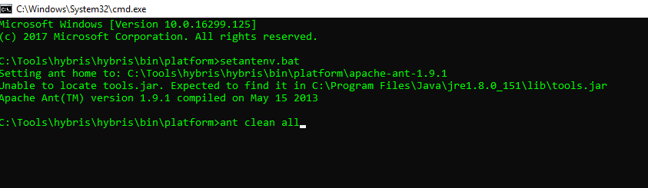

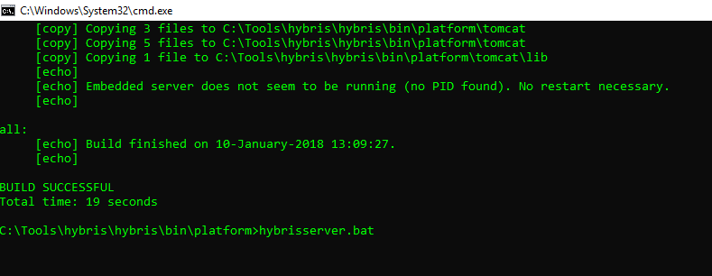

Step 7. Now you can access to hac and hmc using "/admin" and "/manage" URL respectively.

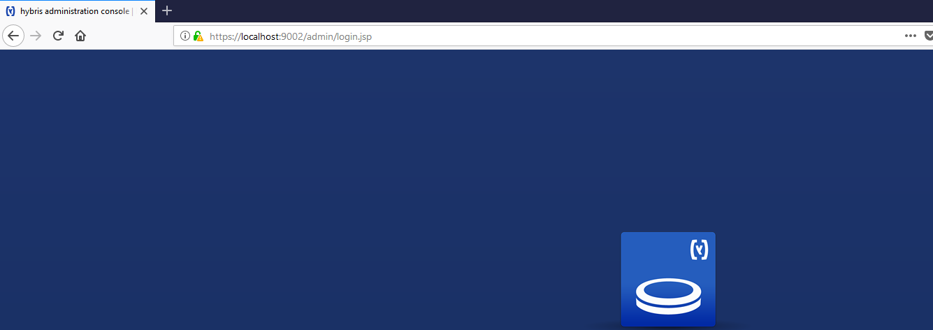

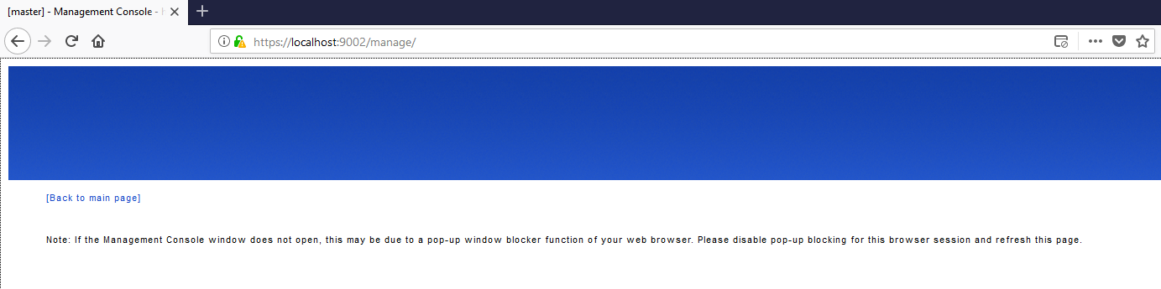

Link: https://git.epam.com/Vitalii_Myroniuk/hybris-mentoring/commit/442500f8d84fdf5b07ca15f7b63f10cc78ba195e

