Step 1. Open MySQL Workbench and create a new schema.

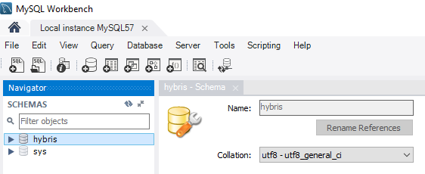

Step 2. Create a new user with access to this schema.

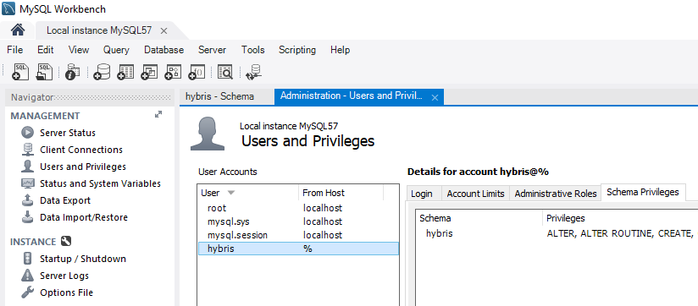

Step 3. Download an appropriate mysql connector into {HYBRIS_BIN_DIR}/platform/lib/dbdriver folder.

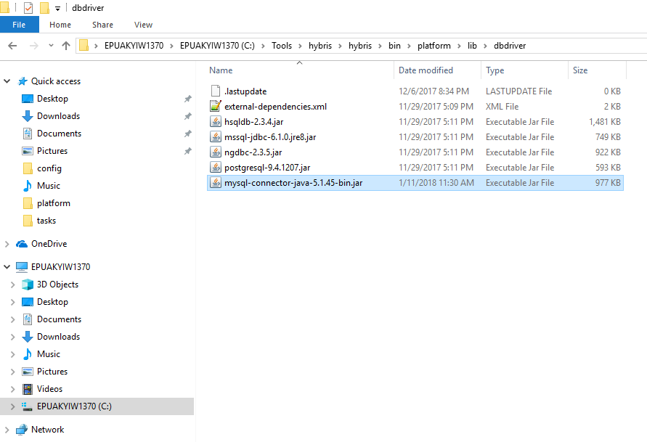

Step 4. Open local.properties file in {HYBRIS_HOME}/hybris/config folder and add necessary properties.

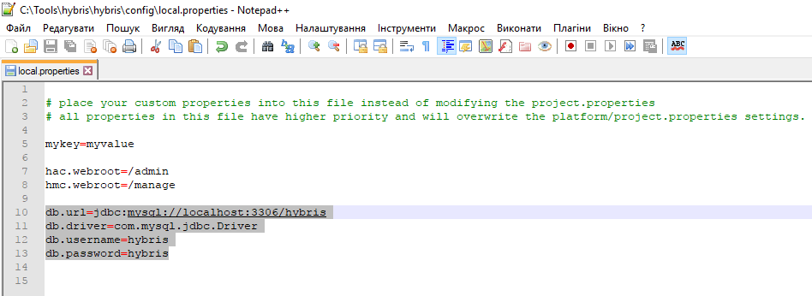

Step 5. Rebuild your project and relaunch hybris server.

Step 6. Press button “Initialize” in HAC (or enter “ant initialize” in the command prompt).

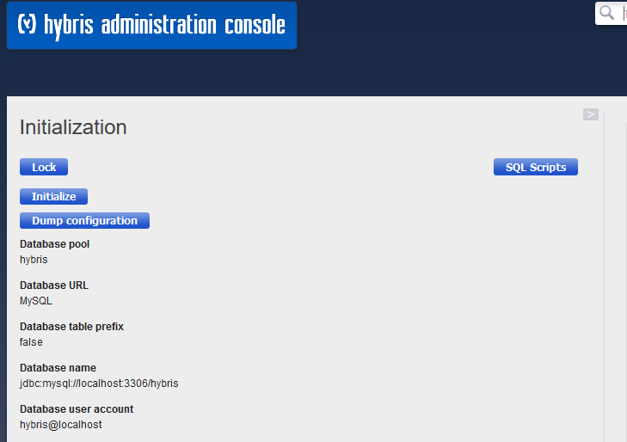

Link: https://git.epam.com/Vitalii_Myroniuk/hybris-mentoring/commit/07bdbc7870f641e0a113d37facb473a59106c46a

