Step 1. Open myextension-item.xml file at /myextension/resources directory.

Step 2. Add new itemtype as follows.

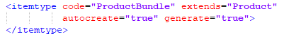

Step 3. Add new relation in the same file as follows. Please, note that <relations> tag should be before <items> tag.

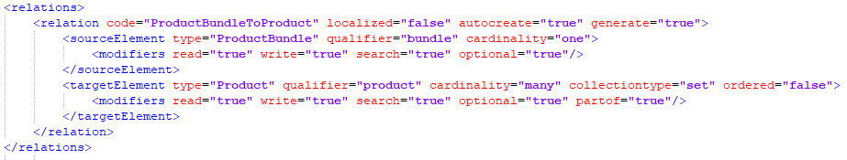

Step 4. Go to /myextension/resources/localization directory and open corresponding property file to set up localization.

Step 5. Add necessary properties to localize your new attribute. Set appropriate encoding of the file, e.g. UTF-8.

en:
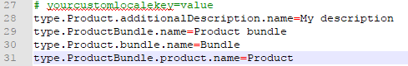

ru:
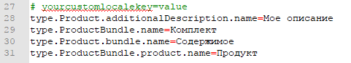

Step 6. Rebuild your project and update your system.

Step 7. Start hybris server. Now you can create ProductBundle type at HMC.

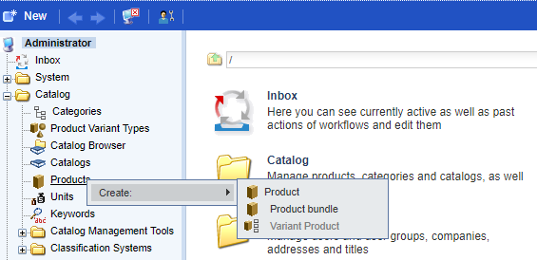

Link: https://git.epam.com/Vitalii_Myroniuk/hybris-mentoring/commit/a4dc9cc2148436a54228fc08f17493c03be45594

Refactoring of qualifier "product":
https://git.epam.com/Vitalii_Myroniuk/hybris-mentoring/commit/11f1ad3d8e7921bd9dd04336d455ba626be187d1

Localization refactoring:
https://git.epam.com/Vitalii_Myroniuk/hybris-mentoring/commit/6dad1ef6b97d378733af2b188119060b322ccbc7

