Step 1. Add the following line to your config/local.properties file.

Step 2. Create new myextensionhmc and import it into your project.

Step 3. Add myextensionhmc into {HYBRYS_CONFIG_DIR}/localextensions.xml file.

Step 4. Edit the extensioninfo.xml file in myextensionhmc (add hmcmodule element and delete webmodule element).

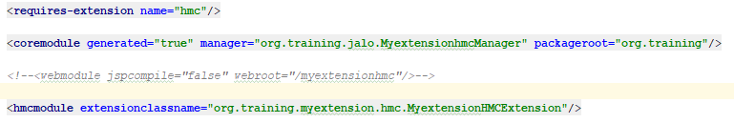

Step 5. Open myextension-item.xml file at /myextension/resources directory and add new itemtype as follows.

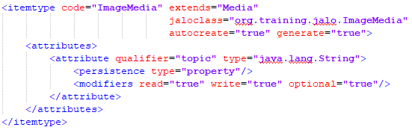

Step 6. Create a new source folder hmc/src in myextensionhmc and add it to your build path.

Step 7. In that source folder create a package org.training.myextension.hmc and write MyextensionHMCExtension class that extends HMCExtension class.

Step 8. Create the myextensionhmc/hmc/resources/hmc.xml file and implement necessary logic there.

Step 9. Create myextensionhmc/hmc/resources/org/training/myextensionhmc/hmc/locales_en.properties file and add necessary properties.

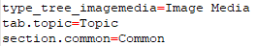

Step 10. Go to myextension/resources/localization/myextension-locales_en.properties file directory and add necessary properties.

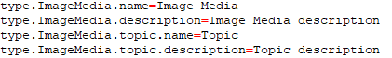

Step 11. Rebuild your project and update your system.

Step 12. Start hybris server.

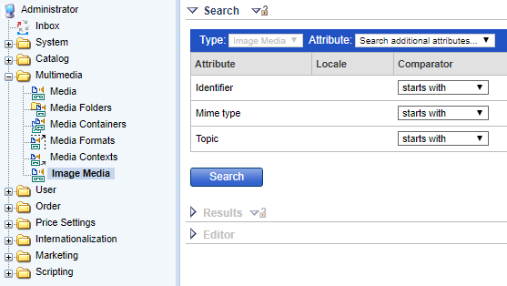

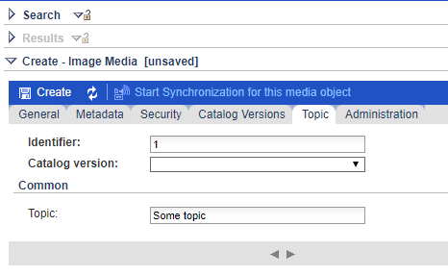

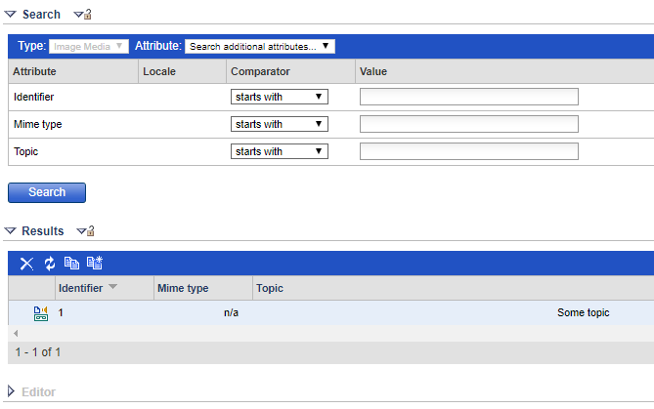
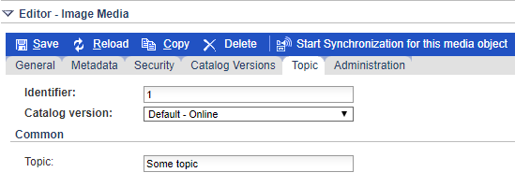

Link: https://git.epam.com/Vitalii_Myroniuk/hybris-mentoring/commit/6ff033477c3aab0095e60251bb28447eee132076

