Step 1. Log into HMC as an admin and create a new user group.

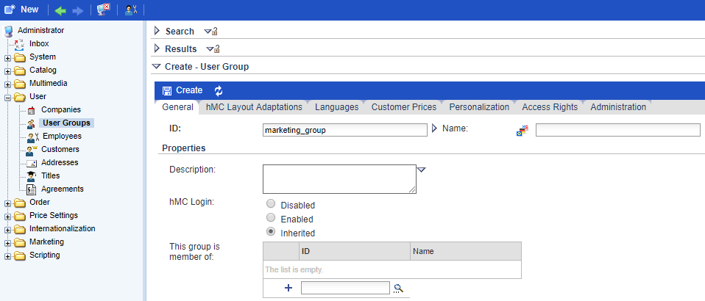

Step 2. Go to Access Rights tab and add necessary objects.

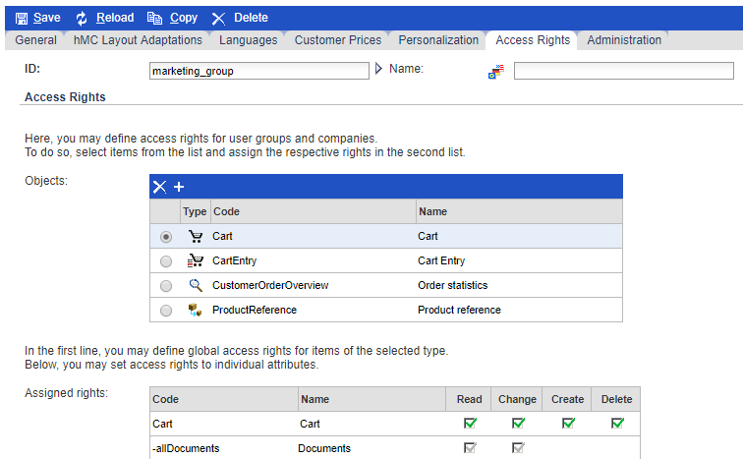

Step 3. Create a new employee and include him into marketing_group.

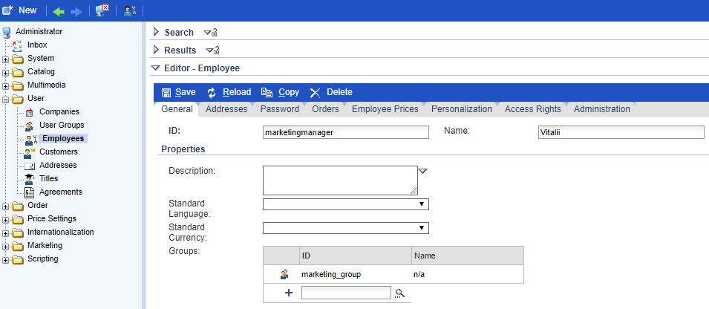

Step 4. Go to Password tab and change password.

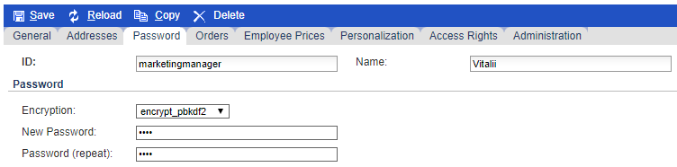

Step 5. Now if you log into HMC as a marketingmanager you will see only Marketing folder.

