Step 1. Go to localextensions.xml and add platform webservices extension.

Step 2. Rebuild, start and update your project. After that necessary “Resource” and “DTO” classes should be automatically generated in your project.

Step 3. We will use a Postman client to test the web-services functionality. To authorize your client, use login “admin” and password “nimda”.

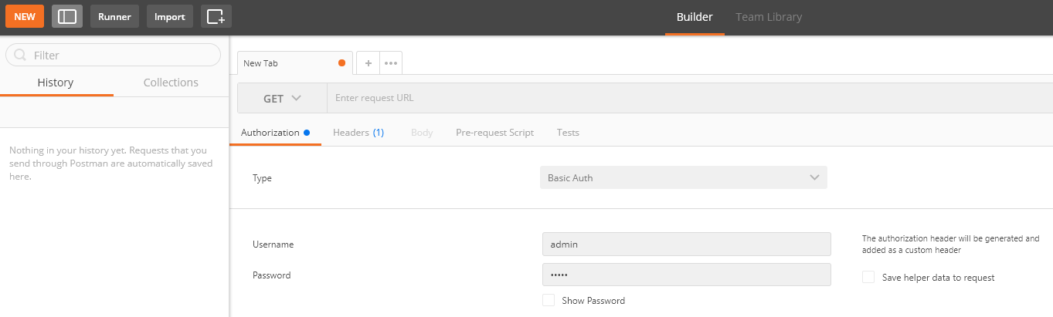

Step 4. Perform PUT request to create a new user that is assigned to “customergroup”.

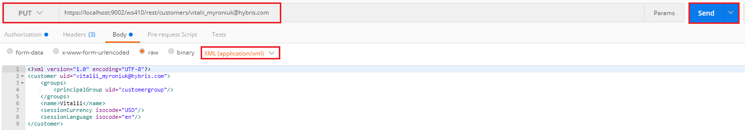

Step 5. Perform GET request to check that a new user was created.

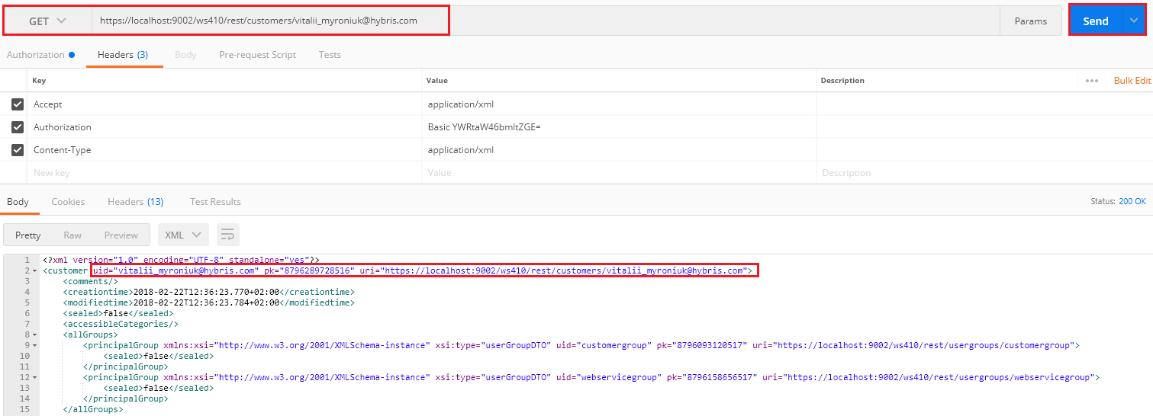

Step 6. You can also go to HMC and check that user was created and assigned to “customergroup”.

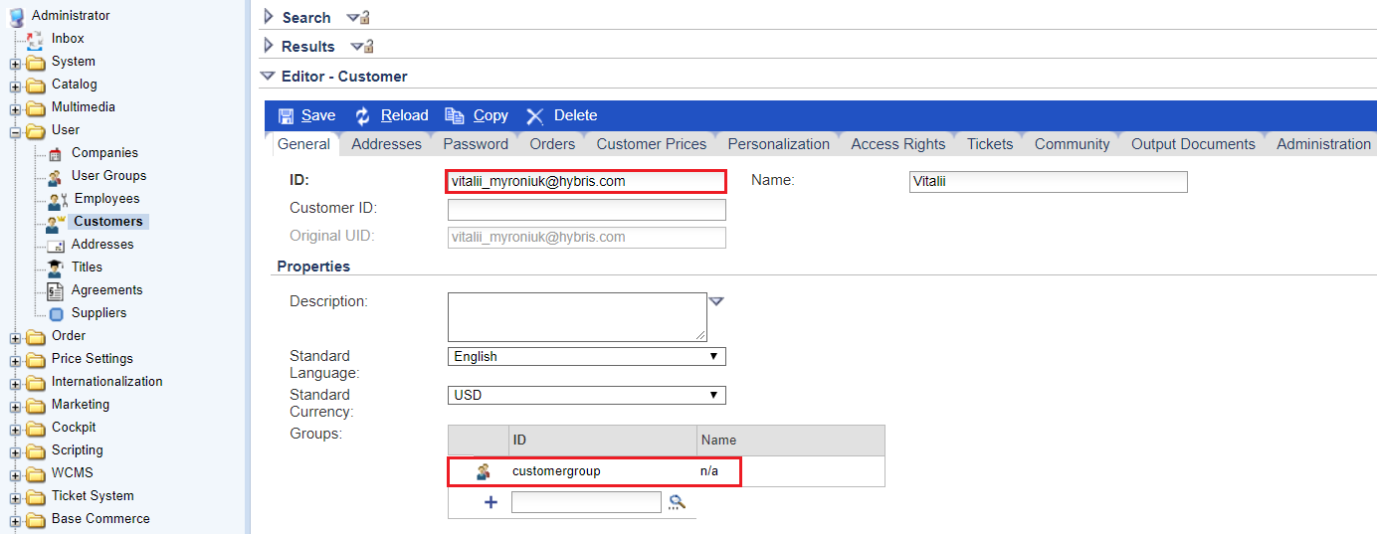

Link:

