Step 1. Open myextension-item.xml file at /myextension/resources directory.

Step 2. Add new itemtype as follows.

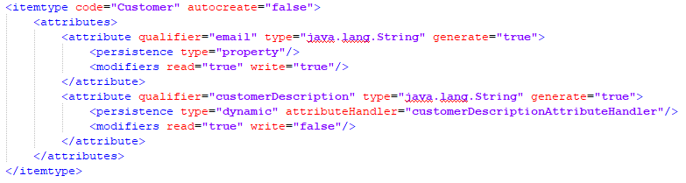

Step 3. Open myextension-spring.xml file at /myextension/resources directory.

Step 4. Add new bean as follows.

Step 5. Create a new package /myextension/src/mypackage/handler and write CustomerDescriptionAttributeHandler class that implements DynamicAttributeHandler<String, CustomerModel> interface.

Step 6. Write unit tests for CustomerDescriptionAttributeHandler class.

Step 7. Go to /myextension/resources/localization directory and open corresponding property file to set up localization.

Step 8. Add necessary properties to localize your new attribute. Set appropriate encoding of the file, e.g. UTF-8.

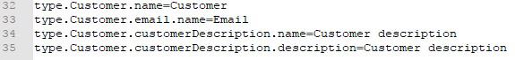

Step 9. Rebuild your project and update your system.

Step 10. Start hybris server. Now you can create a new Customer. The field “Customer description” is generated dynamically.

