Step 1. Go to HAC > Monitoring > Cache. Here you can see all cache regions with their configurations.

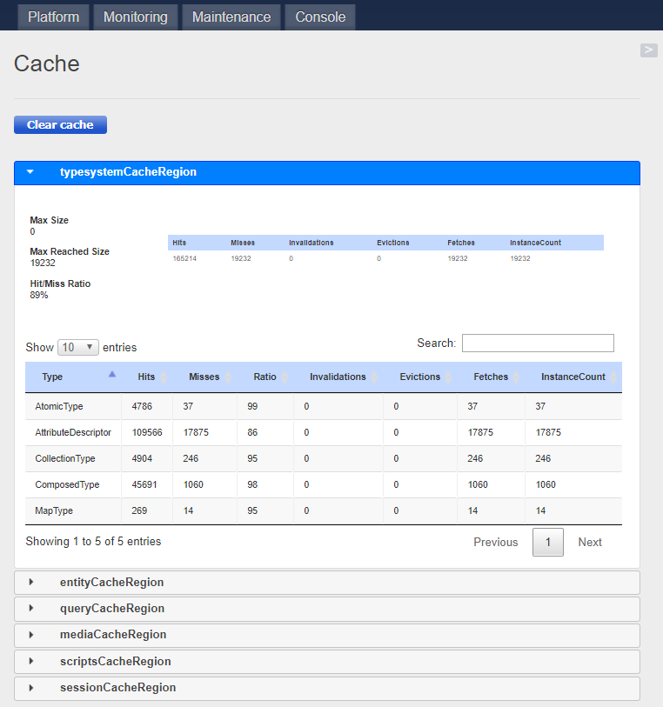
Step 2. Click “Clear cache” button to clear all cache regions.

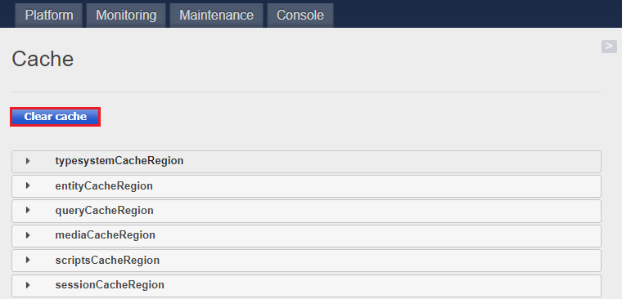

Step 3. Implement “CacheManager” class to demonstrate programing approach of the cache cleaning (see more details at the repository).

Link:

