Step 1. Implement findProductsThatBecomeOffline(int days) method at ProductModelDaoImpl class (see more details at repository).

Step 2. Ensure that ProductModelDaoImpl is registered as a spring bean at myextension-spring.xml file.

Step 3. Implement findProductsThatBecomeOffline(int days) method at ProductServiceImpl class (see more details at repository).

Step 4. Ensure that ProductServiceImpl is registered as a spring bean at myextension-spring.xml file.

Step 5. Write ExportProductCodesJob class with necessary logic (see more details at repository).

Step 6. Register ExportProductCodesJob as a spring bean at myextension-spring.xml file.

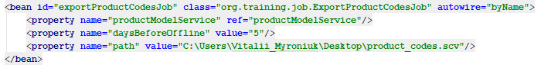

Step 7. Rebuild, restart and update your program to create corresponding ServiceLayerJob instance. It should be noted that instead of update your program you can just run an appropriate impex-script manually to create corresponding ServiceLayerJob instance.

Step 8. Execute the following impex-script in order to create CronJob and Trigger.

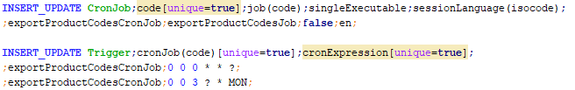

Step 9. Go to HMC, find a few products and set an appropriate offline date for them.

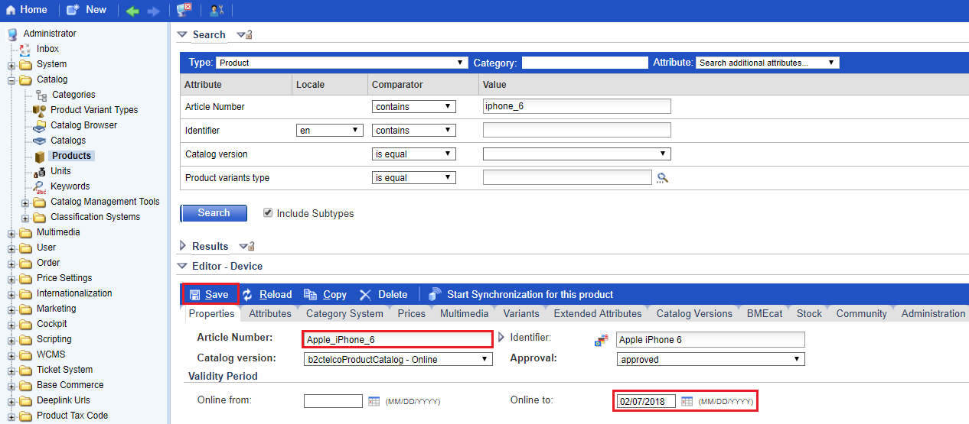

Step 10. Go to HMC and execute ExportProductCodesJob manually.

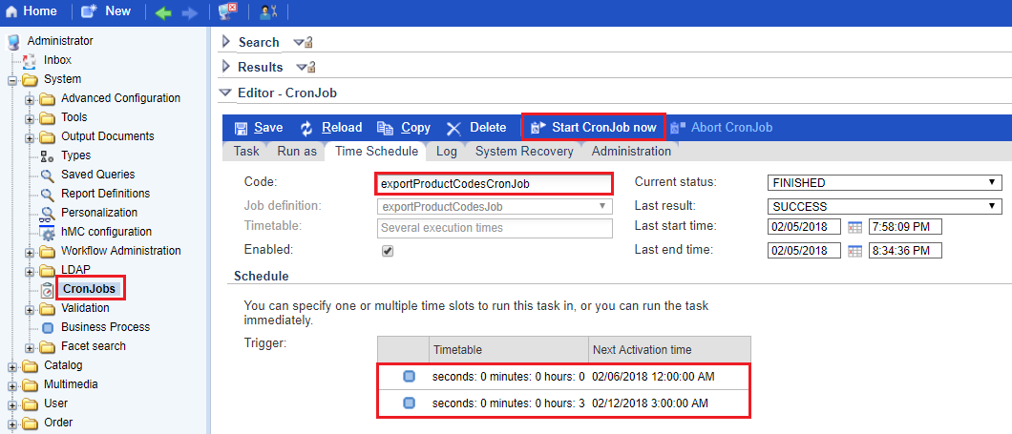

Step 11. In your file system you should find a new created csv-file that contains all product codes becoming offline in 5 days or less.

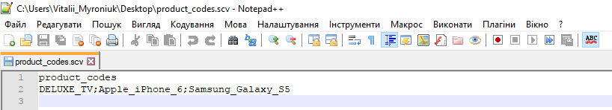

Link: https://git.epam.com/Vitalii_Myroniuk/hybris-mentoring/commit/1aa8007ab62388af0556f4a297164859fb3b46b0

