Step 1. Generate a new cockpit extension by using “ant extgen” command.

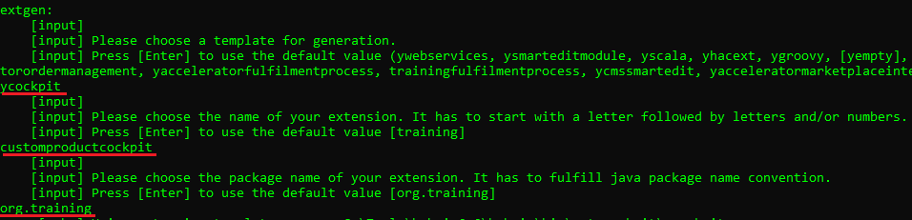

Step 2. Copy above created cockpit extension into your custom directory.

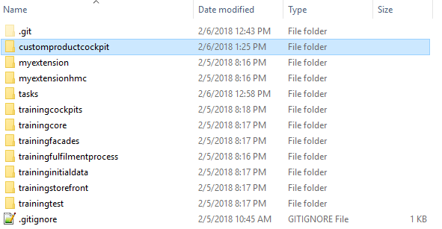

Step 3. Add above created cockpit extension to localextensions.xml file.

Step 4. Go to myextension-items.xml and add “metaInfo” attribute to “Product” item type.

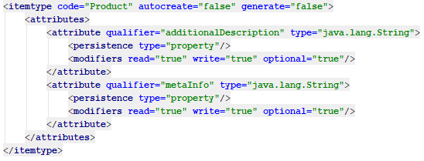

Step 5. Go to myextension-locales_en.properties and localize “metaInfo” attribute of “Product” item type.

Step 6. Create the folder customproductcockpit/resources/customproductcockpit-config. This will be the base folder for your custom cockpit UI configuration.

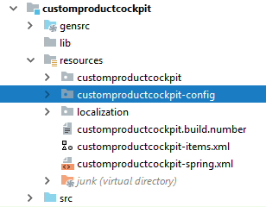

Step 7. Create the file “base_Product.xml” in customproductcockpit/resources/customproductcockpit-config/admingroop. As an example, you may use corresponding “base_Product.xml” file from trainingcockpits extension of telco accelerator.

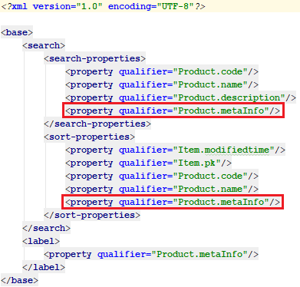

Step 8. Rebuild, restart and update your project (do not forget to select project data of customproductcockpit).

Step 9. Go to HMC, find some product and fill in “metaInfo” attribute at “Administration” tab.

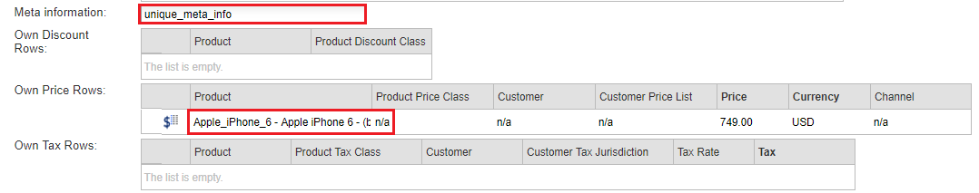
Step 10. Go to customproductcockpit website and check possibility to search products by “metaInfo” attribute.

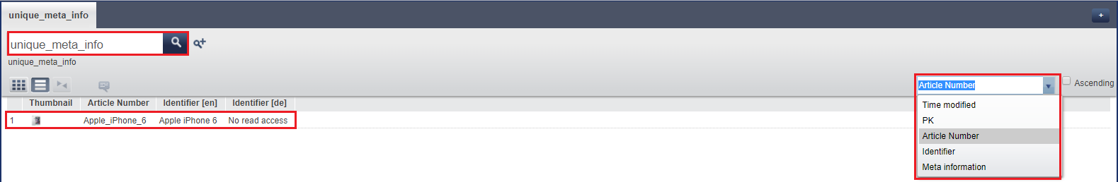

Link: https://git.epam.com/Vitalii_Myroniuk/hybris-mentoring/commit/04f94b415178d4b75af1cf03057dbd435bc843b3

