Step 1. Generate a new backoffice extension by using “ant extgen” command.

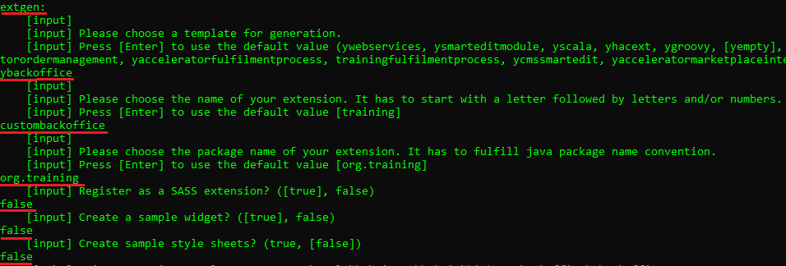

Step 2. Copy above created backoffice extension into your custom directory.

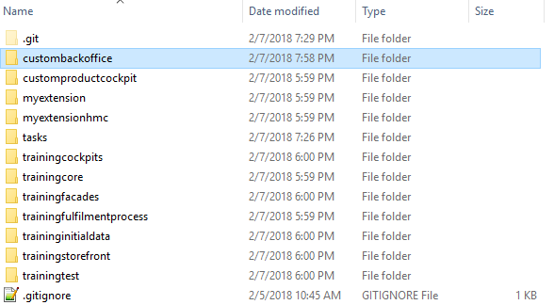

Step 3. Add above created backoffice extension to localextensions.xml file.

Step 4. Go to custombackoffice\resources\custombackoffice-backoffice-config.xml file and add the following configuration.

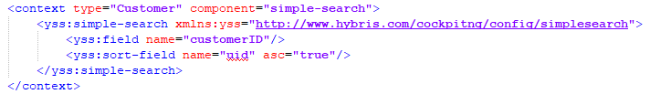

Step 5. Rebuild, restart and update your project (do not forget to select project data of custombackoffice).

Step 6. Go to HMC and create some new customer.

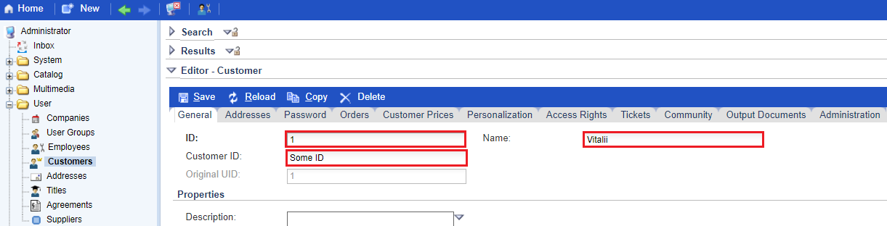

Step 7. Go to backoffice website and check possibility to search customers by “customerID” attribute.

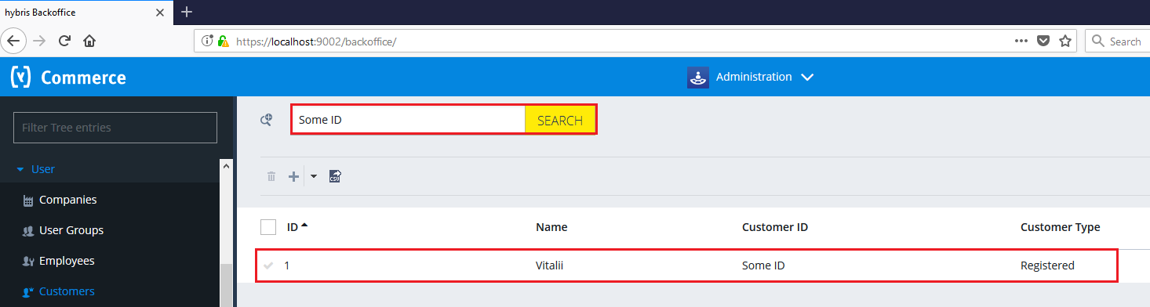

Link: https://git.epam.com/Vitalii_Myroniuk/hybris-mentoring/commit/76bcb09d8ff5be30e3da9c092f9f7ea7492c28f1

