Step 1. Open a command prompt at {HYBRIS_BIN_DIR}/platform directory.

Step 2. Run setantenv.bat file.

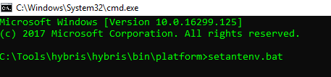

Step 3. Custom extension by default is created in {HYBRIS_BIN_DIR}/custom/<extension_name>. You can specify other settings for default creation of extension at {HYBRIS_BIN_DIR}/platform/extgen/project.properties file.

Step 4. Run ant extgen.

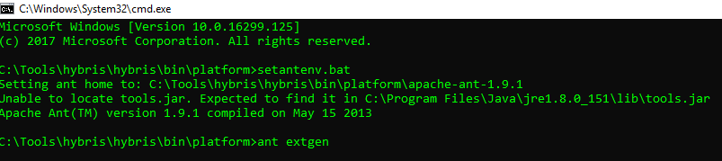

Step 5. Chose the most appropriate template (or just press enter to choose default [yempty] template).

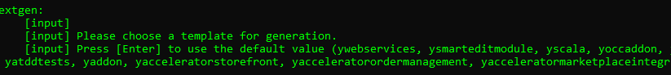

Step 6. Enter name of extension (or press enter to accept default value).

Step 7. Enter java package name of extension (or press enter to accept default value).

Step 8. Add extension into {HYBRYS_CONFIG_DIR}/localextensions.xml file.
or (if you save extension outside {HYBRIS_BIN_DIR} directory e.g. at C:\customextensions)

Step 9. Rebuild project and relaunch server.

Step 10. Now you can see your new extension at HAC.

