Step 1. Write “ProductModelService” interface that contains the following method.

Step 2. Write implementation of “ProductModelService” interface.

…
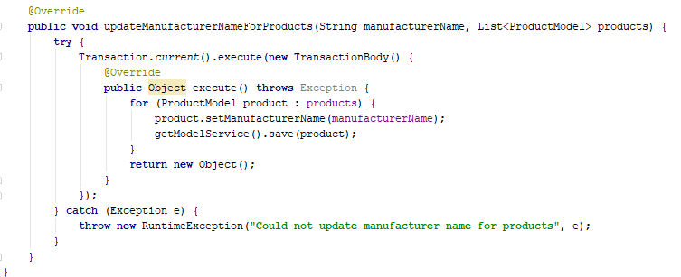

Step 3. Write “ProductModelServiceImplIntegrationTest” to check transactional method functionality (see more details at the repository).

Step 4. Run “ProductModelServiceImplIntegrationTest” to ensure that everything works fine.

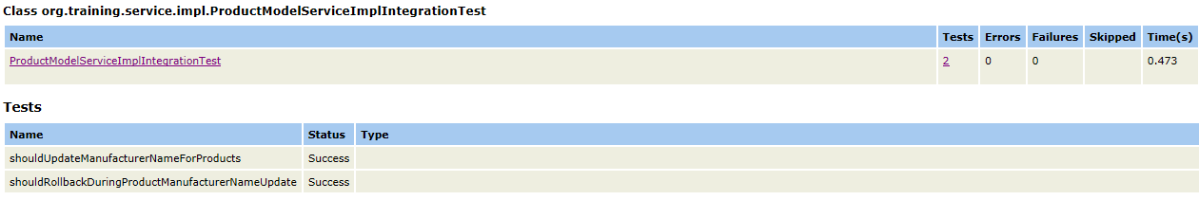
Link: https://git.epam.com/Vitalii_Myroniuk/hybris-mentoring/commit/c4d14918031c590fd2ddc7ca3ede11cd74ab4656

