Step 1. Create a new ProductCodeDecorator class.

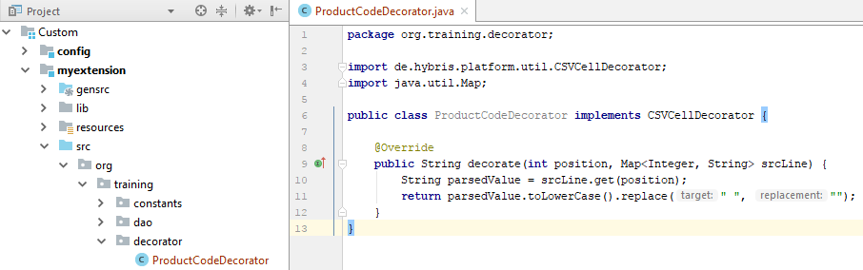

Step 2. Go to HAC>Console>ImpEX Import and import the following content.

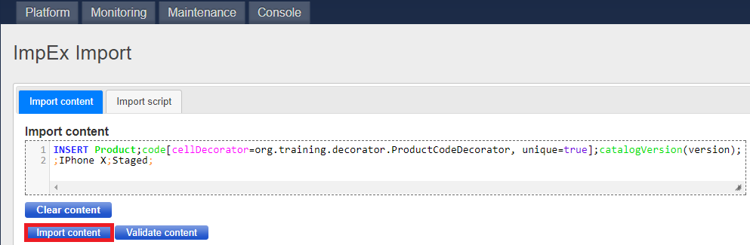

Step 3. Now, if you go to HMC and search above created product you will see the following result.

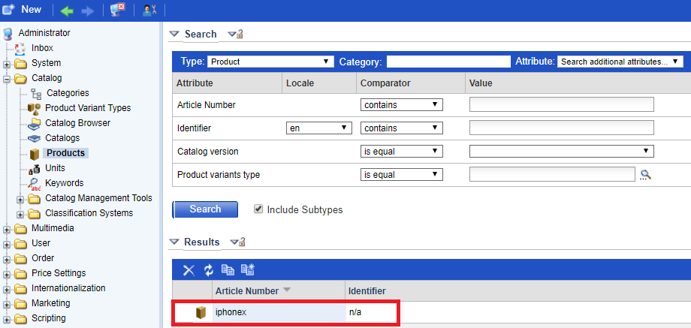

Link:

