Step 1. Write ProductModelDao interface.

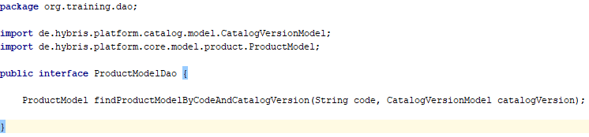

Step 2. Write DAO implementation for ProductModelDao interface.

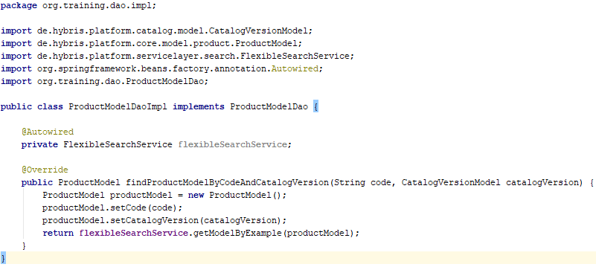

Step 3. Open myextension-spring.xml file and add the following lines.

Step 4. Write DAO integration test ProductModelDaoImplTest.

Step 5. Initialize junit tenant (use HAC or just run “ant yunitinit” in the command prompt).

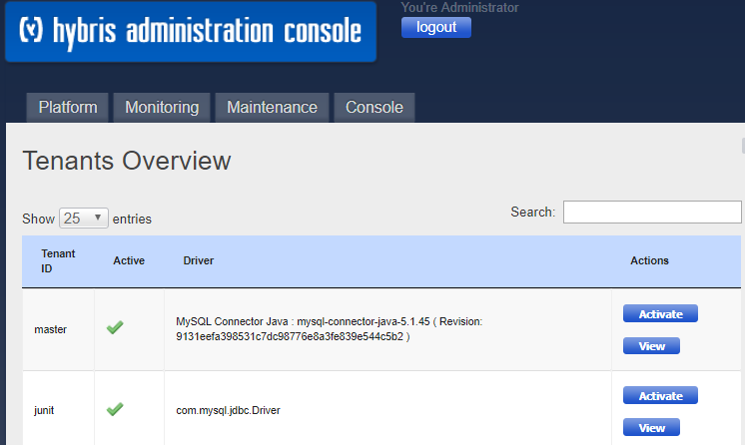

Step 6. Execute “ant clean all” and run tests (use IDE or command prompt).

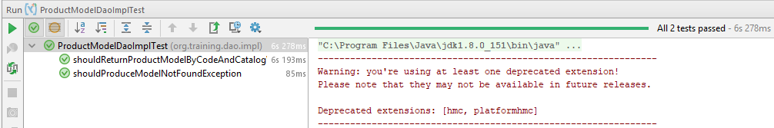

Link:

