Step 1. Open HMC and create several new customers with “Standard Language: Russian”.

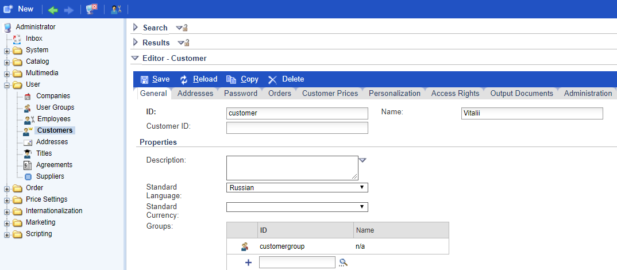

Step 2. Create myextension/resources/impex/essentialdata.impex file with the following script.

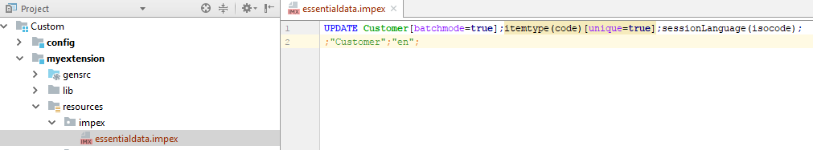

Step 3. Rebuild and update your project.

Step 4. Now, if you go to HMC and search above created customers you will see that “Standard Language” attribute is updated to “English”.

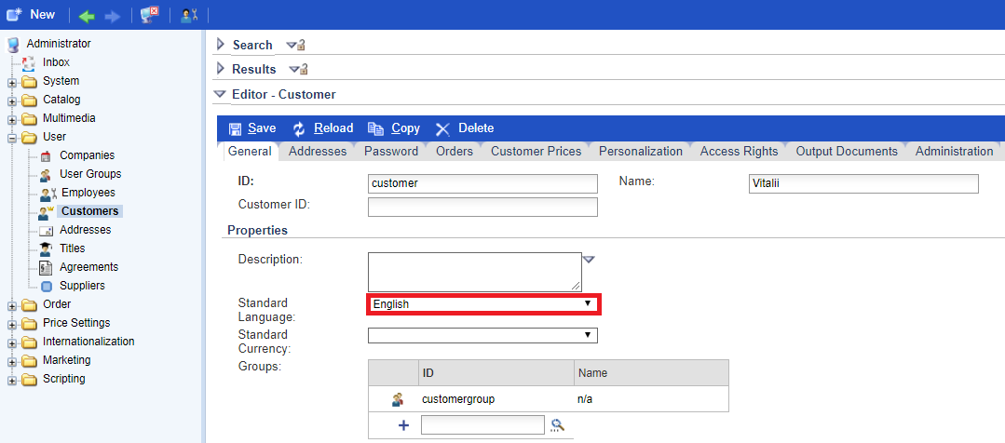

Step 5 (Optional). You can achieve the same result by using HAC (there are two ways to do this).

a)

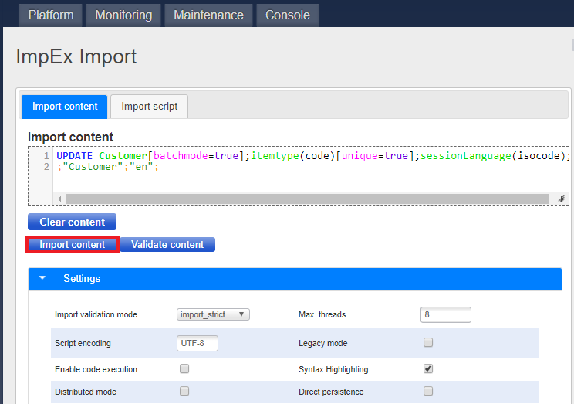

b)

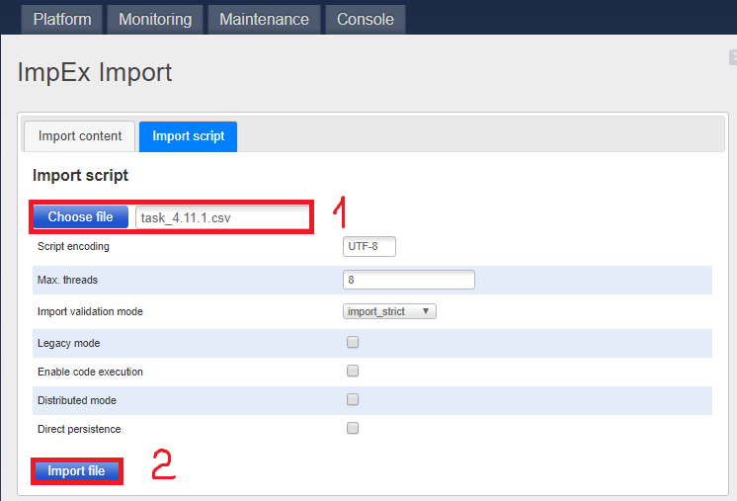

Link: https://git.epam.com/Vitalii_Myroniuk/hybris-mentoring/commit/cda4ea0f5d0cb5f1718d5f5ba47842b310dfd052

