Step 1. Download the SAP Hybris Commerce suite and b2ctelco accelerator.

Step 2. Unzip the Commerce suite to any location. For example: WINDOWS: C:\hybris6.6

Step 3. Unzip the telco accelerator to any location. For example: WINDOWS: C:\telco

Step 4. Copy the content of the telco accelerator to the commerce suit (C:\telco -> C:\hybris6.6).

Step 5. Download MongoDB and install it in a directory of your choice. For example: WINDOWS: C:/mongodb.

Step 6. Navigate to the {MONGODB_INSTALLATION_DIRECTORY}/bin folder. Using the command prompt, run the database:

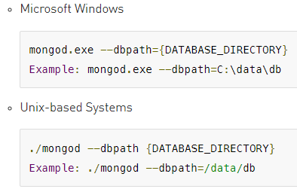

Step 7. Navigate to the C:/hybris6.6/installer directory and type the below command. This will create the config folder.

WINDOWS: install.bat -r b2c_telco

Step 8. Initialize Hybris telco accelerator platform with the below command:

WINDOWS: install.bat -r b2c_telco initialize

Step 9. Start the Hybris Server with the below command:

WINDOWS: install.bat -r b2c_telco start

Step 10. In your internet browser, navigate to the following address: https://b2ctelco.local:9002/yacceleratorstorefront/b2ctelco/en/. If you see the b2ctelco home page the installation is successful.

Step 11. Navigate to the <HYBRIS_BIN_DIR>/platform directory. Run the ant modulegen command and modify the input name and input package parameters as required, for example:

Step 12. Go to <HYBRIS_BIN_DIR>/custom directory and copy new generated extensions into your custom directory.

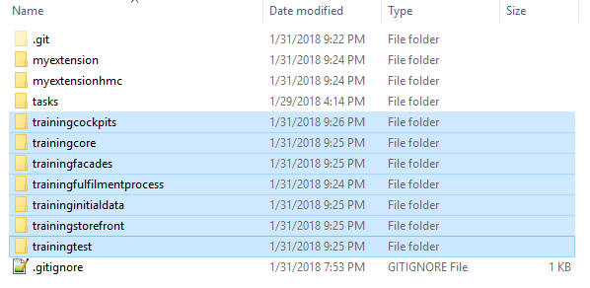

Step 13. Add the new extensions generated by modulegen to the localextensions.xml file. The exact XML snippet to add is displayed in your console output. The following is an example:

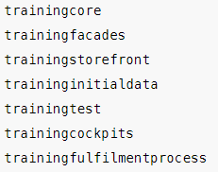

Step 14. As instructed in the console output, remove any of the following extensions that might appear in your localextensions.xml file:

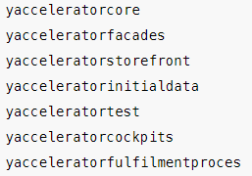

Step 15. Rebuild, start and update your project.

Step 16. In your internet browser, navigate to the following address: https://b2ctelco.local:9002/trainingstorefront/b2ctelco/en/. You should see the b2ctelco home page.

Link:

