Step 1. At first, we need to understand what is going on when the user updates his account. Go to “AccountPageController” and investigate “updateProfile(…)” method. As you can see, the main logic is at the line that contains “customerFacade.updateProfile(customerData)”. So, let us dive deeper to “updateProfile(…)” method in “DefaultCustomerFacade” class. Here we can find “getCustomerAccountService().updateProfile(…)” line. Don’t stop and move further to “updateProfile(…)” method in “DefaultCustomerAccountService” class. Ok, now it seems that we have found the source method that we need to modify or, it would be more precise to say, “override”.

Step 2. Write “CustomDefaultCustomerAccountService” class that extends “DefaultCustomerAccountService” (see more details at the repository) and implement a necessary logic, i.e. override “updateProfile(…)” method.

Step 3. Go to trainingcore-spring.xml and define spring bean for the “CustomDefaultCustomerAccountService” class.

Step 4. Go to trainingcore-items.xml and create “AccountUpdateProcess” item type.

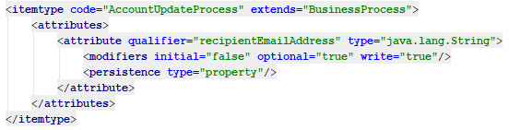

Step 5. Localize above created “AccountUpdateProcess” item type.

Step 6. Rebuild your project to generate “AccountUpdateProcessModel” class.

Step 7. Go to trainingcore\resources\trainingcore\processes and create customerAccountUpdateEmailProcess.xml file as follows.

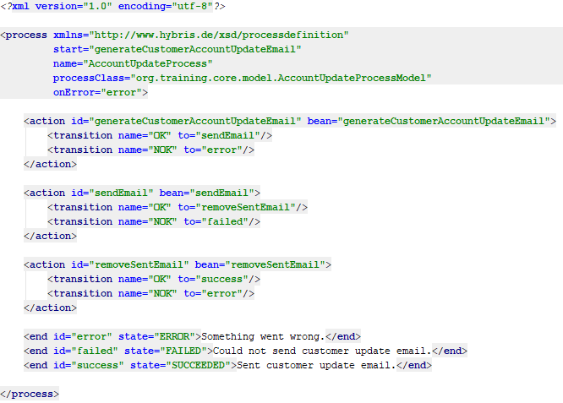

Step 8. Add process definition to trainingcore-spring.xml file.

Step 9. Implementing the process defining actions (see more details at the repository). Please, note that we implement only first “generateCustomerAccountUpdateEmail” action and for other actions we use corresponding implementations of the telco accelerator.

Step 10. Add above created action class to trainingcore-spring.xml file.

Step 11. Configure SMTP settings so that you can receive notifications by email. To achieve this purpose, add the following configuration to local.properties file.

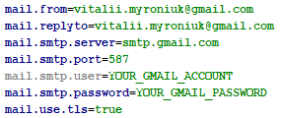

Step 12. Rebuild, start and update your project.

Step 13. Log into telco website and update your profile.

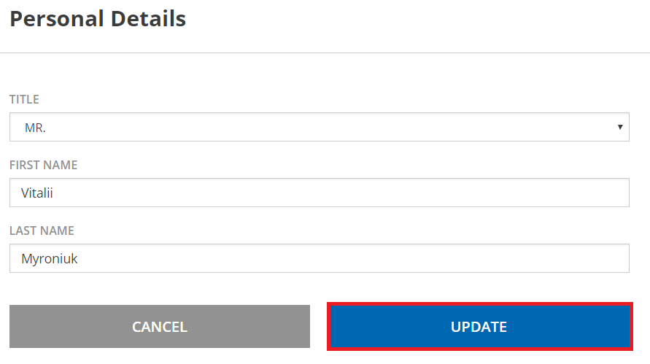

Step 14. If everything is fine you should receive an email with notification.

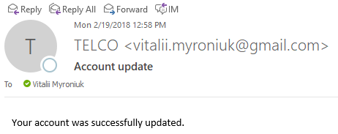

Step 15. You can also check the result of execution at HMC.

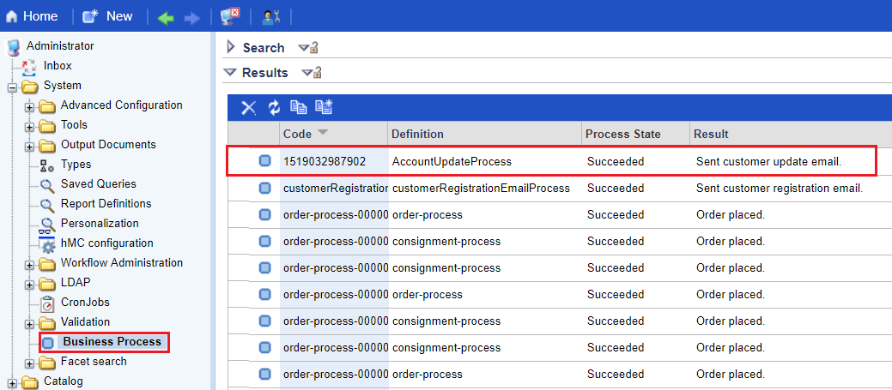

Link:

