Step 1. Go to HMC > Catalog > Catalogs and select Default-Staged.

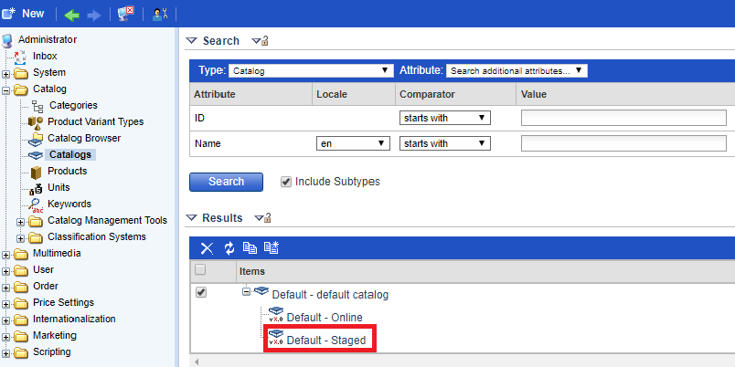

Step 2. Go to Catalog version and double click on Synchronization target.

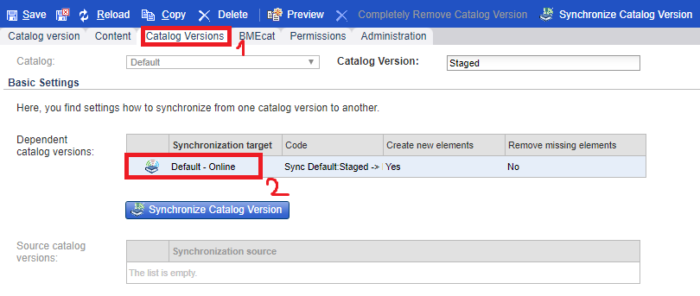

Step 3. Go to Synchronization Properties > Supplier and uncheck “description” attribute to make it ignored. Press “Save” button.

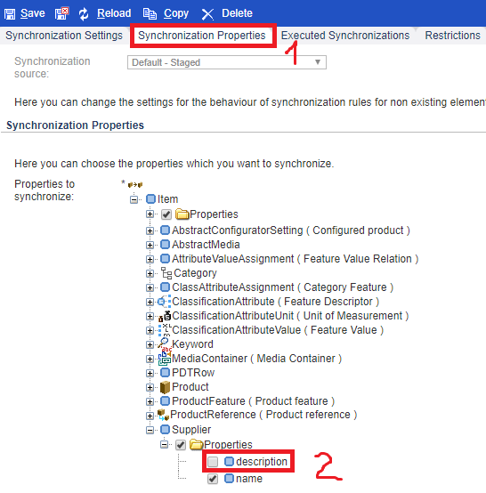

Link:

