Step 1. Install “telko” accelerator:

https://help.hybris.com/6.6.0/hcd/8af25b6586691014bc9b9069f05b3535.html

Step 2. Create necessary custom extensions and copy them to your custom directory:

https://help.hybris.com/6.6.0/hcd/8ace75c786691014a5e9dcafa29d5410.html

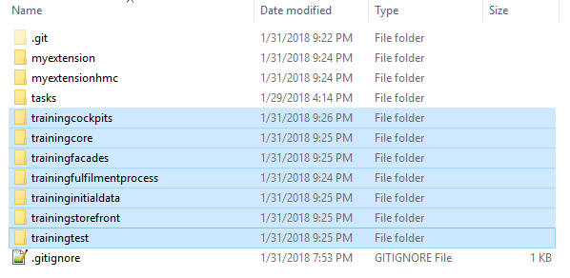

Step 3. Go org.training.storefront.controllers.pages.ProductPageController.class and have a look at the bean’s name that has to be injected into productFacade field.

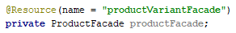

Step 4. Go to trainingfacades-spring.xml and add the following bean.

Step 5. Write CustomProductFacade with necessary logic (see more details at repository).
Step 6. Rebuild and restart your project.

Step 7. Go to HMC, find some product with “Online” version and submit some review with rating >= 2.

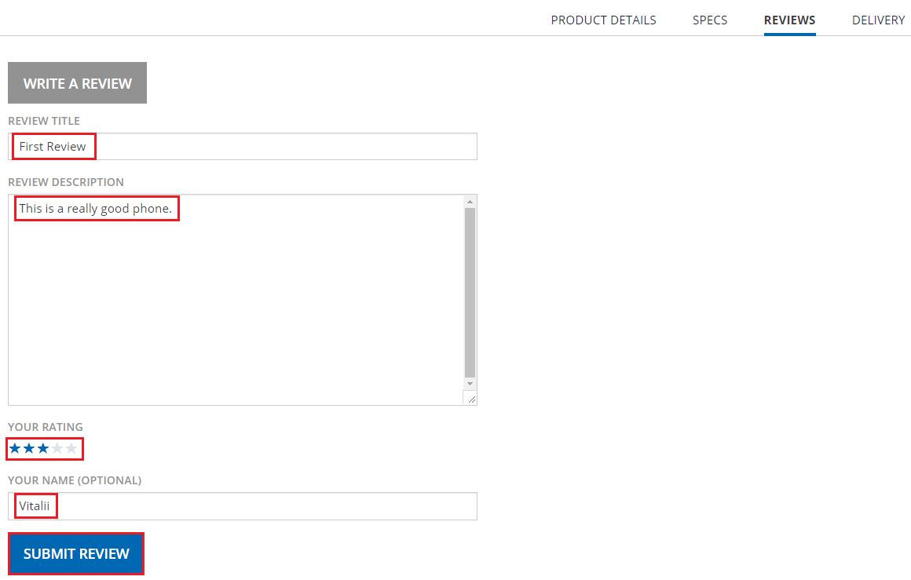

Step 8. Go to “telko” website and find a corresponding product. If everything is fine than you will see a corresponding review.

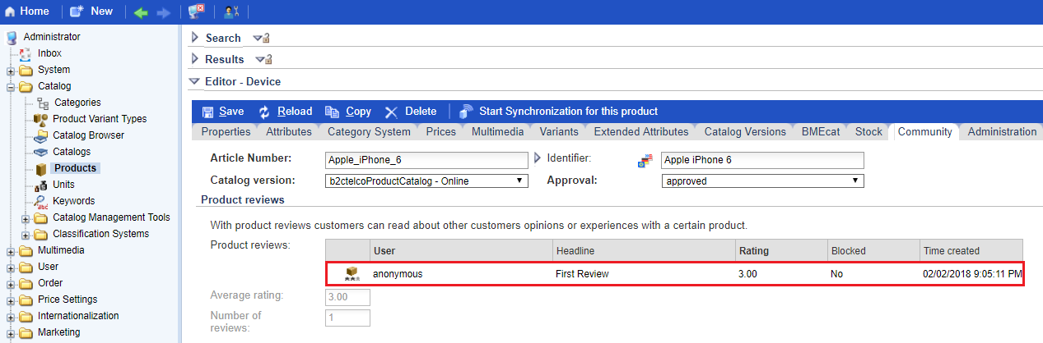

Step 9. Go to HMC again and try to submit another review for the same product with rating < 2.

Step 10. Go to “telko” website and find corresponding product. If everything is fine than you should not see the second review.

Link:

