Step 1. Install “telko” accelerator:

https://help.hybris.com/6.6.0/hcd/8af25b6586691014bc9b9069f05b3535.html

Step 2. Create necessary custom extensions and copy them to your custom directory:

https://help.hybris.com/6.6.0/hcd/8ace75c786691014a5e9dcafa29d5410.html

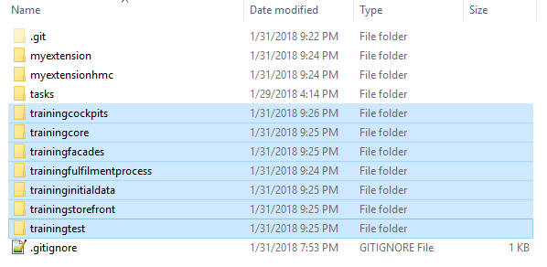

Step 3. Go to trainingfacades-beans.xml and add “daysBeforeOffline” attribute to “ProductData” DTO.

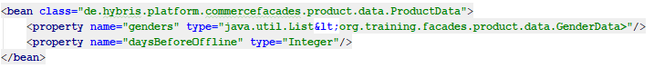

Step 4. Rebuild your project.

Step 5. Write DaysBeforeOfflineProductPopulator with necessary logic (see more details at repository).

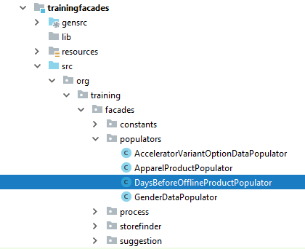

Step 6. Write unit tests to test DaysBeforeOfflineProductPopulator.

Step 7. Go to trainingfacades-spring.xml and add the following beans.

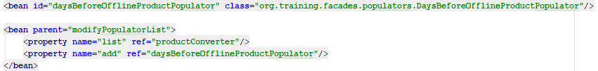

Step 8. Go to base bundle of trainingstorefront extension and add corresponding message for “daysBeforeOffline” field.

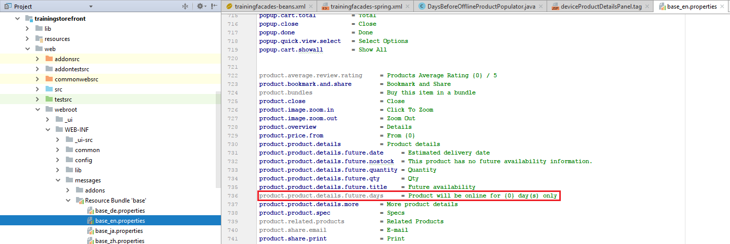

Step 9. Go to trainingstorefront\web\webroot\WEB-INF\tags\responsive\product\productDetailsTab.tag and add “daysBeforeOffline” value to display on the product page.

Step 10. Rebuild and restart your project.

Step 11. Go to HMC find some product with “Online” version and set offline date as follows.

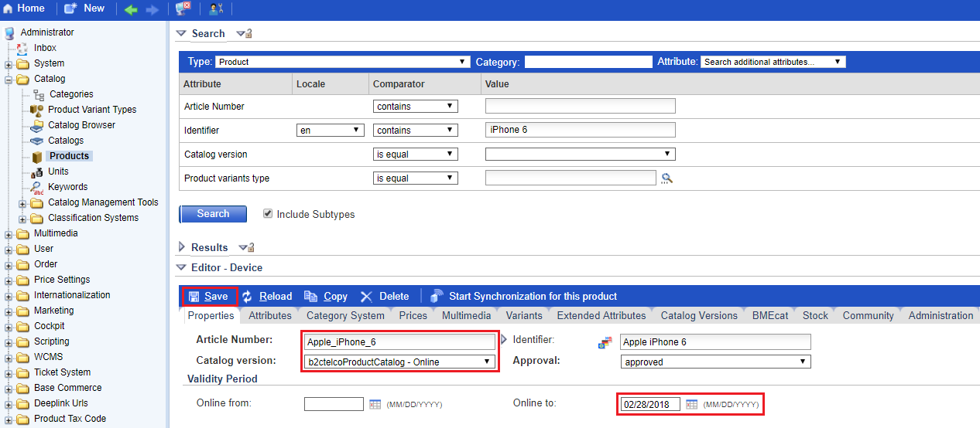

Step 12. Go to “telko” website and find corresponding product. If everything is fine than you will see an expected message.

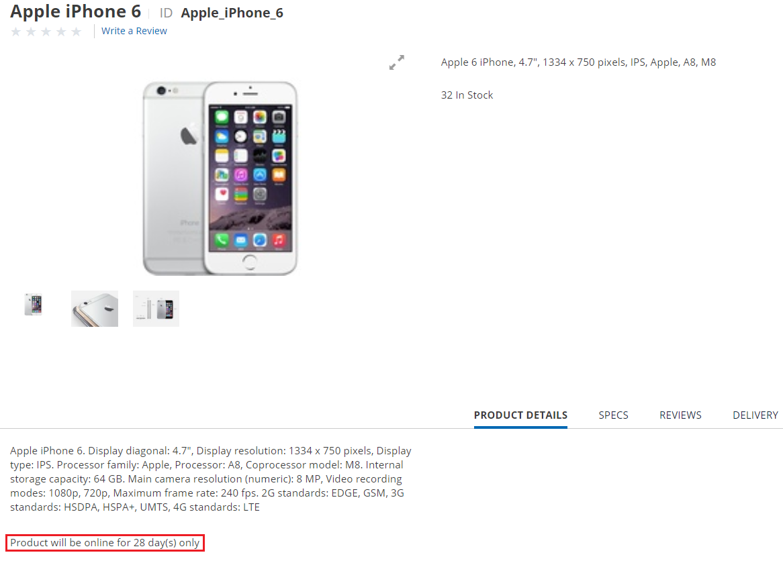

Link:

