Step 1. Go to myextension-items.xml and add “dateOfBirth” attribute to “User” type.

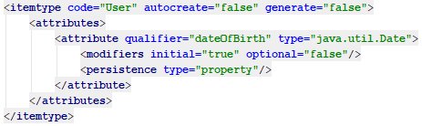

Step 2. Localize “dateOfBirth” attribute.

Step 3. Write “UserAgeValidateInterceptor” class (see more details at repository).

Step 4. Go to myextension-spring.xml, add interceptor bean and map it to “User” type.

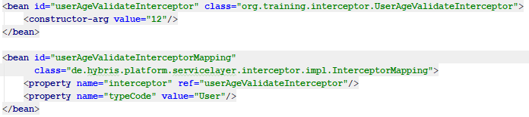

Step 5. Write unit tests.

Step 6. Rebuild, restart and update your project.

Step 7. Go to HMC and try to create the user with age >= 12. Everything should work fine.

Step 8. Now, if you try to create the user with age < 12 you should obtain the following error.

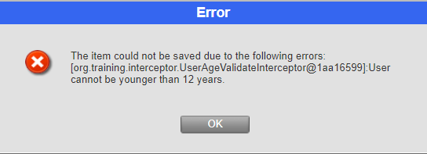

Link: https://git.epam.com/Vitalii_Myroniuk/hybris-mentoring/commit/99727e7740238a6f23aa5292e3159e06dc51a26f

