Step 1. Install “telko” accelerator:

https://help.hybris.com/6.6.0/hcd/8af25b6586691014bc9b9069f05b3535.html

Step 2. Create necessary custom extensions and copy them to your custom directory:

https://help.hybris.com/6.6.0/hcd/8ace75c786691014a5e9dcafa29d5410.html

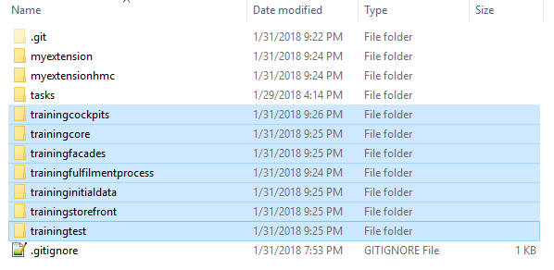

Step 3. Go to myextension-items.xml and add “additionalDescription” attribute to “Product” item.

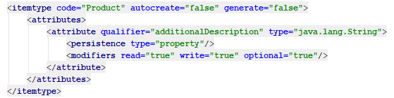

Step 4. Localize above mentioned “additionalDescription” attribute in myextension-locales_en.properties file.

Step 5. Go to trainingfacades-beans.xml, add “additionalDescription” attribute to “ProductData” DTO and ADDITIONAL_DESCRIPTION value to “ProductOption” enum.

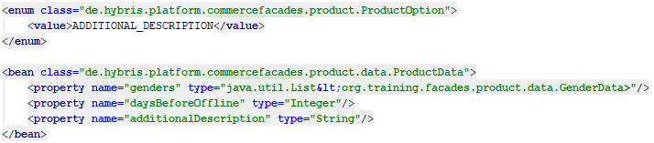

Step 6. Rebuild your project.

Step 7. Write AdditionalDescriptionProductPopulator with necessary logic (see more details at repository).

Step 8. Go to org.training.storefront.controllers.pages.ProductPageController.class and add above created ADDITIONAL_DESCRIPTION value to “options” list.

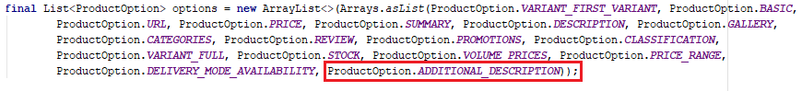

Step 9. Go to trainingfacades-spring.xml and add the following beans.

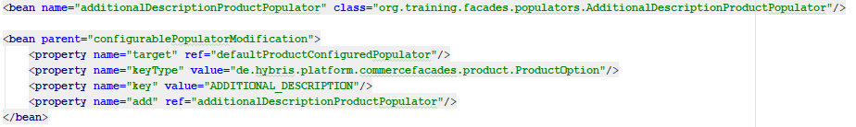

Step 10. Go to trainingstorefront\web\webroot\WEB-INF\tags\responsive\product\ productDetailsTab.tag and add “additionanlDescription” value to display on the product page.

Step 11. Rebuild, restart and update your project.

Step 12. Go to HMC find some product with “Online” version and set some additional description.

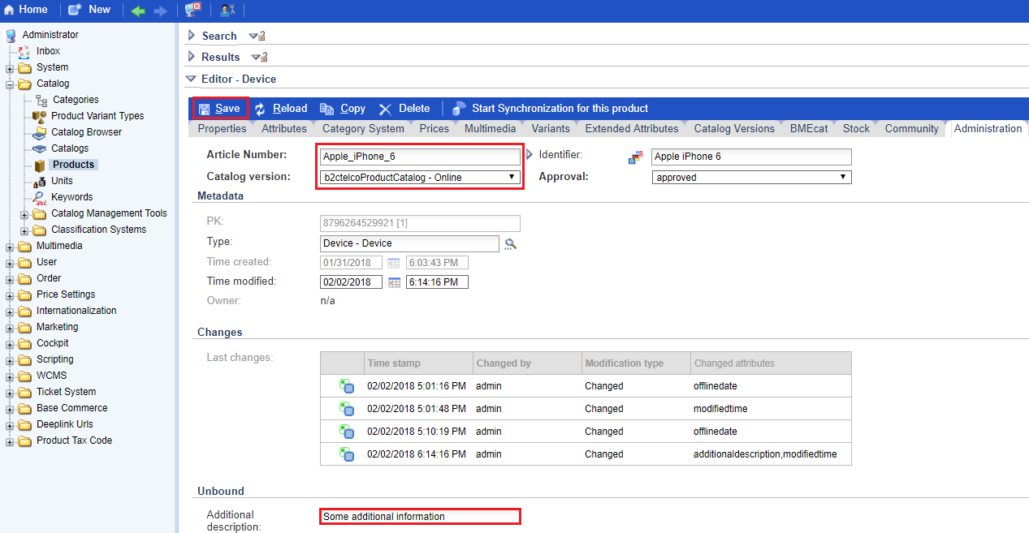

Step 13. Go to “telko” website and find corresponding product. If everything is fine than you will see an expected additional description.

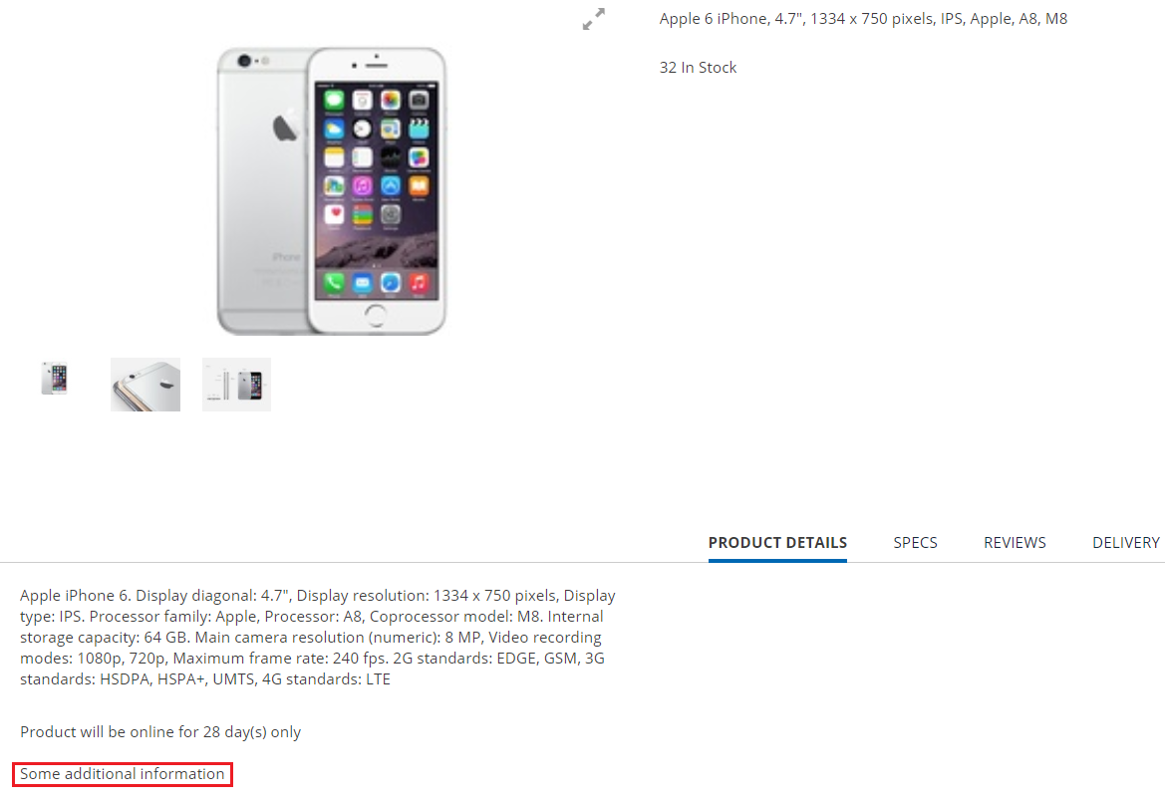

Link: https://git.epam.com/Vitalii_Myroniuk/hybris-mentoring/commit/6b6ad9d89218ce6636c9c94b81d81feb7ed40902

