Links

<https://www.codeschool.com/courses/javascript-road-trip-part-1>

<http://shamansir.github.io/JavaScript-Garden/>

<http://learn.jquery.com/about-jquery/how-jquery-works/>

<http://www.1stwebdesigner.com/tutorials/jquery-beginners-1/>

<http://www.reddit.com/r/javascript/comments/2d3kns/looking_to_learn_js_have_feedbackquestions_about/>

<https://github.com/yckart/jquery.storage.js>

templating:   
<https://github.com/janl/mustache.js>

<http://handlebarsjs.com/>

# First task

Technical Tips:  
  
 - for this task we need to use jQuery, jQueryUI and jQuery Validation plugin (used for form validation)  
 - you don't need to use the styles as in the screenshots, it is not mandatory

- you don’t need to make the pagination

- you can use plugins like jqGrid if you like

- you can use templating engines like jQuery Template, mustache.js or handlebars.js

- you can use localstorage for keeping the data

- for styling you can use twitter bootstrap or basic jQuery styling   
  
  
Task Specifications:  
  
 1. we need a blank page with a table and one button to interact with the grid.   
 Below the grid there will be 3 labels that summaries the information in the grid (see 1.jpg)  
  
 2. the Grid contains 8 rows, as shown in 1.jpg, the last row contains two action buttons - "Edit Row" and "Delete Row"   
  
 3. The 3 labels at the bottom of the page show the following:  
 #of Market Launches: - total number of rows in the grid  
 Regional total amount of estimated sales potential: - total of "Est. Sales Potential(USD)"  
 Global total amount of estimated sales potential: - total of "Est. Sales Potential(CHF)"  
  
 4. the "Add Market Launch" button, is used to Add a new data row in the grid, When user clicks on this button a   
 modal window appears as shown in 2.jpg.  
 This modal Window has 2 mandatory fields ("Title" and "Estimated sales amount" ), therefore if the user tries to save  
 the data without entering these two fields, the fields are coloured in red, as shown in 2.jpg.   
 When the form is validated, a new row is added in the grid.  
  
 5. the 6th row in the grid "Est. Sales Potential(CHF)" is calculated from "Est. Sales Potential(USD)" by the formula  
 1CHF = 1.1USD  
  
 6. the "Edit Row" button, must be present on each row. If clicked, it will open the same modal as described in #4, the only  
 difference is that the modal window is populated with data from the grid. (see 3.jpg)  
  
 7. the "Remove row" button, must be present on each row. If clicked, it will open a modal warning window, as shown in 4.jpg.  
 If the user clicked "yes" the row is removed from the grid (see 5.jpg) and the Status labels are updated respectively.

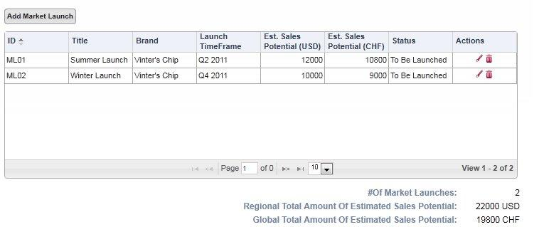

1.jpg

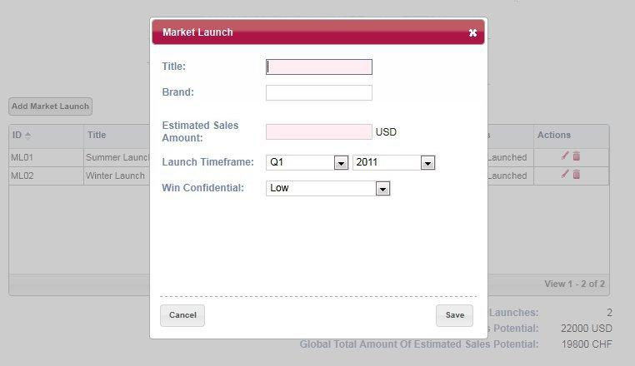

2.jpg

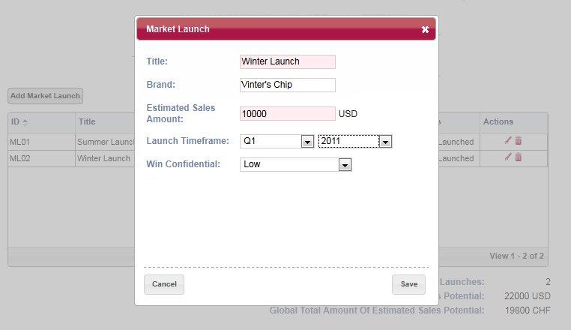

3.jpg

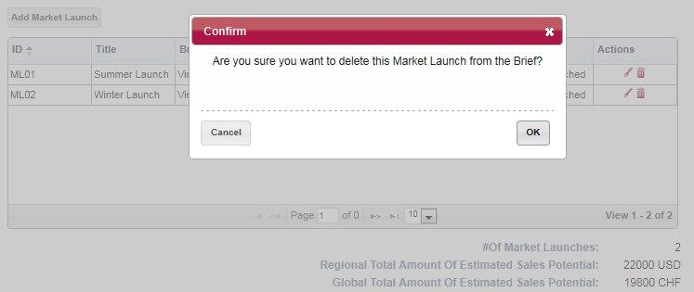

4.jpg

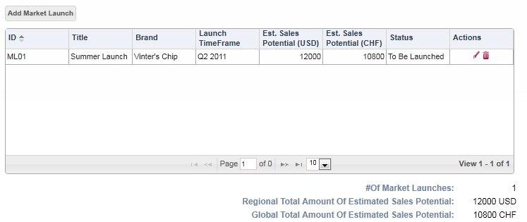 5.jpg