Software Requirements Specification

*Lviv, 2010*

Table of Contents

Functional Description 3

1.1 Comments Page 3

1.1.1 Refresh button functionality 5

1.1.2 Delete action message 6

1.1.3 Remove from Category validation 6

1.1.4 Remove from Category message 6

1.2 Edit/New/Duplicate Comment Page 7

1.2.1 Comment Text validation 9

1.2.2 Comment Code validation 9

1.2.3 Comment category validation 9

## Functional Description

“Comments” module allows users to create, edit, duplicate one comment, delete, activate and inactive one or multiple comments within a list of comments. In addition, it allows the user to assign one or multiple category to each comment. The list of comments can be filtered by category, status or both.

A comment consist of a “Comment text” (alphanumeric text field up to 50 characters in length) and an optional “Code number” and must be related to at least one category from the list of available categories. The “code number” can be a number between 1 and 999 (number must be unique) or blank.

The module “Comments” has two functionalities: “Comments page” and ‘Edit/New/Duplicate Comment page’. These pages are described below.

## Comments Page

The “Comments page” (shown below in fig. 1) allows user to view a list of comments which can be sorted by “Comment text”, “Number” and “Active” status (comments sorted in ascending order by “Comment Text” by default). Comments can be selected by checking off appropriate checkbox. On this page user can delete selected comments, filter the comments by category and/or activity status. In addition, user can remove one or multiple comments from currently selected (using filter) category, activate or inactivate selected comments.

The page consists of a “New…”, “Edit…”, “Duplicate…”, “Delete” and “Refresh” buttons, “Select an Action” dropdown (contains “Activate”, “Inactivate” and “Remove from Category” elements which provides appropriate actions), filtering controls, table with comments and page navigation. The filtering controls consist of “Category Name:” and “Status:” labels with appropriate dropdowns (“Category Name” dropdown default value is “All”, “Status” dropdown default value is “Active”) and “Apply” button to activate the selected filters. Filter applies only after clicking on “Apply” button.

This page is depicted in Figure 1.

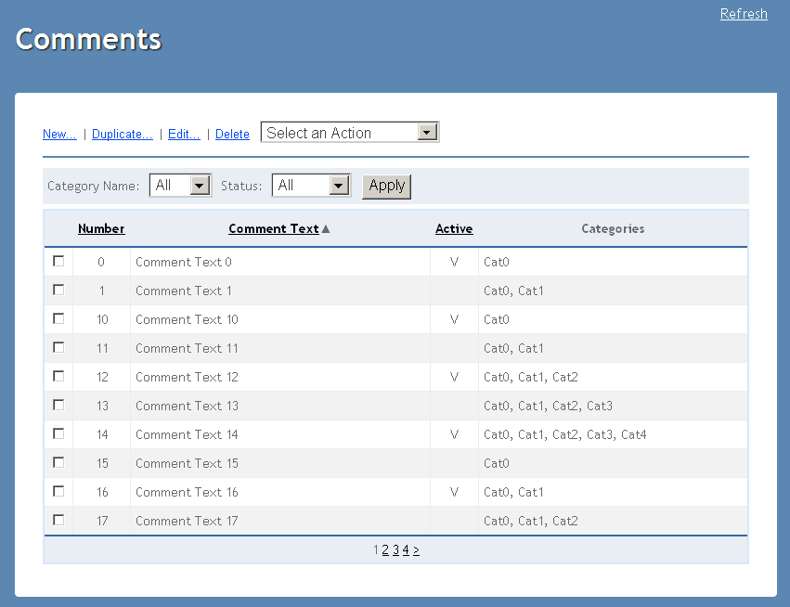

Figure 1. Comments page

The “Category Name” dropdown contains the collection of available categories plus the “All” element. The “Status” dropdown contains “All”, “Active” and “Inactive” elements. By selecting any category or status from the dropdowns and clicking “Apply” button the user can filter the list of displayed comments to show only those comments which have the selected category assigned to them and have the selected status.

Comments grid contains “Code Number”, “Comment Text”, “Active” and “Categories” columns filled with data from database. Categories that comment is assigned to are comma delimited. If a comment is active, a check mark appears in the “Active” column for the row representing that comment. Otherwise, for an inactive comment, that column is left blank for that row.

The items in the comments table can be sorted by “Comment text”, “Number” and “Active” status in ascending or descending order by clicking the corresponding column header. On the first click of a column header, the list will be sorted in ascending order based on the column which header was clicked. If that same column header is clicked a second time in a row, then the list will be sorted in descending order based on that column. If the list is to be sorted by number then the items without any number assigned will be placed in the end of the table and will be sorted by name in ascending order.

The ‘Comment’ page menu has the following options:

|  |  |
| --- | --- |
| **Menu Item** | **Action** |
| New | Navigates to the ‘Edit/New/Duplicate Comment page’ with the default entries to create a new comment. |
| Edit | Navigates to the ‘Edit/New/Duplicate Comment page’ with the entries of selected comment to edit an existing comment. |
| Duplicate | Navigates to the ‘Edit/New/Duplicate Comment page’ for selected comment to create a copy of existing comment. |
| Delete | Deletes the selected comment. Prompts the user to confirm the action with a standard yes/no confirmation dialog. Can be performed on one or more comments at a time. After delete comment(s) ‘Comments page’ opened on page 1, sorting and filtering are the same as before removing. |
| Select an Action | This menu item represents a drop down which, when clicked expands (drop down) to display a number of group-based operations as described below. |
| Select an Action/Activate | Activates the selected comment(s). Can be performed on one or more comments at a time. If one or more of the selected comments are already active, make the inactive selected comments active and disregard the command for the remaining selected active comments. |
| Select an Action/Inactivate | Makes the selected comment(s) inactive. Can be performed on one or more comments at a time. If one or more of the selected comments are already inactive, make the active selected comments inactive and disregard the command for the remaining selected inactive comments. |
| Select an Action/Remove from Category | Removes the selected comment(s) from currently selected category. Can be performed on one or more comments at a time. If one or more of the selected comments are assigned only to one category, remove the remaining selected comments (those assigned to more than one category) from the selected category. Then, present the following message to the user in a dialog box: ‘One or more selected comment is assigned to only one category and therefore cannot be removed from the selected category. Should these comments be made inactive?’ If the user selects the “Yes” option from the dialog box, inactivate these remaining selected comments. Otherwise, deselect these comments but take no further action relative to them. |
| Refresh | If the ‘Refresh’ menu item is clicked the data is reloaded with the last saved data, ‘Comments page’ is opened on page 1 with default view. |

Table . Comment Page Menu Items

Data entry for all comments is done in the Edit/New/Duplicate Comment page, which is reached by choosing the new, duplicate or edit actions from the menu.

### Refresh button functionality

If the ‘Refresh’ button is clicked the page data is reloaded from database. The current page number and sort order aren’t preserved on Refresh action.

### Delete action message

If the user deletes a comment, a standard confirmation dialog with the following message will appear: “Are you sure you want to delete the selected item(s)?” Pressing the ‘Yes’ button in the confirmation dialog will delete the selected comment(s). Choosing ‘No’ will leave the remaining comment(s) undeleted and selected. After successful “Delete” action the user will get the following message “Selected comments deleted successful” in green color above the filtering controls.

If the user click on “Delete” without choosing a comment, a standard comments application message with the following message will appear: “Please select at least one comment”. Pressing the ‘Ok’ button in the confirmation dialog will close it.

### Remove from Category validation

If the user attempts to invoke the ‘Remove from Category’ action for selected comments having ‘All’ categories selected in the ‘Category Name’ filter the following error message will be displayed in a standard comments application message: “Please, select category using filter”. Pressing the ‘Ok’ button in the confirmation dialog will close it and the selection sate of items will be preserved.  
If the user attempts to invoke the ‘Remove from Category’ action having any selected comments the following error message will be displayed in a standard comments application message: “Please select at least one comment”. Pressing the ‘Ok’ button in the confirmation dialog will close it.

### Remove from Category message

If the user attempts to remove a comment from the currently selected category and the comment is assigned only to one category then it can’t be removed from that category. In this case, any comments which were selected and which can be removed from the category (because they are assigned to more than one category) should be removed from the selected category. Then, a standard confirmation dialog should appear with the following message: “One or more selected comments are assigned to only one category and therefore cannot be removed from the selected category. Should these comments be made inactive?” If the user clicks the ’Yes’ button, the remaining selected comments are inactivated. If user clicks ‘No’ the remaining comments are selected and no further action is taken on them.

## Edit/New/Duplicate Comment Page

The ‘Edit/New/Duplicate Comment page’ allows the user to edit an existing or duplicated comment or to provide data for a newly created comment. On this page user can also assign categories to the comment and choose to activate or inactivate the comment. The page consists of ‘Comment Text’ and ‘Code Number’ text boxes, an ’Active’ checkbox and an available/selected control. The ‘Selected’ categories will be empty for a new item, contain the assigned categories for an edited comment and contain the categories assigned to the comment on which this duplicate was based for a duplicated comment.

In all cases, the ‘Available’ categories will be populated with the collection of available categories excluding those that are in the ‘Selected’ categories list box.

The ‘New Comment page’ is depicted in Figures 2 below.

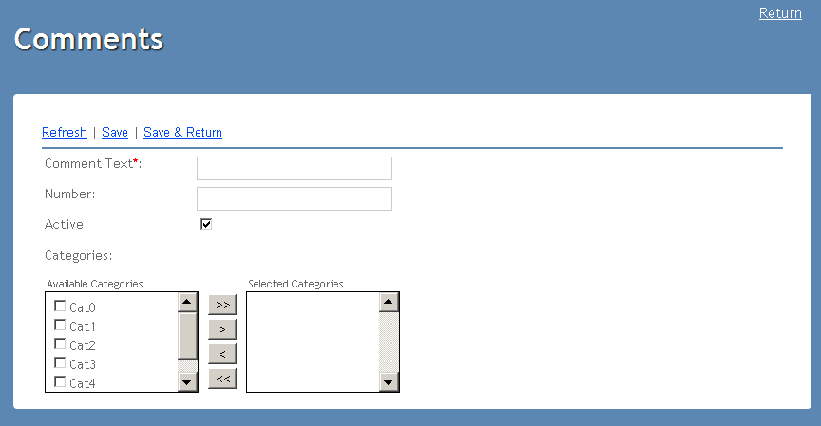

Figure 2. New Comments page

The ‘Edit Comment page’ is depicted in Figures 3 below.

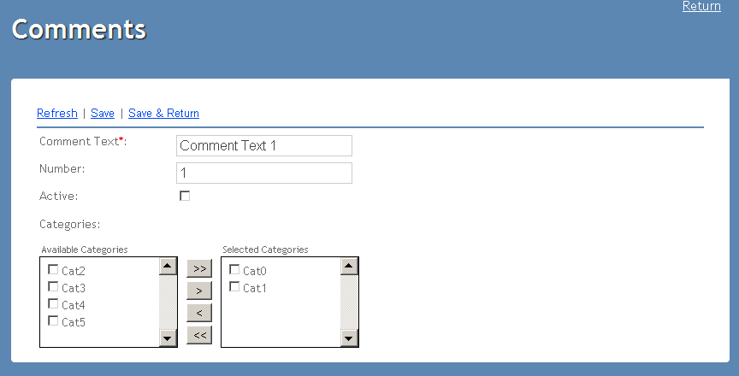

Figure 3. Edit Comments page

The ‘Duplicate Comment page’ is depicted in Figures 4 below.

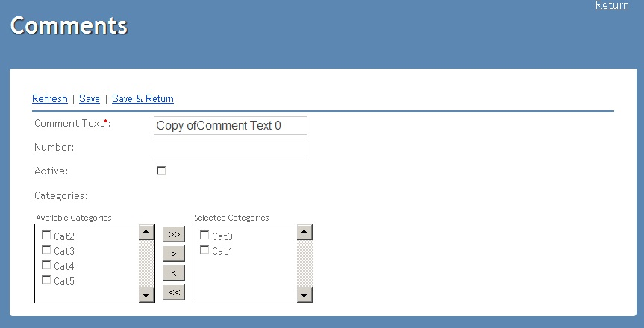

Figure 4. Duplicate Comments page

The ‘Comment Text’ and ‘Code Number’ text boxes are used for data entry.

These text boxes have the following format:

* ’Comment Text’: 50 characters optional field, case sensitive, has to be unique. Cannot contain reserved characters (=,/, |, \, *, (, ), _, :, ;, #, %, ^, ?, [, ]).
* ’Code Number’: integer number (from 1 to 999), optional field.

Fields are empty on ‘New’ user action. On the ‘Duplicate’ action the comment text is modified using the standard duplicate protocol “Copy of {comment text value}.” and the number field is cleared. On the ‘Edit’ fields are entered.

The ‘Active’ checkbox indicates (when checked) that the comment is active. If it is not checked, it indicates that the comment is inactive. The ‘Active’ checkbox is checked by default for a new Comment.

Using the available/selected control, the user can add categories to or remove categories from the comment. A comment must have at least one category assigned to it.

The ‘Edit/New/Duplicate Comment page’ menu has the following options:

|  |  |
| --- | --- |
| **Menu Item** | **Action** |
| Refresh | Refreshes page without saving data |
| Save | Accepts the entered data, if valid, and stores it to the database without leaving the page.  In the case of a new comment, after a successful save the ‘Comment Text’ and ‘Code Number’ fields are cleared and all categories are moved to ‘Available Categories Group’. When editing a comment, this action simply updates the database for the comment that is currently being edited based on the data entered and then leaves the fields displaying the entered data.  In the case of a duplicated comment, after a successful save, the page is left populated with the newly entered/edited data. If no changes have been made, this results in no database update. |
| Save & Return | Saves the entered data to the database and returns user to ‘Comments page’. |
| Return (above the main body) | Returns to the main Comment Page without saving data |

### Comment Text validation

The ‘Comment Text’ field is case sensitive and has to be unique. User will get an error in red color with the following message when trying to save comment with some existing text: “Comment already exists”. The ‘Comment Text’ field will be highlighted.

When user enters reserved characters in ‘Comment Text’ field and tries to save comment, appears error in red color: “The Comment Text field should contain alphanumeric characters only.”

When user tries to save comment with empty field ‘Comment Text’ appears error message in red color: "The "Comment Text" field is required."

When user tries to save comment with more than 50 symbols in "Comment Text" field then appears error message in red color: “The maximum length of the "Comment Text" field is 50 characters.”

### Comment Code validation

Only a unique comment code number is accepted. Thus when trying to save a comment with a code number matching some previously existing code number or number is not in diapason from 1 to 999, or it is not numeric value, the system will display the following error in red color: “The ‘Number’ field should contain value from 1 to 999 and should be unique.”

### Comment category validation

Comments must have at least one category assigned to them. If no categories have been selected, and the user attempts to save the comment then following error in red color will be displayed: “Comments must be assigned to at least one category. Please select a category before trying to save this comment again.”

**Note:**

All messages should look like:

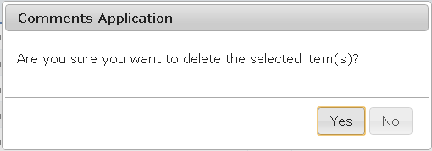

All errors in red color should look like:

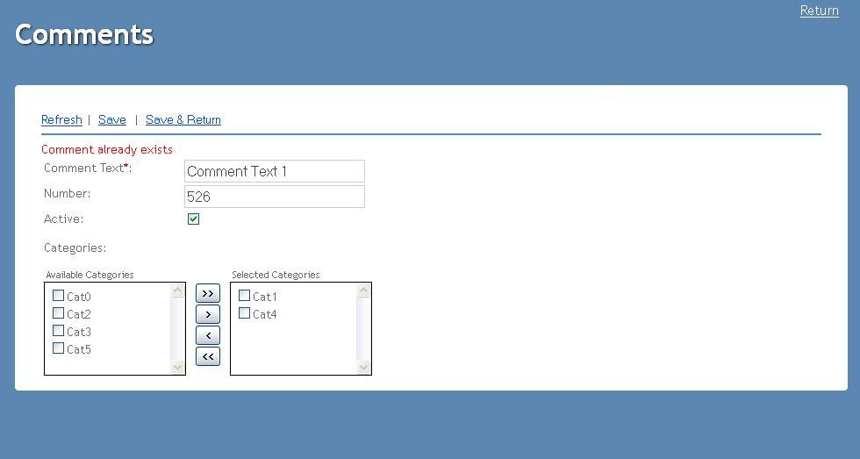

**Figure 5. Error message at Edit/New/Duplicate Comments page**