Практична робота № 4

**Тема**: Розробка мобільних додатків для ОС Android

**Мета**:

* ознайомлення із інтерфейсом середовища розробки програмного забезпечення;
* вивчення структури проекту;
* навчитись створювати власні структури даних та використовувати їх у мобільних додатках;
* навчитись створювати інтерфейси для мобільних додатків;
* навчитись використовувати додаткові ресурси та можливості пристрою;
* ознайомитись із локалізацією мобільних додатків.

Завдання:

**Завдання 1:**

Розробити додаток калькулятор, який максимально забезпечити функціональністю: виконання арифметичних операцій, переведення в системи числення(двійкова, вісімкова, десяткова, шістнадцяткова), виконання тригонометричних функцій(sin, cos, tan, ctan), знаходження експоненти, логарифмів, піднесення до степеню, знаходження кореня з числа і т.д. Забезпечити введення лише в одне текстове поле.

**Завдання 2:**

Предметна область: інтернет-магазин, клас: товар, орієнтовний перелік полів: назва товару, категорія, опис товару, ціна за одиницю, наявність на складі, кількість, дата поставки. Вивести окремо список відсутніх товарів. Реалізувати пошук товарів за вказаною категорією.

**Хід роботи:**

Завдання 1:

Код програми:

MainActivity.java:

package com.example.calculator;  
  
import androidx.annotation.RequiresApi;  
import androidx.appcompat.app.AppCompatActivity;  
import org.mariuszgromada.math.mxparser.*;  
  
import android.os.Build;  
import android.os.Bundle;  
import android.text.SpannableStringBuilder;  
import android.view.View;  
import android.widget.EditText;  
  
public class MainActivity extends AppCompatActivity {  
  
 private EditText display;  
 private boolean operator = true;  
  
 @RequiresApi(api = Build.VERSION_CODES.*LOLLIPOP*)  
 @Override  
 protected void onCreate(Bundle savedInstanceState) {  
 super.onCreate(savedInstanceState);  
 setContentView(R.layout.*activity_main*);  
 getSupportActionBar().hide();  
  
 display = findViewById(R.id.*input*);  
 display.setShowSoftInputOnFocus(false);  
 display.setCursorVisible(false);  
  
 display.setOnClickListener(new View.OnClickListener() {  
 @Override  
 public void onClick(View v) {  
 if (getString(R.string.*display*).equals(display.getText().toString()))  
 {  
 display.setText("");  
 }  
 }  
 });  
 }  
  
 private void updateText(String strToAdd) {  
 String oldStr = display.getText().toString();  
 int cursorPos = display.getSelectionStart();  
 String leftStr = oldStr.substring(0, cursorPos);  
 String rightSrt = oldStr.substring(cursorPos);  
  
 if("Помилка".equals(display.getText().toString()))  
 {  
 display.setText("");  
 display.setText(strToAdd);  
 }  
 else if (getString(R.string.*display*).equals(display.getText().toString())) {  
 display.setText(strToAdd);  
 display.setSelection(cursorPos + 1);  
 }  
 else {  
 display.setText(String.*format*("%s%s%s", leftStr, strToAdd, rightSrt));  
 display.setSelection(cursorPos + 1);  
 }  
 }  
  
 public void zeroBTN(View view) { updateText("0"); operator = false;}  
 public void oneBTN(View view) { updateText("1"); operator = false;}  
 public void twoBTN(View view) { updateText("2"); operator = false;}  
 public void threeBTN(View view) { updateText("3"); operator = false;}  
 public void fourBTN(View view) { updateText("4"); operator = false;}  
 public void fiveBTN(View view) { updateText("5"); operator = false;}  
 public void sixBTN(View view) { updateText("6"); operator = false;}  
 public void sevenBTN(View view) { updateText("7"); operator = false;}  
 public void eightBTN(View view) { updateText("8"); operator = false;}  
 public void nineBTN(View view) { updateText("9"); operator = false;}  
 public void interestBTN(View view) {  
 String userExp = display.getText().toString();  
  
 userExp = userExp.replaceAll("÷", "/");  
 userExp = userExp.replaceAll("×", "*");  
 userExp = userExp.replaceAll("e", "2.71828");  
  
 if(operator) {  
 userExp = userExp.substring(0, userExp.length() - 1);  
 }  
 userExp = userExp + "*0.01";  
 Expression exp = new Expression(userExp);  
  
 String result = String.*valueOf*(exp.calculate());  
 if(result.equals("NaN") || result.equals("Infinity"))  
 result = "Помилка";  
 display.setText(result);  
 display.setSelection(result.length());  
 operator = false;  
 }  
 public void piBTN(View view) {  
 String userExp = display.getText().toString();  
  
 userExp = userExp.replaceAll("÷", "/");  
 userExp = userExp.replaceAll("×", "*");  
 userExp = userExp.replaceAll("e", "2.71828");  
  
 if(operator) {  
 userExp = userExp.substring(0, userExp.length() - 1);  
 }  
 userExp = "Pi(" + userExp + ")";  
 Expression exp = new Expression(userExp);  
  
 String result = String.*valueOf*(exp.calculate());  
 if(result.equals("NaN") || result.equals("Infinity"))  
 result = "Помилка";  
 display.setText(result);  
 display.setSelection(result.length());  
 operator = false;  
 }  
 public void sinBTN(View view) {  
 String userExp = display.getText().toString();  
  
 userExp = userExp.replaceAll("÷", "/");  
 userExp = userExp.replaceAll("×", "*");  
 userExp = userExp.replaceAll("e", "2.71828");  
  
 if(operator) {  
 userExp = userExp.substring(0, userExp.length() - 1);  
 }  
 userExp = "sin(" + userExp + ")";  
 Expression exp = new Expression(userExp);  
  
 String result = String.*valueOf*(exp.calculate());  
 if(result.equals("NaN") || result.equals("Infinity"))  
 result = "Помилка";  
 display.setText(result);  
 display.setSelection(result.length());  
 }  
 public void cosBTN(View view) {  
 String userExp = display.getText().toString();  
  
 userExp = userExp.replaceAll("÷", "/");  
 userExp = userExp.replaceAll("×", "*");  
 userExp = userExp.replaceAll("e", "2.71828");  
  
 if(operator) {  
 userExp = userExp.substring(0, userExp.length() - 1);  
 }  
 userExp = "cos(" + userExp + ")";  
 Expression exp = new Expression(userExp);  
  
 String result = String.*valueOf*(exp.calculate());  
 if(result.equals("NaN") || result.equals("Infinity"))  
 result = "Помилка";  
 display.setText(result);  
 display.setSelection(result.length());  
 }  
 public void tanBTN(View view) {  
 String userExp = display.getText().toString();  
  
 userExp = userExp.replaceAll("÷", "/");  
 userExp = userExp.replaceAll("×", "*");  
 userExp = userExp.replaceAll("e", "2.71828");  
  
 if(operator) {  
 userExp = userExp.substring(0, userExp.length() - 1);  
 }  
 userExp = "tan(" + userExp + ")";  
 Expression exp = new Expression(userExp);  
  
 String result = String.*valueOf*(exp.calculate());  
 if(result.equals("NaN") || result.equals("Infinity"))  
 result = "Помилка";  
 display.setText(result);  
 display.setSelection(result.length());  
 }  
 public void lnBTN(View view) {  
 String userExp = display.getText().toString();  
  
 userExp = userExp.replaceAll("÷", "/");  
 userExp = userExp.replaceAll("×", "*");  
 userExp = userExp.replaceAll("e", "2.71828");  
  
 if(operator) {  
 userExp = userExp.substring(0, userExp.length() - 1);  
 }  
 userExp = "ln(" + userExp + ")";  
 Expression exp = new Expression(userExp);  
  
 String result = String.*valueOf*(exp.calculate());  
 if(result.equals("NaN") || result.equals("Infinity"))  
 result = "Помилка";  
 display.setText(result);  
 display.setSelection(result.length());  
 operator = false;  
 }  
 public void lgBTN(View view) {  
 String userExp = display.getText().toString();  
  
 userExp = userExp.replaceAll("÷", "/");  
 userExp = userExp.replaceAll("×", "*");  
 userExp = userExp.replaceAll("e", "2.71828");  
  
 if(operator) {  
 userExp = userExp.substring(0, userExp.length() - 1);  
 }  
 userExp = "log10(" + userExp + ")";  
 Expression exp = new Expression(userExp);  
  
 String result = String.*valueOf*(exp.calculate());  
 if(result.equals("NaN") || result.equals("Infinity"))  
 result = "Помилка";  
 display.setText(result);  
 display.setSelection(result.length());  
 operator = false;  
 }  
 public void eBTN(View view) { updateText("e"); operator = false;}  
 public void sqrtBTN(View view) { String userExp = display.getText().toString();  
  
 userExp = userExp.replaceAll("÷", "/");  
 userExp = userExp.replaceAll("×", "*");  
 userExp = userExp.replaceAll("e", "2.71828");  
  
 if(operator) {  
 userExp = userExp.substring(0, userExp.length() - 1);  
 }  
 userExp = "sqrt(" + userExp + ")";  
 Expression exp = new Expression(userExp);  
  
 String result = String.*valueOf*(exp.calculate());  
 if(result.equals("NaN") || result.equals("Infinity"))  
 result = "Помилка";  
 display.setText(result);  
 display.setSelection(result.length());  
 operator = false; }  
 public void exponent2BTN(View view) {  
 String userExp = display.getText().toString();  
  
 userExp = userExp.replaceAll("÷", "/");  
 userExp = userExp.replaceAll("×", "*");  
 userExp = userExp.replaceAll("e", "2.71828");  
  
 if(operator) {  
 userExp = userExp.substring(0, userExp.length() - 1);  
 }  
 userExp = userExp + "^2";  
 Expression exp = new Expression(userExp);  
  
 String result = String.*valueOf*(exp.calculate());  
 if(result.equals("NaN") || result.equals("Infinity"))  
 result = "Помилка";  
 display.setText(result);  
 display.setSelection(result.length());  
 operator = false;  
 }  
 public void clearBTN(View view) { display.setText("0"); }  
 public void exponentBTN(View view) {  
 if (display.getText().toString().isEmpty() || operator) {  
 return;  
 } else {  
 updateText("^");  
 operator = true;  
 }  
 }  
 public void paranthesesBTN(View view) {  
 int cursorPos = display.getSelectionStart();  
 int openPar = 0;  
 int closePar = 0;  
 int textLen = display.getText().length();  
  
 for(int i = 0; i < cursorPos; i++){  
 if (display.getText().toString().substring(i, i + 1).equals("("))  
 openPar += 1;  
 if (display.getText().toString().substring(i, i + 1).equals(")"))  
 closePar += 1;  
 }  
   
 if (openPar == closePar || display.getText().toString().substring(textLen - 1, textLen).equals("(")) {  
 updateText("(");  
 display.setSelection(cursorPos + 1);  
 }  
 else if (closePar < openPar && !display.getText().toString().substring(textLen - 1, textLen).equals("(")) {  
 updateText(")");  
 }  
 display.setSelection(cursorPos + 1);  
 }  
 public void divideBTN(View view) {  
 if (display.getText().toString().isEmpty() || operator) {  
 return;  
 } else {  
 updateText("÷");  
 operator = true;  
 }  
 }  
 public void multiplyBTN(View view) {  
 if (display.getText().toString().isEmpty() || operator) {  
 return;  
 } else {  
 updateText("×");  
 operator = true;  
 }  
 }  
 public void addBTN(View view) {  
 if (display.getText().toString().isEmpty() || operator) {  
 return;  
 } else {  
 updateText("+");  
 operator = true;  
  
 }  
 }  
 public void subtractBTN(View view) {  
 if (display.getText().toString().isEmpty() || operator) {  
 return;  
 } else {  
 updateText("-");  
 operator = true;  
 }  
 }  
 public void pointBTN(View view) {  
  
 updateText(".");  
 }  
 public void equalsBTN(View view) {  
 String userExp = display.getText().toString();  
  
 userExp = userExp.replaceAll("÷", "/");  
 userExp = userExp.replaceAll("×", "*");  
 userExp = userExp.replaceAll("e", "2.71828");  
  
 if(operator) {  
 userExp = userExp.substring(0, userExp.length() - 1);  
 }  
 Expression exp = new Expression(userExp);  
  
 String result = String.*valueOf*(exp.calculate());  
 if(result.equals("NaN") || result.equals("Infinity"))  
 result = "Помилка";  
 display.setText(result);  
 display.setSelection(result.length());  
 operator = false;  
  
 }  
 public void backspaceBTN(View view) {  
 int cursorPos = display.getSelectionStart();  
 int textLen = display.getText().length();  
  
 if (cursorPos !=0 && textLen != 0)  
 {  
 SpannableStringBuilder selection = (SpannableStringBuilder) display.getText();  
 selection.replace(cursorPos - 1, cursorPos, "");  
 display.setText(selection);  
 display.setSelection(cursorPos - 1);  
 }  
 operator = false;  
 }  
}

Файли макетів:

activity_main.xml:

*<?*xml version="1.0" encoding="utf-8"*?>*<androidx.constraintlayout.widget.ConstraintLayout xmlns:android="http://schemas.android.com/apk/res/android"  
 xmlns:app="http://schemas.android.com/apk/res-auto"  
 xmlns:tools="http://schemas.android.com/tools"  
 android:layout_width="match_parent"  
 android:layout_height="match_parent"  
 android:background="#161719"  
 tools:context=".MainActivity">  
  
 <TableLayout  
 android:id="@+id/tableLayout"  
 android:layout_width="match_parent"  
 android:layout_height="wrap_content"  
 app:layout_constraintBottom_toBottomOf="parent"  
 app:layout_constraintEnd_toEndOf="parent"  
 app:layout_constraintStart_toStartOf="parent"  
 app:layout_constraintTop_toTopOf="parent"  
 app:layout_constraintVertical_bias="0.95">  
  
 <TableRow  
 android:layout_width="match_parent"  
 android:layout_height="43dp">  
  
 <Button  
 android:id="@+id/clearBTN"  
 style="@android:style/Widget.Holo.Button"  
 android:layout_width="wrap_content"  
 android:layout_height="64dp"  
 android:layout_weight="1"  
 android:onClick="clearBTN"  
 android:text="@string/clear"  
 android:textAllCaps="false"  
 android:textColor="#A19D9D"  
 android:textSize="24sp"  
 app:backgroundTint="#161719"  
 app:iconTint="#161719" />  
  
 <Button  
 android:id="@+id/backspaceBTN"  
 style="@android:style/Widget.Holo.Button"  
 android:layout_width="wrap_content"  
 android:layout_height="64dp"  
 android:layout_weight="1"  
 android:onClick="backspaceBTN"  
 android:text="@string/backspace"  
 android:textAllCaps="false"  
 android:textColor="#A19D9D"  
 android:textSize="24sp"  
 app:backgroundTint="#161719" />  
  
 <Button  
 android:id="@+id/paranthesesBTN"  
 style="@android:style/Widget.Holo.Button"  
 android:layout_width="wrap_content"  
 android:layout_height="64dp"  
 android:layout_weight="1"  
 android:onClick="paranthesesBTN"  
 android:text="@string/parantheses"  
 android:textAllCaps="false"  
 android:textColor="#A19D9D"  
 android:textSize="24sp"  
 app:backgroundTint="#161719" />  
  
 <Button  
 android:id="@+id/interestBTN"  
 style="@android:style/Widget.Holo.Button"  
 android:layout_width="wrap_content"  
 android:layout_height="64dp"  
 android:layout_weight="1"  
 android:onClick="interestBTN"  
 android:text="@string/interest"  
 android:textAllCaps="false"  
 android:textColor="#A19D9D"  
 android:textSize="24sp"  
 app:backgroundTint="#161719" />  
  
 <Button  
 android:id="@+id/piBTN"  
 style="@android:style/Widget.Holo.Button"  
 android:layout_width="wrap_content"  
 android:layout_height="64dp"  
 android:layout_weight="1"  
 android:onClick="piBTN"  
 android:text="@string/pi"  
 android:textAllCaps="false"  
 android:textColor="#A19D9D"  
 android:textSize="24sp"  
 app:backgroundTint="#161719" />  
  
 </TableRow>  
  
 <TableRow  
 android:layout_width="match_parent"  
 android:layout_height="match_parent">  
  
 <Button  
 android:id="@+id/sinBTN"  
 style="@android:style/Widget.Holo.Button"  
 android:layout_width="wrap_content"  
 android:layout_height="64dp"  
 android:layout_weight="1"  
 android:onClick="sinBTN"  
 android:text="@string/sin"  
 android:textAllCaps="false"  
 android:textColor="#A19D9D"  
 android:textSize="24sp"  
 app:backgroundTint="#161719" />  
  
 <Button  
 android:id="@+id/sqrtBTN"  
 style="@android:style/Widget.Holo.Button"  
 android:layout_width="wrap_content"  
 android:layout_height="64dp"  
 android:layout_weight="1"  
 android:onClick="sqrtBTN"  
 android:text="@string/sqrt"  
 android:textAllCaps="false"  
 android:textColor="#A19D9D"  
 android:textSize="24sp"  
 app:backgroundTint="#161719" />  
  
 <Button  
 android:id="@+id/exponent2BTN"  
 style="@android:style/Widget.Holo.Button"  
 android:layout_width="wrap_content"  
 android:layout_height="64dp"  
 android:layout_weight="1"  
 android:onClick="exponent2BTN"  
 android:text="@string/exponent2"  
 android:textAllCaps="false"  
 android:textColor="#A19D9D"  
 android:textSize="24sp"  
 app:backgroundTint="#161719" />  
  
 <Button  
 android:id="@+id/exponentBTN"  
 style="@android:style/Widget.Holo.Button"  
 android:layout_width="wrap_content"  
 android:layout_height="64dp"  
 android:layout_weight="1"  
 android:onClick="exponentBTN"  
 android:text="@string/exponent"  
 android:textAllCaps="false"  
 android:textColor="#A19D9D"  
 android:textSize="24sp"  
 app:backgroundTint="#161719" />  
  
 <Button  
 android:id="@+id/divideBTN"  
 style="@android:style/Widget.Holo.Button"  
 android:layout_width="wrap_content"  
 android:layout_height="64dp"  
 android:layout_weight="1"  
 android:onClick="divideBTN"  
 android:text="@string/divide"  
 android:textAllCaps="false"  
 android:textColor="#A19D9D"  
 android:textSize="24sp"  
 app:backgroundTint="#161719" />  
 </TableRow>  
  
 <TableRow  
 android:layout_width="match_parent"  
 android:layout_height="match_parent">  
  
 <Button  
 android:id="@+id/cosBTN"  
 style="@android:style/Widget.Holo.Button"  
 android:layout_width="wrap_content"  
 android:layout_height="64dp"  
 android:layout_weight="1"  
 android:onClick="cosBTN"  
 android:text="@string/cos"  
 android:textAllCaps="false"  
 android:textColor="#A19D9D"  
 android:textSize="24sp"  
 app:backgroundTint="#161719" />  
  
 <Button  
 android:id="@+id/sevenBTN"  
 style="@android:style/Widget.Holo.Button"  
 android:layout_width="wrap_content"  
 android:layout_height="64dp"  
 android:layout_weight="1"  
 android:onClick="sevenBTN"  
 android:text="@string/seven"  
 android:textAllCaps="false"  
 android:textSize="24sp"  
 app:backgroundTint="#161719" />  
  
 <Button  
 android:id="@+id/eigthBTN"  
 style="@android:style/Widget.Holo.Button"  
 android:layout_width="wrap_content"  
 android:layout_height="64dp"  
 android:layout_weight="1"  
 android:onClick="eightBTN"  
 android:text="@string/eight"  
 android:textAllCaps="false"  
 android:textSize="24sp"  
 app:backgroundTint="#161719" />  
  
 <Button  
 android:id="@+id/nineBTN"  
 style="@android:style/Widget.Holo.Button"  
 android:layout_width="wrap_content"  
 android:layout_height="64dp"  
 android:layout_weight="1"  
 android:onClick="nineBTN"  
 android:text="@string/nine"  
 android:textAllCaps="false"  
 android:textSize="24sp"  
 app:backgroundTint="#161719" />  
  
 <Button  
 android:id="@+id/multiplyBTN"  
 style="@android:style/Widget.Holo.Button"  
 android:layout_width="wrap_content"  
 android:layout_height="64dp"  
 android:layout_weight="1"  
 android:onClick="multiplyBTN"  
 android:text="@string/multiply"  
 android:textAllCaps="false"  
 android:textColor="#A19D9D"  
 android:textSize="24sp"  
 app:backgroundTint="#161719" />  
 </TableRow>  
  
 <TableRow  
 android:layout_width="match_parent"  
 android:layout_height="match_parent">  
  
 <Button  
 android:id="@+id/tanBTN"  
 style="@android:style/Widget.Holo.Button"  
 android:layout_width="wrap_content"  
 android:layout_height="64dp"  
 android:layout_weight="1"  
 android:onClick="tanBTN"  
 android:text="@string/tan"  
 android:textAllCaps="false"  
 android:textColor="#A19D9D"  
 android:textSize="24sp"  
 app:backgroundTint="#161719" />  
  
 <Button  
 android:id="@+id/fourBTN"  
 style="@android:style/Widget.Holo.Button"  
 android:layout_width="wrap_content"  
 android:layout_height="64dp"  
 android:layout_weight="1"  
 android:onClick="fourBTN"  
 android:text="@string/four"  
 android:textAllCaps="false"  
 android:textSize="24sp"  
 app:backgroundTint="#161719" />  
  
 <Button  
 android:id="@+id/fiveBTN"  
 style="@android:style/Widget.Holo.Button"  
 android:layout_width="wrap_content"  
 android:layout_height="64dp"  
 android:layout_weight="1"  
 android:onClick="fiveBTN"  
 android:text="@string/five"  
 android:textAllCaps="false"  
 android:textSize="24sp"  
 app:backgroundTint="#161719" />  
  
 <Button  
 android:id="@+id/sixBTN"  
 style="@android:style/Widget.Holo.Button"  
 android:layout_width="wrap_content"  
 android:layout_height="64dp"  
 android:layout_weight="1"  
 android:onClick="sixBTN"  
 android:text="@string/six"  
 android:textAllCaps="false"  
 android:textSize="24sp"  
 app:backgroundTint="#161719" />  
  
 <Button  
 android:id="@+id/subtractBTN"  
 style="@android:style/Widget.Holo.Button"  
 android:layout_width="wrap_content"  
 android:layout_height="64dp"  
 android:layout_weight="1"  
 android:onClick="subtractBTN"  
 android:text="@string/subtract"  
 android:textAllCaps="false"  
 android:textColor="#A19D9D"  
 android:textSize="24sp"  
 app:backgroundTint="#161719" />  
 </TableRow>  
  
 <TableRow  
 android:layout_width="match_parent"  
 android:layout_height="match_parent">  
  
 <Button  
 android:id="@+id/lnBTN"  
 style="@android:style/Widget.Holo.Button"  
 android:layout_width="wrap_content"  
 android:layout_height="64dp"  
 android:layout_weight="1"  
 android:onClick="lnBTN"  
 android:text="@string/ln"  
 android:textAllCaps="false"  
 android:textColor="#A19D9D"  
 android:textSize="24sp"  
 app:backgroundTint="#161719" />  
  
 <Button  
 android:id="@+id/oneBTN"  
 style="@android:style/Widget.Holo.Button"  
 android:layout_width="wrap_content"  
 android:layout_height="64dp"  
 android:layout_weight="1"  
 android:onClick="oneBTN"  
 android:text="@string/one"  
 android:textAllCaps="false"  
 android:textSize="24sp"  
 app:backgroundTint="#161719" />  
  
 <Button  
 android:id="@+id/twoBTN"  
 style="@android:style/Widget.Holo.Button"  
 android:layout_width="wrap_content"  
 android:layout_height="64dp"  
 android:layout_weight="1"  
 android:onClick="twoBTN"  
 android:text="@string/two"  
 android:textAllCaps="false"  
 android:textSize="24sp"  
 app:backgroundTint="#161719" />  
  
 <Button  
 android:id="@+id/threeBTN"  
 style="@android:style/Widget.Holo.Button"  
 android:layout_width="wrap_content"  
 android:layout_height="64dp"  
 android:layout_weight="1"  
 android:onClick="threeBTN"  
 android:text="@string/three"  
 android:textAllCaps="false"  
 android:textSize="24sp"  
 app:backgroundTint="#161719" />  
  
 <Button  
 android:id="@+id/addBTN"  
 style="@android:style/Widget.Holo.Button"  
 android:layout_width="wrap_content"  
 android:layout_height="64dp"  
 android:layout_weight="1"  
 android:onClick="addBTN"  
 android:text="@string/add"  
 android:textAllCaps="false"  
 android:textColor="#A19D9D"  
 android:textSize="24sp"  
 app:backgroundTint="#161719" />  
 </TableRow>  
  
 <TableRow  
 android:layout_width="match_parent"  
 android:layout_height="match_parent">  
  
 <Button  
 android:id="@+id/lgBTN"  
 style="@android:style/Widget.Holo.Button"  
 android:layout_width="wrap_content"  
 android:layout_height="64dp"  
 android:layout_weight="1"  
 android:onClick="lgBTN"  
 android:text="@string/lg"  
 android:textAllCaps="false"  
 android:textColor="#A19D9D"  
 android:textSize="24sp"  
 app:backgroundTint="#161719" />  
  
 <Button  
 android:id="@+id/eBTN"  
 style="@android:style/Widget.Holo.Button"  
 android:layout_width="wrap_content"  
 android:layout_height="64dp"  
 android:layout_weight="1"  
 android:onClick="eBTN"  
 android:text="@string/e"  
 android:textAllCaps="false"  
 android:textColor="#A19D9D"  
 android:textSize="24sp"  
 app:backgroundTint="#161719" />  
  
 <Button  
 android:id="@+id/zeroBTN"  
 style="@android:style/Widget.Holo.Button"  
 android:layout_width="wrap_content"  
 android:layout_height="64dp"  
 android:layout_weight="1"  
 android:onClick="zeroBTN"  
 android:text="@string/zero"  
 android:textAllCaps="false"  
 android:textSize="24sp"  
 app:backgroundTint="#161719" />  
  
 <Button  
 android:id="@+id/pointBTN"  
 style="@android:style/Widget.Holo.Button"  
 android:layout_width="wrap_content"  
 android:layout_height="64dp"  
 android:layout_weight="1"  
 android:onClick="pointBTN"  
 android:text="@string/point"  
 android:textAllCaps="false"  
 android:textSize="24sp"  
 app:backgroundTint="#161719" />  
  
 <Button  
 android:id="@+id/equalsBTN"  
 style="@android:style/Widget.Holo.Button"  
 android:layout_width="wrap_content"  
 android:layout_height="64dp"  
 android:layout_weight="1"  
 android:onClick="equalsBTN"  
 android:text="@string/equals"  
 android:textAllCaps="false"  
 android:textColor="#FFFFFF"  
 android:textColorLink="#FFFFFF"  
 android:textSize="24sp"  
 app:backgroundTint="#03A9F4" />  
 </TableRow>  
 </TableLayout>  
  
 <EditText  
 android:id="@+id/input"  
 android:layout_width="match_parent"  
 android:layout_height="wrap_content"  
 android:layout_marginTop="100dp"  
 android:autofillHints="false"  
 android:backgroundTint="@android:color/transparent"  
 android:gravity="center"  
 android:inputType="textNoSuggestions"  
 android:text="@string/display"  
 android:textColor="#FFFFFF"  
 android:textSize="36sp"  
 app:layout_constraintEnd_toEndOf="parent"  
 app:layout_constraintStart_toStartOf="parent"  
 app:layout_constraintTop_toTopOf="parent"  
 tools:ignore="LabelFor" />  
  
</androidx.constraintlayout.widget.ConstraintLayout>

activity_land.xml:

*<?*xml version="1.0" encoding="utf-8"*?>*<androidx.constraintlayout.widget.ConstraintLayout xmlns:android="http://schemas.android.com/apk/res/android"  
 xmlns:app="http://schemas.android.com/apk/res-auto"  
 xmlns:tools="http://schemas.android.com/tools"  
 android:layout_width="match_parent"  
 android:layout_height="match_parent"  
 android:background="#161719"  
 tools:context=".MainActivity">  
  
 <TableLayout  
 android:id="@+id/tableLayout"  
 android:layout_width="match_parent"  
 android:layout_height="wrap_content"  
 app:layout_constraintBottom_toBottomOf="parent"  
 app:layout_constraintEnd_toEndOf="parent"  
 app:layout_constraintStart_toStartOf="parent"  
 app:layout_constraintTop_toTopOf="parent"  
 app:layout_constraintVertical_bias="0.95">  
  
 <TableRow  
 android:layout_width="match_parent"  
 android:layout_height="43dp">  
  
 <Button  
 android:id="@+id/clearBTN"  
 style="@android:style/Widget.Holo.Button"  
 android:layout_width="match_parent"  
 android:layout_height="45dp"  
 android:layout_weight="1"  
 android:onClick="clearBTN"  
 android:text="@string/clear"  
 android:textAllCaps="false"  
 android:textColor="#A19D9D"  
 android:textSize="18sp"  
 app:backgroundTint="#161719"  
 app:iconTint="#161719" />  
  
 <Button  
 android:id="@+id/backspaceBTN"  
 style="@android:style/Widget.Holo.Button"  
 android:layout_width="match_parent"  
 android:layout_height="45dp"  
 android:layout_weight="1"  
 android:onClick="backspaceBTN"  
 android:text="@string/backspace"  
 android:textAllCaps="false"  
 android:textColor="#A19D9D"  
 android:textSize="18sp"  
 app:backgroundTint="#161719" />  
  
 <Button  
 android:id="@+id/paranthesesBTN"  
 style="@android:style/Widget.Holo.Button"  
 android:layout_width="match_parent"  
 android:layout_height="45dp"  
 android:layout_weight="1"  
 android:onClick="paranthesesBTN"  
 android:text="@string/parantheses"  
 android:textAllCaps="false"  
 android:textColor="#A19D9D"  
 android:textSize="18sp"  
 app:backgroundTint="#161719" />  
  
 <Button  
 android:id="@+id/interestBTN"  
 style="@android:style/Widget.Holo.Button"  
 android:layout_width="match_parent"  
 android:layout_height="45dp"  
 android:layout_weight="1"  
 android:onClick="interestBTN"  
 android:text="@string/interest"  
 android:textAllCaps="false"  
 android:textColor="#A19D9D"  
 android:textSize="18sp"  
 app:backgroundTint="#161719" />  
  
 <Button  
 android:id="@+id/piBTN"  
 style="@android:style/Widget.Holo.Button"  
 android:layout_width="match_parent"  
 android:layout_height="45dp"  
 android:layout_weight="1"  
 android:onClick="piBTN"  
 android:text="@string/pi"  
 android:textAllCaps="false"  
 android:textColor="#A19D9D"  
 android:textSize="18sp"  
 app:backgroundTint="#161719" />  
  
 </TableRow>  
  
 <TableRow  
 android:layout_width="match_parent"  
 android:layout_height="match_parent">  
  
 <Button  
 android:id="@+id/sinBTN"  
 style="@android:style/Widget.Holo.Button"  
 android:layout_width="match_parent"  
 android:layout_height="45dp"  
 android:layout_weight="1"  
 android:onClick="sinBTN"  
 android:text="@string/sin"  
 android:textAllCaps="false"  
 android:textColor="#A19D9D"  
 android:textSize="18sp"  
 app:backgroundTint="#161719" />  
  
 <Button  
 android:id="@+id/sqrtBTN"  
 style="@android:style/Widget.Holo.Button"  
 android:layout_width="match_parent"  
 android:layout_height="45dp"  
 android:layout_weight="1"  
 android:onClick="sqrtBTN"  
 android:text="@string/sqrt"  
 android:textAllCaps="false"  
 android:textColor="#A19D9D"  
 android:textSize="18sp"  
 app:backgroundTint="#161719" />  
  
 <Button  
 android:id="@+id/exponent2BTN"  
 style="@android:style/Widget.Holo.Button"  
 android:layout_width="match_parent"  
 android:layout_height="45dp"  
 android:layout_weight="1"  
 android:onClick="exponent2BTN"  
 android:text="@string/exponent2"  
 android:textAllCaps="false"  
 android:textColor="#A19D9D"  
 android:textSize="18sp"  
 app:backgroundTint="#161719" />  
  
 <Button  
 android:id="@+id/exponentBTN"  
 style="@android:style/Widget.Holo.Button"  
 android:layout_width="match_parent"  
 android:layout_height="45dp"  
 android:layout_weight="1"  
 android:onClick="exponentBTN"  
 android:text="@string/exponent"  
 android:textAllCaps="false"  
 android:textColor="#A19D9D"  
 android:textSize="18sp"  
 app:backgroundTint="#161719" />  
  
 <Button  
 android:id="@+id/divideBTN"  
 style="@android:style/Widget.Holo.Button"  
 android:layout_width="match_parent"  
 android:layout_height="45dp"  
 android:layout_weight="1"  
 android:onClick="divideBTN"  
 android:text="@string/divide"  
 android:textAllCaps="false"  
 android:textColor="#A19D9D"  
 android:textSize="18sp"  
 app:backgroundTint="#161719" />  
 </TableRow>  
  
 <TableRow  
 android:layout_width="match_parent"  
 android:layout_height="match_parent">  
  
 <Button  
 android:id="@+id/cosBTN"  
 style="@android:style/Widget.Holo.Button"  
 android:layout_width="match_parent"  
 android:layout_height="45dp"  
 android:layout_weight="1"  
 android:onClick="cosBTN"  
 android:text="@string/cos"  
 android:textAllCaps="false"  
 android:textColor="#A19D9D"  
 android:textSize="18sp"  
 app:backgroundTint="#161719" />  
  
 <Button  
 android:id="@+id/sevenBTN"  
 style="@android:style/Widget.Holo.Button"  
 android:layout_width="match_parent"  
 android:layout_height="45dp"  
 android:layout_weight="1"  
 android:onClick="sevenBTN"  
 android:text="@string/seven"  
 android:textAllCaps="false"  
 android:textSize="18sp"  
 app:backgroundTint="#161719" />  
  
 <Button  
 android:id="@+id/eigthBTN"  
 style="@android:style/Widget.Holo.Button"  
 android:layout_width="match_parent"  
 android:layout_height="45dp"  
 android:layout_weight="1"  
 android:onClick="eightBTN"  
 android:text="@string/eight"  
 android:textAllCaps="false"  
 android:textSize="18sp"  
 app:backgroundTint="#161719" />  
  
 <Button  
 android:id="@+id/nineBTN"  
 style="@android:style/Widget.Holo.Button"  
 android:layout_width="match_parent"  
 android:layout_height="45dp"  
 android:layout_weight="1"  
 android:onClick="nineBTN"  
 android:text="@string/nine"  
 android:textAllCaps="false"  
 android:textSize="18sp"  
 app:backgroundTint="#161719" />  
  
 <Button  
 android:id="@+id/multiplyBTN"  
 style="@android:style/Widget.Holo.Button"  
 android:layout_width="match_parent"  
 android:layout_height="45dp"  
 android:layout_weight="1"  
 android:onClick="multiplyBTN"  
 android:text="@string/multiply"  
 android:textAllCaps="false"  
 android:textColor="#A19D9D"  
 android:textSize="18sp"  
 app:backgroundTint="#161719" />  
 </TableRow>  
  
 <TableRow  
 android:layout_width="match_parent"  
 android:layout_height="match_parent">  
  
 <Button  
 android:id="@+id/tanBTN"  
 style="@android:style/Widget.Holo.Button"  
 android:layout_width="match_parent"  
 android:layout_height="45dp"  
 android:layout_weight="1"  
 android:onClick="tanBTN"  
 android:text="@string/tan"  
 android:textAllCaps="false"  
 android:textColor="#A19D9D"  
 android:textSize="18sp"  
 app:backgroundTint="#161719" />  
  
 <Button  
 android:id="@+id/fourBTN"  
 style="@android:style/Widget.Holo.Button"  
 android:layout_width="match_parent"  
 android:layout_height="45dp"  
 android:layout_weight="1"  
 android:onClick="fourBTN"  
 android:text="@string/four"  
 android:textAllCaps="false"  
 android:textSize="18sp"  
 app:backgroundTint="#161719" />  
  
 <Button  
 android:id="@+id/fiveBTN"  
 style="@android:style/Widget.Holo.Button"  
 android:layout_width="match_parent"  
 android:layout_height="45dp"  
 android:layout_weight="1"  
 android:onClick="fiveBTN"  
 android:text="@string/five"  
 android:textAllCaps="false"  
 android:textSize="18sp"  
 app:backgroundTint="#161719" />  
  
 <Button  
 android:id="@+id/sixBTN"  
 style="@android:style/Widget.Holo.Button"  
 android:layout_width="match_parent"  
 android:layout_height="45dp"  
 android:layout_weight="1"  
 android:onClick="sixBTN"  
 android:text="@string/six"  
 android:textAllCaps="false"  
 android:textSize="18sp"  
 app:backgroundTint="#161719" />  
  
 <Button  
 android:id="@+id/subtractBTN"  
 style="@android:style/Widget.Holo.Button"  
 android:layout_width="match_parent"  
 android:layout_height="45dp"  
 android:layout_weight="1"  
 android:onClick="subtractBTN"  
 android:text="@string/subtract"  
 android:textAllCaps="false"  
 android:textColor="#A19D9D"  
 android:textSize="18sp"  
 app:backgroundTint="#161719" />  
 </TableRow>  
  
 <TableRow  
 android:layout_width="match_parent"  
 android:layout_height="match_parent">  
  
 <Button  
 android:id="@+id/lnBTN"  
 style="@android:style/Widget.Holo.Button"  
 android:layout_width="match_parent"  
 android:layout_height="45dp"  
 android:layout_weight="1"  
 android:onClick="lnBTN"  
 android:text="@string/ln"  
 android:textAllCaps="false"  
 android:textColor="#A19D9D"  
 android:textSize="18sp"  
 app:backgroundTint="#161719" />  
  
 <Button  
 android:id="@+id/oneBTN"  
 style="@android:style/Widget.Holo.Button"  
 android:layout_width="match_parent"  
 android:layout_height="45dp"  
 android:layout_weight="1"  
 android:onClick="oneBTN"  
 android:text="@string/one"  
 android:textAllCaps="false"  
 android:textSize="18sp"  
 app:backgroundTint="#161719" />  
  
 <Button  
 android:id="@+id/twoBTN"  
 style="@android:style/Widget.Holo.Button"  
 android:layout_width="match_parent"  
 android:layout_height="45dp"  
 android:layout_weight="1"  
 android:onClick="twoBTN"  
 android:text="@string/two"  
 android:textAllCaps="false"  
 android:textSize="18sp"  
 app:backgroundTint="#161719" />  
  
 <Button  
 android:id="@+id/threeBTN"  
 style="@android:style/Widget.Holo.Button"  
 android:layout_width="match_parent"  
 android:layout_height="45dp"  
 android:layout_weight="1"  
 android:onClick="threeBTN"  
 android:text="@string/three"  
 android:textAllCaps="false"  
 android:textSize="18sp"  
 app:backgroundTint="#161719" />  
  
 <Button  
 android:id="@+id/addBTN"  
 style="@android:style/Widget.Holo.Button"  
 android:layout_width="match_parent"  
 android:layout_height="45dp"  
 android:layout_weight="1"  
 android:onClick="addBTN"  
 android:text="@string/add"  
 android:textAllCaps="false"  
 android:textColor="#A19D9D"  
 android:textSize="18sp"  
 app:backgroundTint="#161719" />  
 </TableRow>  
  
 <TableRow  
 android:layout_width="match_parent"  
 android:layout_height="match_parent">  
  
 <Button  
 android:id="@+id/lgBTN"  
 style="@android:style/Widget.Holo.Button"  
 android:layout_width="match_parent"  
 android:layout_height="45dp"  
 android:layout_weight="1"  
 android:onClick="lgBTN"  
 android:text="@string/lg"  
 android:textAllCaps="false"  
 android:textColor="#A19D9D"  
 android:textSize="18sp"  
 app:backgroundTint="#161719" />  
  
 <Button  
 android:id="@+id/eBTN"  
 style="@android:style/Widget.Holo.Button"  
 android:layout_width="match_parent"  
 android:layout_height="45dp"  
 android:layout_weight="1"  
 android:onClick="eBTN"  
 android:text="@string/e"  
 android:textAllCaps="false"  
 android:textColor="#A19D9D"  
 android:textSize="18sp"  
 app:backgroundTint="#161719" />  
  
 <Button  
 android:id="@+id/zeroBTN"  
 style="@android:style/Widget.Holo.Button"  
 android:layout_width="match_parent"  
 android:layout_height="45dp"  
 android:layout_weight="1"  
 android:onClick="zeroBTN"  
 android:text="@string/zero"  
 android:textAllCaps="false"  
 android:textSize="18sp"  
 app:backgroundTint="#161719" />  
  
 <Button  
 android:id="@+id/pointBTN"  
 style="@android:style/Widget.Holo.Button"  
 android:layout_width="match_parent"  
 android:layout_height="45dp"  
 android:layout_weight="1"  
 android:onClick="pointBTN"  
 android:text="@string/point"  
 android:textAllCaps="false"  
 android:textSize="18sp"  
 app:backgroundTint="#161719" />  
  
 <Button  
 android:id="@+id/equalsBTN"  
 style="@android:style/Widget.Holo.Button"  
 android:layout_width="match_parent"  
 android:layout_height="45dp"  
 android:layout_weight="1"  
 android:onClick="equalsBTN"  
 android:text="@string/equals"  
 android:textAllCaps="false"  
 android:textColor="#FFFFFF"  
 android:textColorLink="#FFFFFF"  
 android:textSize="18sp"  
 app:backgroundTint="#03A9F4" />  
 </TableRow>  
 </TableLayout>  
  
 <EditText  
 android:id="@+id/input"  
 android:layout_width="match_parent"  
 android:layout_height="wrap_content"  
 android:layout_marginBottom="5dp"  
 android:autofillHints="false"  
 android:backgroundTint="@android:color/transparent"  
 android:gravity="center"  
 android:inputType="textNoSuggestions"  
 android:text="@string/display"  
 android:textColor="#FFFFFF"  
 android:textSize="36sp"  
 app:layout_constraintBottom_toTopOf="@+id/tableLayout"  
 app:layout_constraintEnd_toEndOf="parent"  
 app:layout_constraintStart_toStartOf="parent"  
 app:layout_constraintTop_toTopOf="parent"  
 app:layout_constraintVertical_bias="0.0"  
 tools:ignore="LabelFor" />  
  
</androidx.constraintlayout.widget.ConstraintLayout>

Приклад роботи програми:

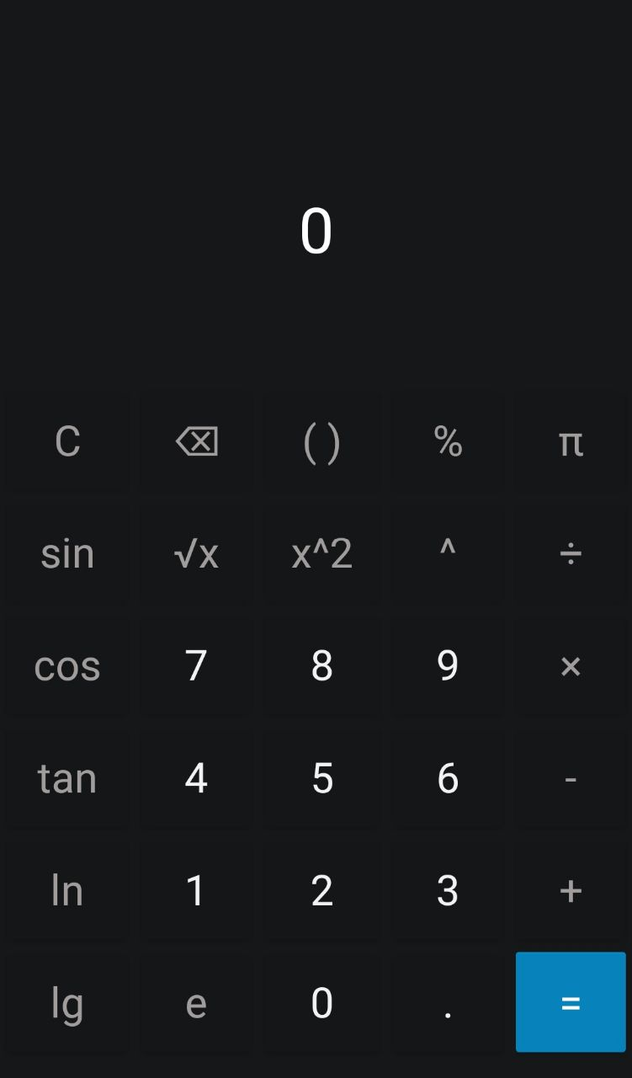

Рисунок 1 – Початкове вікно програми

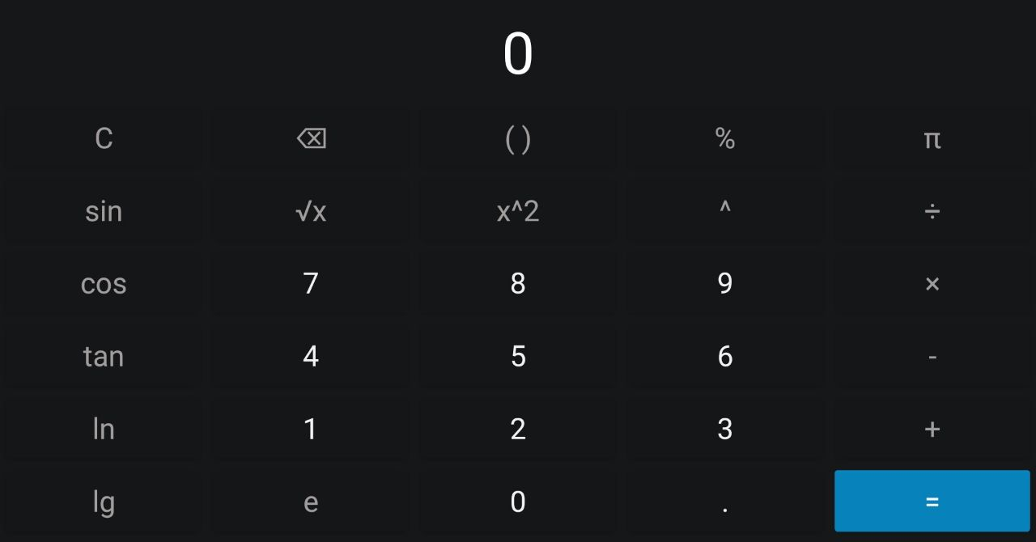

Рисунок 2 – Вікно програми у перевернутому вигляді

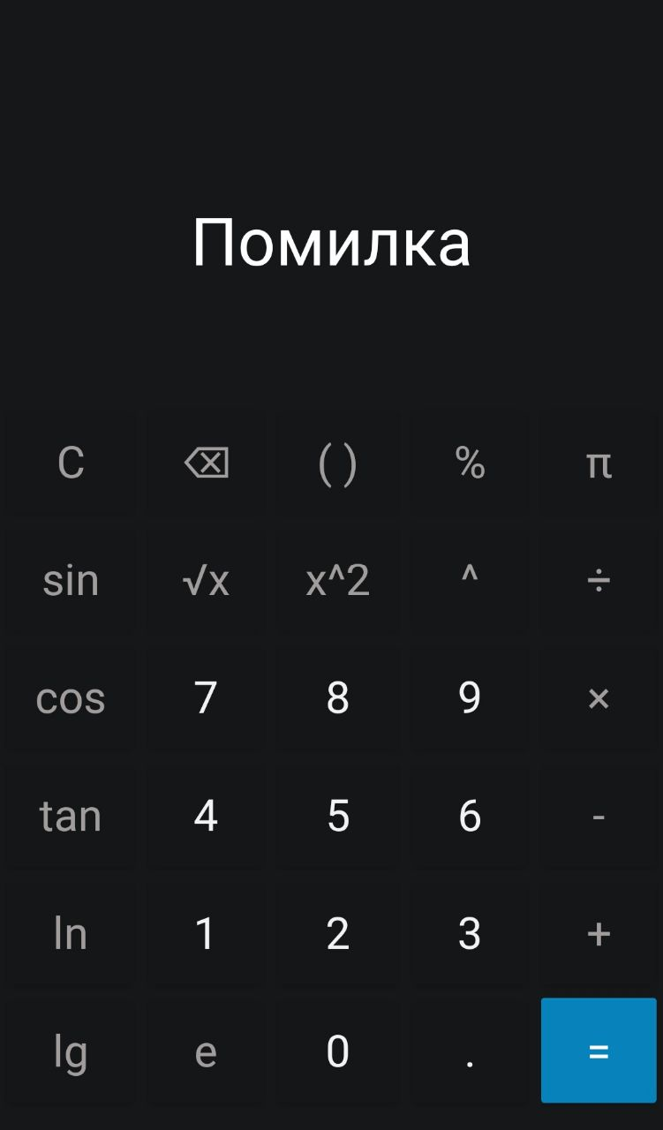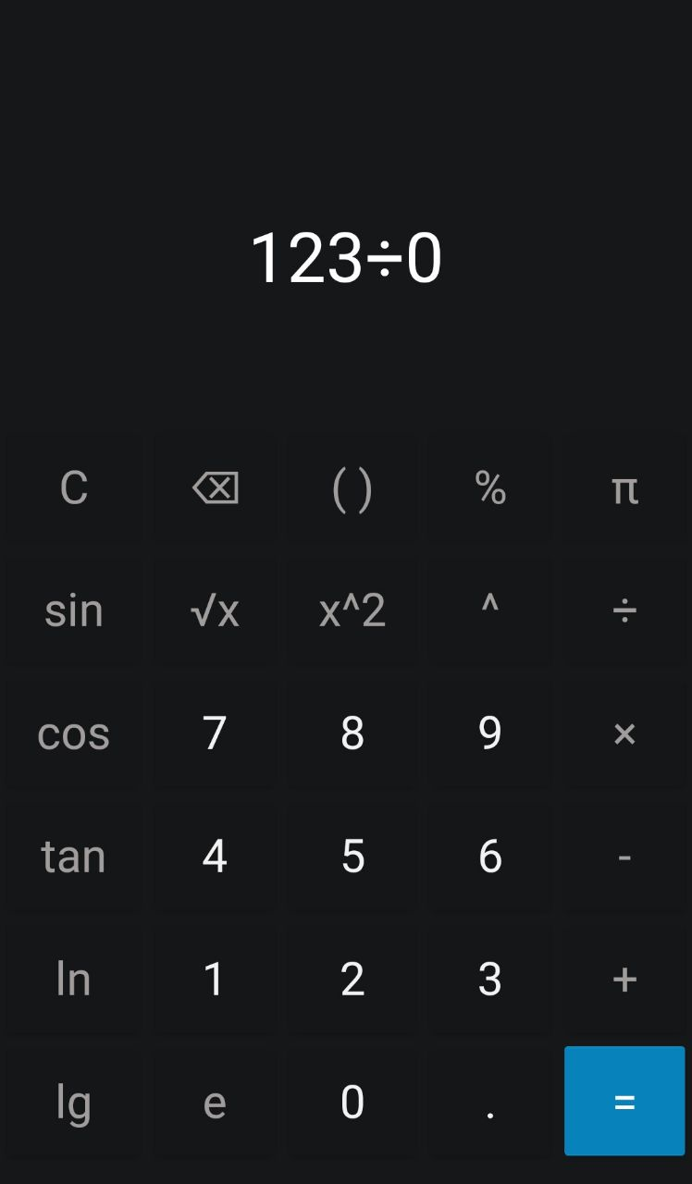

Рисунок 3 – Результат ділення на 0

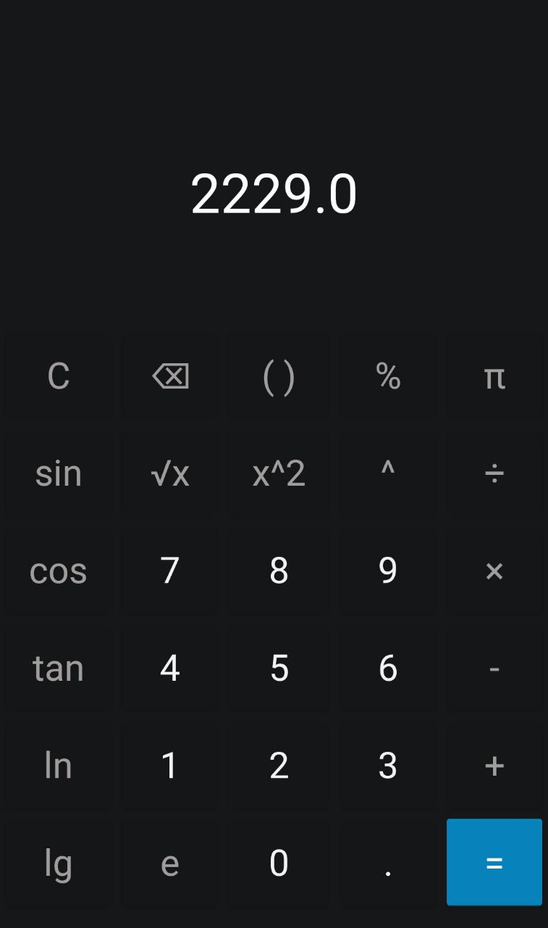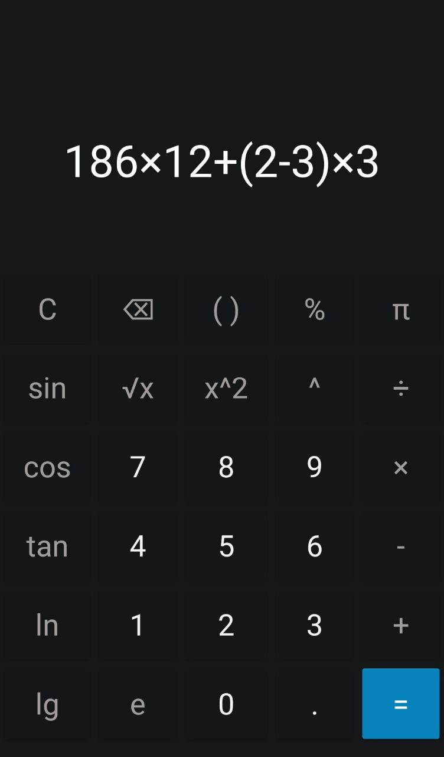

Рисунок 4 – Результат обчислень програми

Завдання 2:

Код програми:

MainActivity.java:

package com.example.store;  
  
import androidx.annotation.RequiresApi;  
import androidx.appcompat.app.AppCompatActivity;  
  
import android.content.Context;  
import android.content.Intent;  
import android.os.Build;  
import android.os.Bundle;  
import android.view.View;  
import android.widget.CheckBox;  
import android.widget.EditText;  
import android.widget.ListView;  
import android.widget.Toast;  
  
import com.google.android.material.floatingactionbutton.FloatingActionButton;  
  
import java.io.FileInputStream;  
import java.io.FileOutputStream;  
import java.io.IOException;  
import java.io.ObjectInputStream;  
import java.io.ObjectOutputStream;  
import java.util.ArrayList;  
  
public class MainActivity extends AppCompatActivity {  
  
 private static ArrayList<Goods> *goodsArrayList*;  
 private AvailableGoodsAdapter availableGoods;  
 private NotAvailableGoodsAdapter notAvailableGoods;  
 private String filename = "data.txt";  
  
 @RequiresApi(api = Build.VERSION_CODES.*O*)  
 @Override  
 protected void onCreate(Bundle savedInstanceState) {  
 super.onCreate(savedInstanceState);  
 setContentView(R.layout.*activity_main*);  
  
 *goodsArrayList* = new ArrayList<>();  
  
 availableGoods = new AvailableGoodsAdapter(this, *goodsArrayList*);  
 ListView availableListView = findViewById(R.id.*listView*);  
  
 availableListView.setAdapter(availableGoods);  
  
 FloatingActionButton fab = findViewById(R.id.*fab*);  
 fab.setOnClickListener(v -> {  
 Intent intent = new Intent(MainActivity.this, GoodsAdd.class);  
 startActivity(intent);  
 });  
  
 availableListView.setOnItemClickListener((parent, view, position, id) -> {  
  
 Intent intent = new Intent(MainActivity.this, GoodsAdd.class);  
 intent.putExtra("Goods", position);  
 startActivity(intent);  
 });  
  
 try {  
 deserialize();  
 } catch (IOException e) {  
 e.printStackTrace();  
 } catch (ClassNotFoundException e) {  
 e.printStackTrace();  
 }  
 }  
  
 @Override  
 protected void onResume () {  
 super.onResume();  
  
 updateListView();  
 }  
  
 private void updateListView () {  
 ListView listView = findViewById(R.id.*listView*);  
 listView.setAdapter(availableGoods);  
 }  
  
 public static ArrayList<Goods> getGoodsList () {  
 return *goodsArrayList*;  
 }  
 public static void setGoodsList (ArrayList<Goods> goodsArrayList) {  
 MainActivity.*goodsArrayList* = goodsArrayList;  
 }  
  
 public void onSearchButtonClick (View view) {  
 EditText searchET = findViewById(R.id.*searchET*);  
 ArrayList<Goods> result;  
 ListView listView = findViewById(R.id.*listView*);  
  
 if (!String.*valueOf*(searchET.getText()).isEmpty()) {  
 result = getSearch(String.*valueOf*(searchET.getText()));  
  
 availableGoods = new AvailableGoodsAdapter(this, result);  
 listView.setAdapter(availableGoods);  
 availableGoods.notifyDataSetChanged();  
 } else {  
 availableGoods = new AvailableGoodsAdapter(this, *goodsArrayList*);  
 listView.setAdapter(availableGoods);  
 }  
 }  
  
 private ArrayList<Goods> getSearch (String category) {  
 ArrayList<Goods> result = new ArrayList<>();  
  
 for (Goods g: *goodsArrayList*) {  
 if (g.getCategory().equals(category)) {  
 result.add(g);  
 }  
 }  
 return result;  
 }  
  
 public void onSaveButtonClick (View view) throws IOException {  
 FileOutputStream fos = getBaseContext().openFileOutput(filename, Context.*MODE_PRIVATE*);  
 ObjectOutputStream os = new ObjectOutputStream(fos);  
 os.writeObject(*goodsArrayList*);  
 os.close();  
 fos.close();  
  
 availableGoods.notifyDataSetChanged();  
  
 Toast.*makeText*(getApplicationContext(), "Записи збережено", Toast.*LENGTH_SHORT*).show();  
 }  
  
 public void onLoadButtonClick (View view) throws IOException, ClassNotFoundException {  
 deserialize();  
 }  
  
 private void deserialize () throws IOException, ClassNotFoundException {  
 FileInputStream fis = getBaseContext().openFileInput(filename);  
 ObjectInputStream is = new ObjectInputStream(fis);  
 *goodsArrayList* = (ArrayList<Goods>) is.readObject();  
 is.close();  
 fis.close();  
  
 ListView listView = findViewById(R.id.*listView*);  
 availableGoods = new AvailableGoodsAdapter(this, *goodsArrayList*);  
 listView.setAdapter(availableGoods);  
 availableGoods.notifyDataSetChanged();  
  
 Toast.*makeText*(getApplicationContext(), "Записи зчитано", Toast.*LENGTH_SHORT*).show();  
 }  
  
 public void onCheckBoxClicked (View view) {  
 CheckBox availableCheckBox = findViewById(R.id.*availableCB*);  
 CheckBox notAvailableCheckBox = findViewById(R.id.*notAvailable*);  
 EditText category = findViewById(R.id.*searchET*);  
  
 ListView lv = findViewById(R.id.*listView*);  
 ArrayList<Goods> result = new ArrayList<>();  
  
 if (availableCheckBox.isChecked() && notAvailableCheckBox.isChecked()) {  
 result = *goodsArrayList*;  
 } else if (!availableCheckBox.isChecked() && !notAvailableCheckBox.isChecked()) {  
 for (Goods g: *goodsArrayList*){  
  
 if (g.isAvailability()) {  
 result.add(g);  
 }  
 }  
 } else if (!availableCheckBox.isChecked() && notAvailableCheckBox.isChecked()) {  
 for (Goods g: *goodsArrayList*){  
  
 if (!g.isAvailability()) {  
 result.add(g);  
 }  
 }  
 }  
  
 availableGoods = new AvailableGoodsAdapter(this, result);  
 lv.setAdapter(availableGoods);  
 availableGoods.notifyDataSetChanged();  
 }  
}

GoodsAdd.java:

package com.example.store;  
  
import androidx.annotation.RequiresApi;  
import androidx.appcompat.app.AppCompatActivity;  
  
import android.app.DatePickerDialog;  
import android.icu.util.Calendar;  
import android.os.Build;  
import android.os.Bundle;  
import android.view.View;  
import android.widget.Button;  
import android.widget.CheckBox;  
import android.widget.EditText;  
import android.widget.RadioButton;  
import android.widget.RadioGroup;  
import android.widget.TextView;  
import android.widget.Toast;  
  
import java.text.SimpleDateFormat;  
import java.util.Date;  
import java.util.GregorianCalendar;  
import java.util.Locale;  
  
public class GoodsAdd extends AppCompatActivity {  
  
 private EditText nameET;  
 private EditText categoryET;  
 private EditText descriptionET;  
 private EditText priceET;  
 private CheckBox availability;  
 private EditText numberET;  
 private EditText deliveryDateET;  
 private Button addBTN;  
  
 Button deleteButton;  
 int position;  
  
 Calendar myCalendar;  
 DatePickerDialog.OnDateSetListener date;  
  
 Bundle arguments;  
  
 @RequiresApi(api = Build.VERSION_CODES.*N*)  
 @Override  
 protected void onCreate(Bundle savedInstanceState) {  
  
 super.onCreate(savedInstanceState);  
 setContentView(R.layout.*activity_goods_add*);  
  
 nameET = findViewById(R.id.*nameET*);  
 categoryET = findViewById(R.id.*categoryET*);  
 descriptionET = findViewById(R.id.*descriptionET*);  
 priceET = findViewById(R.id.*priceET*);  
 availability = findViewById(R.id.*checkBox*);  
 numberET = findViewById(R.id.*numberET*);  
 deliveryDateET = findViewById(R.id.*deliveryDateET*);  
  
 addBTN = findViewById(R.id.*addBTN*);  
  
 myCalendar = Calendar.*getInstance*();  
  
 date = (view, year, monthOfYear, dayOfMonth) -> {  
  
 myCalendar.set(Calendar.*YEAR*, year);  
 myCalendar.set(Calendar.*MONTH*, monthOfYear);  
 myCalendar.set(Calendar.*DAY_OF_MONTH*, dayOfMonth);  
 updateLabel();  
 };  
  
 arguments = getIntent().getExtras();  
  
 if (arguments != null) {  
 position = (int) arguments.get("Goods");  
  
 Goods goods = MainActivity.*getGoodsList*().get(position);  
 nameET.setText(String.*valueOf*(goods.getName()));  
 categoryET.setText(String.*valueOf*(goods.getCategory()));  
 descriptionET.setText(String.*valueOf*(goods.getDescription()));  
 priceET.setText(String.*valueOf*(goods.getPrice()));  
 availability.setChecked(goods.isAvailability());  
 numberET.setText(String.*valueOf*(goods.getNumber()));  
 deliveryDateET.setText(goods.getStringOfDate());  
  
 deleteButton = findViewById(R.id.*delBTN*);  
 deleteButton.setVisibility(View.*VISIBLE*);  
  
 TextView header = findViewById(R.id.*addGoodsTV*);  
 header.setText("Редагувати запис");  
  
 addBTN.setText("Редагувати");  
  
  
 if (availability.isChecked()) {  
 numberET.setVisibility(View.*INVISIBLE*);  
 deliveryDateET.setVisibility(View.*INVISIBLE*);  
 } else {  
 numberET.setVisibility(View.*VISIBLE*);  
 deliveryDateET.setVisibility(View.*VISIBLE*);  
 }  
 }  
 }  
  
 @RequiresApi(api = Build.VERSION_CODES.*N*)  
 public void onClickListener (View view) {  
 DatePickerDialog datePicker = new DatePickerDialog(  
 GoodsAdd.this,  
 date,  
 myCalendar.get(Calendar.*YEAR*),  
 myCalendar.get(Calendar.*MONTH*),  
 myCalendar.get(Calendar.*DAY_OF_MONTH*)  
 );  
  
 datePicker.getDatePicker().setMaxDate(new Date().getTime());  
 datePicker.show();  
 }  
  
 @RequiresApi(api = Build.VERSION_CODES.*N*)  
 private void updateLabel() {  
 String myFormat = "MM/dd/yy";  
 SimpleDateFormat sdf = new SimpleDateFormat(myFormat, Locale.*UK*);  
  
 deliveryDateET.setText(sdf.format(myCalendar.getTime()));  
 }  
  
 public void onCheckBoxClicked (View view) {  
 if (((CheckBox) view).isChecked()) {  
 numberET.setVisibility(View.*VISIBLE*);  
 deliveryDateET.setVisibility(View.*VISIBLE*);  
 } else {  
 numberET.setVisibility(View.*INVISIBLE*);  
 deliveryDateET.setVisibility(View.*INVISIBLE*);  
 }  
 }  
  
 private boolean validateFields () {  
 if (!String.*valueOf*(nameET.getText()).isEmpty()  
 && !String.*valueOf*(categoryET.getText()).isEmpty()  
 && !String.*valueOf*(descriptionET.getText()).isEmpty()  
 && !String.*valueOf*(priceET.getText()).isEmpty()  
 && !String.*valueOf*(numberET.getText()).isEmpty()) {  
 if (availability.isChecked()) {  
 return true;  
 } else {  
 return !String.*valueOf*(numberET.getText()).isEmpty()  
 && !String.*valueOf*(deliveryDateET.getText()).isEmpty();  
 }  
 } else {  
 return false;  
 }  
 }  
  
 @RequiresApi(api = Build.VERSION_CODES.*O*)  
 public void onAddButtonClicked (View view) {  
  
 if (validateFields()) {  
 GregorianCalendar calendar = null;  
  
 if (!availability.isChecked()) {  
 String[] date = String.*valueOf*(deliveryDateET.getText()).split("/");  
 calendar = new GregorianCalendar();  
  
 calendar.set(Calendar.*YEAR*, Integer.*parseInt*(date[2]));  
 calendar.set(Calendar.*MONTH*, Integer.*parseInt*(date[1]));  
 calendar.set(Calendar.*DAY_OF_MONTH*, Integer.*parseInt*(date[0]));  
 }  
  
 Goods goods = new Goods(  
 String.*valueOf*(nameET.getText()),  
 String.*valueOf*(categoryET.getText()),  
 String.*valueOf*(descriptionET.getText()),  
 Double.*parseDouble*(String.*valueOf*(priceET.getText())),  
 availability.isChecked(),  
 availability.isChecked() ? 0 : Integer.*parseInt*(String.*valueOf*(numberET.getText())),  
 availability.isChecked() ? null: calendar);  
  
 if (arguments != null) {  
 MainActivity.*getGoodsList*().get(position).Edit(goods);  
 Toast.*makeText*(getApplicationContext(), "Товар відредаговано!", Toast.*LENGTH_SHORT*).show();  
 } else {  
 MainActivity.*getGoodsList*().add(goods);  
 Toast.*makeText*(getApplicationContext(), "Товар додано!", Toast.*LENGTH_SHORT*).show();  
 }  
  
 nameET.setText("");  
 categoryET.setText("");  
 descriptionET.setText("");  
 priceET.setText("");  
 availability.setChecked(true);  
 numberET.setText("");  
 deliveryDateET.setText("");  
 numberET.setVisibility(View.*INVISIBLE*);  
 deliveryDateET.setVisibility(View.*INVISIBLE*);  
  
 finish();  
 }  
 }  
  
 public void onDeleteButtonClick (View view) {  
 MainActivity.*getGoodsList*().remove(position);  
 Toast.*makeText*(getApplicationContext(), "Товар видалено", Toast.*LENGTH_SHORT*).show();  
  
 finish();  
 }  
}

Goods.java:

package com.example.store;  
  
import java.io.Serializable;  
import java.util.Calendar;  
  
public class Goods implements Serializable {  
 private String name;  
 private String category;  
 private String description;  
 private double price;  
 private boolean availability;  
 private long number;  
 private Calendar deliveryDate;  
  
 public Goods(String name, String category, String description,  
 double price, boolean availability, long number, Calendar deliveryDate) {  
 this.name = name;  
 this.category = category;  
 this.description = description;  
 this.price = price;  
 this.availability = availability;  
 this.number = number;  
 this.deliveryDate = deliveryDate;  
 }  
  
 public String getName() {  
 return name;  
 }  
 public void setName(String name) {  
 this.name = name;  
 }  
  
 public String getCategory() {  
 return category;  
 }  
 public void setCategory(String category) {  
 this.category = category;  
 }  
  
 public String getDescription() {  
 return description;  
 }  
 public void setDescription(String description) {  
 this.description = description;  
 }  
  
 public double getPrice() {  
 return price;  
 }  
 public void setPrice(double price) {  
 this.price = price;  
 }  
  
 public boolean isAvailability() {  
 return availability;  
 }  
 public void setAvailability(boolean availability) {  
 this.availability = availability;  
 }  
  
 public long getNumber() {  
 return number;  
 }  
 public void setNumber(long number) {  
 this.number = number;  
 }  
  
 public Calendar getDeliveryDate() {  
 return deliveryDate;  
 }  
 public void setDeliveryDate(Calendar deliveryDate) {  
 this.deliveryDate = deliveryDate;  
 }  
  
 public String getStringOfDate () {  
 return availability ? "" : deliveryDate.get(Calendar.*DAY_OF_MONTH*) + "/"  
 + deliveryDate.get(Calendar.*MONTH*) + "/" + deliveryDate.get(Calendar.*YEAR*);  
 }  
  
 public void Edit(Goods goods)  
 {  
 this.name = goods.getName();  
 this.category = goods.getCategory();  
 this.description = goods.getDescription();  
 this.price = goods.getPrice();  
 this.availability = goods.isAvailability();  
 this.number = goods.getNumber();  
 this.deliveryDate = goods.getDeliveryDate();  
 }  
}

GoodsAdapter.java:

package com.example.store;  
  
import android.annotation.SuppressLint;  
import android.content.Context;  
import android.view.LayoutInflater;  
import android.view.View;  
import android.view.ViewGroup;  
import android.widget.BaseAdapter;  
import android.widget.TextView;  
  
import java.util.ArrayList;  
  
public class GoodsAdapter extends BaseAdapter {  
  
 Context context;  
 LayoutInflater layoutInflater;  
 ArrayList<Goods> list;  
  
 public GoodsAdapter(Context context, ArrayList<Goods> list) {  
 this.context = context;  
 this.list = list;  
 this.layoutInflater = (LayoutInflater) context.getSystemService(Context.*LAYOUT_INFLATER_SERVICE*);  
 }  
  
 @Override  
 public int getCount () {  
 return list.size();  
 }  
  
 @Override  
 public Object getItem (int position) {  
 return list.get(position);  
 }  
  
 @Override  
 public long getItemId (int position) {  
 return position;  
 }  
  
 @SuppressLint("SetTextI18n")  
 @Override  
 public View getView (int position, View convertView, ViewGroup parent) {  
  
 View view = convertView;  
  
 if (view == null) {  
 view = layoutInflater.inflate(R.layout.*available_item*, parent, false);  
 }  
  
 Goods g = getProduct(position);  
  
 ((TextView) view.findViewById(R.id.*textView1*)).setText(g.getName());  
 ((TextView) view.findViewById(R.id.*textView2*)).setText("Ціна: " + g.getPrice());  
 ((TextView) view.findViewById(R.id.*textView3*)).setText("Наявність: " + g.isAvailability());  
  
 return view;  
 }  
  
 private Goods getProduct (int position) {  
 return (Goods) getItem(position);  
 }  
}

Файли макетів:

activity_main.xml:

*<?*xml version="1.0" encoding="utf-8"*?>*<androidx.constraintlayout.widget.ConstraintLayout xmlns:android="http://schemas.android.com/apk/res/android"  
 xmlns:tools="http://schemas.android.com/tools"  
 xmlns:app="http://schemas.android.com/apk/res-auto"  
 android:layout_width="match_parent"  
 android:layout_height="match_parent"  
 tools:context=".MainActivity">  
  
 <FrameLayout  
 android:layout_width="match_parent"  
 android:layout_height="match_parent">  
  
 <LinearLayout  
 android:orientation="vertical"  
 android:layout_width="match_parent"  
 android:layout_height="match_parent">  
  
 <Button  
 android:id="@+id/loadBTN"  
 android:layout_width="match_parent"  
 android:layout_height="wrap_content"  
 android:onClick="onLoadButtonClick"  
 android:text="@string/load"  
 app:backgroundTint="#00BCD4" />  
  
 <Button  
 android:id="@+id/saveBTN"  
 android:layout_width="match_parent"  
 android:layout_height="wrap_content"  
 android:onClick="onSaveButtonClick"  
 android:text="@string/save"  
 app:backgroundTint="#00BCD4"  
 app:iconTint="#FFFFFF" />  
  
 <LinearLayout  
 android:orientation="horizontal"  
 android:layout_width="match_parent"  
 android:layout_marginBottom="40dp"  
 android:layout_height="match_parent">  
  
 <EditText  
 android:id="@+id/searchET"  
 android:layout_width="wrap_content"  
 android:layout_height="wrap_content"  
 android:ems="10"  
 android:focusable="false"  
 android:hint="@string/category"  
 android:inputType="textPersonName" />  
  
 <Button  
 android:id="@+id/searchBTN"  
 android:layout_width="wrap_content"  
 android:layout_height="wrap_content"  
 android:layout_weight="1"  
 android:onClick="onSearchButtonClick"  
 android:text="@string/search"  
 android:textSize="12sp"  
 app:backgroundTint="#00BCD4" />  
  
 </LinearLayout>  
  
  
 </LinearLayout>  
  
 <LinearLayout  
 android:orientation="horizontal"  
 android:layout_width="match_parent"  
 android:layout_marginTop="140dp"  
 android:layout_marginLeft="40dp"  
 android:layout_height="match_parent">  
  
 <CheckBox  
 android:id="@+id/availableCB"  
 android:layout_width="wrap_content"  
 android:layout_height="wrap_content"  
 android:layout_weight="1"  
 android:checked="true"  
 android:onClick="onCheckBoxClicked"  
 android:text="@string/available" />  
  
 <CheckBox  
 android:id="@+id/notAvailable"  
 android:layout_width="wrap_content"  
 android:layout_height="wrap_content"  
 android:layout_weight="1"  
 android:checked="true"  
 android:onClick="onCheckBoxClicked"  
 android:text="@string/notAvailable" />  
 </LinearLayout>  
  
 <com.google.android.material.floatingactionbutton.FloatingActionButton  
 android:id="@+id/fab"  
 android:layout_width="wrap_content"  
 android:layout_height="wrap_content"  
 android:layout_gravity="end|bottom"  
 android:src="@drawable/add"  
 android:layout_margin="16dp" />  
  
 <LinearLayout  
 android:layout_width="match_parent"  
 android:layout_height="wrap_content"  
 android:orientation="vertical"  
 android:layout_marginTop="180dp"  
 android:padding="10dip" >  
  
 <ListView  
 android:id="@+id/listView"  
 android:layout_width="match_parent"  
 android:layout_height="wrap_content"  
 android:layout_marginTop="10dip" >  
 </ListView>  
  
  
 </LinearLayout>  
  
 </FrameLayout>  
  
  
</androidx.constraintlayout.widget.ConstraintLayout>

activity_goods_add.xml:

*<?*xml version="1.0" encoding="utf-8"*?>*<androidx.constraintlayout.widget.ConstraintLayout xmlns:android="http://schemas.android.com/apk/res/android"  
 xmlns:app="http://schemas.android.com/apk/res-auto"  
 xmlns:tools="http://schemas.android.com/tools"  
 android:layout_width="match_parent"  
 android:layout_height="match_parent"  
 tools:context=".GoodsAdd">  
  
 <TextView  
 android:id="@+id/addGoodsTV"  
 android:layout_width="wrap_content"  
 android:layout_height="wrap_content"  
 android:layout_marginTop="10dp"  
 android:text="@string/addGoods"  
 android:textColor="@color/black"  
 android:textSize="24sp"  
 android:textStyle="bold"  
 app:layout_constraintBottom_toTopOf="@+id/nameET"  
 app:layout_constraintEnd_toEndOf="parent"  
 app:layout_constraintStart_toStartOf="parent"  
 app:layout_constraintTop_toTopOf="parent" />  
  
 <EditText  
 android:id="@+id/nameET"  
 android:layout_width="330dp"  
 android:layout_height="50dp"  
 android:layout_marginStart="41dp"  
 android:layout_marginLeft="41dp"  
 android:layout_marginTop="10dp"  
 android:layout_marginEnd="41dp"  
 android:layout_marginRight="41dp"  
 android:autofillHints=""  
 android:hint="@string/name"  
 android:inputType="textPersonName"  
 app:layout_constraintEnd_toEndOf="parent"  
 app:layout_constraintStart_toStartOf="parent"  
 app:layout_constraintTop_toBottomOf="@+id/addGoodsTV"  
 tools:ignore="MissingConstraints" />  
  
 <EditText  
 android:id="@+id/categoryET"  
 android:layout_width="330dp"  
 android:layout_height="50dp"  
 android:layout_marginStart="41dp"  
 android:layout_marginLeft="41dp"  
 android:layout_marginTop="10dp"  
 android:layout_marginEnd="41dp"  
 android:layout_marginRight="41dp"  
 android:ems="10"  
 android:hint="@string/category"  
 android:inputType="textPersonName"  
 app:layout_constraintEnd_toEndOf="parent"  
 app:layout_constraintStart_toStartOf="parent"  
 app:layout_constraintTop_toBottomOf="@+id/nameET" />  
  
 <EditText  
 android:id="@+id/descriptionET"  
 android:layout_width="330dp"  
 android:layout_height="50dp"  
 android:layout_marginStart="41dp"  
 android:layout_marginLeft="41dp"  
 android:layout_marginTop="10dp"  
 android:layout_marginEnd="41dp"  
 android:layout_marginRight="41dp"  
 android:autofillHints=""  
 android:hint="@string/description"  
 android:inputType="textPersonName"  
 app:layout_constraintEnd_toEndOf="parent"  
 app:layout_constraintStart_toStartOf="parent"  
 app:layout_constraintTop_toBottomOf="@+id/categoryET"  
 tools:ignore="MissingConstraints" />  
  
 <EditText  
 android:id="@+id/priceET"  
 android:layout_width="330dp"  
 android:layout_height="50dp"  
 android:layout_marginStart="41dp"  
 android:layout_marginLeft="41dp"  
 android:layout_marginTop="10dp"  
 android:layout_marginEnd="41dp"  
 android:layout_marginRight="41dp"  
 android:autofillHints=""  
 android:hint="@string/price"  
 android:inputType="numberDecimal"  
 app:layout_constraintEnd_toEndOf="parent"  
 app:layout_constraintStart_toStartOf="parent"  
 app:layout_constraintTop_toBottomOf="@+id/descriptionET"  
 tools:ignore="MissingConstraints" />  
  
 <CheckBox  
 android:id="@+id/checkBox"  
 android:layout_width="wrap_content"  
 android:layout_height="wrap_content"  
 android:layout_marginTop="10dp"  
 android:checked="true"  
 android:onClick="onCheckBoxClicked"  
 android:text="@string/available"  
 app:layout_constraintEnd_toEndOf="parent"  
 app:layout_constraintStart_toStartOf="parent"  
 app:layout_constraintTop_toBottomOf="@+id/priceET" />  
  
 <EditText  
 android:id="@+id/numberET"  
 android:layout_width="330dp"  
 android:layout_height="50dp"  
 android:layout_marginStart="41dp"  
 android:layout_marginLeft="41dp"  
 android:layout_marginTop="10dp"  
 android:layout_marginEnd="41dp"  
 android:layout_marginRight="41dp"  
 android:autofillHints=""  
 android:hint="@string/number"  
 android:inputType="number"  
 app:layout_constraintEnd_toEndOf="parent"  
 app:layout_constraintStart_toStartOf="parent"  
 app:layout_constraintTop_toBottomOf="@+id/checkBox"  
 tools:ignore="MissingConstraints"  
 tools:visibility="visible" />  
  
 <EditText  
 android:id="@+id/deliveryDateET"  
 android:layout_width="330dp"  
 android:layout_height="50dp"  
 android:layout_marginStart="41dp"  
 android:layout_marginLeft="41dp"  
 android:layout_marginTop="10dp"  
 android:layout_marginEnd="41dp"  
 android:layout_marginRight="41dp"  
 android:autofillHints=""  
 android:hint="@string/deliveryDate"  
 android:inputType="date"  
 android:onClick="onClickListener"  
 app:layout_constraintEnd_toEndOf="parent"  
 app:layout_constraintStart_toStartOf="parent"  
 app:layout_constraintTop_toBottomOf="@+id/numberET"  
 tools:ignore="MissingConstraints"  
 tools:visibility="visible" />  
  
 <Button  
 android:id="@+id/addBTN"  
 android:layout_width="135dp"  
 android:layout_height="54dp"  
 android:layout_marginStart="41dp"  
 android:layout_marginLeft="41dp"  
 android:onClick="onAddButtonClicked"  
 android:text="@string/add"  
 app:backgroundTint="#00BCD4"  
 app:layout_constraintBottom_toBottomOf="parent"  
 app:layout_constraintStart_toStartOf="parent"  
 app:layout_constraintTop_toBottomOf="@+id/deliveryDateET"  
 app:layout_constraintVertical_bias="0.100000024" />  
  
 <Button  
 android:id="@+id/delBTN"  
 android:layout_width="135dp"  
 android:layout_height="54dp"  
 android:onClick="onDeleteButtonClick"  
 android:text="@string/del"  
 app:backgroundTint="#00BCD4"  
 app:layout_constraintBottom_toBottomOf="parent"  
 app:layout_constraintEnd_toEndOf="parent"  
 app:layout_constraintStart_toEndOf="@+id/addBTN"  
 app:layout_constraintTop_toBottomOf="@+id/deliveryDateET"  
 app:layout_constraintVertical_bias="0.100000024"  
 tools:visibility="invisible" />  
</androidx.constraintlayout.widget.ConstraintLayout>

available_item.xml:

*<?*xml version="1.0" encoding="utf-8"*?>*<androidx.constraintlayout.widget.ConstraintLayout xmlns:android="http://schemas.android.com/apk/res/android"  
 xmlns:tools="http://schemas.android.com/tools"  
 xmlns:app="http://schemas.android.com/apk/res-auto"  
 android:layout_width="match_parent"  
 android:layout_height="match_parent"  
 tools:context=".MainActivity">  
  
 <LinearLayout  
 android:orientation="vertical"  
 android:layout_width="match_parent"  
 android:layout_height="match_parent"  
 tools:layout_editor_absoluteY="200dp"  
 tools:layout_editor_absoluteX="104dp"  
  
 android:background="@color/light_green">  
  
 <TextView  
 android:layout_width="match_parent"  
 android:layout_height="50dp"  
 android:id="@+id/textView1"  
 android:includeFontPadding="false"  
 android:textSize="20sp"  
 android:textColor="@color/black"  
 android:background="@color/light_green" />  
  
 <LinearLayout  
 android:orientation="horizontal"  
 android:layout_width="match_parent"  
 android:layout_height="match_parent"  
 tools:layout_editor_absoluteY="200dp"  
 tools:layout_editor_absoluteX="104dp"  
 >  
  
 <TextView  
 android:layout_width="200dp"  
 android:layout_height="50dp"  
 android:id="@+id/textView3" />  
  
 <TextView  
 android:layout_width="200dp"  
 android:layout_height="50dp"  
 android:id="@+id/textView2" />  
  
 </LinearLayout>  
  
 </LinearLayout>  
</androidx.constraintlayout.widget.ConstraintLayout>

not_available_item.xml:

*<?*xml version="1.0" encoding="utf-8"*?>*<androidx.constraintlayout.widget.ConstraintLayout xmlns:android="http://schemas.android.com/apk/res/android"  
 xmlns:tools="http://schemas.android.com/tools"  
 xmlns:app="http://schemas.android.com/apk/res-auto"  
 android:layout_width="match_parent"  
 android:layout_height="match_parent"  
 tools:context=".MainActivity">  
  
 <LinearLayout  
 android:orientation="vertical"  
 android:layout_width="match_parent"  
 android:layout_height="match_parent"  
 tools:layout_editor_absoluteY="200dp"  
 tools:layout_editor_absoluteX="104dp">  
  
 <TextView  
 android:layout_width="match_parent"  
 android:layout_height="50dp"  
 android:id="@+id/textView1"  
 android:includeFontPadding="false"  
 android:textSize="20sp"  
 android:textColor="@color/black"  
 android:background="@color/light_red" />  
  
 <LinearLayout  
 android:orientation="horizontal"  
 android:layout_width="match_parent"  
 android:layout_height="match_parent"  
 tools:layout_editor_absoluteY="200dp"  
 tools:layout_editor_absoluteX="104dp"  
 android:background="@color/light_red">  
  
 <TextView  
 android:layout_width="200dp"  
 android:layout_height="50dp"  
 android:id="@+id/textView3" />  
  
 <TextView  
 android:layout_width="200dp"  
 android:layout_height="50dp"  
 android:id="@+id/textView2" />  
  
 </LinearLayout>  
  
 </LinearLayout>  
</androidx.constraintlayout.widget.ConstraintLayout>

Приклад роботи програми:

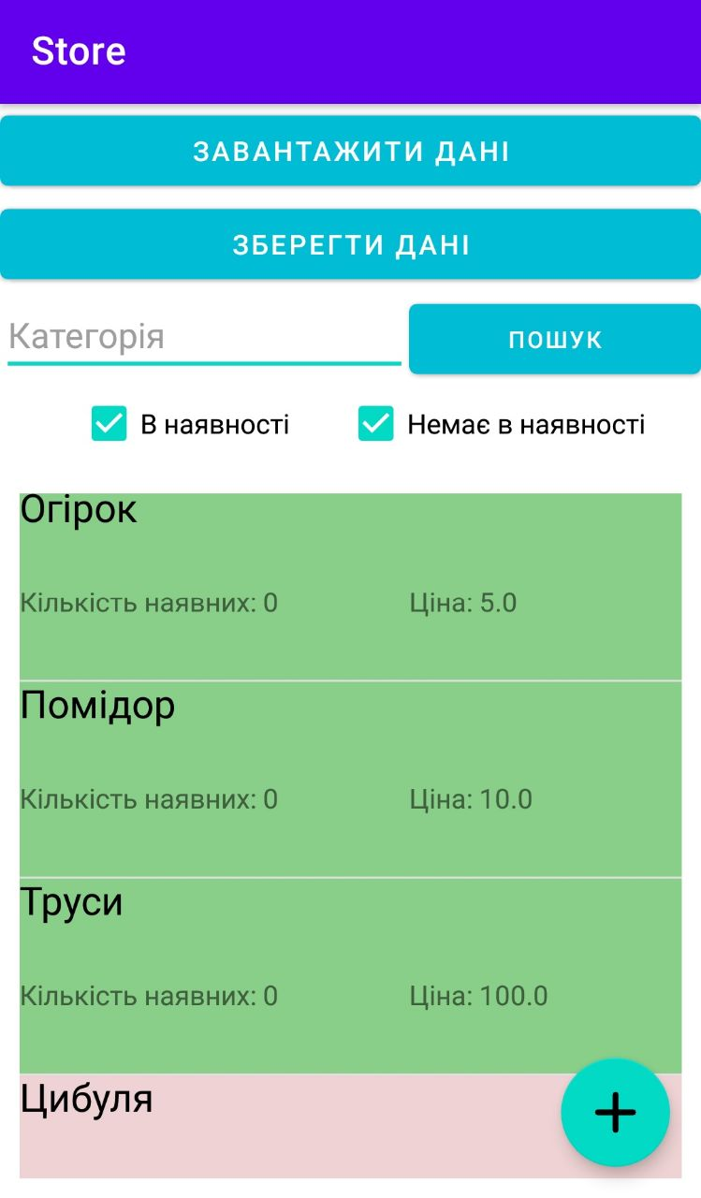

Рисунок 1 – Початкове вікно програми

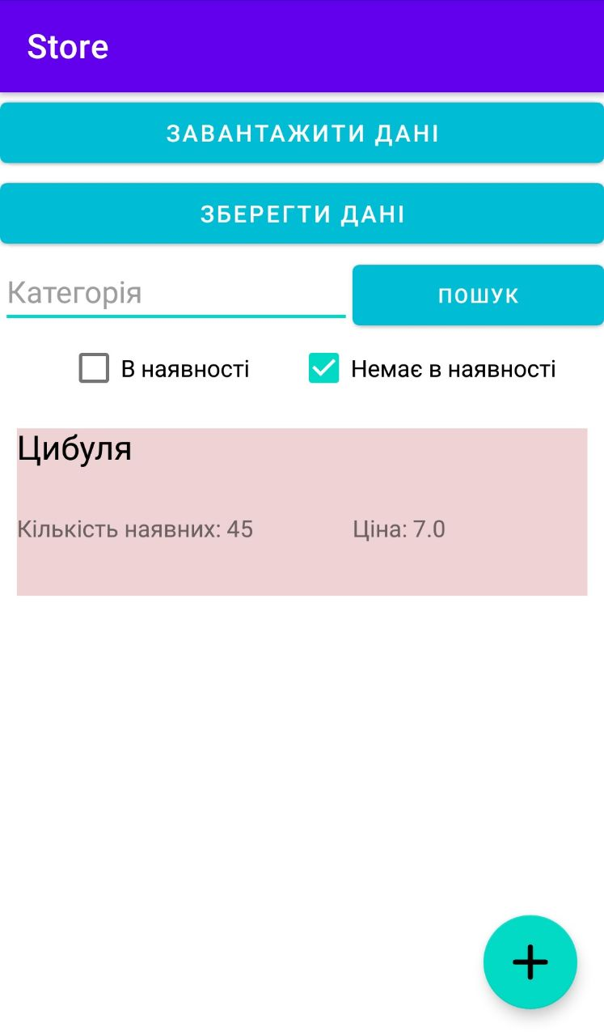

Рисунок 2 – Вибрано фільтр «Показувати товари яких немає в наявності»

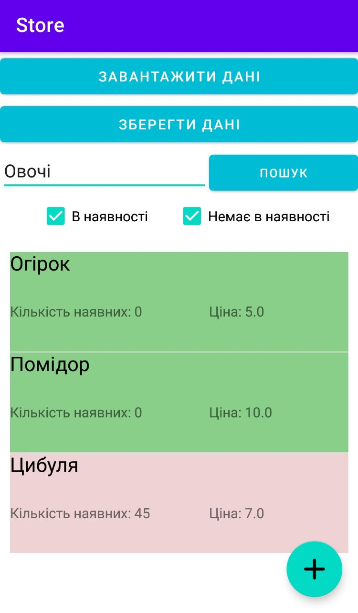

Рисунок 3 – Результат фільтрування

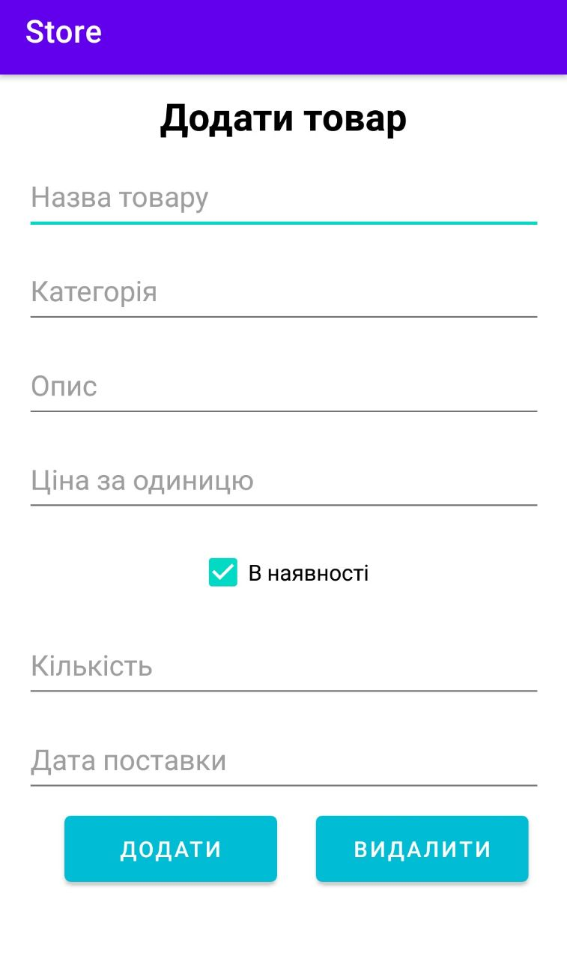

Рисунок 4 – Вікно створення товару

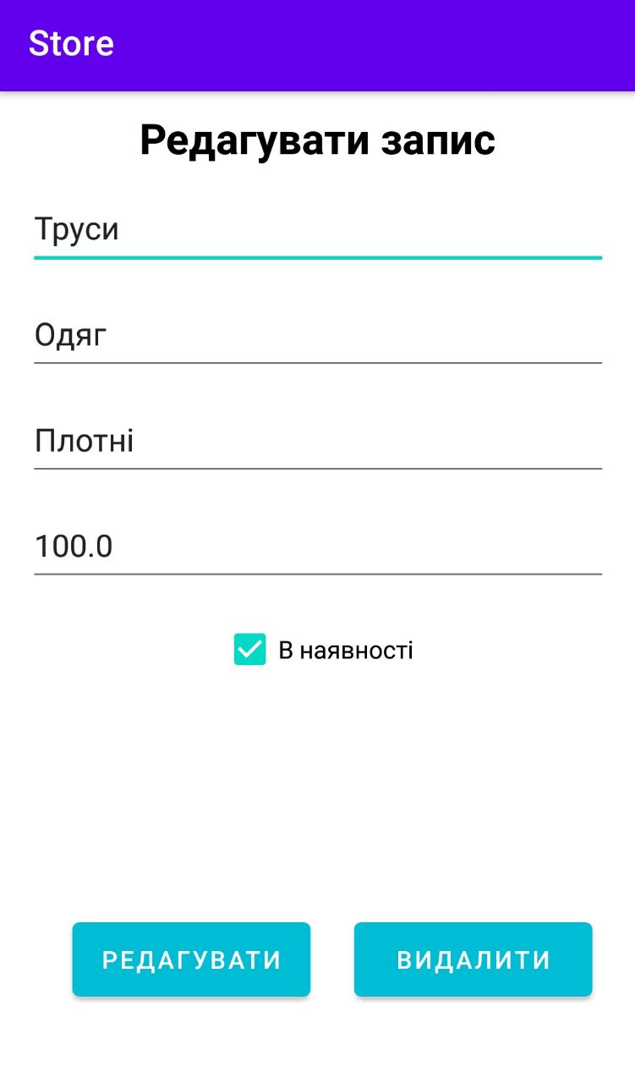

Рисунок 5– Вікно редагування товару

**Висновки*:***Я ознайомився із інтерфейсом середовища розробки програмного забезпечення, вивчив структури проекту, навчився створювати власні структури даних та використовувати їх у мобільних додатках, створювати інтерфейси для мобільних додатків та використовувати додаткові ресурси та можливості пристрою.