关于一些链环的投影图的解纽数的研究

郑权

**Abstract**

We calculate the unknoting number of Kanenobu knots, generalized Kanenobu knots and asymmetric Kanenobu knots, then prove the result withe the method of extreme terms of Jones polynomial.

# Section 1. Introduction

The knot is something that people see every day. It is said that the ancient people had knotted the rope to remember, Alexander the Great cut the knot and began the roaring conquest of the East, and now it is even more common in magic shows, and it is because of the knot in the movie "Deadly Magic" that a human life is lost. Then begins the bizarre, fascinating and deeply explored story of human nature. But the knot actually contains an interesting, fascinating and practical mathematical theory: the theory of the knot. So what is a knot? It can be commonly thought of as a knot, and more mathematically speaking, a knot is a simple Closed curve. The history of knot theory can be traced back to Gauss, Listing and others in the 19th century. The fascinating modern theoretical physics of String theory is where the theory of knots shines. First, let's introduce topology, for my thesis is about knot theory , which is a branch of topology, and topology is a beautiful branch of mathematics.

## Topology

Topology is a subject whose object is a topological space, and whose morphism is a continuous function. Its form is that of a continuous function. This category is much more flexible than the category of measure spaces. For example, it allows the construction of arbitrary quotients and intersections of spaces. Intersection of spaces. Thus, topology is the basis or foundation for many different areas of mathematics areas of mathematics, such as functional analysis, operator algebra, manifold/graph theory, algebraic geometry theory, and hence algebraic and differential geometry, as well as the study of topological groups, topological vector spaces Groups, topological vector spaces, local rings, etc. Most importantly, this gave rise to the field of homomorphism theory isomorphism theory, in which we also consider continuous deformations of continuous functions continuous deformations of the function itself ("isomorphisms"). Topology itself has many ramifications, such as. low-dimensional topology or topological domain theory.

## Knot Theory ATTACH

Knot theory is the study of mathematical knots. Inspired by knots that found in everyday life, such as shoelaces and ropes, the mathematical knot is distinguished by the fact that the the ends are connected in such a way that it cannot be untied, the simplest knot being a ring ("unkot").

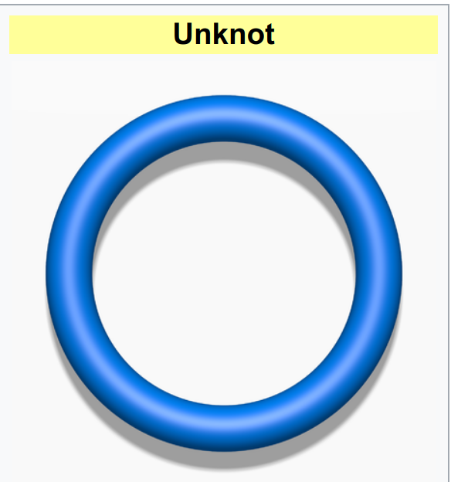

In mathematical language, a knot is an embedding of a circle in 3-dimensional Euclidean space, $R^{3}$ (in topology, a circle isn't bound to the classical geometric concept, but to all of its homeomorphisms). Two mathematical knots are equivalent if one can be transformed into the other via a deformation of upon itself (known as an ambient isotopy); these transformations correspond to manipulations of a knotted string that do not involve cutting the string or passing the string through itself.

Knots can be described in various ways. Given a method of description, however, there may be more than one description that represents the same knot. For example, a common method of describing a knot is a planar diagram called a knot diagram. Any given knot can be drawn in many different ways using a knot diagram. Therefore, a fundamental problem in knot theory is determining when two descriptions represent the same knot.A complete algorithmic solution to this problem exists, which has unknown complexity. In practice, knots are often distinguished by using a knot invariant, a "quantity" which is the same when computed from different descriptions of a knot. Important invariants include knot polynomials, knot groups, and hyperbolic invariants.

The original motivation for the founders of knot theory was to create a table of knots and links, which are knots of several components entangled with each other. More than six billion knots and links have been tabulated since the beginnings of knot theory in the 19th century.

To gain further insight, mathematicians have generalized the knot concept in several ways. Knots can be considered in other three-dimensional spaces and objects other than circles can be used; see knot (mathematics). Higher-dimensional knots are n-dimensional spheres in m-dimensional Euclidean space.

## The Meaning of Researches on Knot Theory

# Section 2. Propaedeutics

A knot invariant is map from isotopy equivalence classes of knots to any kind of structure you could imagine. These are helpful because it is often much easier to check that the structures one maps to (numbers, groups, etc.) are different than it is to check that knots are different. To define a knot invariant, it suffices to define its value on knot diagrams and check that this value is preserved under the Reidemeister moves (possibly with the exception of the first Reidemeister move, in the case of an invariant of framed knots).

## Knot Diagram

In this article, we assume are positive integers, is the unit interval, is the square or 2-dimensional disk. All Knot or link could be in many phases on A useful way to visualise and manipulate knots is to project the knot onto a plane—think of the knot casting a shadow on the wall. A small change in the direction of projection will ensure that it is one-to-one except at the double points, called crossings, where the "shadow" of the knot crosses itself once transversely (Rolfsen 1976). At each crossing, to be able to recreate the original knot, the over-strand must be distinguished from the under-strand. This is often done by creating a break in the strand going underneath. The resulting diagram is an immersed plane curve with the additional data of which strand is over and which is under at each crossing. (These diagrams are called knot diagrams when they represent a knot and link diagrams when they represent a link.) Analogously, knotted surfaces in 4-space can be related to immersed surfaces in 3-space.

A reduced diagram is a knot diagram in which there are no reducible crossings (also nugatory or removable crossings), or in which all of the reducible crossings have been removed.

## Reidemeister Move ATTACH

In the mathematical area of knot theory, a Reidemeister move is any of three local moves on a link diagram. Kurt Reidemeister (1927) and, independently, James Waddell Alexander and Garland Baird Briggs (1926), demonstrated that two knot diagrams belonging to the same knot, up to planar isotopy, can be related by a sequence of the three Reidemeister moves. Each move operates on a small region of the diagram and is one of three types:

1. Twist and untwist in either direction.
2. Move one loop completely over another.
3. Move a string completely over or under a crossing.

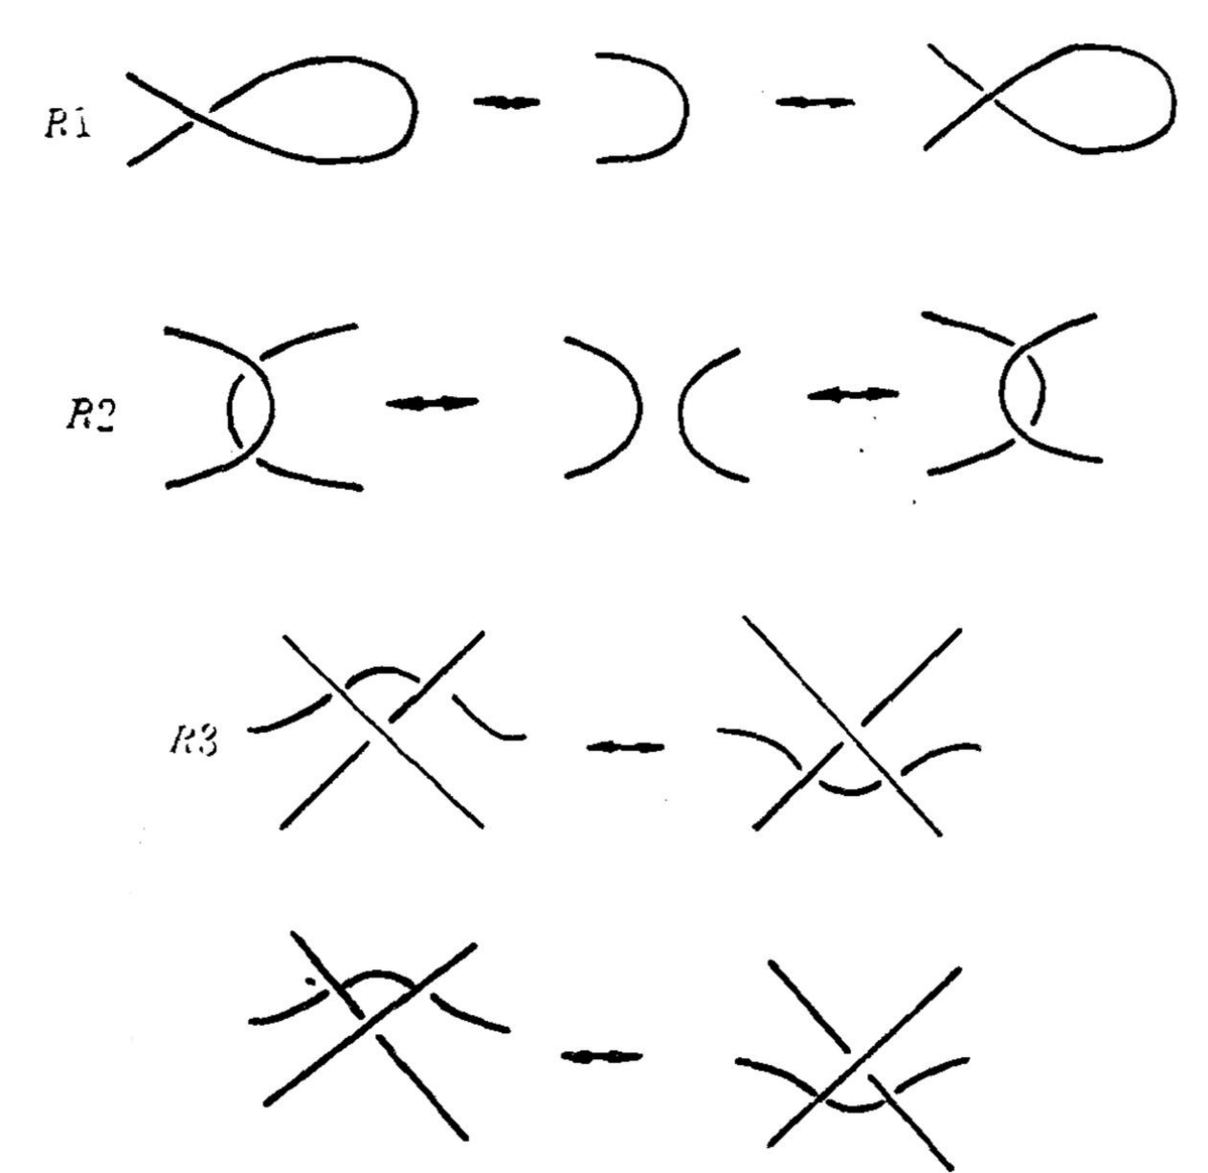

No other part of the diagram is involved in the picture of a move, and a planar isotopy may distort the picture. The numbering for the types of moves corresponds to how many strands are involved, e.g. a type II move operates on two strands of the diagram. The three types of moves are called R1, R2, R3 move, respectively. One important context in which the Reidemeister moves appear is in defining knot invariants. By demonstrating a property of a knot diagram which is not changed when we apply any of the Reidemeister moves, an invariant is defined. Many important invariants can be defined in this way, including the Jones polynomial.

## Knot Invariants

### The Jones Polynomial, HOMFLY-PT polynomial and Alexander polynomial

The Jones Polynomial could be said to be the most important knot invariant so far. It is a special case of the HOMFLY-PT polynomial. he HOMFLY-PT polynomial is a knot and link invariant. Confusingly, there are several variants depending on exactly which relationships are used to define it. All are related by simple substitutions .

1. Definition

* To compute the HOMFLY-PT polynomial, one starts from an oriented link diagram and uses the following rules:
  1. is an isotopy invariant (thus, unchanged by Reidemeister moves).
  2. Let , , and be links which are the same except for one part where they differ according to the diagrams below. Then, depending on the choice of variables:
     1. .
     2. . (Sometimes is used instead of )
     3. .
     4. Using **three** variables: .

$$
\begin{array}{ccc}
\begin{svg}[[!include SVG skein positive crossing]]\end{svg} &
\begin{svg}[[!include SVG skein negative crossing]]\end{svg} &
\begin{svg}[[!include SVG skein no crossing]]\end{svg} \\
L_+ & L_- & L_0
\end{array}
$$

* From the rules, one can read off the relationships between the different formulations:
  1. ,
  2. , .

1. Properties

* The HOMFLY polynomial generalises both the Jones polynomial and the Alexander polynomial.
  1. To get the Jones polynomial, make one of the following substitutions:
     1. and
     2. and
     3. and
  2. To get the Alexander polynomial, make one of the following substitutions:
     1. ,
     2. ,
     3. ,

### The Unknotting number ATTACH

In the mathematical area of knot theory, the unknotting number of a knot is the minimum number of times the knot must be passed through itself (crossing switch) to untie it. If a knot has unknotting number n, then there exists a diagram of the knot which can be changed to unknot by switching n crossings. If you had a piece of string possibly tangled up, and could, at a crossing, pull one part of the string through the other, then, intuitively, repeating this enough times, the string would become unknotted. At the mathematical level, there is a corresponding notion of a crossing change on a diagram.

**Definition**. A crossing change in a diagram exchanges an overpass and underpass at a crossing, as below:

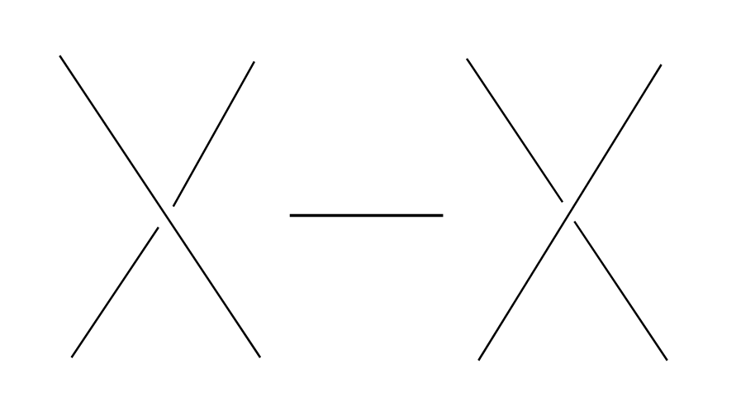 (The central arrow should be a left-right arrow, but the arrowheads do not come out!) Crossing changes will usually alter the isotopy type of the diagram. **Lemma**. Let be a diagram with crossings, then changing at most crossings of D produces a diagram of the unknot. **Proof**. After changing a crossing of , we could reduce at lease one crossing with a R1 move. **Definition**. The unknotting number, , is the smallest number of crossing changes required to obtain the unknot from some diagram of the knot .

## Kanenobu Knot, Generalized Kanenobu Knot and twisted knots ATTACH

The Kanenobu Knots, which are infinitely many knots with the same knot ploynomial invariant, [@kanenobuInfinitelyManyKnots1986] , are knots like following:

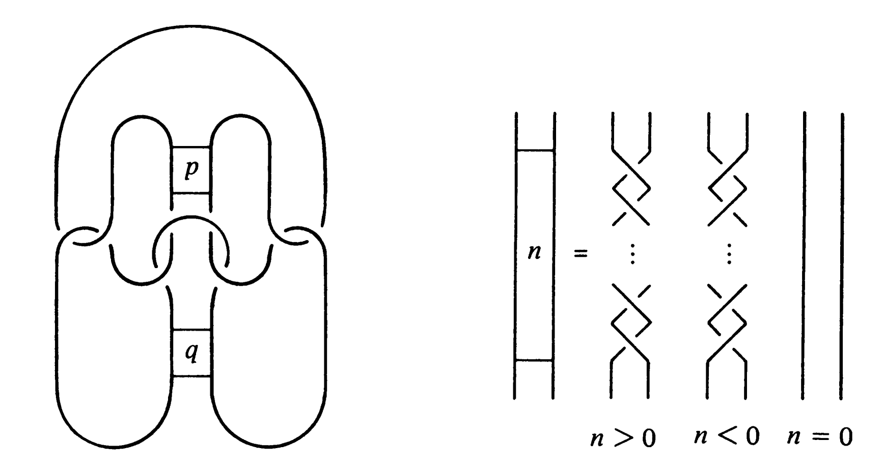

The Kanenobu knot with parameter p, q is represented by K(p,q). When p>0, the upper braid has the right curve above. When p<0, the upper braid has the left curve above. When q>0, then lower braid has the left curve above. The q<0, the lower braid has the left curve above.

### Generalized Kanenobu Knot ATTACH

The Kanenobu knot could be generalized by adding more parameters. After adding twisting between every crossing point of it, we get K(p, q, m, n):

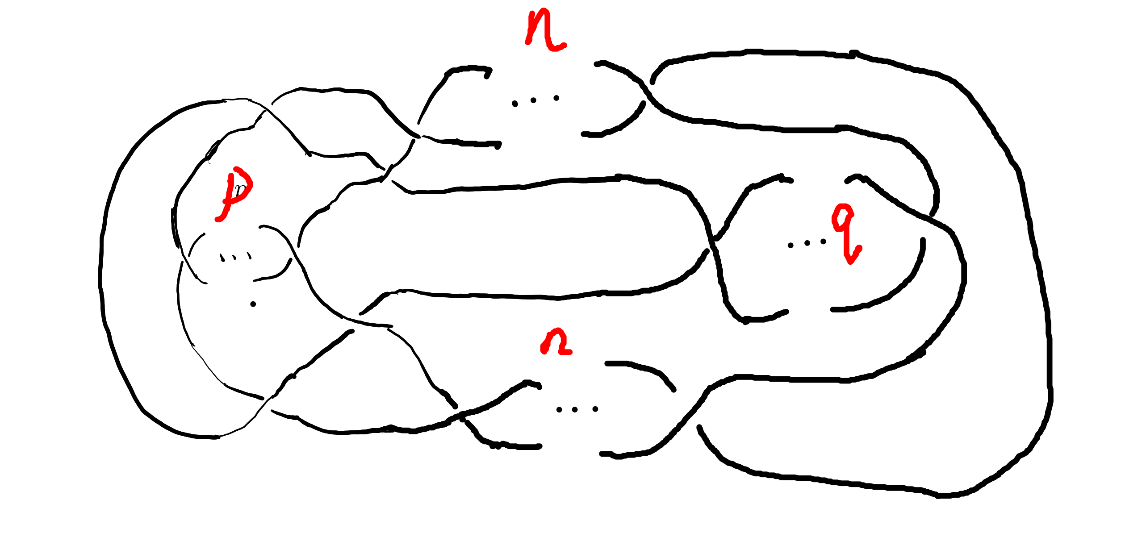

By adding parameters further, we get K(m, n, l, p, q):

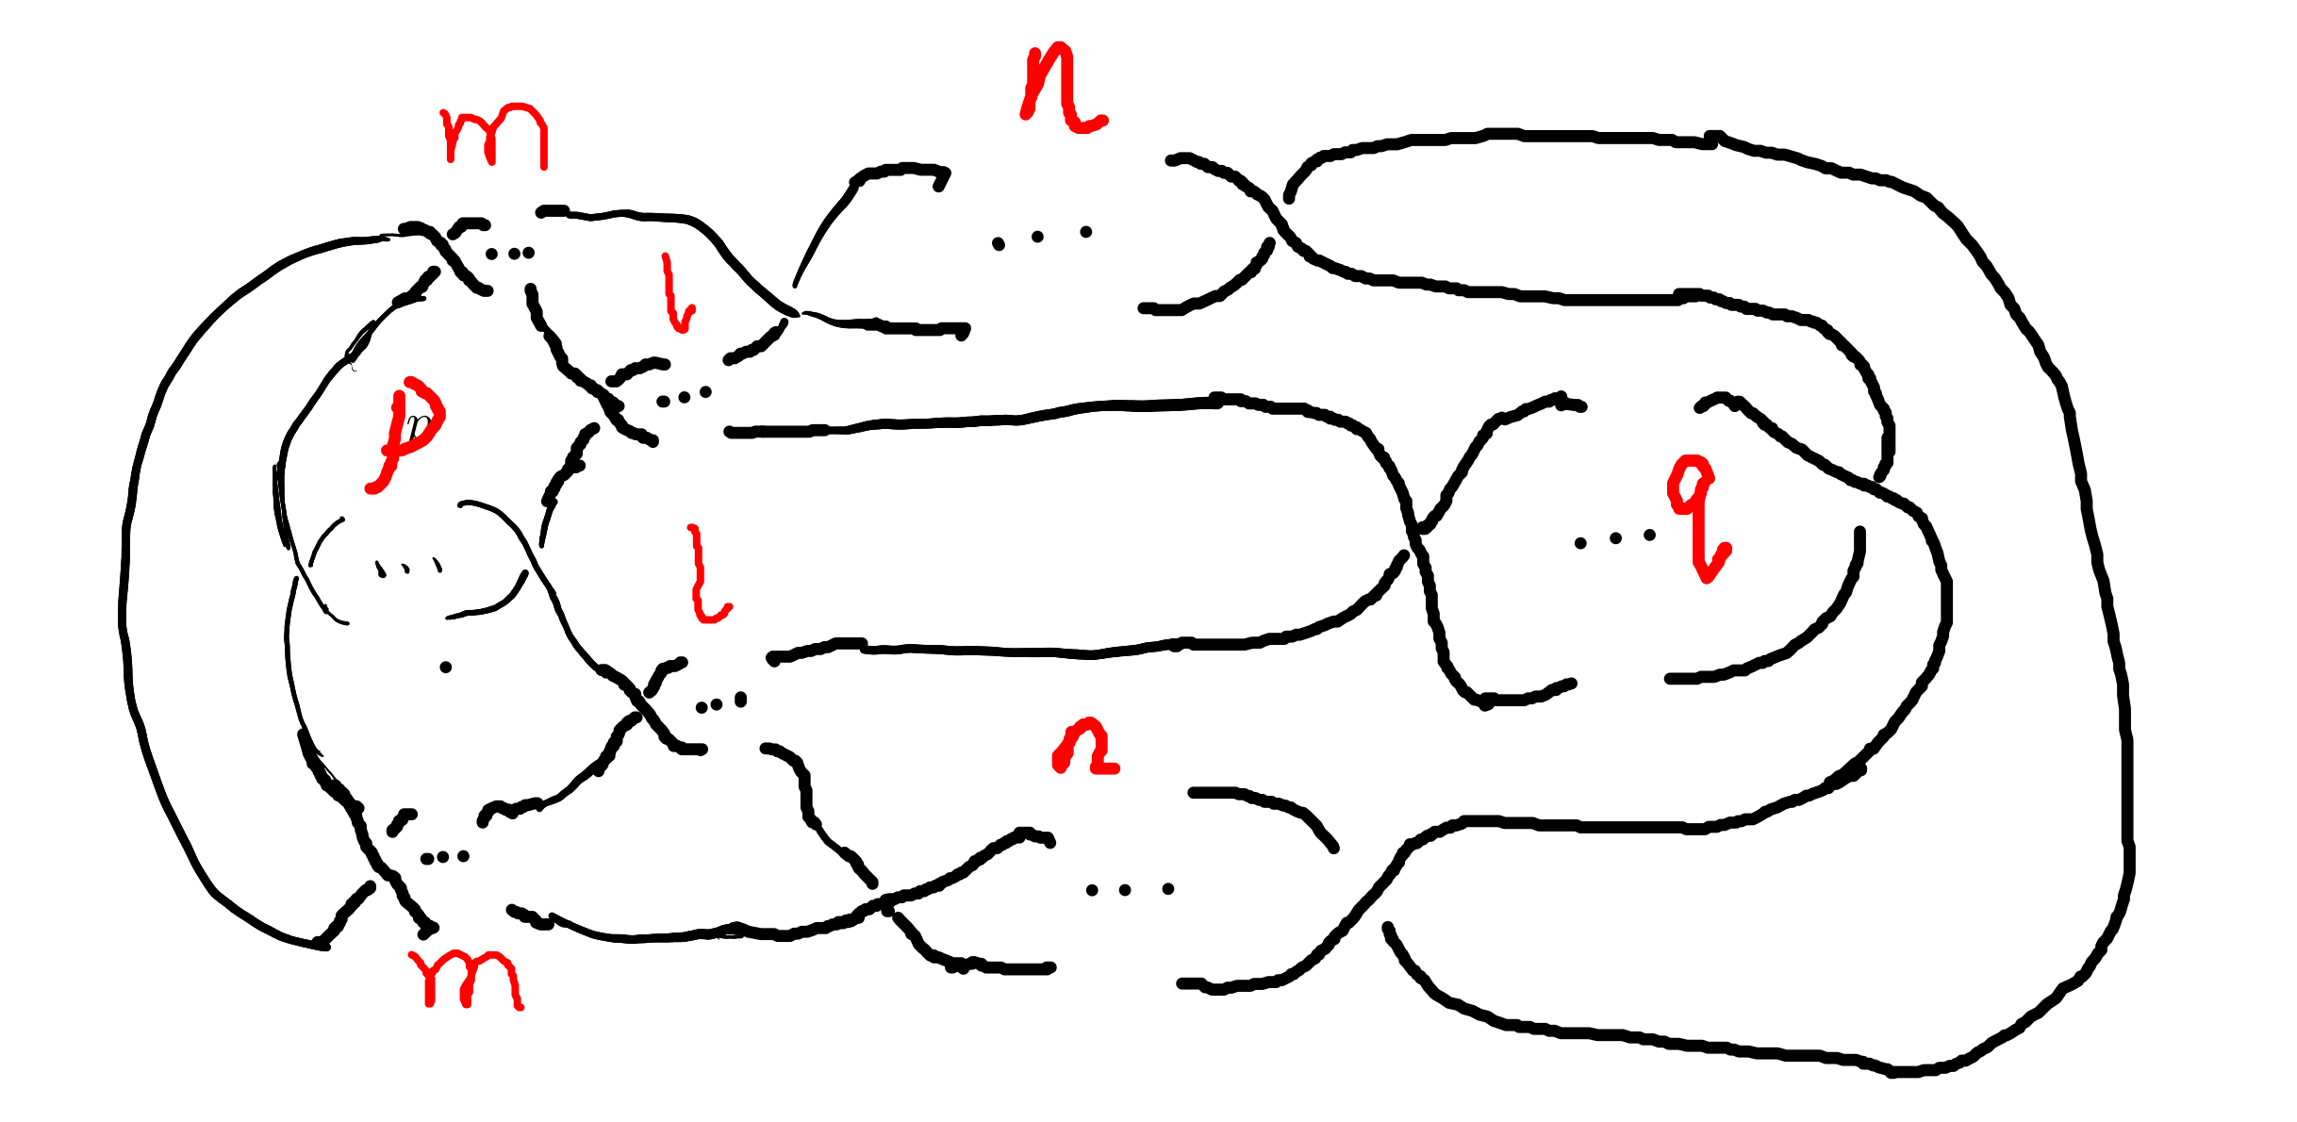 Which has all its crossing point be a crossing point family.

### Twist Knot ATTACH

A twist knot is a knot formed by repeatedly twisting a closed loop and then joining the two ends. (That is, a twisted knot is any Whitehead double of an untwisted knot.) Twisted knots are an infinite family of knots and are considered to be the simplest type of knot after the loop knot.

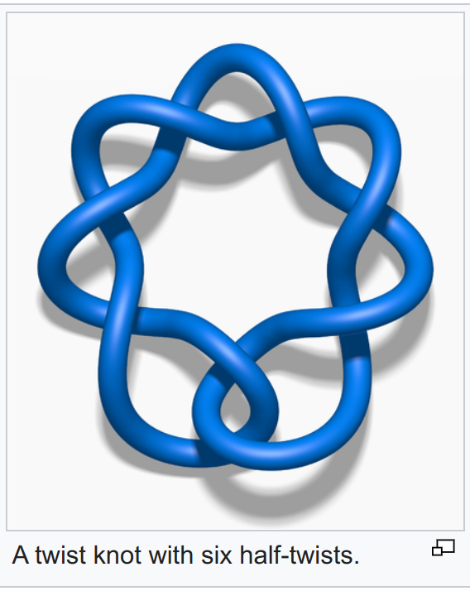

# Section 3. Unknotting Number for Kanenobu Knot

## Theorem 3.1 The unknotting number for a twist knot is 1.

**Proof**. Obviously, Every twist knot is not the unknot. And after untie the two ends of the twisted knot, the knot becomes unknot. Thus the unknotting number is 1.

## Theorem 3.1: the unknotting number of Kanenobu knot K(0,0) is 2. ATTACH

**Proof** . When p = 0, q = 0, the Kanenobu knot is like:

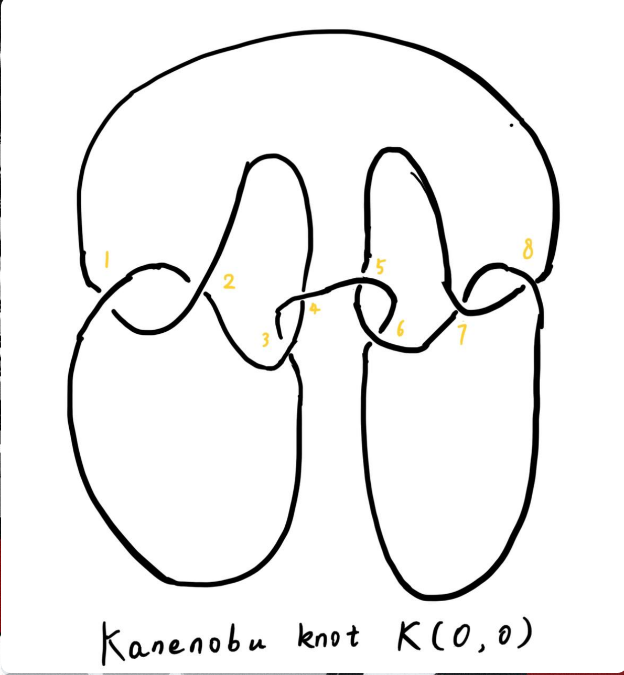

And we label the crossing point with numbers 1, 2, … , 8. First, we show that after changing the crossing point 1 and 8, this Kanenobu knot K(0, 0) will be transformed into an unknot.

1. After changing 1 and 8, the knot becomes:

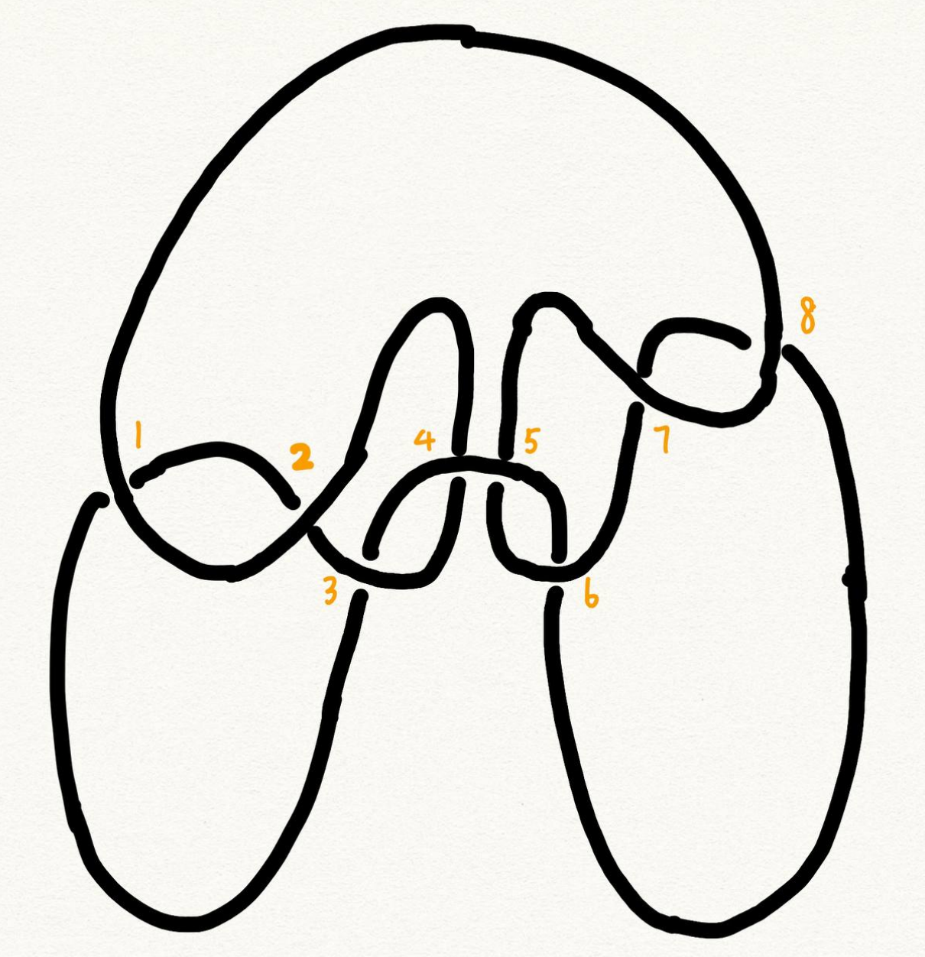

1. Then we put a R2 move to the part between crossing point 1 and 2, and another R2 move to the part between crossing point 7 and 8, we get:
2. put a R2 move to the part between crossing point 4 and 5, we get:
3. put a R2 move to the part between crossing point 3 and 4, and another R2 move to the part between crossing point 5 and 6, we get the unknot.

Second, we show that for any one change to the crossing point, the Kanenobu knot won't be transformed to the unknot.

1. If we change the crossing point 1, we get an twisted knot, and twisted knot is not an unknot:
2. If we change the crossing point 2, we get an twisted knot, and twisted knot is not an unknot:
3. If we change the crossing point 3, we get an twisted knot, and twisted knot is not an unknot:
4. If we change the crossing point 4, we get an twisted knot, and twisted knot is not an unknot:
5. If we change the crossing point 5, we get an twisted knot, and twisted knot is not an unknot:

All other circumstances could be applied to the same procedure. Thus the knot can't be untied by changing one crossing. Then we proved the unknotting number for Kanenobu knot K(0, 0) is 2.

# Section 4. Unknotting Number for Generalized Kanenobu Knot

## Theorem 4.1 The unknotting number for Generalized Kanenobu knot K(p, q) is 2. ATTACH

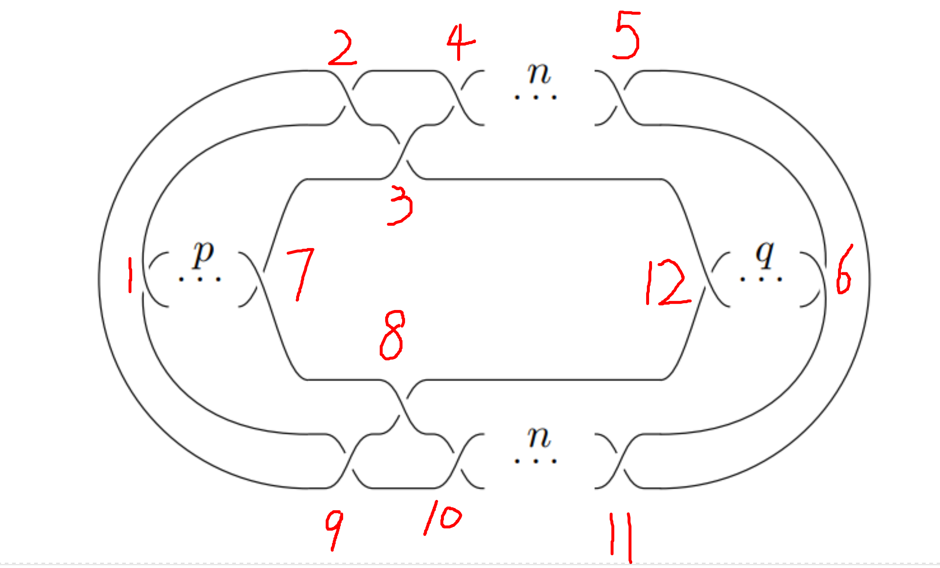

**Proof**. Label the 12 crossing points (excluding the p, q, n crossing points) with number 1, 2, …, 12. First, change crossing points 2, 9, then we could untie all the crossing point between 6 and 12. We could untie all the crossing points between 4 and 5, 10 and 11. Thus the all the points are all untied.

Then we must prove changing points less than 2 we can not untie this knot. If we changes 0 crossing point, this problem is trivial: the Kanenobu knot K(p, q, n) remains not an unknot. If we changes only 1 crossing point:

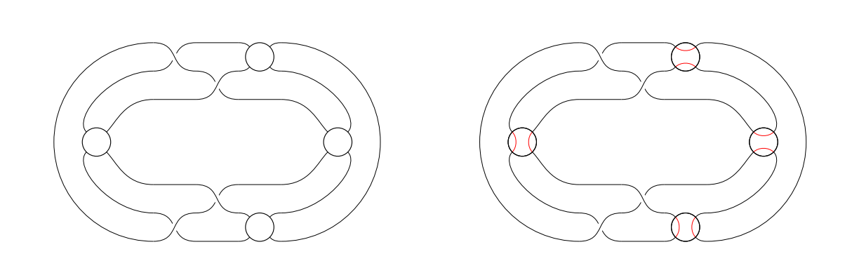

1. if we change the crossing point 1, the part between is a twist and the whole knot is not an unknot.
2. if we change the crossing point 2, the knot will become:

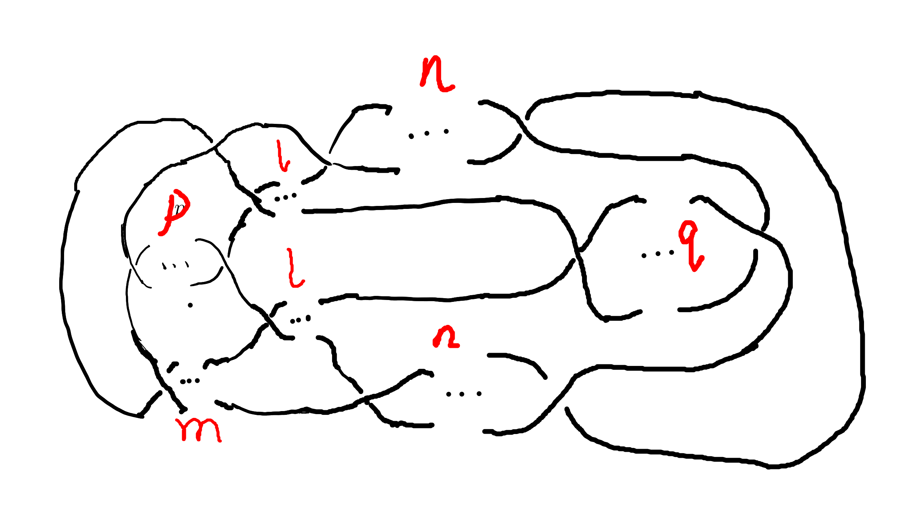 And it is not an unknot because we can not untie the twist in the part, for locally it is an twist knot.

1. If we change any crossing point other than 1, 2, the situation are similar to thing above.

Thus we can't untie the knot with only 1 crossing point change. Then we proved the unknotting number for generalized Kanenobu knot is 2.

# Section 5. Unknotting Number for More Generalized Kanenobu Knot

The more generalized Kanenobu knot is complex then we will break this problem into several situations. First, we introduce plat form for a surface-link to help solve this problem.

## 5.1 a plat form for a surface-link ATTACH

In this section, we introduce a plat form for a surface-link.We assume . Let be a regular neighborhood of in , which is parameterized with such that and , where .

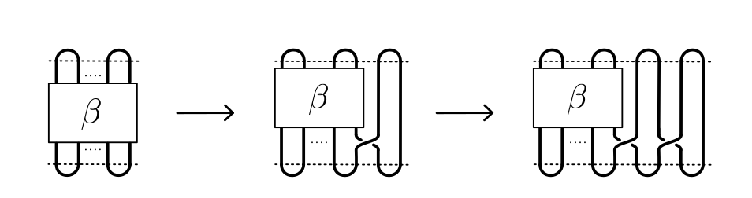

### Definition 5.1.1 A surface A in is of m-wicket type (or simply of wicket type) if it is a properly embeded surface in satisfying the following conditions.

(1) is the standard m-wicket system when we identify with . (2) For each , is an m-wicket system.

Definition 5.1.2 A braided surface in is adequate if there exists a surface of m-wicket type, , in such that the boundaries of S and A coincide: .

It's tivial that the degree of an adequate braided surface is even. Note that for each , the seciton is determined from the boundary of A and hence A is determined by . Therefore, for an adequate braided surface , such a surface A of wicket is uniquely determined.

We consider a condition for a braided surface to admit the plat closure. For a braided surface of degree n, let be a geometric -braided obtained by cutting the closed braid along . It is easy to say that in the braided group if two braided surfaces and are equivalent.

### Theorem 5.1.2 A braided surface is equivalent to an adequate one if and only if ${\rm deg} S = 2m$ for some and the braid belongs to .

**Proof** . Let be equivalent to an adequate braided surface , and let be a surface surface of -wrick type such that . Thus ${\rm deg} S = {\rm deg } S_{0} = 2m$ for some , and . Let be a map defined by . Then is a loop in such that is the standard m-wicket system. By the isomorphism, the element corresponds to the braid . Since , we have . Thus, .

## Theorem 5.1 The unknotting number for more generalized Kanenobu knot is:

### When , the unknotting number for is , where is the integer part of

### When , the unknotting number for is , where is the integer part of ATTACH

**Proof**. First we should show that with the numbers of crossing point changes, we can untie the knot. When , after changes the crossing points in the and part (do this by reduing crossing points), we get the knot like:

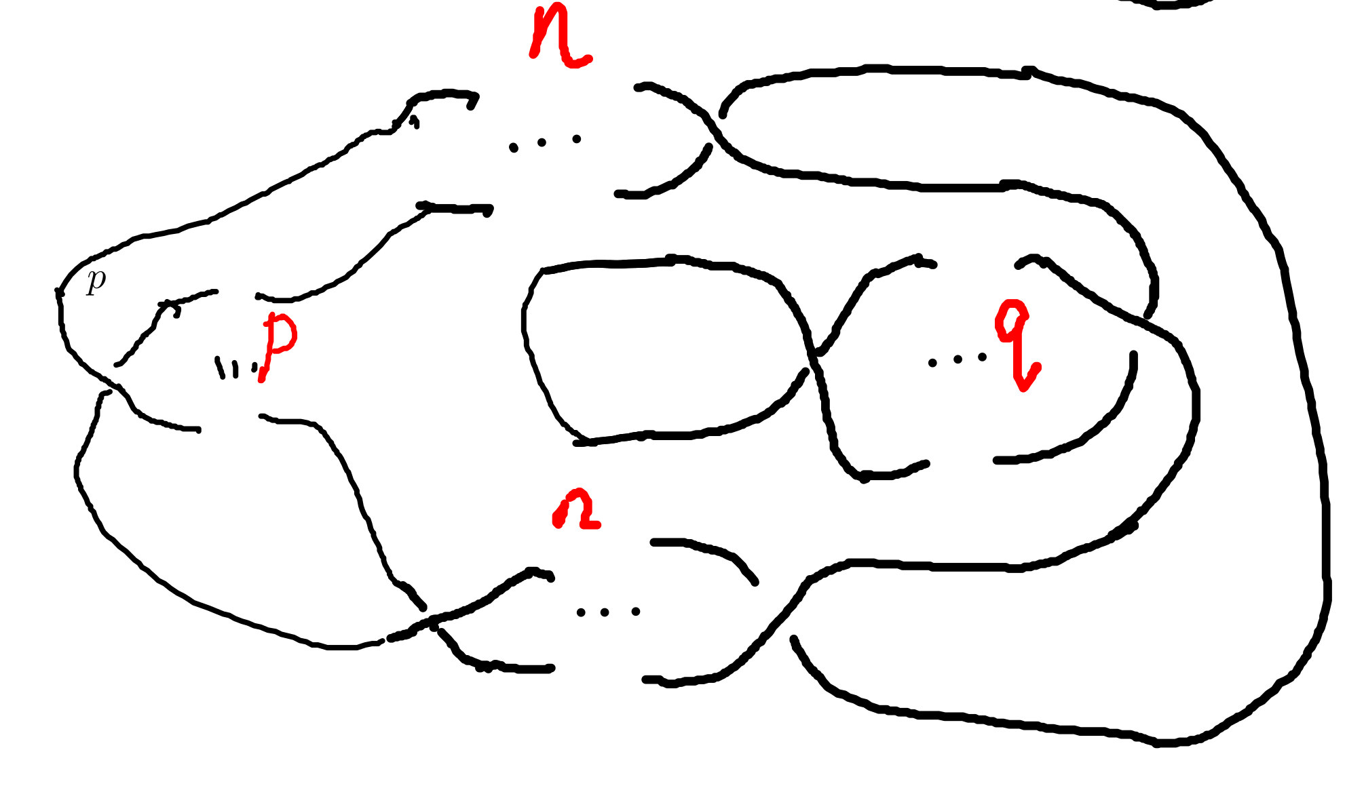

We can untie this knot by twisting the crossing numbers first, then the 2 crossing points.

When , after changing the crossing points in and part(do this by reducing crossing numbers), we get the knot like:

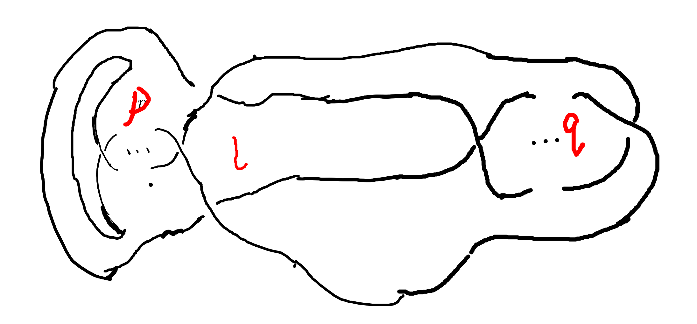

We can untie this knot by reducing the part first, then part.

Second, we must show we can not untie this knot with any other ways. With theorem 5.1.2, the braid has the same plat form with the part, they are the only two ways to untie this knot. This completes this proof.

# Section 6. Acknowledgements

　After more than four months of hard work, I finally finished writing my thesis. From the beginning of receiving the thesis topic to the implementation of the system and then to the completion of the thesis article, each step was a new trial and challenge for me, and it was the biggest project I have completed independently during my time at university. During this time, I learned a lot and felt a lot. From knowing nothing, I started to study and experiment independently, checking relevant materials and books, making the vague concepts in my mind gradually clear, and making my very young work perfect step by step. Every time I understood a new concept and new theorem was the gain of my study, and every successful proof of a theorem would make me excited for a long time.

　My thesis work is not very mature and has many shortcomings. But this experience of doing my dissertation has benefited me for life. I feel that doing a dissertation is something that you really have to put your heart and soul into, it is truly a process of learning and researching on your own, without learning there can be no potential for research, without your own research there will be no breakthrough, and then it will not be called a dissertation. I hope that this experience will inspire me to continue to progress in my future studies.

June, it's always sunny. In June, it's always the end of the song. In June, we refuse to be sentimental. The flowers give up their fragrance and we welcome the fruits. Graduation brings farewell, and we are on our way to glory. As I finish my thesis, I would like to express my deepest gratitude to my supervisor and my dear family who have helped me in the process of writing this thesis! I would like to thank my supervisor, Ms. Wan Liangxia. She has been a role model for me, a trusted mentor and friend, both as a person and in her studies. In spite of the heavy teaching and workload, he took the initiative to care about my study and research. From choosing a topic for my dissertation, writing the opening report, searching for information, to perfecting the structure, she gave me careful guidance so that I could successfully complete my dissertation. She also often supervised and motivated the lazy me to finish my characters on time. Thank you, Ms Wan!

In addition, I would like to thank my family for their encouragement and support, which enabled me to devote myself to my studies and work and complete my studies successfully. Thanks to the Instant App, I had a fun group of online friends to keep me company while I was writing my dissertation. I used Emacs and org-mode to produce all my papers, and then used word to format them to the university's requirements. Thanks to the creator of org-mode Dominik and the current maintainer Bastien Guerry, and to everyone in the Emacs community.

# Bibliography

## Kanenobu, Taizo - Infinitely {{Many Knots}} with the {{Same Polynomial Invariant}}