VIST Group


Name: | VIST Group | Similar companies  Dassault Systèmes GEOVIA Inc.  ISS Group Limited  Micromine Pty Ltd.  Modular Mining Systems, Inc.  RungePincockMinarco Limited
Founded: | 1999
Country: | Russia
Industry: | Mining industry software
Employees: | 130
Web: | http://www.vistgroup.ru/

VIST Group has been working in the IT market for more than 25 years, providing vast experience in the development of information systems and the capabilities of working with complex solutions for various applications in mining and metallurgy, power-engineering, science and telecommunications industries.
VIST Group is a leader in the deployment of mine fleet management systems, control systems in Russia, Mongolia and CIS. We successfully implement software systems across broad industrial mining enterprises throughout Russia, CIS, Africa, South America.

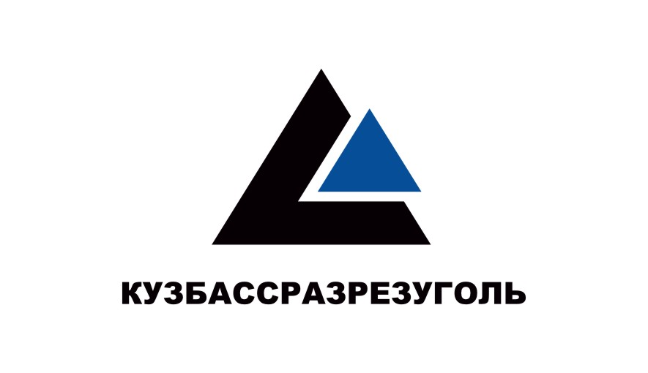




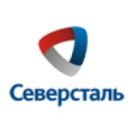


Company main products

KARIER Mine Fleet Management System
KARIER is mining-and-transport complex dispatch system implementation is aimed at increase of operational control efficiency of production and enhancement of integrity and operability of accounting and control of mining-and- transport complex application.

System of the Automation of mine-surveyor works (SAMARA)
The essence of the SAMARA system application consists in the development of the mine enterprise information-geometric model, its (model) current completion and use for the solution of the laboratory data processing problems: design, settlement, graphic. The built-in set of instruments make it possible to perform processing data of field measurements, to document it, to supplement the graphic part of the model on the basis of the obtained results, to prepare the graphic documentation of different designation and scales, to carry out design calculations and tracings.

ORLACO VISION SOLUTIONS
It is Orlaco’s viewpoint that optimal vision around every vehicle and vessel should be the norm. It provides safety, comfort and efficiency.
Orlaco's vision solutions are suitable for professional use on all types of vehicles (dump trucks, excavators, bulldozers, wheel loaders, scrapers etc.). The camera and monitor systems are shockproof and present a sharp image under extreme conditions. Quality checks ensure excellent performance and longevity.

Company financial results

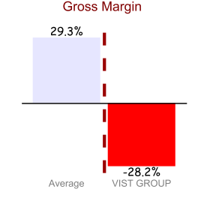 | 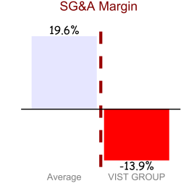
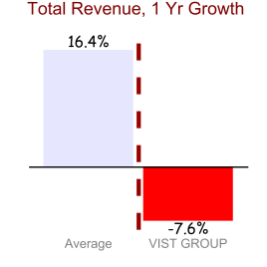 | 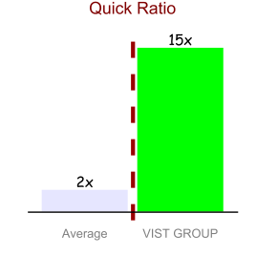
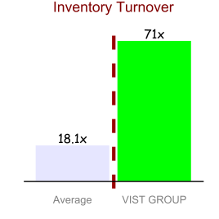

Industry key stats

Trading Multiples | 2011 | 2012 | 2013 | 2014 | 2015
TEV/Total Revenue | 0.5x | 0.9x | 1.3x | 1.4x | 1.1x
TEV/EBITDA | 4.7x | 14.4x | 93.5x | NA | 45.6x
P/E | 8.2x | NA | NA | NA | NA
P/BV | 1.0x | 1.8x | 2.0x | 1.7x | 1.7x
P/TangibleBV | 2.7x | 5.6x | 4.6x | 2.9x | 2.8x
Profitability
Return on Assets % | 5.4% | 2.6% | (1.0%) | (3.3%) | (0.0%)
Return on Capital % | 7.6% | 3.6% | (1.4%) | (4.2%) | (0.1%)
Return on Equity % | 12.2% | (4.8%) | (7.5%) | (16.5%) | (12.3%)
Margin Analysis
Gross Margin % | 33.6% | 31.0% | 26.4% | 26.2% | 27.3%
SG&A Margin % | 17.5% | 18.4% | 20.5% | 22.0% | 20.2%
EBITDA Margin % | 10.6% | 6.1% | 1.4% | (3.5%) | 2.5%
EBITA Margin % | 7.3% | 3.4% | (1.7%) | (6.8%) | (0.1%)
EBIT Margin % | 7.3% | 3.4% | (1.7%) | (6.8%) | (0.1%)
Earnings from Continuing Operatios Margin % | 6.1% | (2.2%) | (5.4%) | (16.6%) | (10.9%)
Net Income Margin % | 6.1% | (2.2%) | (5.4%) | (16.6%) | (10.9%)
Net Income Avail. for Common Margin % | 6.1% | (2.2%) | (5.4%) | (16.6%) | (10.9%)
Normalized Net Income Margin % | 4.3% | 1.6% | (1.3%) | (4.2%) | 0.3%
Levered Free Cash Flow Margin % | 5.3% | 1.6% | 9.6% | (2.4%) | (6.5%)
Unlevered Free Cash Flow Margin % | 5.8% | 2.0% | 10.0% | (2.2%) | (6.4%)
Asset Turnover
Total Asset Turnover | 1.2x | 1.2x | 0.9x | 0.8x | 0.8x
Fixed Asset Turnover | 9.4x | 9.9x | 9.3x | 13.7x | 24.2x
Accounts Receivable Turnover | 4.8x | 5.1x | 3.9x | 4.4x | 3.6x
Inventory Turnover | 18.9x | 17.4x | 23.0x | 13.1x | 39.2x
Short Term Liquidity
Current Ratio | 1.8x | 1.9x | 1.6x | 2.6x | 2.2x
Avg Days Inventory Outstanding | 21.5 | 20.1 | 18.9 | 21.3 | 16.2
Quick Ratio | 2.0x | 1.9x | 2.0x | 2.0x | 1.9x
Avg Days Payable Outstanding | 25.6 | 21.3 | 27.1 | 35.8 | 21.5
Avg Days Sales Outstanding | 72.3 | 73.8 | 80.7 | 91.4 | 85.6
Avg Cash Conversion Cycle | 20 | 20.2 | 24.3 | 24 | 18.4
Long Term Solvency
Total Debt/Equity | 19.4% | 30.5% | 0.0% | 0.0% | 0.0%
Total Debt/Capital | 16.2% | 23.4% | 0.0% | 0.0% | 0.0%
Total Liabilities/Total Assets | 40.3% | 44.5% | 32.1% | 22.3% | 28.4%
EBITDA / Interest Exp. | 14.5x | 8.9x | 2.1x | NM | 8.9x
(EBITDA-CAPEX) / Interest Exp. | 14.5x | 8.9x | 2.1x | NM | 8.9x
Total Debt/EBITDA | 0.9x | 2.2x | 0.0x | NM | 0.0x
Growth Over Prior Year
Total Revenue, 1 Yr Growth % | 8.1% | (1.2%) | (38.6%) | (17.5%) | (16.3%)
Gross Profit, 1 Yr Growth % | (9.9%) | (8.9%) | (47.7%) | (18.1%) | (10.5%)
Accounts Receivable, 1 Yr Growth % | 20.7% | (7.0%) | (18.5%) | (26.9%) | 27.5%
Inventory, 1 Yr Growth % | (4.2%) | 11.5% | (50.3%) | 45.5% | (65.3%)
Net PP&E, 1 Yr Growth % | 15.7% | (6.9%) | (34.1%) | (44.4%) | (67.1%)
Common Equity, 1 Yr Growth % | 4.0% | (11.8%) | (1.3%) | 15.1% | 11.9%
Total Assets, 1 Yr Growth % | 4.9% | (5.1%) | (19.3%) | 0.5% | 1.5%
Tangible Book Value, 1 Yr Growth % | 28.9% | (24.3%) | 31.1% | 59.2% | 58.9%

Trading multiples
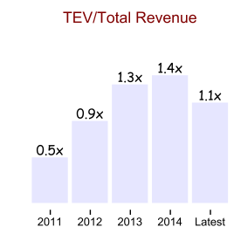 | 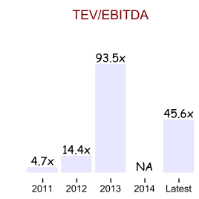
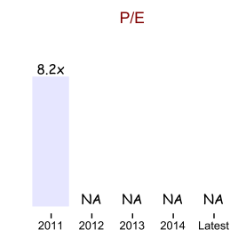 | 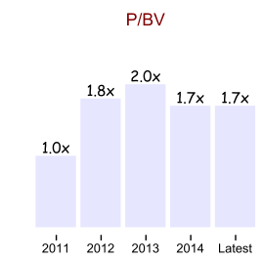
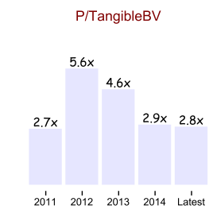

Profitability
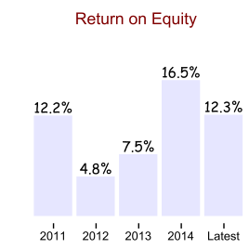 | 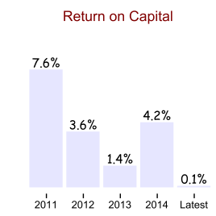
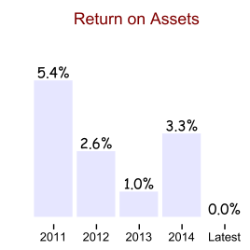

Margin analysis
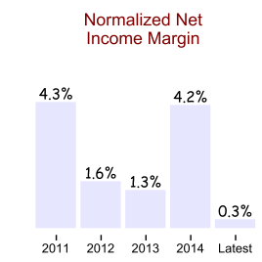 | 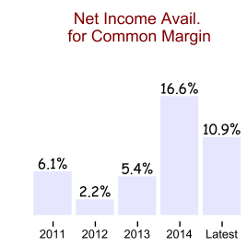

Long term solvency
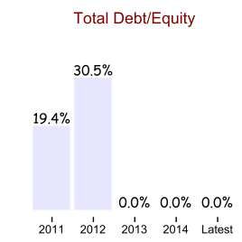 | 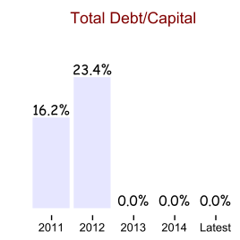

Growth over prior year
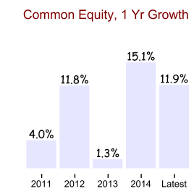
Industry trends

“The Mining industry is at the roots of so much of what we take for granted in our daily lives, and people may have forgotten the pivotal role it plays in our modern societies. Without mineral resources, economic or social development would not be possible. The act of mining, itself, gives us the opportunity of a close encounter with our natural environment, with the responsibilities for sustainable exploitation that come along with that: I am therefore especially interested in the role that technology can play, to ensure that a millennium-old human activity can continue to fuel the progress of society in a context of demographic growth yet in a manner respectful to our planet.”

— Rick Moignard, GEOVIA CEO

The mining sector in 2015 can be defined by its lack of certainty. From the question of obtaining finance in a cautious global economy to geopolitical unrest, rising costs, declining revenues and market contraction, the sector is beset by unknowns. Despite this, mining and mining services organisations can still build competitiveness and increase profitability by maintaining tight management over the one thing they can control – their own business operations.
In the current environment sound business knowledge, high productivity, an eye for innovation and the flexibility to respond to market changes are prerequisites. To support and encourage every one of these traits, a good IT strategy and the right information systems are essential.

Mining software strategies

 | 1. Go modular  These days, few if any companies have the luxury of spare resources waiting to work on getting a “big bang” software deployment right. Nor do they have the time to spare integrating, updating and maintaining multiple systems. By deploying modular solutions, mining companies can implement incremental change, introducing technologies and processes at a pace that doesn't overwhelm the business.
 | 2. Keep it scalable  From exploration and feasibility studies to production and sales, it's impossible to be sure how big any operation will grow. Rather than face the disruption of upgrading to a larger system a few years down the track, look for solutions that can grow with your company, supporting additional users, increasing workloads and providing additional functionality as you move through the cycle of mining production.
 | 3. Consider the cloud  The cloud offers many benefits to the mining sector including real time access to information from multiple sites, a single source of the truth, complete scalability and a reduction in IT costs. By making information more readily accessible, activities such as monthly reporting can be completed faster and more efficiently. Timely access to information also leads to faster decision making, something that is especially important when dealing with remote locations.
 | 4. Bring Your Own Device  Mobile devices such as tablets and smartphones are excellent tools for providing connectivity to employees everywhere. Used in conjunction with mobile-accessible business applications, they have the potential to streamline processes, improve productivity and enhance communication in the workplace.
 | 5. Choose software that is designed for the industry  One-size-fits-all business applications can never capture the full complexity of a mining or mining services business. To support efficiency in every part of your organisation, look for a solution that understands mining's unique challenges and which has been developed with the sector's interests at its heart.
 | 6. Get a good business engine  Never forget that underneath all the mining functionality, you still need a business engine, one that can handle the myriad financial and management needs of the organisation including inventory, purchase orders, payroll, human resources, occupational health and safety, job cost and financial management.
Информация с сайта www.australianmining.com.au

