HGSOC survival analysis

Table of Contents

Multiple studies have assessed the timing of surgery in high grade serous ovarian cancer (HGSOC). There is some evidence that neoadjuvant chemotherapy (NACT) followed by interval debulking surgery is non-inferior to primary cytoreductive surgery. The ICON 8b study results are awaited to evaluate the use of upfront bevacizumab in these patients. However, there is currently limited evidence supporting switching chemotherapy regimens after 3 cycles of NACT when disease remains inoperable. In this retrospective study, we evaluated survival outcomes following a change of chemotherapy regimen in previously inoperable patients.

The research questions in this project are three-fold:

1. Within patient who were eventually operated, is there any survival difference between patient who received operation after 3 cycles or after 6 cycles of NACT?
2. Within patient who weren’t operable after 3 cycles of NACT and operable after 6 cycles of NACT, did switch in chemotherapy offer a survival advantage?
3. What are the predictors of eventual surgical inoperabilities, if any?

# 1 Missing data pattern

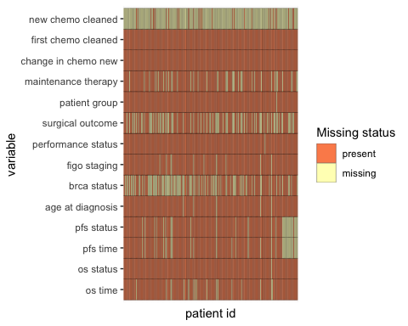

# 2 Comparing survival profile between patients receiving 3 cycle vs 6 cycle of neo-adjuvant chemotherapy

Patients who remains inoperable after 3 cycles of Neoadjuvant chemotherapy went on for further cycles before going for surgeries. We wanted to assess if there is any survival difference stemming from the different number of cycles of neoadjuvant chemotherapy received. We assessed any possible survival difference via log-rank test using the KM curve as well as multi-variate cox regression model adjusted for confounding factors including age, performance status, initial figo staging and surgical outcome.

## 2.1 Clinical baseline characteristics

Baseline comparison between the two groups revealed [to be filled]

## Setting theme `JAMA`

## 1 observations missing `patient_group` have been removed. To include these observations, use `forcats::fct_explicit_na()` on `patient_group` column before passing to `tbl_summary()`.

| Characteristic | N | 3_cycle_surgery, N = 116 | 6_cycle_no_surgery, N = 57 | 6_cycle_surgery, N = 63 | p-value1 |
| --- | --- | --- | --- | --- | --- |
| **Age at diagnosis, Median (IQR)** | 231 | 67 (59 – 71) | 71 (64 – 79) | 65 (58 – 73) | **0.004** |
| **brca status, n (%)** | 137 |  |  |  | 0.69 |
| BRCA 1 mutation |  | 6 (7.9) | 0 (0) | 3 (7.7) |  |
| BRCA 2 mutation |  | 5 (6.6) | 1 (4.5) | 4 (10) |  |
| normal |  | 65 (86) | 21 (95) | 32 (82) |  |
| **figo staging, n (%)** | 226 |  |  |  | 0.16 |
| 3 |  | 61 (54) | 26 (49) | 24 (39) |  |
| 4 |  | 51 (46) | 27 (51) | 37 (61) |  |
| **performance status, n (%)** | 235 |  |  |  | **0.021** |
| 0 |  | 20 (17) | 5 (8.8) | 9 (14) |  |
| 1 |  | 71 (62) | 26 (46) | 30 (48) |  |
| 2 |  | 21 (18) | 20 (35) | 21 (33) |  |
| 3 |  | 3 (2.6) | 6 (11) | 3 (4.8) |  |
| **surgical outcome, n (%)** | 154 |  |  |  | 0.71 |
| optimal |  | 78 (74) | 0 (NA) | 35 (71) |  |
| suboptimal |  | 27 (26) | 0 (NA) | 14 (29) |  |
| **maintenance therapy, n (%)** | 196 | 51 (45) | 16 (73) | 32 (52) | 0.057 |
| **change_in_chemo_new, n (%)** | 236 |  |  |  | **<0.001** |
| changed |  | 0 (0) | 16 (28) | 10 (16) |  |
| no change |  | 116 (100) | 41 (72) | 53 (84) |  |
| **first_chemo_cleaned, n (%)** | 236 |  |  |  | **<0.001** |
| bevacizumab_based |  | 8 (6.9) | 1 (1.8) | 7 (11) |  |
| carbo |  | 8 (6.9) | 27 (47) | 8 (13) |  |
| carbo_pac |  | 100 (86) | 29 (51) | 48 (76) |  |
| **new_chemo_cleaned, n (%)** | 27 |  |  |  | 0.36 |
| anti-hormone |  | 0 (0) | 2 (12) | 0 (0) |  |
| bevacizumab_based |  | 1 (100) | 2 (12) | 3 (30) |  |
| caelyx |  | 0 (0) | 1 (6.2) | 0 (0) |  |
| carbo |  | 0 (0) | 2 (12) | 2 (20) |  |
| carbo_caelyx |  | 0 (0) | 3 (19) | 0 (0) |  |
| carbo_pac |  | 0 (0) | 1 (6.2) | 0 (0) |  |
| carbo_weekly_pac |  | 0 (0) | 2 (12) | 5 (50) |  |
| stopped |  | 0 (0) | 1 (6.2) | 0 (0) |  |
| weekly_pac |  | 0 (0) | 2 (12) | 0 (0) |  |
| 1Kruskal-Wallis rank sum test; Fisher's exact test; Pearson's Chi-squared test | | | | | |

## 2.2 KM curve & log-rank test

### 2.2.1 Overall survival between 3 cycle and 6 cycle surgery group

No significant difference was noted between the KM survival curve between 3 cycle and 6 cycle surgery group assessed by log-rank test (p=0.25).

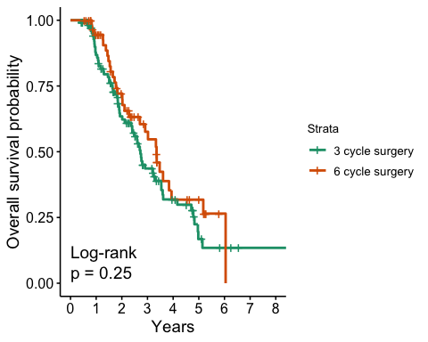

### 2.2.2 Progression free survival between 3 cycle and 6 cycle surgery group

No significant difference was noted between the KM survival curve between 3 cycle and 6 cycle surgery group assessed by log-rank test (p=0.15).

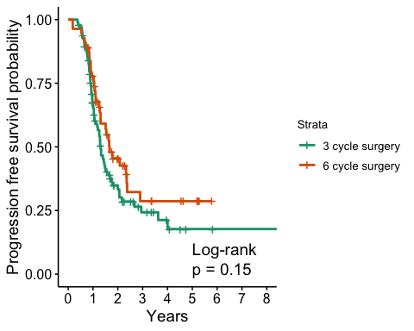

## 2.3 Multivariate cox regression

Compare both os and pfs between 3 and 6 cycle of chemotherapy before going for interval debulking surgery while adjusting for age, performance status, figo staging surgical outcome.

6 cycle group is associated with a increased progression free survival after adjusting for clinical confounders, with a hazard raito of 0.56 (95% CI 0.34 to 0.93, p=0.026). There is a similar trend for overall survival however the result did not reach statistical significance, where 6 cycle group has a hazard ratio of 0.63 (95% CI 0.38 to 1.07, p= 0.086)

|  | Overall survival | | | | | Progression free survival | | | | |
| --- | --- | --- | --- | --- | --- | --- | --- | --- | --- | --- |
| Characteristic | N | HR (95% CI)12 | SE2 | 95% CI2 | p-value | N | HR (95% CI)12 | SE2 | 95% CI2 | p-value |
| patient group | 146 |  |  |  |  | 132 |  |  |  |  |
| 3_cycle_surgery |  | — | — | — |  |  | — | — | — |  |
| 6_cycle_surgery |  | 0.63 | 0.265 | 0.38 to 1.07 | 0.086 |  | 0.56* | 0.258 | 0.34 to 0.93 | **0.026** |
| age at diagnosis | 146 | 1.00 | 0.012 | 0.98 to 1.03 | 0.72 | 132 | 0.99 | 0.012 | 0.96 to 1.01 | 0.24 |
| surgical_outcome | 146 |  |  |  |  | 132 |  |  |  |  |
| optimal |  | — | — | — |  |  | — | — | — |  |
| suboptimal |  | 1.57 | 0.255 | 0.95 to 2.59 | 0.076 |  | 1.60 | 0.255 | 0.97 to 2.63 | 0.066 |
| figo staging | 146 |  |  |  |  | 132 |  |  |  |  |
| 3 |  | — | — | — |  |  | — | — | — |  |
| 4 |  | 1.18 | 0.240 | 0.74 to 1.88 | 0.50 |  | 0.94 | 0.235 | 0.59 to 1.49 | 0.79 |
| performance status | 146 |  |  |  |  | 132 |  |  |  |  |
| 0 |  | — | — | — |  |  | — | — | — |  |
| 1 |  | 1.92 | 0.352 | 0.96 to 3.82 | 0.065 |  | 2.20* | 0.373 | 1.06 to 4.58 | **0.034** |
| 2 |  | 2.08 | 0.400 | 0.95 to 4.55 | 0.068 |  | 2.93** | 0.416 | 1.30 to 6.63 | **0.010** |
| 3 |  | 1.89 | 0.586 | 0.60 to 5.96 | 0.28 |  | 3.61* | 0.591 | 1.14 to 11.5 | **0.030** |
| 1*p<0.05; **p<0.01; ***p<0.001 | | | | | | | | | | |
| 2HR = Hazard Ratio, CI = Confidence Interval, SE = Standard Error, CI = Confidence Interval | | | | | | | | | | |

# 3 Compare utility of chemotherapy switch after no-response to 3 cycles of Nac

Patients who remains inoperable after 3 cycles of Neoadjuvant chemotherapy went on for further chemotherapies and a subset subsequently achieved satisfactory tumour regression and therefore deemed operable after completing 6 cycles. Within this patient population, we wanted to assess if switching chemotherapy added survival benefit. For patients who received 6 cycle of Nac and subseuqent interval debulking surgery, we assessed any possible survival difference between patient who had either switch in chemo or same chemo via log-rank test using the KM curve as well as multi-variate cox regression model adjusted for confounding factors including age, performance status and initial figo staging

## 3.1 KM curve & log-rank test

### 3.1.1 Overall survival between 6 cycle switch and 6 cycle no-switch group

There was no signficant difference in overall survival between the two groups from log-rank test in KM curve (p=0.19)

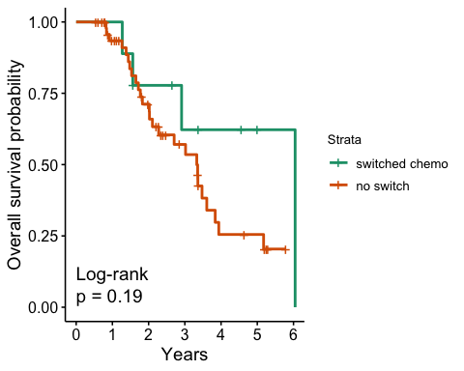

### 3.1.2 Progression free survival between 6 cycle switch and 6 cycle no-switch group

There was no signficant difference in progression free survival between the two groups from log-rank test in KM curve (p=0.54)

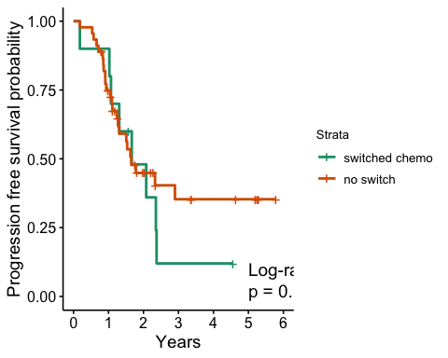

## 3.2 Multivariate cox analysis

Compare both os and pfs between chemo switch and no switch group during 6 cycle of neoadjvuant chemotherapy before going for interval debulking surgery while adjusting for age, performance status, figo staging surgical outcome.

Patient who did not have a switch in their neoadjuvant chemotherapy had a significantly raised hazard ratio of 14.9 for overall survival (95% C.I. 2.48 - 89.6, p=0.03) This effect was not observed for progression free survival where patient who had no switch in neoadjuvant chemotherapy had a hazard ratio of 1.91 (95% C.I. 0.49-7.51, p=0.35)

|  | Overall survival | | | | | Progression free survival | | | | |
| --- | --- | --- | --- | --- | --- | --- | --- | --- | --- | --- |
| Characteristic | N | HR (95% CI)12 | SE2 | 95% CI2 | p-value | N | HR (95% CI)12 | SE2 | 95% CI2 | p-value |
| chemotherapy switch | 47 |  |  |  |  | 46 |  |  |  |  |
| changed |  | — | — | — |  |  | — | — | — |  |
| no change |  | 14.9** | 0.915 | 2.48 to 89.6 | **0.003** |  | 1.91 | 0.698 | 0.49 to 7.51 | 0.35 |
| age at diagnosis | 47 | 0.99 | 0.027 | 0.94 to 1.04 | 0.62 | 46 | 0.99 | 0.023 | 0.95 to 1.04 | 0.76 |
| surgical_outcome | 47 |  |  |  |  | 46 |  |  |  |  |
| optimal |  | — | — | — |  |  | — | — | — |  |
| suboptimal |  | 6.67** | 0.611 | 2.01 to 22.1 | **0.002** |  | 3.00 | 0.612 | 0.90 to 9.97 | 0.072 |
| figo staging | 47 |  |  |  |  | 46 |  |  |  |  |
| 3 |  | — | — | — |  |  | — | — | — |  |
| 4 |  | 1.03 | 0.538 | 0.36 to 2.96 | 0.95 |  | 0.59 | 0.448 | 0.24 to 1.41 | 0.23 |
| performance status | 47 |  |  |  |  | 46 |  |  |  |  |
| 0 |  | — | — | — |  |  | — | — | — |  |
| 1 |  | 0.45 | 0.694 | 0.12 to 1.76 | 0.25 |  | 1.47 | 0.696 | 0.37 to 5.74 | 0.58 |
| 2 |  | 1.66 | 0.638 | 0.48 to 5.78 | 0.43 |  | 1.82 | 0.693 | 0.47 to 7.08 | 0.39 |
| 3 |  | 0.86 | 0.95 | 0.13 to 5.55 | 0.88 |  | 1.65 | 0.855 | 0.31 to 8.81 | 0.56 |
| 1*p<0.05; **p<0.01; ***p<0.001 | | | | | | | | | | |
| 2HR = Hazard Ratio, CI = Confidence Interval, SE = Standard Error, CI = Confidence Interval | | | | | | | | | | |

# 4 Finding baseline predictors of inoperability after 6 cycles of neoadjuvant chemotherapy

Finally, we aimed to establish prognostic factors that can predict the lack of response to 6 cycles of neoadjuvant chemotherapy and eventual surgical inoperability. Logistic regression was performed to predict the eventual outcome of either operable and inoperable.

Note in this analysis, change into anti-hormone or stopping chemotherapy wasn’t counted as chemo switch as they do not represent a switch for any potential added benefit

Old age was significantly associated with inoperability with an odds ratio of 1.09 (95% CI 1.05 to 1.14, p < 0.001). Meanwhile, worsening performance status of 3 shows a trend towards inoperability but did not reach statistical significance with an odds ratio of 4.86 (95% CI 0.89 to 27.7, p=0.067). No change in Nac regimen is significantly associated with eventual operability with an odds ratio of 0.13 (95% CI 0.04 to 0.37, p<0.001)

## 4.1 All patients

| Characteristic | N | OR (95% CI)12 | SE2 | 95% CI2 | p-value |
| --- | --- | --- | --- | --- | --- |
| age at diagnosis | 221 | 1.09*** | 0.022 | 1.05 to 1.14 | **<0.001** |
| figo staging | 221 |  |  |  |  |
| 3 |  | — | — | — |  |
| 4 |  | 1.43 | 0.380 | 0.68 to 3.06 | 0.34 |
| performance status | 221 |  |  |  |  |
| 0 |  | — | — | — |  |
| 1 |  | 1.07 | 0.569 | 0.37 to 3.58 | 0.91 |
| 2 |  | 1.44 | 0.609 | 0.46 to 5.15 | 0.55 |
| 3 |  | 4.72 | 0.855 | 0.88 to 26.5 | 0.070 |
| chemotherapy switch | 221 |  |  |  |  |
| changed |  | — | — | — |  |
| no change |  | 0.13*** | 0.551 | 0.04 to 0.38 | **<0.001** |
| 1*p<0.05; **p<0.01; ***p<0.001 | | | | | |
| 2OR = Odds Ratio, CI = Confidence Interval, SE = Standard Error, CI = Confidence Interval | | | | | |

## 4.2 6 cycle NACT

Considering all 3 cycle surgery group wouldn’t have a change in chemotherapy potentially biasing the result, we repeated the analysis looking specifically within patients who received 6 cycles of Nac before interval debulking surgery.

Similar results could again be replicated for old age where it was significantly associated with inoperability with an odds ratio of 1.07 (95% CI 1.02 to 1.12, p = 0.006). However, no change in Nac regimen is no longer significantly associated with eventual operability with an odds ratio of 0.41 (95% CI 0.546 to 1.19, p=0.10)

| Characteristic | N | OR (95% CI)12 | SE2 | 95% CI2 | p-value |
| --- | --- | --- | --- | --- | --- |
| age at diagnosis | 110 | 1.07** | 0.024 | 1.02 to 1.12 | **0.007** |
| figo staging | 110 |  |  |  |  |
| 3 |  | — | — | — |  |
| 4 |  | 1.02 | 0.452 | 0.42 to 2.51 | 0.97 |
| performance status | 110 |  |  |  |  |
| 0 |  | — | — | — |  |
| 1 |  | 1.55 | 0.645 | 0.45 to 5.88 | 0.49 |
| 2 |  | 1.21 | 0.676 | 0.33 to 4.83 | 0.77 |
| 3 |  | 3.35 | 0.947 | 0.54 to 24.0 | 0.20 |
| chemotherapy switch | 110 |  |  |  |  |
| changed |  | — | — | — |  |
| no change |  | 0.42 | 0.546 | 0.14 to 1.21 | 0.11 |
| 1*p<0.05; **p<0.01; ***p<0.001 | | | | | |
| 2OR = Odds Ratio, CI = Confidence Interval, SE = Standard Error, CI = Confidence Interval | | | | | |