Stage 3 rectal cancer adjuvant management: survival analysis

Table of Contents

1 Patient baseline profiles 1

2 Missing data pattern 3

3 Survival analysis 4

3.1 KM curve and log-rank test for adjuvant chemo vs surveillance 4

3.1.1 Overall survival 4

3.1.2 Recurrence-free survival 5

3.2 KM curve and log-rank test for distance from anal verge 6

3.2.1 Overall survival 6

3.2.2 Recurrence-free survival 7

3.3 Univariate cox regression 8

3.3.1 Overall survival 8

3.3.2 Recurrence free survival 10

3.4 multivariable cox regression 12

3.4.1 Overall survival 12

3.4.2 Recurrence free survival 13

3.5 Multivariable analysis v2 (with staging ypRT) 14

3.5.1 Overall survival 14

3.5.2 Recurrence free survival 15

The patient cohort in this study are those who have undergone surgical resection for stage III rectal cancer. This project aims to evaluate the survival performance between two different post-op management, namely between patients who have been managed with adjuvant chemotherapy or surveillance.

# 1 Patient baseline profiles

First, the baseline profiles between adjuvant chemo versus surveillance group were compared to assess potential differences. Compared to the adjuvant chemotherapy group, patients in the surveillance group tends to be older and present with better prognostic profile, specifically fewer number of positive CRM, EMVI and lower staging after radiotherapy and surgery.

## Setting theme `JAMA`

## 5 observations missing `adjuvant_management` have been removed. To include these observations, use `forcats::fct_explicit_na()` on `adjuvant_management` column before passing to `tbl_summary()`.

| Characteristic | N | adjuvant_chemo, N = 95 | surveillence, N = 73 | p-value1 |
| --- | --- | --- | --- | --- |
| **Age at diagnosis, Median (IQR)** | 167 | 63 (55 – 69) | 70 (61 – 78) | **<0.001** |
| **CRM, n (%)** | 143 |  |  | **0.006** |
| pos |  | 70 (89) | 45 (70) |  |
| neg |  | 9 (11) | 19 (30) |  |
| **R status, n (%)** | 159 |  |  | 0.057 |
| R0 |  | 74 (85) | 68 (94) |  |
| R1 |  | 13 (15) | 4 (5.6) |  |
| **TRG status, n (%)** | 76 |  |  | 0.95 |
| TRG3 |  | 12 (28) | 11 (33) |  |
| TRG0 |  | 0 (0) | 0 (0) |  |
| TRG1 |  | 3 (7.0) | 3 (9.1) |  |
| TRG2 |  | 24 (56) | 16 (48) |  |
| TRG4 |  | 2 (4.7) | 2 (6.1) |  |
| TRG5 |  | 2 (4.7) | 1 (3.0) |  |
| **Distance from anal verge, Median (IQR)** | 143 | 3.00 (1.00 – 6.00) | 4.50 (2.00 – 6.25) | 0.083 |
| **Distance from anal verge category, n (%)** | 143 |  |  | 0.13 |
| <5cm |  | 52 (63) | 30 (50) |  |
| 5-10cm |  | 31 (37) | 30 (50) |  |
| **EMVI, n (%)** | 116 |  |  | **<0.001** |
| neg |  | 17 (26) | 31 (61) |  |
| pos |  | 48 (74) | 20 (39) |  |
| **Time between radiotherapy and surgery, Median (IQR)** | 165 | 86 (77 – 99) | 89 (77 – 118) | 0.20 |
| **Baseline histological grade, n (%)** | 159 |  |  | 0.83 |
| G3 |  | 12 (13) | 10 (14) |  |
| G2 |  | 78 (87) | 59 (86) |  |
| **Cancer staging post surgery, n (%)** | 164 |  |  | **<0.001** |
| stage_3 |  | 32 (34) | 9 (13) |  |
| stage_0 |  | 8 (8.6) | 10 (14) |  |
| stage_1 |  | 14 (15) | 34 (48) |  |
| stage_2 |  | 39 (42) | 18 (25) |  |
| **Cancer staging post radiotherapy, n (%)** | 128 |  |  | **0.003** |
| stage_3 |  | 33 (46) | 18 (32) |  |
| stage_1 |  | 7 (9.7) | 19 (34) |  |
| stage_2 |  | 32 (44) | 19 (34) |  |
| 1Wilcoxon rank sum test; Pearson's Chi-squared test; Fisher's exact test | | | | |

# 2 Missing data pattern

TRG status, EMVI and cancer stage post radiotherapy are observed to display more than 20% missingness. These co-variates are excluded from subsequent multivariate analysis.

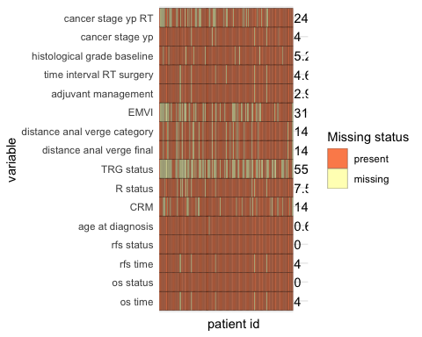

# 3 Survival analysis

## 3.1 KM curve and log-rank test for adjuvant chemo vs surveillance

### 3.1.1 Overall survival

Using log-rank test based on the KM curves of two groups. No significant difference in overall survival was detected between the (p=0.84)

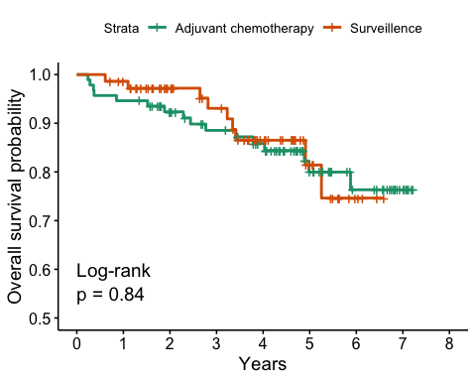

### 3.1.2 Recurrence-free survival

Using log-rank test based on the KM curves of two groups, there is a significantly better recurrence free survival in the surveillance group compared to the neoadjuvant chemotherapy group (p=0.037)

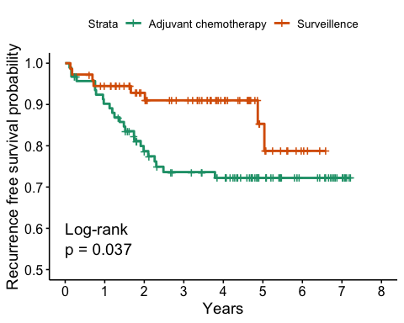

## 3.2 KM curve and log-rank test for distance from anal verge

### 3.2.1 Overall survival

Using log-rank test based on the KM curves of two groups. No significant difference in overall survival was detected between patients with a different distance from anal verge (p=0.92)

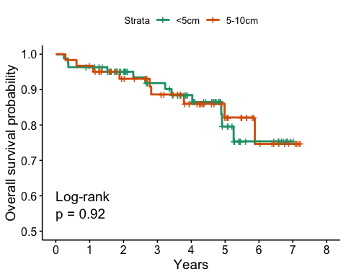

### 3.2.2 Recurrence-free survival

Using log-rank test based on the KM curves of two groups,no significant difference in RFS was found between patients with a different distance from anal verge (p=0.96)

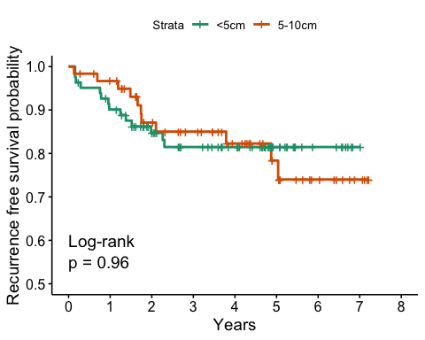

## 3.3 Univariate cox regression

Univariate cox regression was conducted to assess each included variable’s influence on the respective survival outcome.

### 3.3.1 Overall survival

## Warning in coxph.fit(X, Y, istrat, offset, init, control, weights = weights, :  
## Loglik converged before variable 1 ; coefficient may be infinite.

## Warning in coxph.fit(X, Y, istrat, offset, init, control, weights = weights, :  
## Loglik converged before variable 4,5 ; coefficient may be infinite.

| Characteristic | N | HR (95% CI)1 | p-value |
| --- | --- | --- | --- |
| Age at diagnosis | 165 | 1.00 (0.96 to 1.03) | 0.80 |
| CRM | 141 |  |  |
| pos |  | — |  |
| neg |  | 0.00 (0.00 to Inf) | >0.99 |
| R status | 159 |  |  |
| R0 |  | — |  |
| R1 |  | 6.99 (3.01 to 16.2) | **<0.001** |
| TRG status | 76 |  |  |
| TRG3 |  | — |  |
| TRG0 |  |  |  |
| TRG1 |  | 1.39 (0.15 to 12.5) | 0.77 |
| TRG2 |  | 0.76 (0.21 to 2.85) | 0.69 |
| TRG4 |  | 0.00 (0.00 to Inf) | >0.99 |
| TRG5 |  | 0.00 (0.00 to Inf) | >0.99 |
| Distance from anal verge | 143 | 1.04 (0.89 to 1.21) | 0.63 |
| Distance from anal verge category | 143 |  |  |
| <5cm |  | — |  |
| 5-10cm |  | 0.95 (0.40 to 2.27) | 0.92 |
| EMVI | 115 |  |  |
| neg |  | — |  |
| pos |  | 1.18 (0.47 to 3.01) | 0.72 |
| adjuvant_management | 166 |  |  |
| adjuvant_chemo |  | — |  |
| surveillence |  | 0.92 (0.40 to 2.09) | 0.84 |
| Time between radiotherapy and surgery | 165 | 1.00 (1.00 to 1.01) | 0.76 |
| Baseline histological grade | 157 |  |  |
| G3 |  | — |  |
| G2 |  | 0.40 (0.16 to 0.97) | **0.043** |
| Cancer staging post surgery | 164 |  |  |
| stage_3 |  | — |  |
| stage_0 |  | 0.51 (0.11 to 2.31) | 0.38 |
| stage_1 |  | 0.19 (0.04 to 0.88) | **0.034** |
| stage_2 |  | 0.90 (0.38 to 2.12) | 0.81 |
| Cancer staging post radiotherapy | 128 |  |  |
| stage_3 |  | — |  |
| stage_1 |  | 1.37 (0.40 to 4.71) | 0.61 |
| stage_2 |  | 1.28 (0.46 to 3.52) | 0.64 |
| 1HR = Hazard Ratio, CI = Confidence Interval | | | |

### 3.3.2 Recurrence free survival

## Warning in coxph.fit(X, Y, istrat, offset, init, control, weights = weights, :  
## Loglik converged before variable 4,5 ; coefficient may be infinite.

| Characteristic | N | HR (95% CI)1 | p-value |
| --- | --- | --- | --- |
| Age at diagnosis | 165 | 0.98 (0.95 to 1.01) | 0.15 |
| CRM | 141 |  |  |
| pos |  | — |  |
| neg |  | 0.25 (0.06 to 1.06) | 0.060 |
| R status | 159 |  |  |
| R0 |  | — |  |
| R1 |  | 7.08 (3.23 to 15.5) | **<0.001** |
| TRG status | 76 |  |  |
| TRG3 |  | — |  |
| TRG0 |  |  |  |
| TRG1 |  | 5.01 (1.01 to 24.9) | **0.049** |
| TRG2 |  | 1.38 (0.36 to 5.35) | 0.64 |
| TRG4 |  | 0.00 (0.00 to Inf) | >0.99 |
| TRG5 |  | 0.00 (0.00 to Inf) | >0.99 |
| Distance from anal verge | 143 | 1.08 (0.94 to 1.24) | 0.27 |
| Distance from anal verge category | 143 |  |  |
| <5cm |  | — |  |
| 5-10cm |  | 1.02 (0.46 to 2.24) | 0.97 |
| EMVI | 115 |  |  |
| neg |  | — |  |
| pos |  | 1.65 (0.64 to 4.30) | 0.30 |
| adjuvant_management | 166 |  |  |
| adjuvant_chemo |  | — |  |
| surveillence |  | 0.44 (0.20 to 0.97) | **0.043** |
| Time between radiotherapy and surgery | 165 | 1.00 (1.00 to 1.00) | 0.92 |
| Baseline histological grade | 157 |  |  |
| G3 |  | — |  |
| G2 |  | 0.58 (0.24 to 1.42) | 0.23 |
| Cancer staging post surgery | 164 |  |  |
| stage_3 |  | — |  |
| stage_0 |  | 0.22 (0.03 to 1.69) | 0.14 |
| stage_1 |  | 0.59 (0.22 to 1.55) | 0.29 |
| stage_2 |  | 1.09 (0.48 to 2.46) | 0.83 |
| Cancer staging post radiotherapy | 128 |  |  |
| stage_3 |  | — |  |
| stage_1 |  | 0.86 (0.30 to 2.44) | 0.78 |
| stage_2 |  | 0.69 (0.28 to 1.69) | 0.42 |
| 1HR = Hazard Ratio, CI = Confidence Interval | | | |

## 3.4 multivariable cox regression

Next we aimed to compare the OS and RFS between adjuvant chemo and surveillance group using multivariable logistical regression accounting for known clinical prognostic factors including age, R status, distance from anal verge, baseline histological grade, cancer staging post surgery and time interval between radiotherapy and surgery. Note data was pre-processed such that within each categorical variables, groups with very small number of samples (<2) were removed. The same set of pre-processed data was used throughout the entire data analysis to ensure consistency.

### 3.4.1 Overall survival

No significant difference was found in overall survival between surveillance and adjuvant chemotherapy. Only R1 status was significantly associated with worse overall survival compared to R0.

## Warning in coxph.fit(X, Y, istrat, offset, init, control, weights = weights, :  
## Loglik converged before variable 2 ; coefficient may be infinite.

| Characteristic | N | HR (95% CI)1 | p-value |
| --- | --- | --- | --- |
| Age at diagnosis | 116 | 0.99 (0.93 to 1.05) | 0.68 |
| CRM | 116 |  |  |
| pos |  | — |  |
| neg |  | 0.00 (0.00 to Inf) | >0.99 |
| R status | 116 |  |  |
| R0 |  | — |  |
| R1 |  | 6.44 (1.60 to 25.9) | **0.009** |
| Distance from anal verge | 116 | 1.23 (0.79 to 1.90) | 0.36 |
| Distance from anal verge category | 116 |  |  |
| <5cm |  | — |  |
| 5-10cm |  | 0.35 (0.03 to 4.22) | 0.41 |
| adjuvant_management | 116 |  |  |
| adjuvant_chemo |  | — |  |
| surveillence |  | 1.31 (0.38 to 4.54) | 0.67 |
| Time between radiotherapy and surgery | 116 | 1.00 (0.99 to 1.01) | 0.55 |
| Baseline histological grade | 116 |  |  |
| G3 |  | — |  |
| G2 |  | 1.17 (0.31 to 4.47) | 0.81 |
| Cancer staging post surgery | 116 |  |  |
| stage_3 |  | — |  |
| stage_0 |  | 1.29 (0.18 to 9.17) | 0.80 |
| stage_1 |  | 0.28 (0.03 to 3.20) | 0.31 |
| stage_2 |  | 1.15 (0.30 to 4.43) | 0.84 |
| 1HR = Hazard Ratio, CI = Confidence Interval | | | |

### 3.4.2 Recurrence free survival

Patient undergoing surveillance was found to have a significantly lowered risk in recurrence free survival when compared to patient undergoing adjuvant chemotherapy. R1 status was again significantly associated with worse overall survival compared to R0. Distance from anal verge was also found to

| Characteristic | N | HR (95% CI)1 | p-value |
| --- | --- | --- | --- |
| Age at diagnosis | 116 | 1.02 (0.97 to 1.07) | 0.43 |
| CRM | 116 |  |  |
| pos |  | — |  |
| neg |  | 0.36 (0.04 to 2.98) | 0.34 |
| R status | 116 |  |  |
| R0 |  | — |  |
| R1 |  | 4.13 (1.06 to 16.1) | **0.041** |
| Distance from anal verge | 116 | 2.09 (1.35 to 3.23) | **<0.001** |
| Distance from anal verge category | 116 |  |  |
| <5cm |  | — |  |
| 5-10cm |  | 0.01 (0.00 to 0.18) | **<0.001** |
| adjuvant_management | 116 |  |  |
| adjuvant_chemo |  | — |  |
| surveillence |  | 0.16 (0.04 to 0.74) | **0.019** |
| Time between radiotherapy and surgery | 116 | 1.00 (0.99 to 1.01) | 0.51 |
| Baseline histological grade | 116 |  |  |
| G3 |  | — |  |
| G2 |  | 0.34 (0.08 to 1.49) | 0.15 |
| Cancer staging post surgery | 116 |  |  |
| stage_3 |  | — |  |
| stage_0 |  | 0.74 (0.07 to 8.28) | 0.81 |
| stage_1 |  | 1.33 (0.24 to 7.51) | 0.74 |
| stage_2 |  | 1.70 (0.48 to 6.10) | 0.41 |
| 1HR = Hazard Ratio, CI = Confidence Interval | | | |

## 3.5 Multivariable analysis v2 (with staging ypRT)

This is the same multivariable analysis repeated to include staging post radiotherapy as it might be an important prognostic factor.

### 3.5.1 Overall survival

Again, no significant difference was found in overall survival between surveillance and adjuvant chemotherapy group. Only R1 status was significantly associated with worse overall survival compared to R0.

## Warning in coxph.fit(X, Y, istrat, offset, init, control, weights = weights, :  
## Loglik converged before variable 2 ; coefficient may be infinite.

| Characteristic | N | HR (95% CI)1 | p-value |
| --- | --- | --- | --- |
| Age at diagnosis | 91 | 0.99 (0.93 to 1.05) | 0.70 |
| CRM | 91 |  |  |
| pos |  | — |  |
| neg |  | 0.00 (0.00 to Inf) | >0.99 |
| R status | 91 |  |  |
| R0 |  | — |  |
| R1 |  | 4.28 (0.73 to 25.2) | 0.11 |
| Distance from anal verge | 91 | 1.43 (0.85 to 2.41) | 0.18 |
| Distance from anal verge category | 91 |  |  |
| <5cm |  | — |  |
| 5-10cm |  | 0.17 (0.01 to 3.32) | 0.25 |
| adjuvant_management | 91 |  |  |
| adjuvant_chemo |  | — |  |
| surveillence |  | 0.87 (0.19 to 4.05) | 0.86 |
| Time between radiotherapy and surgery | 91 | 1.00 (0.99 to 1.01) | 0.62 |
| Baseline histological grade | 91 |  |  |
| G3 |  | — |  |
| G2 |  | 0.81 (0.10 to 6.23) | 0.84 |
| Cancer staging post surgery | 91 |  |  |
| stage_3 |  | — |  |
| stage_0 |  | 0.88 (0.08 to 9.69) | 0.91 |
| stage_1 |  | 0.21 (0.02 to 2.67) | 0.23 |
| stage_2 |  | 0.99 (0.20 to 4.86) | 0.99 |
| Cancer staging post radiotherapy | 91 |  |  |
| stage_3 |  | — |  |
| stage_1 |  | 2.59 (0.48 to 14.0) | 0.27 |
| stage_2 |  | 1.26 (0.31 to 5.13) | 0.74 |
| 1HR = Hazard Ratio, CI = Confidence Interval | | | |

### 3.5.2 Recurrence free survival

This time, no significant difference was found in RFS between surveillance and adjuvant chemotherapy group.

| Characteristic | N | HR (95% CI)1 | p-value |
| --- | --- | --- | --- |
| Age at diagnosis | 91 | 1.01 (0.96 to 1.06) | 0.68 |
| CRM | 91 |  |  |
| pos |  | — |  |
| neg |  | 0.32 (0.03 to 3.11) | 0.33 |
| R status | 91 |  |  |
| R0 |  | — |  |
| R1 |  | 1.75 (0.29 to 10.8) | 0.54 |
| Distance from anal verge | 91 | 2.50 (1.32 to 4.71) | **0.005** |
| Distance from anal verge category | 91 |  |  |
| <5cm |  | — |  |
| 5-10cm |  | 0.00 (0.00 to 0.20) | **0.005** |
| adjuvant_management | 91 |  |  |
| adjuvant_chemo |  | — |  |
| surveillence |  | 0.24 (0.05 to 1.13) | 0.072 |
| Time between radiotherapy and surgery | 91 | 1.00 (0.99 to 1.01) | 0.56 |
| Baseline histological grade | 91 |  |  |
| G3 |  | — |  |
| G2 |  | 0.44 (0.06 to 3.23) | 0.42 |
| Cancer staging post surgery | 91 |  |  |
| stage_3 |  | — |  |
| stage_0 |  | 0.35 (0.02 to 6.45) | 0.48 |
| stage_1 |  | 0.61 (0.07 to 5.33) | 0.66 |
| stage_2 |  | 2.80 (0.50 to 15.7) | 0.24 |
| Cancer staging post radiotherapy | 91 |  |  |
| stage_3 |  | — |  |
| stage_1 |  | 1.88 (0.34 to 10.3) | 0.47 |
| stage_2 |  | 0.44 (0.11 to 1.76) | 0.25 |
| 1HR = Hazard Ratio, CI = Confidence Interval | | | |