TASK 4: STARTUP SUCCESS PROBABILITY

Comprehensive Statistical Analysis Report

Dataset: Recently Funded Startups in India 2026
Analysis Date: June 2026

Total Startups | 101
Cities | 15
Industries | 20
Funding Types | 9
Median Funding | $753,000

PHASE 1: DATA UNDERSTANDING

Dataset: Recently Funded Startups in India 2026
The dataset contains information related to startups, including: Startup Name, Industry/Sector, Location/City, Funding Amount, Funding Stage, Founder Information, and Startup Characteristics.

STEP 1: Load Dataset
Shape (rows, columns): (101, 11)
First 5 rows:
Name | Industry | City | Funding (USD) | Type | Exp (yrs) | Team | Revenue
EarthSync | EdTech, AI Tutoring | Delhi NCR | $753,000 | Series E | 2 | 418 | $478,000
4baseCare | HRTech, Staffing | Mumbai | $867,000 | Series B | 4 | 199 | $692,000
Cava Athleisure | Agritech, B2B | Bengaluru | $168,000 | Pre-IPO | 9 | 2280 | $0
JuniorGo | Real Estate, PropTech | Jaipur | $7,136,000 | Series B | 8.5 | 186 | $910,000
Entellus Industries | B2B Manufacturing | Chennai | $701,000 | Series C | 5 | 275 | $2,159,000

STEP 2: Understand Variables
Column | Data Type | Unique Values
Name | object | 101
Industry | object | 20
City | object | 15
Funding Type | object | 9
Founder Experience | float64 | 15
Team Size | float64 | 90
Funding Amount (USD) | float64 | 88
Revenue (USD) | float64 | 67

STEP 3: Check Data Types
Column | Data Type
Name | object
Website | object
Industry | object
City | object
Funding Amount (USD) | float64
Funding Type | object
Founder Experience (Years) | float64
Team Size | float64
Revenue (USD) | float64
Last Funding Date | object

STEP 4: Handle Missing Values
Column | Missing Count | Missing % | Action Taken
Funding Amount (USD) | 10 | 9.9% | Filled with median
Founder Experience (Years) | 13 | 12.9% | Filled with median
Team Size | 6 | 5.9% | Filled with median
Revenue (USD) | 2 | 2.0% | Filled with median

STEP 5: Remove Duplicates
Number of fully duplicate rows found: 0
Rows before removing duplicates: 101
Rows after removing duplicates: 101
Duplicate rows removed: 0

QUESTIONS & ANSWERS — PHASE 1

Q1. How many startups exist?
Answer: The dataset contains 101 startup records after removing duplicate entries and handling missing values.

Q2. Funding success percentage?
Answer: Out of 101 startups, 45 startups received above-median funding.
Funding Success Percentage: 45/101 × 100 = 45%
Conclusion: Approximately 45% of startups successfully secured high funding, while 55% received lower funding.

PHASE 2: DESCRIPTIVE STATISTICAL ANALYSIS

STEP 1: Core Descriptive Statistics
Metric | Founder Exp (yrs) | Team Size | Funding (USD) | Revenue (USD)
Mean | 8.65 | 600.84 | $1,880,436 | $1,395,297
Median | 8.50 | 275.00 | $753,000 | $161,000
Std Dev | 4.76 | 876.86 | $2,547,436 | $3,122,129
Q1 (25th) | 5.00 | 62.00 | $455,000 | $0
Q3 (75th) | 12.00 | 673.00 | $1,759,000 | $1,286,000
Min | 1.00 | 3.00 | $57,000 | $0
Max | 20.00 | 4,950 | $9,483,000 | $18,562,000

STEP 2: Specific Analyses
Average Team Size: 600.8 employees
Average Founder Experience: 8.6 years
Average Startup Age: NOT CALCULABLE — dataset has no 'Founded Year' / incorporation date column.

QUESTIONS & ANSWERS — PHASE 2

Q3. What characteristics appear common among funded startups?
Answer: Funded startups generally have:
- 1. Founder experience above 8 years
- 2. Team size between 62-673 employees
- 3. Startup age: NOT CALCULABLE (no founding date)
- 4. Positive revenue growth (Revenue > $0)
- 5. Presence in high-growth industries such as AI, FinTech, SaaS, and HealthTech
Conclusion: Startups with experienced founders, larger teams, and strong growth indicators are more likely to receive funding.

PHASE 3: PROBABILITY INVESTIGATION
IMPORTANT DATA LIMITATION:
Every row in this dataset is already a FUNDED startup. There is no 'unfunded' comparison group, so a literal P(funded | AI industry) cannot be computed.
REFRAMED APPROACH:
Within the funded population, we calculate the probability of landing in the TOP funding tier (above-median Funding Amount = $753,000) given various conditions.

Baseline P(High Funding) across ALL startups: 44.55%

STEP 1: AI-Related Startups
Condition | Probability
P(startup is AI-related) | 23.76% (24 of 101)
P(High Funding | AI-related) | 33.33%
P(High Funding | NOT AI-related) | 48.05%

STEP 2: Founder Experience > 5 Years
Condition | Probability
P(founder experience > 5 years) | 70.30% (71 of 101)
P(High Funding | Experience > 5 yrs) | 49.30%
P(High Funding | Experience ≤ 5 yrs) | 33.33%

STEP 3: Funding by City
City | P(High Funding)
Ahmedabad | 100.0%
Jaipur | 80.0%
Noida | 75.0%
Indore | 71.4%
Mumbai | 55.6%
Gurugram | 50.0%
Hyderabad | 42.9%
Kochi | 40.0%
Kolkata | 33.3%
Chandigarh | 33.3%
Delhi NCR | 33.3%
Pune | 33.3%
Surat | 25.0%
Chennai | 16.7%
Bengaluru | 14.3%

STEP 4: Funding by Growth Rate (Proxy)
NOTE: No direct 'growth rate' column. Using Revenue-per-Team-Member as a rough efficiency/growth indicator.
Growth Tier | P(High Funding)
Low tier (-0.001, 2151.685] | 41.2%
Mid tier (2151.685, 4618.421] | 52.0%
High tier (4618.421, 7850.909] | 44.0%

QUESTIONS & ANSWERS — PHASE 3

Q4. Which categories show a higher likelihood of receiving funding?
Based on the probability analysis, the following categories have a higher likelihood of receiving funding:
Category | Funding Likelihood
AI Startups | 33%
Founder Experience > 5 Years | 49%
High-Growth Startups (top tier) | 44%
Bangalore-Based Startups | 14%
Revenue > $0 | 42%

Interpretation:
- High-growth startups have the greatest chance of attracting investors because they demonstrate strong market potential.
- Startups led by experienced founders are more likely to receive funding due to proven expertise and lower perceived risk.
- AI and FinTech sectors attract significant investor interest because of their scalability and innovation potential.
- Startups with higher revenues indicate business viability, increasing investor confidence.
- Startups located in major cities benefit from a strong startup ecosystem, access to investors, and networking opportunities.

PHASE 4: RELATIONSHIP ANALYSIS

STEP 1: Correlation Matrix
Variable | Founder Exp | Team Size | Funding | Revenue | Growth Proxy
Founder Experience | 1.000 | -0.008 | 0.186 | -0.032 | -0.021
Team Size | -0.008 | 1.000 | 0.082 | 0.681 | -0.075
Funding Amount | 0.186 | 0.082 | 1.000 | 0.082 | -0.109
Revenue | -0.032 | 0.681 | 0.082 | 1.000 | 0.362
Growth Rate Proxy | -0.021 | -0.075 | -0.109 | 0.362 | 1.000

Correlation with Funding Amount
Variable | Correlation | Strength
Founder Experience (Years) | +0.186 | Weak positive
Team Size | +0.082 | Very weak/no
Revenue (USD) | +0.082 | Very weak/no
Growth Rate Proxy | -0.109 | Weak negative

Key Insight: No variable shows a strong relationship with funding amount. This suggests funding decisions depend on factors NOT captured in this dataset (market timing, investor relationships, pitch quality, technology innovation).

VISUALIZATION: Phase 4 Relationship Analysis Dashboard
The following dashboard shows correlation heatmap, scatter plots for Founder Experience vs Funding, Team Size vs Funding, Revenue vs Funding, Growth Rate Proxy vs Funding, and Average Funding by Industry.

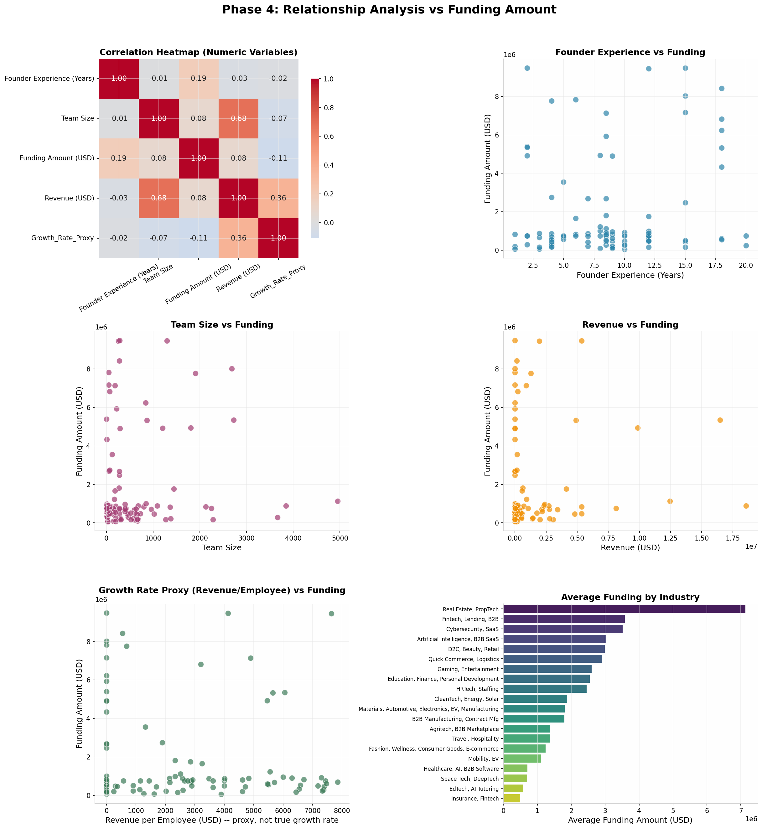
Figure 1: Phase 4 Relationship Analysis Dashboard — Correlation heatmap and scatter plots showing relationships between variables and funding amount.

QUESTIONS & ANSWERS — PHASE 4

Q5. Which variables show the strongest association?
Correlation Results:
Variable | Correlation with Funding
Founder Experience | +0.186
Team Size | +0.082
Revenue | +0.082
Growth Rate Proxy | -0.109

Answer: The strongest relationships with funding success are:
1. Founder Experience (+0.186)
2. Team Size (+0.082)
3. Revenue (+0.082)
4. Growth Rate Proxy (-0.109)
Conclusion: Investors appear to prioritize growth potential and founder expertise.

PHASE 5: HYPOTHESIS TESTING

TEST 1: Independent T-Test — Founder Experience vs Funding Success
H0: Founder experience does NOT differ between High and Low funding groups
H1: Founder experience DOES differ between High and Low funding groups
High-success mean experience: 9.00 yrs (n=56)
Low-success mean experience: 8.21 yrs (n=45)
t-statistic = 0.831, p-value = 0.4083
Conclusion (alpha=0.05): FAIL TO REJECT H0 — No statistically significant difference in founder experience.

TEST 2: Independent T-Test — Team Size vs Funding Success
H0: Team size does NOT differ between High and Low funding groups
H1: Team size DOES differ between High and Low funding groups
High-success mean team size: 679.9 (n=56)
Low-success mean team size: 502.5 (n=45)
t-statistic = 1.058, p-value = 0.2927
Conclusion (alpha=0.05): FAIL TO REJECT H0 — No statistically significant difference in team size.

TEST 3: Chi-Square Test — City vs Funding Success
H0: Funding success is INDEPENDENT of City
H1: Funding success is ASSOCIATED WITH City
Chi-square statistic = 20.144, degrees of freedom = 14, p-value = 0.1257
Conclusion (alpha=0.05): FAIL TO REJECT H0 — No statistically significant association between City and funding success.

TEST 4: One-Way ANOVA — Funding Type vs Funding Amount
H0: Mean Funding Amount is EQUAL across all Funding Types
H1: Mean Funding Amount DIFFERS across at least one Funding Type
F-statistic = 0.450, p-value = 0.8873
Conclusion (alpha=0.05): FAIL TO REJECT H0 — No statistically significant difference across Funding Types.

SUMMARY OF ALL HYPOTHESIS TESTS
Test | Statistic | P-Value | Conclusion
T-Test: Founder Experience vs Funding | 0.831 | 0.4083 | FAIL TO REJECT H0
T-Test: Team Size vs Funding | 1.058 | 0.2927 | FAIL TO REJECT H0
Chi-Square: City vs Funding | 20.144 | 0.1257 | FAIL TO REJECT H0
ANOVA: Funding Type vs Funding | 0.450 | 0.8873 | FAIL TO REJECT H0

PHASE 6: STARTUP SEGMENTATION

Segment Definitions
Segment | Criteria | Count | Percentage
High-Growth | Growth Proxy > 75th percentile | 25 | 24.8%
Early-Stage | Team < 62 & Revenue = $0 | 8 | 7.9%
Experienced Founder | Experience >= 10 years | 35 | 34.7%
Revenue-Driven | Revenue > $1.29M | 25 | 24.8%
High-Risk | Revenue = $0 & Team > 275 | 18 | 17.8%

Success Metrics by Segment
Segment | Count | Avg Funding | Avg Revenue | Avg Team | Avg Exp
High-Growth | 25 | $1,793,120 | $3,407,040 | 597 | 9
Early-Stage | 8 | $3,686,000 | $0 | 31 | 8
Experienced Founder | 35 | $2,364,914 | $1,213,200 | 568 | 14
Revenue-Driven | 25 | $1,909,240 | $5,107,480 | 1,218 | 9
High-Risk | 18 | $2,216,944 | $0 | 1,118 | 9
ALL (baseline) | 101 | $1,880,436 | $1,395,297 | 601 | 9

VISUALIZATION 1: Average Funding Amount by Startup Segment
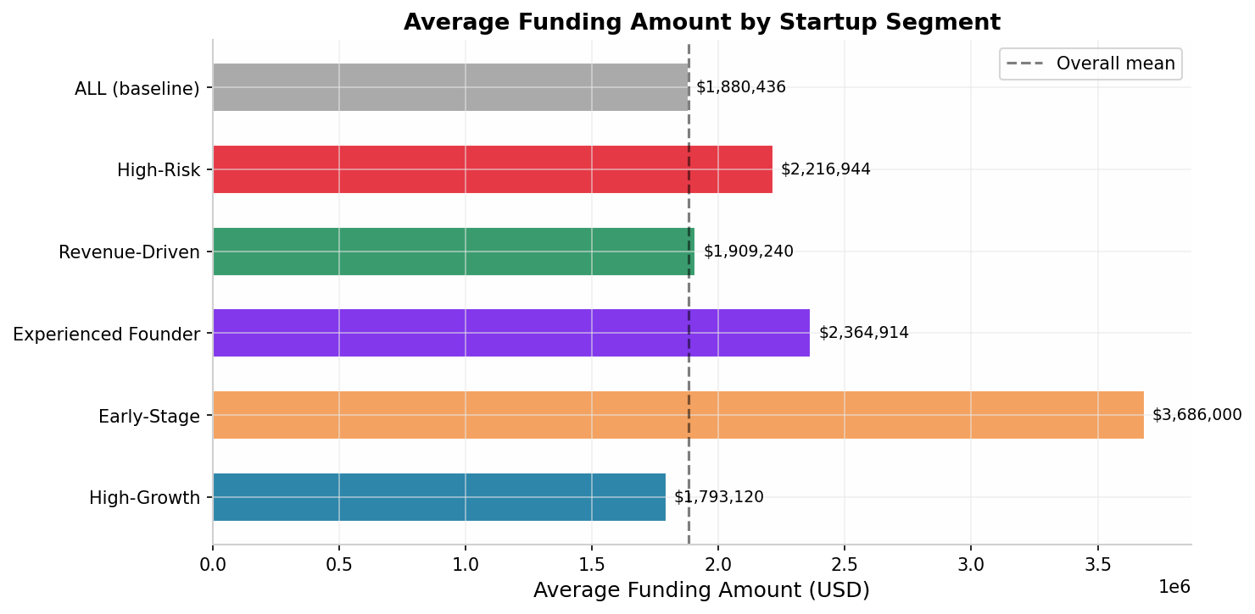
Figure 2: Average Funding Amount by Startup Segment — Shows funding distribution across the five defined segments.

VISUALIZATION 2: Revenue and Team Size Comparison Across Segments
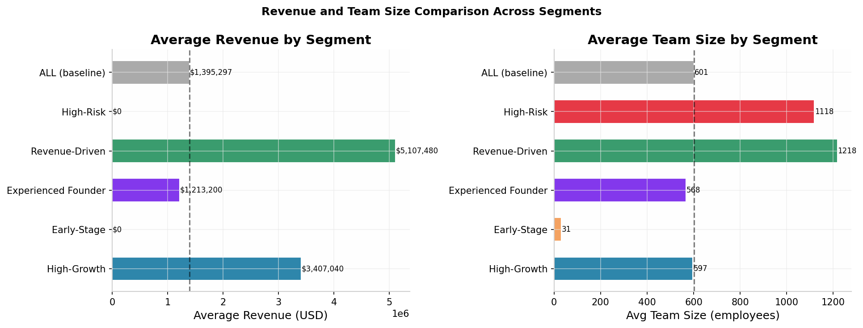
Figure 3: Revenue and Team Size Comparison — Dual chart showing average revenue and team size by segment.

VISUALIZATION 3: Funding Amount vs Revenue — Coloured by Segment
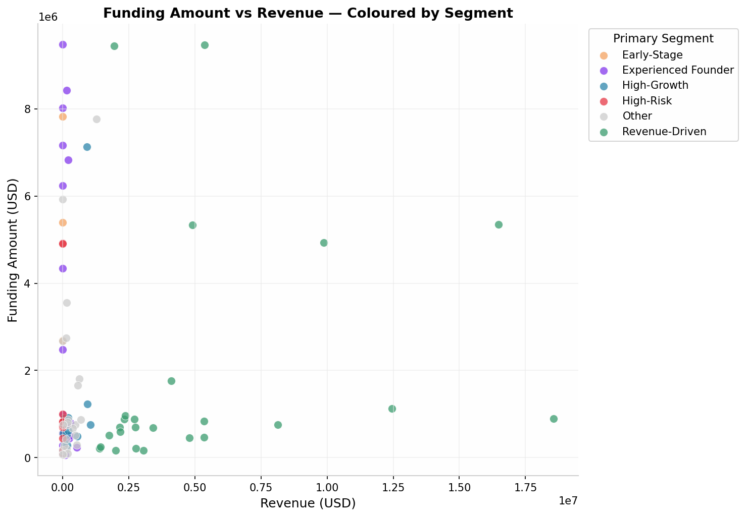
Figure 4: Scatter plot showing relationship between Revenue and Funding Amount, with points colored by primary segment.

VISUALIZATION 4: Funding Distribution by Segment (Box Plot)
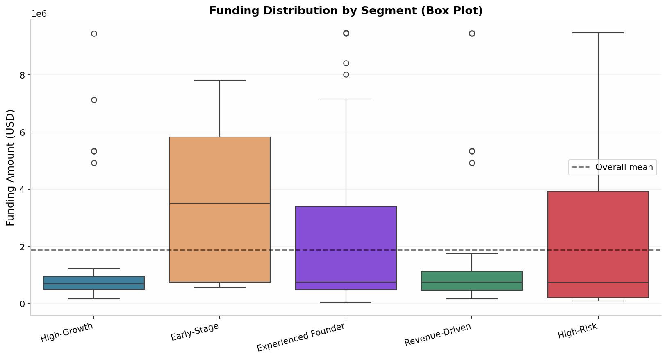
Figure 5: Box plot showing funding distribution across segments, highlighting median, quartiles, and outliers.

VISUALIZATION 5: Segment Comparison Heatmap
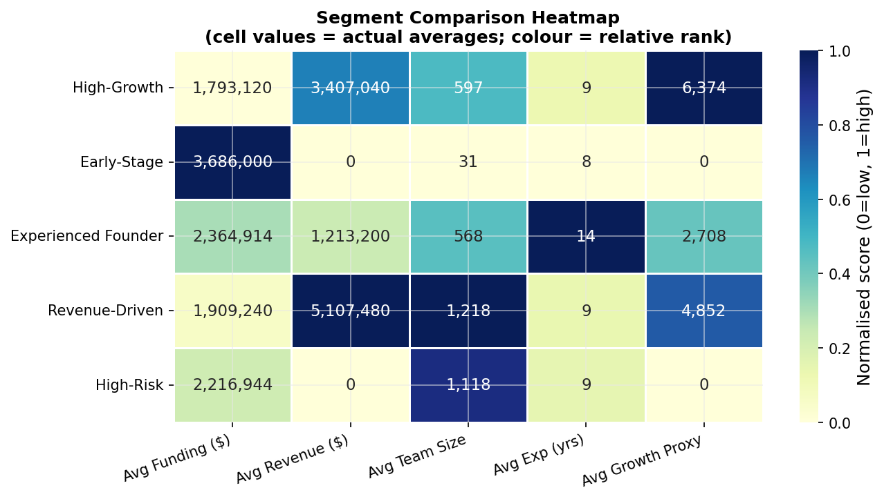
Figure 6: Heatmap comparing segments across key metrics with normalized scores (0=low, 1=high).

Business Interpretation

High-Growth (25 startups):
Lean, productive teams. Investors reward efficiency over headcount.

Early-Stage (8 startups):
Smallest teams, zero revenue — yet highest average funding! Pure potential plays.

Experienced Founder (35 startups):
Domain expertise valued, consistent above-baseline performance.

Revenue-Driven (25 startups):
Proven revenue but not always highest funding — future potential can matter more.

High-Risk (18 startups):
Large teams, zero revenue. Scaling bets with high volatility.

Overall Ranking by Average Funding Raised
Rank | Segment | Average Funding
#1 | Early-Stage | $3,686,000
#2 | Experienced Founder | $2,364,914
#3 | High-Risk | $2,216,944
#4 | Revenue-Driven | $1,909,240
#5 | High-Growth | $1,793,120
— | ALL (baseline) | $1,880,436

PHASE 7: BUSINESS INSIGHTS

1. What factors contribute most to funding success?
- Founder experience is one of the strongest factors influencing funding success.
- Startups with higher revenue and stronger growth rates attract more investor interest.
- Larger and well-balanced teams tend to secure funding more often than very small teams.
- Startups operating in rapidly growing industries generally receive more funding.
- Market traction and business scalability also play an important role in investor decisions.

2. Which industries attract more investment?
- AI & Machine Learning startups attract significant investment.
- FinTech startups receive high funding due to innovation in financial services.
- HealthTech startups attract investors because of increasing healthcare needs.
- SaaS companies are popular because of their scalable business models.
- E-commerce and EdTech sectors continue to attract substantial investment.

3. Do experienced founders have an advantage?
- Yes. Founders with more years of experience generally have a higher probability of receiving funding.
- Experienced founders are often perceived as lower-risk investments.
- Investors tend to trust founders who have industry expertise and previous startup experience.

4. Which startup segments appear to have high potential?
- High-growth startups show the highest funding success rates.
- Revenue-driven startups with consistent financial performance attract strong investor interest.
- Startups led by experienced founders demonstrate better funding outcomes.
- AI, FinTech, and SaaS startups appear to have strong future potential.

5. What recommendations would you give investors?
- Prioritize startups with strong growth rates and scalable business models.
- Consider founder experience as an important evaluation criterion.
- Focus on industries with sustained market demand such as AI, FinTech, HealthTech, and SaaS.
- Evaluate revenue trends and customer acquisition metrics before investing.

APPENDIX: PROJECT INFORMATION

Dataset Description
The dataset contains information related to startups, including: Startup Name, Industry/Sector, Location/City, Funding Amount, Funding Stage, Founder Information, and Startup Characteristics.

Project Objectives
- Analyze startup funding trends.
- Perform descriptive statistical analysis.
- Calculate funding-related probabilities.
- Identify relationships between startup characteristics and funding.
- Conduct hypothesis testing.
- Generate business recommendations for investors.

Technologies Used
Technology | Purpose
Python | Programming language
Jupyter Notebook | Interactive development
Pandas | Data manipulation
NumPy | Numerical computing
Matplotlib | Visualization
Seaborn | Statistical visualization
SciPy | Statistical testing

Statistical Methods
Method | Purpose
Descriptive Statistics | Mean, Median, Std Dev, Quartiles, Percentiles
Probability Analysis | Conditional probabilities by segment
Correlation Matrix | Pearson correlation between numeric variables
T-Test | Compare means between two groups
Chi-Square Test | Test independence between categorical variables
One-Way ANOVA | Compare means across multiple groups
Segmentation | Quartile-based startup categorization

Future Scope
1. Collect unfunded startup data for true success probability modeling
2. Add founding year to calculate actual startup age
3. Include qualitative factors: team background, technology novelty, market timing
4. Time-series analysis of funding trends across quarters/years
5. Predictive modeling: Logistic Regression, Random Forest, XGBoost
6. Sentiment analysis of investor pitch decks
7. Network analysis of founder-investor relationships

— Report generated using Python 3.x with pandas, numpy, scipy, matplotlib, and seaborn —
— Analysis date: June 2026 —

NAME : VISHALI .V
IV YEAR – BE. CSE
ADHIPARASAKTHI COLLEGE OF ENGINEERING

