

**OBJECT DETECTION USING DEEP REINFORCEMENT LEARNING**

**FINAL PROJECT REPORT**



Submitted By: Vitesh Bangar

ID: T2405 243

IIT ROPAR

Under the Supervision of:

Dr. Aparna Akula

**ACKNOWLEDGEMENT**

I would like to express my deepest gratitude to Dr. Aparna Akula, Principal Scientist at CSIR-CSIO, for providing me with the opportunity to undertake this research internship under her esteemed guidance. Her insightful advice, unwavering support, and encouragement have been instrumental in shaping the direction and quality of this research on object detection using deep reinforcement learning. I am also grateful to the entire team at CSIR-CSIO for their invaluable assistance and for providing a conducive research environment.

I would also like to take this opportunity to thank the administration of CSIR-CSIO and other department members for working with me, especially the PhD scholars Mr. Manjeet Singh, Ms. Shalini Dwivedi, technical assistant Mr. Neeraj Guleria for sharing their insightful opinions, providing me with the tools and facilities I needed for my work, and making my internship at CSIR-CSIO such an amazing experience. Finally, I am thankful to my family and friends for their constant support and encouragement throughout this internship.

**TABLE OF CONTENTS**

1. **About the Organization**……..…………………………………………………….5
   1. CSIR…………………………………………………………………………..5
   2. CSIR-CSIO…………………………………………………………………...5
   3. ISenS DEPARTMENT……………………………………………………....5
2. **Theory**………………….....................................................................................6
   1. Reinforcement Learning……….…………………………………………...6
   2. Object Detection……...……………………………………………………..8
   3. Object Detection using Reinforcement Learning ………………………10
3. **Research Paper Overview**……..………………………………………………..12
   1. Hierarchical Model Code………..………………………………………...14
   2. Dynamic Model Code……………………………………………………...17
   3. Conclusion…..……………………………………………………………...20
4. **Experimentation**…………………………………………………………………..20
   1. Q-Learning on CIFAR10…..………………………………………………20
   2. Actor-Critic on CIFAR10……..……………………………………………24
   3. Object Detection on FLIR_ADAS Dataset using DQN…………………26
5. **Conclusion**……………………….………………………………………………..29
   1. Future Directions…………………………………………………………...30
6. **References**………………………………..……………………………………….31

**List of Figures**

| **Sr. No.** | **Description** | **Page No.** |
| --- | --- | --- |
| 1 | Basic Structure of a RL model | 8 |
| 2 | Sample Output of an object detection model | 10 |
| 3 | Sample images from CIFAR10 Dataset | 21 |
| 4 | Sample output of Q-Learning model | 23 |
| 5 | Sample output of Actor-Critic model | 26 |
| 6 | Some images from FLIR_ADAS dataset | 27 |
| 7 | Sample output of DQN model | 28 |

**About the Organization**

1. **CSIR**

CSIR is an abbreviation for the Council of Scientific and Industrial Research. It is a leading Indian government R&D (Research and Development) agency. The CSIR, founded in 1942, is one of the world's largest publicly sponsored research and development institutions. Its purpose is to promote, guide, and organize scientific and industrial research in India while also encouraging innovation, technological improvement, and industrial growth. It provides fellowships, grants, and training programs to develop a pool of bright scientists and researchers.

1. **CSIR-CSIO**

Operating under the auspices of CSIR, India, the Council of Scientific and Industrial Research-Central Scientific Instruments Organization (CSIR-CSIO) is a well-known national laboratory. Research, design, and development of a wide range of scientific and industrial instruments constitute their primary objective. This instrumentation knowledge is useful in a variety of fields, including energy, defense, healthcare, and agriculture. In addition to carrying out this crucial function, CSIR-CSIO promotes industry partnerships and offers skill development initiatives to help India establish an innovative culture.

1. **ISenS Department**

A specialist department known as the Centre of Excellence for Intelligent Sensors and Systems (ISenS) is housed within the CSIR-CSIO. Particularly for defense applications, the department is adept at creating clever sensor applications that frequently make use of artificial intelligence. Their research focuses on cutting-edge sensors and measurement methods, often combining machine learning and powerful computation. ISenS has state-of-the-art testing facilities for many different kinds of sensors, including complex sensor networks, seismic, acoustic, and infrared imaging.

**2. Theory**

The internship report provides a comprehensive overview of experiences at CSIR-CSIO, with a concentrated focus on Object Detection using Deep Reinforcement Learning. Throughout the internship, fundamental algorithms of reinforcement learning were explored. The report elaborates on basic concepts of object detection and reinforcement learning and its advantages.

Much of the work was dedicated to object detection using DQN on the annotated FLIR_ADAS dataset. This involved implementing the knowledge gained from the research papers in this domain.

The practical aspects of the internship involved the deployment of reinforcement learning algorithms for object detection. This included creating custom gym environments based on the dataset, custom action, and state spaces in them, designing the reward function, and setting hyperparameter values. The outcomes highlighted the immense potential of reinforcement learning in the domain of object detection.

In summary, this report encapsulates the reinforcement learning algorithms like Q-Learning and Actor-Critic networks, their implementation on the CIFAR10 dataset, an explanation of codes related to the research paper, and Deep Q-Networks to detect objects in the FLIR_ADAS dataset.

1. **Reinforcement Learning**

Reinforcement learning (RL) is a machine learning technique that teaches software agents to make optimal decisions through trial-and-error interactions with their surroundings in order to maximize a reward.

The key aspects of reinforcement learning are:

**Interaction with an Environment**

In RL, the agent (the machine learning model) interacts directly with an environment, taking action and receiving feedback in the form of rewards or punishments.

**Maximizing Cumulative Reward**

The agent's purpose is to develop a policy - a mapping of states to actions - that maximizes the total cumulative reward it receives over time.

**Learning through Experience**

RL agents learn by experimenting, unlike supervised learning where they are trained on labeled data. They gradually learn which actions lead to the highest rewards through this trial-and-error process.

**Delayed Rewards**

Rewards in RL can be delayed, meaning the best action to take in the short term may not be the one that leads to the highest long-term reward. RL agents need to balance exploration (trying new things) and exploitation (using what they've learned).

**Key Components:**

* Agent: The decision-maker or learner.
* Environment: The external system the agent interacts with.
* State (s): A representation of the current situation.
* Action (a): Choices available to the agent.
* Reward (r): Feedback from the environment.
* Policy (π): The strategy the agent employs to decide actions based on states.
* Value Function (V): Estimates the long-term reward of a state.
* Q-Function (Q): Estimates the long-term reward of a state-action pair.

**Learning Process:**

* Exploration vs. Exploitation: Balancing the need to try new actions (exploration) with the need to optimize the known rewarding actions (exploitation).
* Reward Signal: The agent receives rewards that signal the success of its actions. The goal is to maximize the cumulative reward.
* Policy Improvement: Using algorithms like Q-learning or policy gradients, the agent updates its policy to improve decision-making over time.

**Applications of RL:**

* Game Playing: Notably used in AlphaGo.
* Robotics: For controlling robotic arms and autonomous vehicles.
* Finance: For stock trading strategies.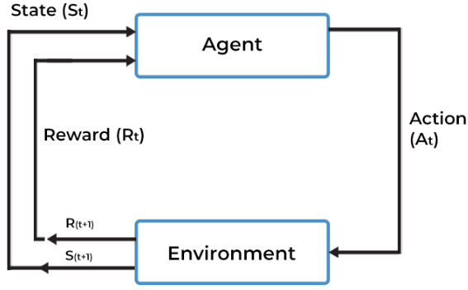

Figure 1-Basic Structure of a RL model

1. **OBJECT DETECTION**

Object detection is a computer vision approach for recognizing and locating specific items in pictures or movies. This technology has numerous uses, ranging from medical imaging to self-driving automobiles, and is an essential component of advanced driver assistance systems (ADAS) and video surveillance systems.

Object detection is a technique that uses neural networks to localize and classify objects in images. It involves two main tasks:

* Object Localization: Determining the location of an object within an image by demarcating it with a bounding box.
* Object Classification: Identifying to which category a detected object belongs.

Deep learning-based object detection models use convolutional neural networks (CNNs) to learn features from images. These models typically consist of a backbone, neck, and head:

* Backbone: Extracts features from the input image.
* Neck: Concatenates the feature maps from the backbone.
* Head: Predicts bounding boxes and classification scores for each feature set.

**Core Techniques:**

* **Convolutional Neural Networks (CNNs):** These are used for feature extraction and classification. CNNs are the backbone of most modern object detection models.
* **Region-based CNN (R-CNN):** Proposes regions in an image and classifies them individually. Variants include Fast R-CNN and Faster R-CNN, which improve speed and accuracy.
* **You Only Look Once (YOLO):** A single-stage object identification system that predicts bounding boxes and class probabilities directly from entire images in one evaluation, allowing for real-time detection.
* **Single Shot MultiBox Detector (SSD):** Similar to YOLO, SSD detects objects in images with a single forward pass through a network.

**Evaluation Metrics:**

* Precision and Recall: Measure the accuracy and completeness of the detection.
* Intersection over Union (IoU): Evaluate the overlap between the predicted and ground-truth bounding boxes.
* Mean Average Precision (mAP): A comprehensive metric that considers both precision and recall across different IoU thresholds.

Object detection is used in various real-world applications, including:

* Autonomous Vehicles: Detecting and tracking objects to ensure safe navigation.
* Medical Imaging: Identifying tumors and other medical anomalies.
* Video Surveillance: Monitoring and tracking objects in real time.
* Business Security: Preventing unauthorized access and theft.

Figure 2-Sample Output of an object detection model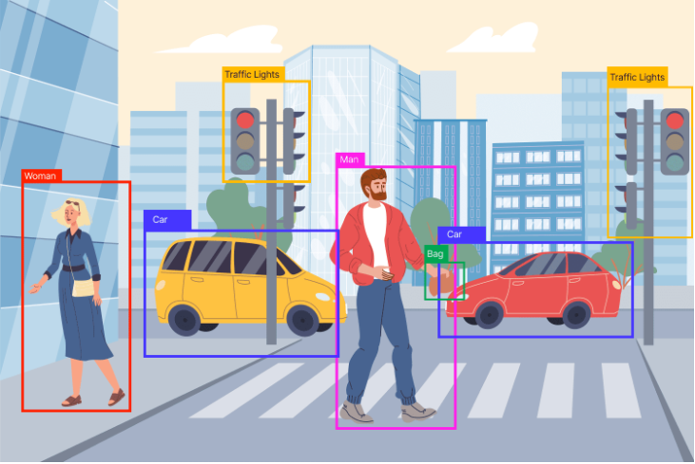

1. **OBJECT DETECTION USING REINFORCEMENT LEARNING**

Object detection is a computer vision task that involves identifying and locating objects of interest within an image or video. Traditional object detection approaches have primarily relied on supervised learning techniques, where models are trained on large datasets of labeled images.

In recent years, researchers have explored the use of reinforcement learning (RL) for object detection, as it offers several potential benefits:

**Adaptive and Dynamic Detection**

RL-based object detectors can learn to actively explore and focus on the most informative regions of an image, adapting their behavior based on the feedback received from the environment.

**Efficient Use of Training Data**

RL agents can learn effective detection policies by interacting with the environment, potentially requiring fewer labeled training examples compared to supervised approaches.

**Handling Partial Observability**

RL can handle partially observable environments, where the agent does not have complete information about the state of the world, which is often the case in real-world object detection scenarios.

**Optimizing for Long-Term Objectives**

RL agents can learn to make decisions that optimize for long-term rewards, such as accurately detecting objects while minimizing the number of false positives.

**Key Approaches:**

Researchers have explored several RL-based approaches for object detection, including:

**Hierarchical RL for Object Localization:**

In this approach, the agent learns a hierarchical policy that first identifies the most promising regions of the image and then focuses on these regions to refine the object detection.

**Dynamic RL for Object Localization:**

Here, the agent dynamically adjusts its attention and exploration strategy based on the current state of the environment, aiming to efficiently locate objects of interest.

**Reinforcement Learning for Region Proposal Networks:**

RL has been used to train region proposal networks (RPNs), which generate object proposals that can then be classified by a separate object detection model.

**Reinforcement Learning for End-to-End Object Detection:**

Some researchers have explored using RL to train entire end-to-end object detection models, where the agent learns to both localize and classify objects in a unified framework.

**Training Process:**

* Environment Setup: The image dataset acts as the environment, and the agent's task is to detect objects within these images.
* Reward System: The reward is based on detection accuracy, encouraging the agent to find the most precise bounding boxes and correct classifications.
* Policy Optimization: Techniques like Q-learning and actor-critic methods are used to optimize the detection policy.

The integration of deep reinforcement learning with object detection represents a significant advancement in computer vision, providing a powerful framework for creating adaptive, efficient, and accurate detection systems.

**3. Research Paper Overview**

Title -” Object Detection with Deep Reinforcement Learning ”

Authors - Manoosh Samiei and Ruofeng Li

Affiliation - McGill University

This research focuses on improving object localization using a novel active object localization algorithm based on deep reinforcement learning (DRL). The study compares two Markov Decision Process (MDP) formulations: hierarchical and dynamic methods. The paper explores the impact of different hyperparameters and architecture changes on the performance of these models. This study aims to improve object detection by formulating it as a dynamic decision process using DRL.

**Markov Decision Process (MDP) Formulation:**

**Actions:**

Hierarchical Method: The agent chooses one of five sub-regions (top-left, top-right, bottom-left, bottom-right, center) of the image.

Dynamic Method: The agent deforms a bounding box using transformations (horizontal and vertical moves, scale changes, aspect ratio changes).

**States:**

Composed of a feature vector (extracted using a pre-trained VGG16 network) and a history vector of previous actions. The feature vector dimensions differ between methods (25088 for hierarchical, 4096 for dynamic).

**Rewards:**

Based on the improvement in Intersection-over-Union (IoU) between predicted and ground truth bounding boxes. Non-terminal actions reward improvements in IoU; terminal actions reward achieving a set IoU threshold.

**Results and Discussions:**

**Hierarchical Method:**

Uses sub-region selection to progressively focus on smaller image areas. Various configurations were tested, including double Q-learning and reward adjustments. The non-overlapping sub-region approach provided the best performance.

**Dynamic Method:**

Allows more flexible bounding box adjustments, moving and resizing freely within the image. Though more versatile, it requires more computational resources and training time.

**Performance Comparisons:**

The hierarchical method generally performed faster but struggled with larger objects due to its progressively smaller sub-region focus. The dynamic method was more adaptable but computationally intensive.

**Conclusions:**

This study demonstrates that treating object detection as a dynamic decision process via DRL offers a promising alternative to traditional methods. While hierarchical methods show quicker convergence, dynamic methods offer greater flexibility. Future work should focus on combining the strengths of both methods and addressing their limitations.

1. **HIERARCHICAL MODEL CODE**

**Libraries Used-**

* TensorFlow and Keras:
  + *import tensorflow as tf*: TensorFlow is an open-source deep learning library.
  + *from keras.initializers import VarianceScaling*: Keras is a high-level neural networks API, and VarianceScaling initializer helps in initializing the weights of the network layers.
  + *from keras.preprocessing import image*: Used for image processing utilities.
  + *from keras.models import Sequential*: The sequential model is a linear stack of layers in Keras.
  + *from keras.layers import Dense, Dropout, Activation, Flatten*: Layers for building neural networks.
  + *from keras.optimizers import RMSprop, SGD, Adam*: Optimizers for training the model.
* *import numpy as np*: Numpy is a fundamental package for scientific computing in Python.
* *from PIL import Image, ImageDraw, ImageFont*: For image manipulation and drawing.
* *import cv2*: OpenCV is a library of programming functions mainly aimed at real-time computer vision.
* *import os*: Provides functions to interact with the operating system.
* *import xml.etree.ElementTree as ET*: For parsing and creating XML data.
* *import random*: Generates random numbers.

The code leverages TensorFlow and Keras for building and training neural networks, focusing on a Markov Decision Process (MDP) to identify and localize objects in images. The main components include setting up the environment, defining the Q-network, preprocessing the dataset, training the model, and visualizing results.

TensorFlow is configured to use available GPUs efficiently by enabling memory growth.

The PASCAL VOC 2012 dataset is used for training and evaluation. The dataset is unzipped and organized into directories for storing models, visualizations, and testing results.

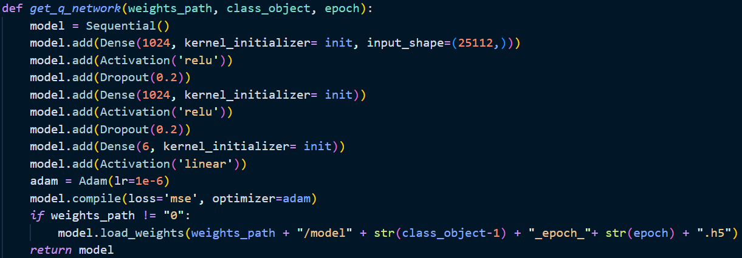

A Q-network is defined using Keras' Sequential API. The network consists of dense layers with ReLU activations and dropout for regularization. An Adam optimizer with a very low learning rate is used to train the network. The model architecture is designed to handle the large state space inherent in object detection tasks.

The MDP framework is applied to object detection by treating each image as an environment. The agent's actions involve selecting sub-regions of the image to focus on and refining its search for the object iteratively. The Q-network is trained using deep Q-learning, where the network learns to predict the value of each action in a given state. The training involves an experience replay mechanism, which stores the agent's experiences and samples them randomly to break the correlation between consecutive samples.

In the hierarchical method, the agent divides the image into sub-regions and decides which region to focus on at each step. This method allows the agent to narrow down the search area progressively, reducing computational complexity.

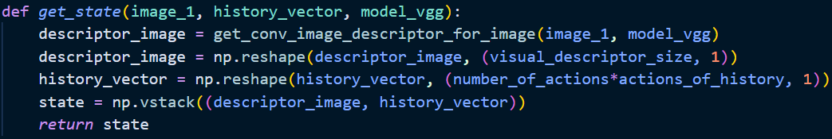

The state representation includes a feature vector extracted from the VGG16 network and a history vector of previous actions. This helps the agent to avoid repetitive actions and focus on promising regions.

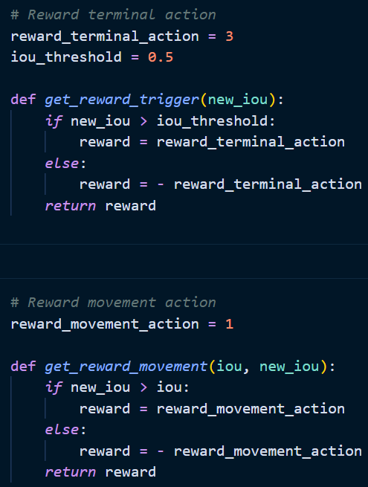

The reward function is based on the improvement in the Intersection-over-Union (IoU) between the predicted and ground truth bounding boxes. Positive rewards are given for improvements, while negative rewards are given for regressions.

The model's performance is evaluated using the average IoU overall testing images. Various hyperparameters and settings are experimented with, including double Q-learning, reward adjustments, overlapping vs. non-overlapping sub-regions, and more. The hierarchical method showed quicker convergence but struggled with larger objects due to its progressively smaller sub-region focus.

1. **DYNAMIC MODEL CODE**

**Libraries Used-**

* Tensorflow and Keras:
  + *from tensorflow.keras import backend as K*: Backend utilities for Keras.
  + *from tensorflow.keras.layers import Dense, Dropout, Activation, Flatten*: Layer types for building neural networks.
  + *from tensorflow.keras.models import Sequential*: Sequential model for stacking layers linearly.
  + *from tensorflow.keras.optimizers import RMSprop, SGD, Adam*: Different optimizers for training the network.
  + *from tensorflow.keras.applications.vgg16 import VGG16*: Pre-trained VGG16 model for feature extraction.
* *import numpy as np*: For array operations, numerical computations, and handling image data.
* *import cv2*: For image processing tasks like reading, displaying, and manipulating images.
* *import os*: For directory and file operations, changing directories, creating folders, etc.
* *import xml.etree.ElementTree as ET*: For parsing XML files, which is often used for reading dataset annotations.
* *import random*: For generating random numbers, shuffling data, and other random operations.
* *import math*: For mathematical operations, though not specifically shown in the provided cells.
* *import pandas as pd*: For data manipulation and analysis.
* *import xmltodict*: For converting XML data into Python dictionaries.
* *import matplotlib.pyplot as plt*: For plotting graphs, displaying images, and visualizing data.

TensorFlow is configured to use available GPUs efficiently by enabling memory growth. This ensures that the model can utilize GPU resources without exhausting memory, leading to better performance and faster training times.

The PASCAL VOC 2012 dataset is used for training and evaluation. The dataset is unzipped and organized into directories for storing models, visualizations, and testing results. The dataset contains images and corresponding annotations in XML format, which are parsed to extract object information.

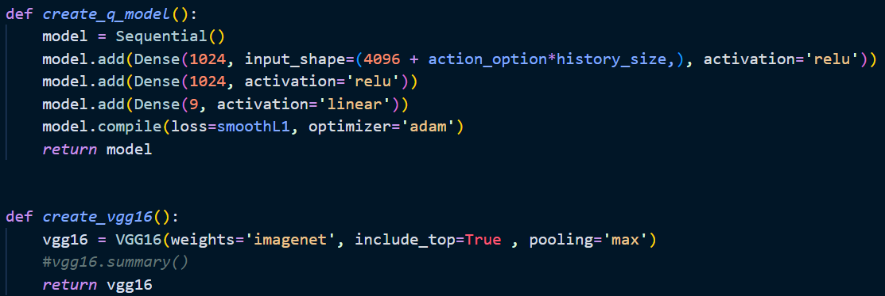

A Q-network is defined using Keras' Sequential API. The network consists of several dense layers with ReLU activations and dropout for regularization. The Adam optimizer with a very low learning rate is used to train the network. The model architecture is designed to handle the large state space inherent in object detection tasks. The Q-network is trained to predict the value of each action in a given state, enabling the agent to make informed decisions.

The MDP framework is applied to object detection by treating each image as an environment. The agent's actions involve adjusting the bounding box to refine its search for the object iteratively. The Q-network is trained using deep Q-learning, where the network learns to predict the value of each action in a given state. The training involves an experience replay mechanism, which stores the agent's experiences and samples them randomly to break the correlation between consecutive samples.

The dynamic method allows flexible adjustments to the bounding box, such as horizontal and vertical moves, scale changes, and aspect ratio changes. This method provides the agent with greater freedom to adapt the bounding box shape and position to fit the object accurately.

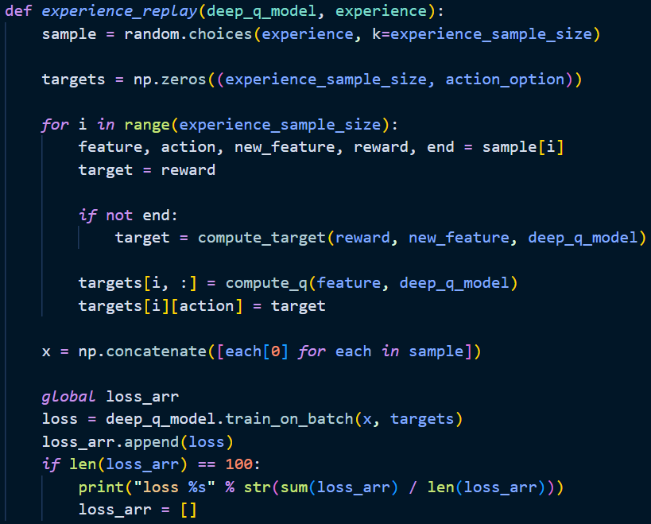

The state representation includes a feature vector extracted from the VGG16 network and a history vector of previous actions. This helps the agent to avoid repetitive actions and focus on promising regions.

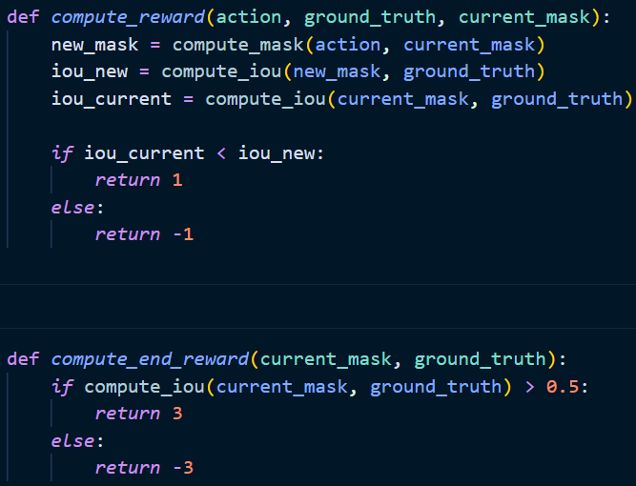

The reward function is based on the improvement in the Intersection-over-Union (IoU) between the predicted and ground truth bounding boxes. Positive rewards are given for improvements, while negative rewards are given for regressions. This encourages the agent to refine the bounding box to maximize the IoU.

The model's performance is evaluated using the average IoU overall testing images. Various hyperparameters and settings are experimented with, including double Q-learning, reward adjustments, overlapping vs. non-overlapping sub-regions, and more.

1. **CONCLUSION**

The hierarchical and dynamic deep reinforcement learning methods for object detection each have distinct strengths. The hierarchical method, which divides the image into sub-regions and progressively focuses on smaller areas, achieves faster convergence and is more computationally efficient, making it suitable for tasks with limited resources. However, it struggles with larger objects due to its limited flexibility in bounding box adjustments. In contrast, the dynamic method offers greater flexibility by allowing the agent to move, resize, and change the aspect ratio of the bounding box, making it more adaptable to complex object shapes and positions. While the dynamic method shows higher potential for precision and adaptability, it requires more extensive hyperparameter tuning and computational resources, leading to slower convergence. Therefore, the choice between these methods depends on the specific requirements of the task, such as the need for efficiency versus adaptability and precision.

**4. Experimentation**

1. **Q-Learning on CIFAR10 Dataset**

The code implements a Q-learning algorithm for object detection using the CIFAR-10 dataset. The code trains an agent to detect objects by interacting with the environment and learning optimal actions through trial and error. The key components of this implementation include setting up the environment, defining the Q-learning agent, preprocessing the dataset, training the agent, and visualizing results.

The code imports essential libraries such as TensorFlow, OpenCV, NumPy, and matplotlib for deep learning, image processing, numerical computations, and visualization.

The CIFAR-10 dataset is loaded and preprocessed. CIFAR-10 consists of 60,000 32x32 color images in 10 classes, with 6,000 images per class. The dataset is divided into training and testing sets, and images are reshaped and normalized to prepare them for training the Q-learning agent.

**Sample Images from Dataset:**

Figure 3-Sample images from CIFAR10 Dataset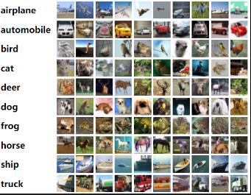

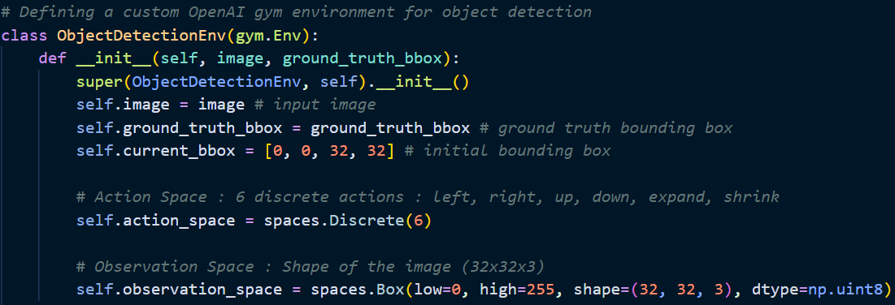

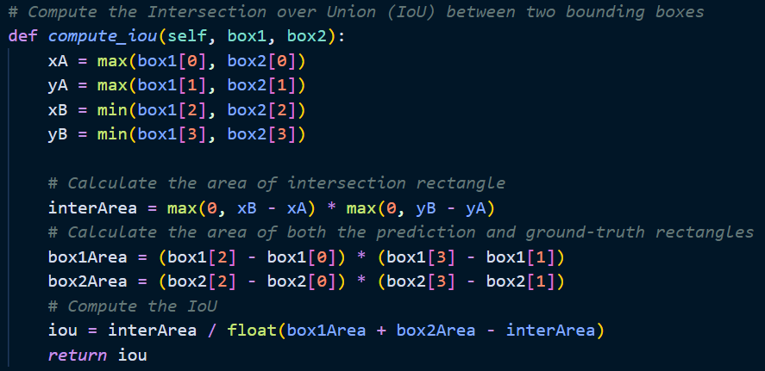

An environment class is defined to simulate the object detection task. This class includes methods to reset the environment, take a step (action), and render bounding boxes for visualization. The environment interacts with the agent, providing state representations, rewards, and next states based on the actions taken by the agent.

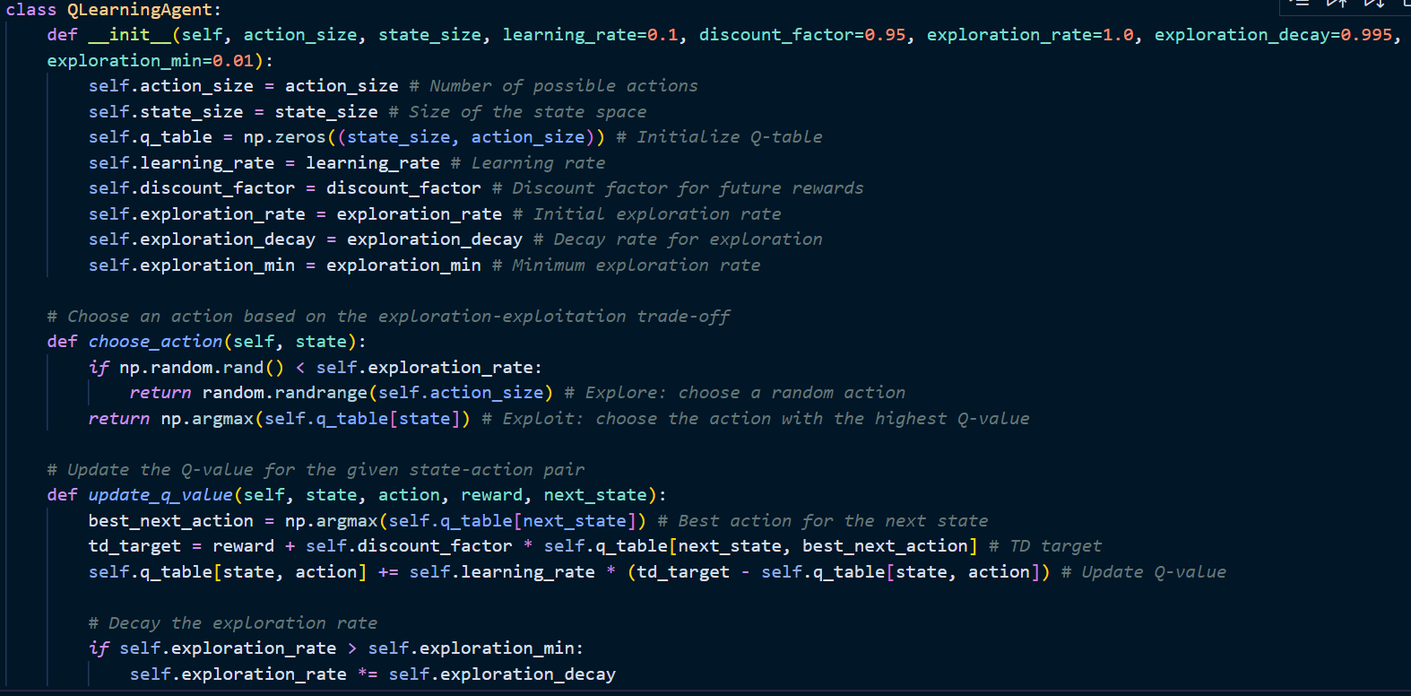

A Q-learning agent class is defined with methods to initialize the Q-table, choose actions, and update Q-values based on the received rewards. The agent follows an epsilon-greedy policy to balance exploration and exploitation. Initially, the agent explores more to gather information, and over time, it exploits the learned Q-values to make optimal decisions.

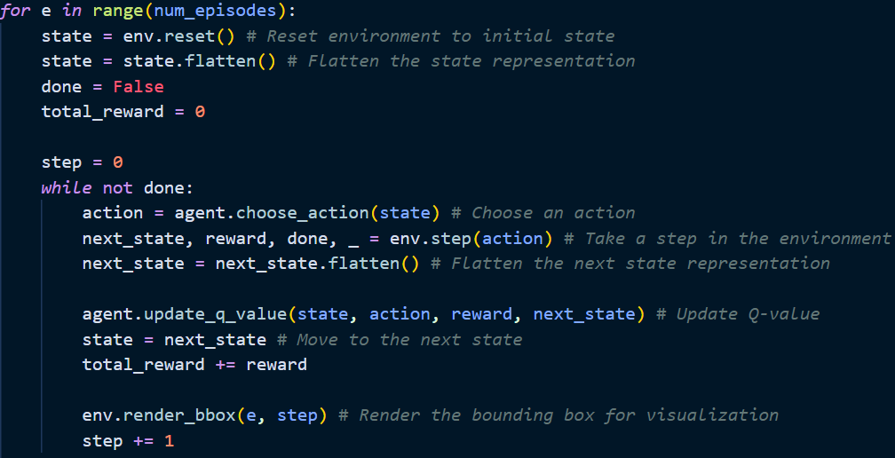

The agent is trained over multiple episodes. In each episode, the environment is reset to its initial state, and the agent interacts with the environment by taking action and receiving feedback. The Q-values are updated using the Bellman equation, which incorporates the reward received and the estimated future rewards.

The training process includes visualizing bounding boxes predicted by the agent on images and providing real-time feedback on the agent's performance.

**Results:**

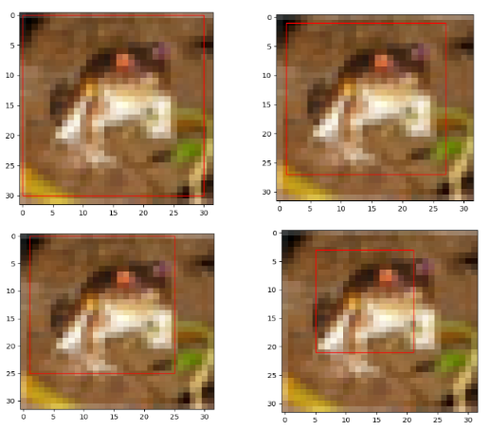

Figure 4-Sample output of Q-Learning model

1. **Actor-Critic Algorithm on CIFAR10 Dataset**

The code implements an Actor-Critic reinforcement learning model to perform object detection using YOLOv8 for obtaining ground truth bounding boxes on the CIFAR-10 dataset. The key components include installing necessary libraries, loading and preprocessing the dataset, defining the actor and critic models, training the models using the Actor-Critic method, and visualizing the results.

The *ultralytics* package is installed for YOLOv8 model usage. Essential libraries such as TensorFlow, PyTorch, OpenCV, NumPy, and matplotlib are imported for deep learning, image processing, numerical computations, and visualization.

The CIFAR-10 dataset is loaded using TensorFlow's dataset utilities. The images are normalized, and labels are one-hot encoded. The CIFAR-10 dataset consists of 60,000 32x32 color images in 10 classes, divided into training and testing sets.

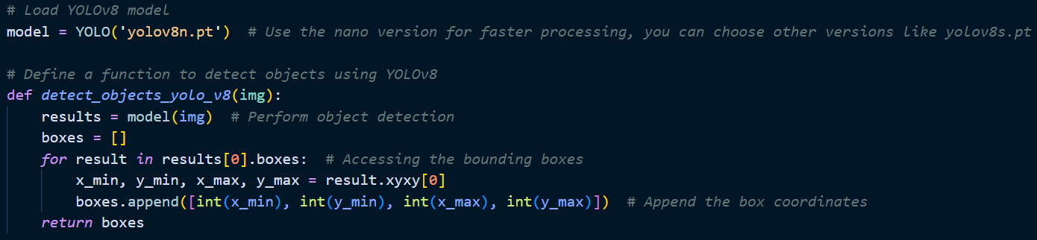

The YOLOv8 model is loaded using the *ultralytics* package. The nano version of the model (*yolov8n.pt*) is used for faster processing. A function *detect_objects_yolo_v8* is defined to perform object detection on images using YOLOv8, returning bounding boxes for detected objects. Ground truth bounding boxes are obtained for the training and testing subsets by applying the YOLOv8 model on the dataset images.

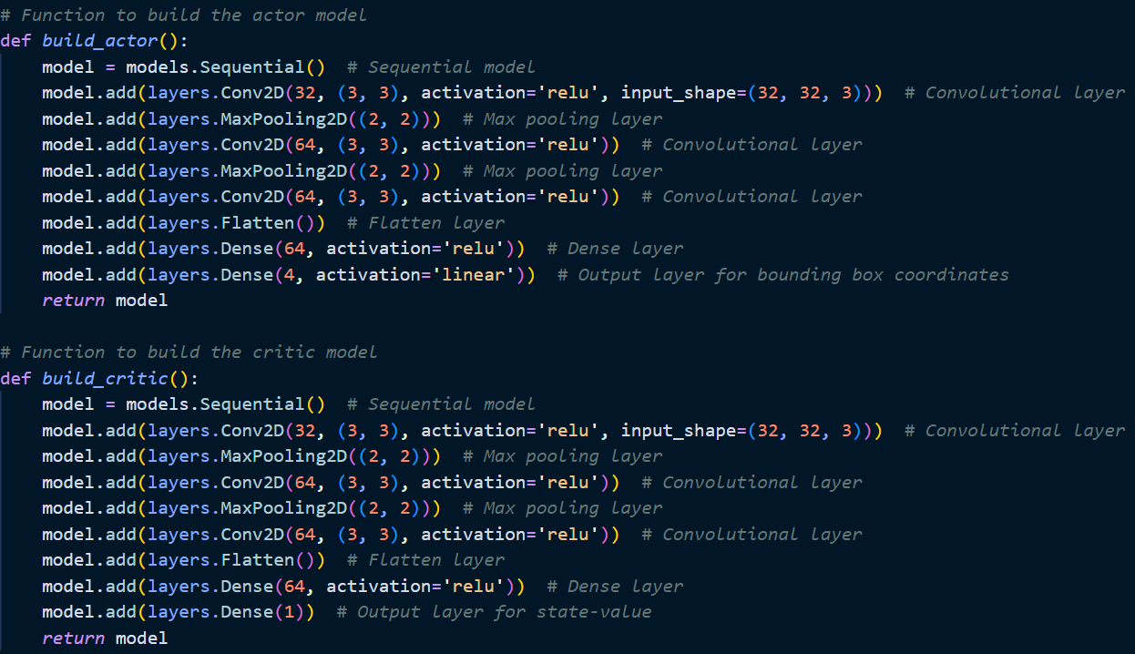

The actor and critic models are defined using Keras' Sequential API. The actor model predicts bounding box coordinates, while the critic model predicts state values. The actor and critic models are compiled using the Adam optimizer with mean squared error (MSE) loss.

A function *iou* is defined to calculate the Intersection over Union (IoU) between two bounding boxes, which serves as the reward signal for the reinforcement learning algorithm.

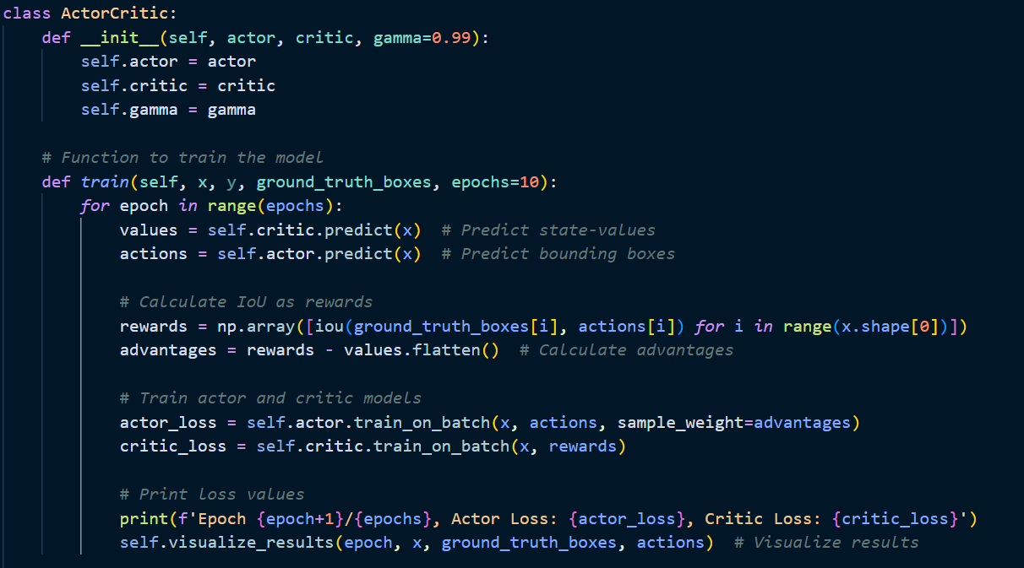

An *ActorCritic* class is defined to encapsulate the actor and critic models along with training and visualization methods. The *train* method trains the actor and critic models over multiple epochs. State-values and bounding boxes are predicted, IoU rewards are calculated, and the models are updated using the calculated advantages. The *visualize_results* method visualizes the ground truth and predicted bounding boxes on sample images to monitor training progress.

Training progress is visualized by plotting the predicted bounding boxes on sample images, providing feedback on the model's performance.

**Results:**

Figure 5-Sample output of Actor-Critic model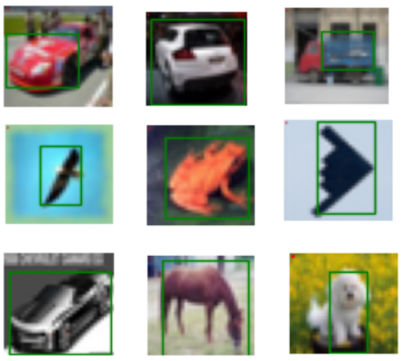

1. **Object Detection on FLIR_ADAS Dataset using Deep-Q Network**

The code implements a Deep-Q Network (DQN) algorithm for object detection. The custom environment is designed using OpenAI Gym to handle object detection tasks on a dataset. The key components include importing necessary libraries, loading and preprocessing the dataset, defining the environment, building the DQN model, and training the model using experience replay.

Essential libraries such as OpenCV, TensorFlow, NumPy, matplotlib, and gym are imported for image processing, deep learning, numerical computations, visualization, and creating the custom environment. A function *load_dataset* is defined to load and preprocess the dataset. Images are resized, and normalized, and corresponding annotations are read from text files.

**Sample Dataset Images:**

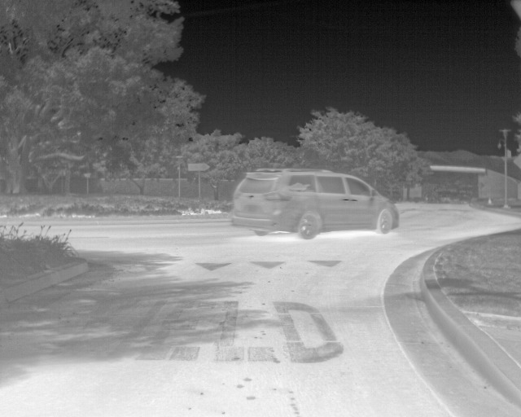 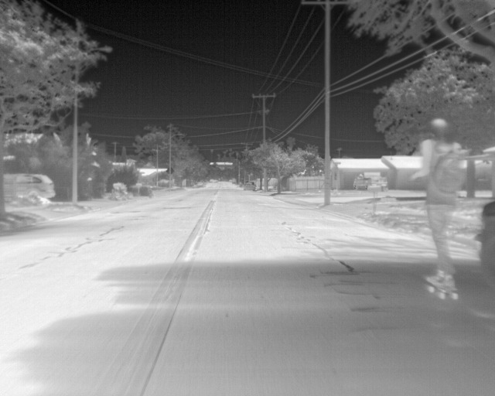

Figure 6-Some images from FLIR_ADAS dataset

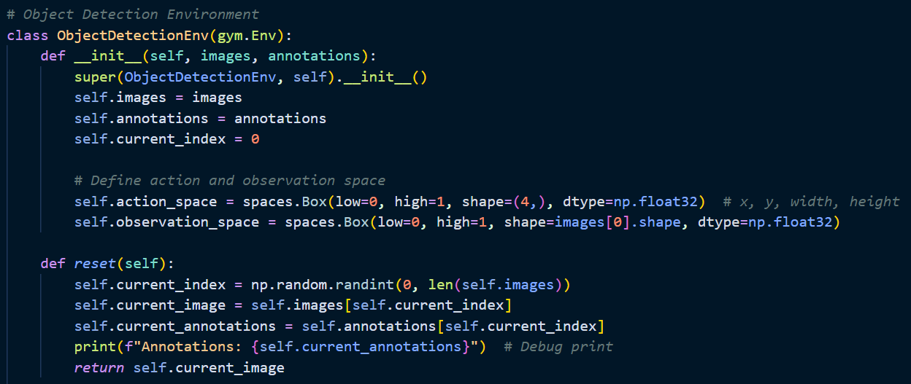

A custom OpenAI Gym environment *ObjectDetectionEnv* is defined to simulate the object detection task. The environment includes methods to reset the environment, take a step (action), and render the current state with bounding boxes. The environment's action space represents bounding box coordinates (x, y, width, height), and the observation space is the image.

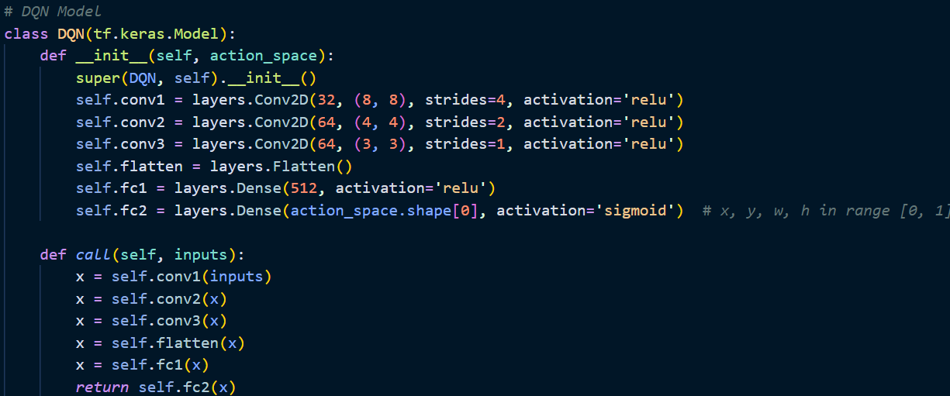

A DQN model is defined using TensorFlow's Keras API. The model consists of convolutional layers for feature extraction and dense layers for predicting bounding box coordinates. The action space shape determines the output layer's size, and the sigmoid activation function ensures the outputs are in the range [0, 1].

Hyperparameters such as learning rate, discount factor (gamma), exploration rate (epsilon), and batch size are defined. A memory buffer is used to store experiences (state, action, reward, next state, done) for experience replay.

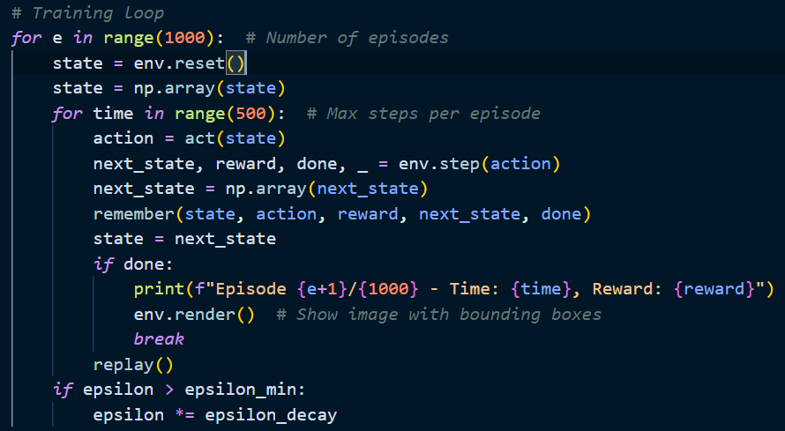

Functions *remember, replay,* and *ac*t are defined to handle memory storage, experience replay, and action selection, respectively. The training loop runs for a specified number of episodes. In each episode, the agent interacts with the environment, and the DQN model is updated using experience replay.

**Results:**

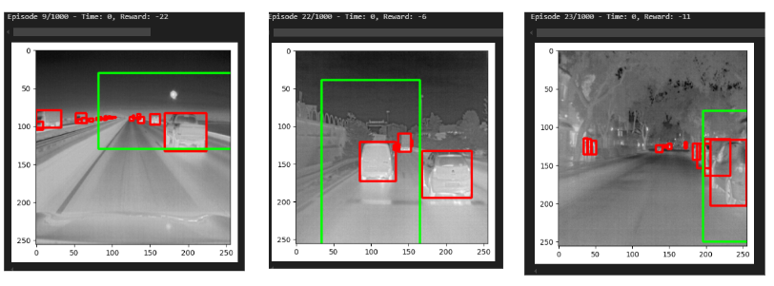

Figure 7-Sample output of DQN model

**5. Conclusion**

This report presents a comprehensive exploration of object detection using deep reinforcement learning techniques, from theoretical foundations to practical implementation. By combining insights from recent research with hands-on development and evaluation, we developed a robust framework for object detection tasks.

**Reinforcement Learning for Object Detection:**

The integration of reinforcement learning (RL) with object detection leverages the decision-making capabilities of RL agents to dynamically adjust detection strategies based on environmental feedback. The hierarchical and dynamic models demonstrated the potential of RL to enhance detection accuracy and efficiency.

**Hierarchical vs. Dynamic Methods:**

The hierarchical method, with its structured approach of focusing on progressively smaller sub-regions, showed faster convergence and computational efficiency. However, it struggled with larger objects due to limited flexibility in bounding box adjustments.

The dynamic method offered greater flexibility in adjusting the bounding box, making it more adaptable to complex object shapes and positions. Although it required more extensive hyperparameter tuning and computational resources, it demonstrated a higher potential for precision.

**Q-Learning on CIFAR-10:**

We implemented a Q-learning algorithm for object detection using the CIFAR-10 dataset. The agent learned to detect objects by interacting with the environment, receiving rewards, and updating its Q-values. This approach highlighted the effectiveness of Q-learning in object detection tasks.

**Actor-Critic Model on CIFAR-10:**

By incorporating YOLOv8 for ground truth bounding boxes, we developed an Actor-Critic model for object detection. This method combined the strengths of RL and advanced object detection algorithms, demonstrating improved accuracy and performance.

**DQN on FLIR_ADAS:**

Finally, we applied the DQN model to a FLIR_ADAS dataset, utilizing a Gym environment for interactive training and evaluation. The environment handled image preprocessing, action space definition, reward calculation, and visualization, enabling the DQN model to learn effective object detection strategies.

1. **Future Directions**

* Further research could explore hybrid approaches that combine the strengths of hierarchical and dynamic methods, potentially achieving better overall performance.
* Extending the current models to handle multiple object classes simultaneously and improving their robustness in diverse environments would be valuable advancements.
* Applying these techniques to larger and more complex datasets could further validate their effectiveness and uncover additional improvements.

In conclusion, this report demonstrates the promising potential of deep reinforcement learning for object detection. By leveraging the decision-making capabilities of RL agents and the powerful feature extraction abilities of deep learning models, we have developed robust, efficient, and highly accurate object detection systems. This work lays the foundation for further exploration and development in this exciting field, offering significant advancements in computer vision applications.

**6. References**

1. Samiei, M. "Object Detection with Deep Reinforcement Learning."
2. Redmon, J., & Farhadi, A. "YOLOv3: An Incremental Improvement."
3. Girshick, R. "Fast R-CNN."
4. "Active Object Detection with Deep Reinforcement Learning" by J. Caicedo and S. Lazebnik
5. "Reinforcement Learning for Weakly Supervised Object Detection" by Yang Liu, Yang Zou, Chen Yu, Jiebo Luo
6. "Efficient Object Detection in Large Images Using Deep Reinforcement Learning" by Burak Uzkent, Christopher Yeh, Stefano Ermon (WACV 2020)
7. "AdaZoom: Adaptive Zoom Network for Multi-Scale Object Detection in Large Scenes"
8. Chatgpt
9. Perplexity AI