**WEB222 Project-Phase 3 Report**

|  |  |
| --- | --- |
| Group Info | Enter your Group no: 10 |
| Enter your group members name: : Vithursh, Angela |

# **Progress Made till this phase** (Outline the tasks that have be completed till now, Provide detailed information on the progress that you made so far in the project , add storyboards, output of web project)

- The head changes color when the uses clicks a mood

- Added validation to the contact us web page

- Displays album cover art, artists name and songs name

- Process and configuring the API data

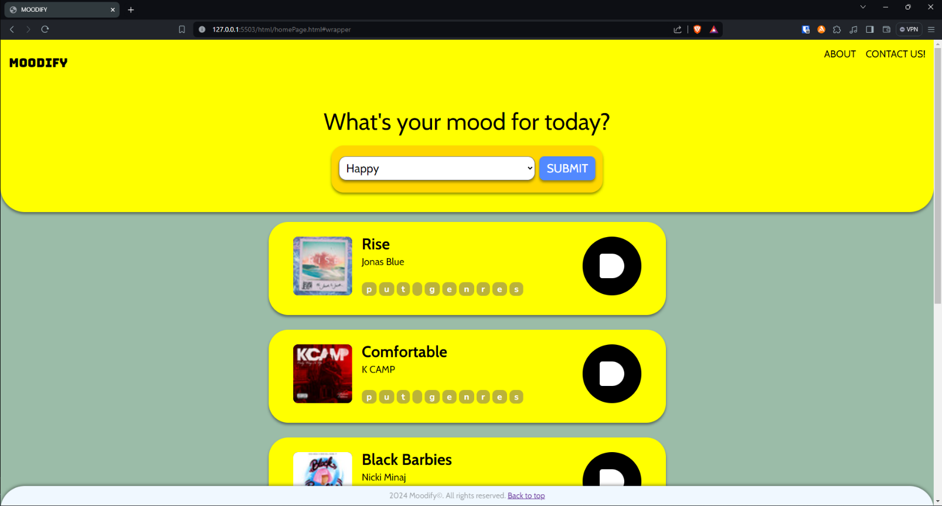

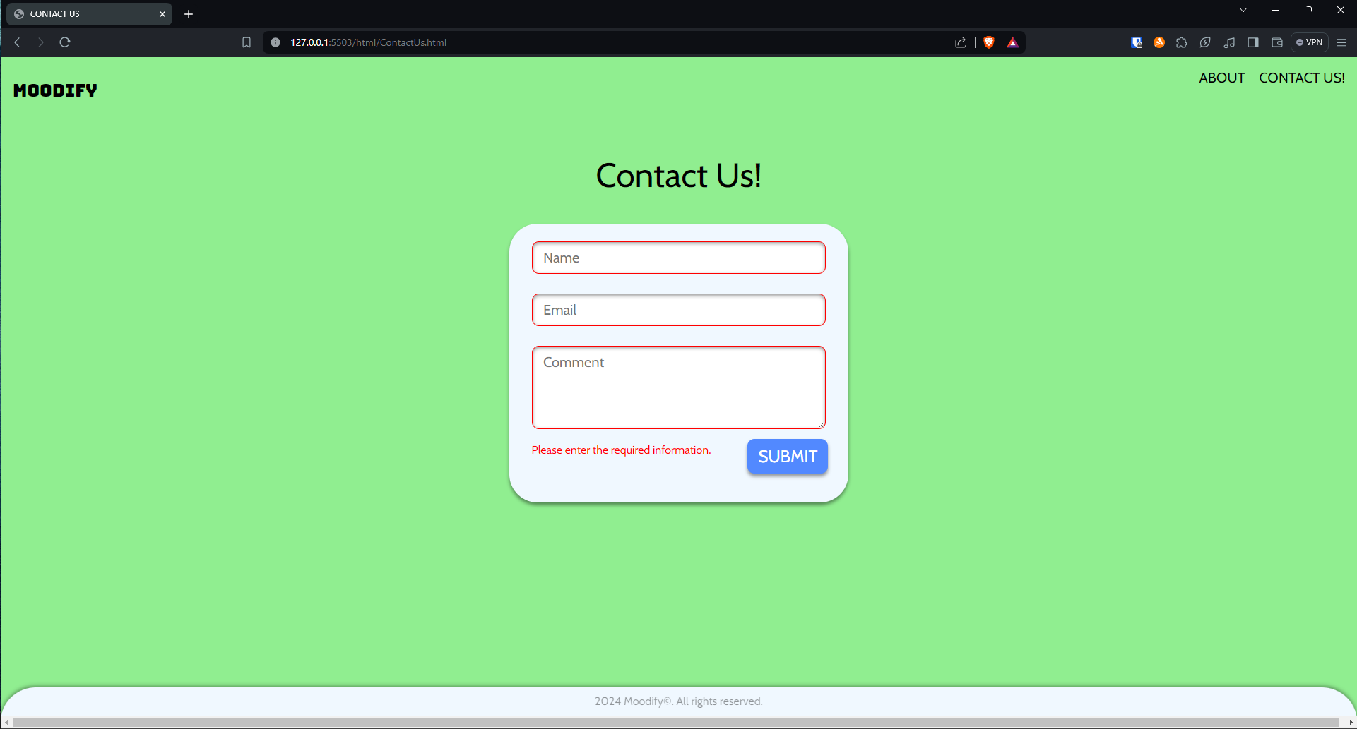

# **How did you divide the work?** (Provide detailed information on the task-assigning to each member)

- Angela: The head changes color when the uses clicks a mood

- Angela: Added validation to the contact us web page

- Vithursh: Displays album cover art, artists name and songs name

- Vithursh: Process and configuring the API data

# **Difficulties Encountered during this phase** (Provide detailed information on the difficulties and challenges that you encountered in the project so far)

* None so far

# **Tasks to Be Completed in Next phases** (Outline the tasks to be completed in the following week and how do you divide the work)

* **Displays the genres.**
* **Sort the genres.**
* **Refresh the recommended songs every time the users click on a new mood.**

# **How do you evaluate your progress** (Evaluate your team progress in this phase and mark your team out of 10)

We made a lot of progress since now the user will see all of the songs based on there mood, there is a background animation that changes every 30 seconds, and the users will be able to scroll back up to the home page.

9/10